Inventory Management System

* Rajesh D
* Jaiguru L
* Abhindhira

Introduction :

The inventory system's database structures essential data across tables for products, users (consumers & sellers), orders, transactions, and reviews. It interlinks these entities using relationships, tracking product details (name, quantity, price), user information (login credentials, contact), order specifics (date, total price), and feedback (ratings, comments). The system efficiently categorizes products, manages inventory levels, and ensures secure transactions, providing a comprehensive foundation for inventory management and e-commerce operations.

The database serves an inventory management system with:

1. **Tables:** Structured entities like **consumer**, **seller**, **products**, **category**, **order**, **transaction**, **review**, storing vital information.
2. **Relations:** Establishes connections via foreign keys between tables (e.g., **sellerID** in **products** linking to **seller**).
3. **Product Details:** Captures product attributes like name, description, quantity, price, and category.
4. **User Management:** Manages consumer and seller details, login credentials, contact information, and trust factors.
5. **Order Processing:** Tracks orders, dates, total prices, and associated transactions.
6. **Feedback Mechanism:** Records customer reviews, ratings, and comments for products.
7. **Categorization:** Organizes products into categories for streamlined navigation.
8. **Inventory Control:** Monitors stock levels, aiding in inventory management and restocking decisions.
9. **Transaction Records:** Stores payment methods, transaction dates, ensuring transparency in financial activities.

Tables In the DataBase :

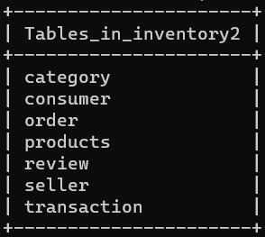

Consumer:

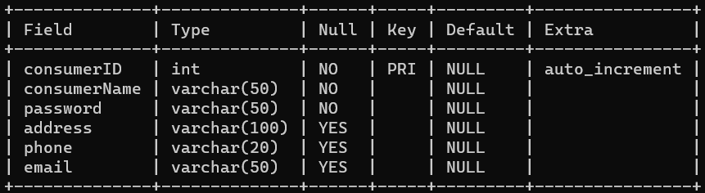

Seller :

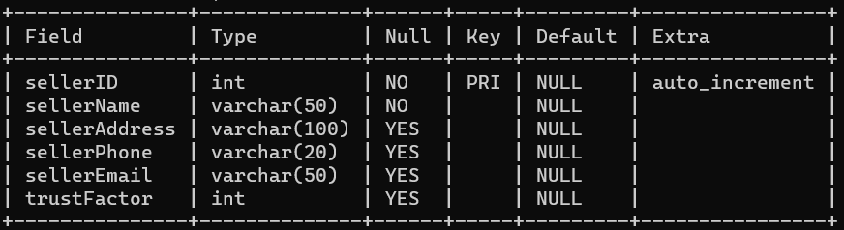

Product :

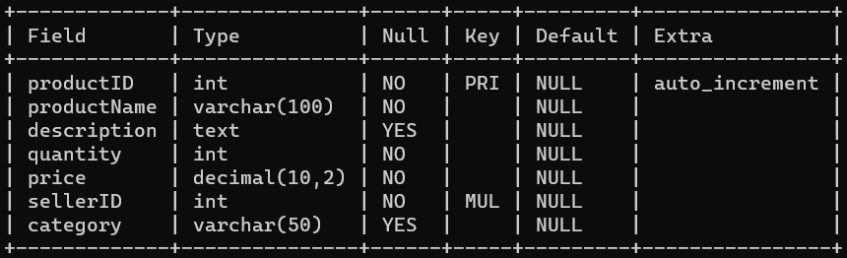

Review :

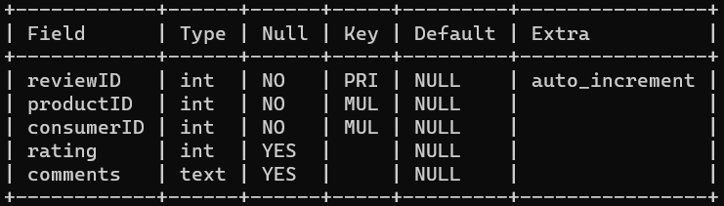

Transaction :

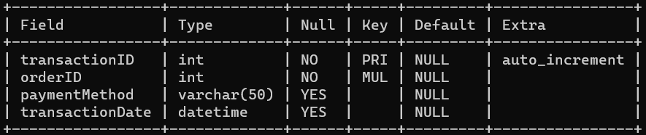

Order :

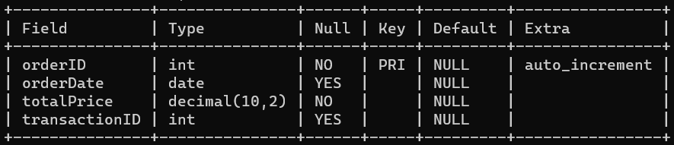

Category :

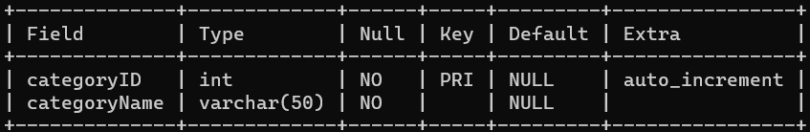

CODE :

CREATE DATABASE inventory2;

use inventory2 ;

CREATE TABLE consumer (

consumerID INT AUTO_INCREMENT PRIMARY KEY,

consumerName VARCHAR(50) NOT NULL,

password VARCHAR(50) NOT NULL,

address VARCHAR(100),

phone VARCHAR(20),

email VARCHAR(50)

);

CREATE TABLE seller (

sellerID INT AUTO_INCREMENT PRIMARY KEY,

sellerName VARCHAR(50) NOT NULL,

sellerAddress VARCHAR(100),

sellerPhone VARCHAR(20),

sellerEmail VARCHAR(50)

);

CREATE TABLE products (

productID INT AUTO_INCREMENT PRIMARY KEY,

productName VARCHAR(100) NOT NULL,

description TEXT,

quantity INT NOT NULL,

price DECIMAL(10, 2) NOT NULL,

sellerID INT NOT NULL,

category VARCHAR(50),

FOREIGN KEY (sellerID) REFERENCES seller(sellerID)

);

ALTER TABLE seller

ADD COLUMN trustFactor INT;

CREATE TABLE category (

categoryID INT AUTO_INCREMENT PRIMARY KEY,

categoryName VARCHAR(50) NOT NULL

);

CREATE TABLE `order` (

orderID INT AUTO_INCREMENT PRIMARY KEY,

orderDate DATE,

totalPrice DECIMAL(10, 2) NOT NULL,

transactionID INT

);

CREATE TABLE transaction (

transactionID INT AUTO_INCREMENT PRIMARY KEY,

orderID INT NOT NULL,

paymentMethod VARCHAR(50),

transactionDate DATETIME,

FOREIGN KEY (orderID) REFERENCES `order`(orderID)

);

CREATE TABLE review (

reviewID INT AUTO_INCREMENT PRIMARY KEY,

productID INT NOT NULL,

consumerID INT NOT NULL,

rating INT,

comments TEXT,

FOREIGN KEY (productID) REFERENCES products(productID),

FOREIGN KEY (consumerID) REFERENCES consumer(consumerID)

);