SOFTWARE REQUIREMENTS SPECIFICATION

**For**

**Inventory Management System**

**Prepared by:-**

*Rajesh D*

*Jaiguru L*

*Abhindhira KP*

# Introduction

## Purpose

The main objective of this document is to illustrate the requirements of the project Inventory Management system. The document gives the detailed description of the both functional and non-functional requirements proposed by the client. The purpose of this project is to provide a friendly environment to maintain the details of books and Inventory members. The main purpose of this project is to maintain easy circulation system using computers and to provide different reports. This project describes the hardware and software interface requirements using ER diagrams and UML diagrams.

## Document Conventions

* + - Entire document should be justified.
    - Convention for Main title

Font face: Times New Roman Font style: Bold

Font Size: 14

* + - Convention for Sub title

Font face: Times New Roman Font style: Bold

Font Size: 12

* + - Convention for body

Font face: Times New Roman Font Size: 12

## Scope of Development Project

The Inventory Management System aims to transition traditional manual inventory processes into a streamlined, web-based application. This system will empower users to effortlessly access comprehensive information about their inventory accounts, check the availability of products, and ascertain maximum limits for procurement.

Specifically designed for the use of inventory managers and system users, this product will serve as an intuitive and comprehensive interface for inventory management processes. It caters to the needs of diverse industries and organizations, offering a versatile solution for efficiently managing inventory, order processing, and monitoring.

## Definitions, Acronyms and Abbreviations

JAVA -> platform independence SQL-> Structured query Language ER-> Entity Relationship

UML -> Unified Modeling Language

IDE-> Integrated Development Environment SRS-> Software Requirement Specification

## References

* + - Books

 Software Requirements and Specifications: A Lexicon of Practice, Principles and Prejudices (ACM Press) by Michael Jackson

Software Requirements (Microsoft) Second Edition By Karl E. Wiegers

Software Engineering: A Practitioner’s Approach Fifth Edition By Roger S. Pressman

* + - Websites

[**http://www.slideshare.net/**](http://www.slideshare.net/)

[**http://ebookily.net/doc/srs-Inventory-management-system**](http://ebookily.net/doc/srs-library-management-system)

# Overall Descriptions

## Product Perspective

Use Case Diagram of Inventory Management System

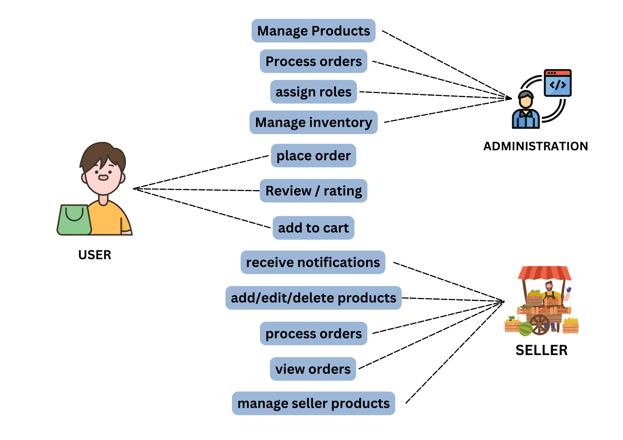

This is a broad level diagram of the project showing a basic overview. The users can be either staff or student. This System will provide a search functionality to facilitate the search of resources. This search will be based on various categories viz. book name or the ISBN. Further the Inventory staff personnel can add/update the resources and the resource users from the system. The users of the system can request issue/renew/return of books for which they would have to follow certain criteria.

## Product Function

## 

## The Online Inventory Management System streamlines and automates inventory-related processes, offering real-time information on available items and user data. This software facilitates tasks such as adding new items, updating stock levels, and processing orders, aiming to reduce manual effort and enhance accuracy. The system, administered by the inventory manager, maintains transaction records, calculates discrepancies, and generates reports for efficient record-keeping. Users with valid access can view pertinent information about their accounts, contributing to a more organized and responsive inventory management approach.

## User Classes and Classifications

The Inventory Management System provides distinct services tailored to different user types, namely Administrators and Users. Administrators have comprehensive control over the system, while Users, who can be customers or staff members, interact with the system to manage their inventory needs.

**Administrator Features:**

1. **Manage Inventory:**
   * Add new products to the inventory database.
   * Edit information for existing products.
2. **View Inventory Details:**
   * Access a comprehensive list of available product categories.
   * View detailed lists of products within each category.
3. **Stock Transactions:**
   * Record stock movements such as deliveries and returns.
   * Track product sales and restocking activities.
4. **Generate Reports:**
   * Retrieve reports on current inventory levels.
   * View reports on product sales, restocking, and movement history.
5. **User Account Management:**
   * Manage user accounts and permissions.
   * Access and view the transaction history of user accounts.
6. **Search Functionality:**
   * Utilize search functionalities to quickly find specific products.

**User Features:**

1. **View Inventory Details:**
   * Access a categorized list of available products.
   * View detailed information on products within each category.
2. **Account Management:**
   * Create and manage a personal account within the system.
   * View the transaction history associated with the user's account.
3. **Stock Requests:**
   * Submit requests for new products to be added to the inventory.
   * Track the status of submitted requests.
4. **Transaction History:**
   * View a history of products previously acquired.
   * Access information on the date and details of past transactions.
5. **Search Functionality:**
   * Utilize search functionalities to find specific products of interest.
6. **Inventory Alerts:**
   * Receive notifications or alerts related to inventory activities (e.g., low stock alerts).

The product will be operating in windows environment. The Inventory Management System is a website and shall operate in all famous browsers, for a model we are taking Microsoft Internet Explorer, Google Chrome, and Mozilla Firefox. Also it will be compatible with the IE 6.0. Most of the features will be compatible with the Mozilla Firefox & Opera 7.0 or higher version. The only requirement to use this online product would be the internet connection.

The hardware configuration include Hard Disk: 40 GB, Monitor: 15” Color monitor, Keyboard: 122 keys. The basic input devices required are keyboard, mouse and output devices are monitor, printer etc.

## Assumptions and Dependencies

1. **Error-Free Coding:**
   * The coding for the system is assumed to be error-free to ensure smooth functionality.
2. **User-Friendly Interface:**
   * The system is designed to be user-friendly, facilitating easy use for administrators and users alike.
3. **Database Accessibility:**
   * All information related to products, users, and inventory will be stored in an accessible database.
4. **Storage Capacity and Speed:**
   * The system is expected to have ample storage capacity and provide fast access to the database to support efficient inventory management.
5. **Search Facility and Quick Transactions:**
   * The system will incorporate a search facility for easy navigation and support quick transactions for inventory-related activities.
6. **24/7 System Availability:**
   * The Inventory Management System is designed to run continuously, offering 24/7 availability for users.
7. **Remote Access:**
   * Users may access the system from any computer with internet browsing capabilities and an internet connection, ensuring flexibility in usage.
8. **User Authentication:**
   * Users must use correct usernames and passwords for secure access to their online accounts and perform actions within the system.

**Dependencies for the Inventory Management System:**

1. **Specific Hardware and Software:**
   * The system's functionality depends on specific hardware and software configurations to ensure optimal performance.
2. **Requirements and Specifications:**
   * The project's development and operation are dependent on accurately listed requirements and specifications.
3. **User Understanding:**
   * End users, particularly administrators, are expected to have a proper understanding of the system to effectively manage and operate it.
4. **Reporting System:**
   * The system relies on a reporting mechanism to store and retrieve general reports related to inventory management.
5. **Database Connectivity:**
   * Information about products, users, and inventory will be stored in a database accessible by the Inventory Management System.
6. **Accurate Data Entry:**
   * The system's effectiveness is contingent on accurate data entry, particularly regarding updates and changes to inventory status.
   * These assumptions and dependencies serve as the foundation for the successful development, implementation, and operation of the Inventory Management System, ensuring its reliability and functionality in various scenarios.Top of Form

## Requirement

Software Configuration:-

This software package is developed using java as front end which is supported by sun micro system. Microsoft SQL Server as the back end to store the database.

Operating System: Windows NT, windows 98, Windows XP

Language: Java Runtime Environment, Net beans 7.0.1 (front end)

Database: MS SQL Server (back end)

Hardware Configuration:

Processor: Pentium(R) Dual-core CPU Hard Disk: 40GB

RAM: 256 MB or more

## Date Requirement

The inputs consist of the query to the database and the output consists of the solutions for the query. The output also includes the user receiving the details of their accounts. In this project the input will be the queries as fired by the users like create an account, selecting books and putting into account. Now the output will be visible when the user requests the server to get details of their account in the form of time, date and which books are currently in the account.

# External Interface Requirement

## GUI

**Graphical User Interface for the Inventory Management System:**

The software offers a user-friendly graphical interface for both users and administrators. The

Administrator can seamlessly perform tasks such as creating, updating, and viewing book details

Through an intuitive interface. Key features of the graphical interface include:

1. **Quick Reports:**
   * Users can easily view quick reports on inventory activities, such as stock issued or returned within a specified time frame.
2. **Stock Verification and Search:**
   * The system provides stock verification tools and a search facility based on various criteria to enhance user convenience.
3. **Customizable User Interface:**
   * Administrators have the ability to customize the user interface according to their preferences, ensuring flexibility in design and layout.
4. **Module Integration:**
   * All software modules seamlessly integrate into the graphical user interface, adhering to defined standards.
5. **Simple Design and Standard Templates:**
   * The design of the interface is kept simple, and different interfaces adhere to a standard template for consistency and ease of use.
6. **User Management Interaction:**
   * The user interface interacts seamlessly with the user management module, dedicating a section for login/logout functionality.

**Login Interface:**

* Users can register by entering their details to create an account.
* Once registered, users can log in by entering their username and password.
* An error message appears in case of incorrect username or password entry.

**Search Functionality:**

* Users, whether members or administrators, can search for specific inventory items by entering relevant criteria such as product type or title.

**Categories View:**

* Categories view displays the different categories of inventory items.
* Librarians have the ability to add, edit, or delete categories directly from this view.

**Administrator's Control Panel:**

* The control panel empowers administrators to manage users, add or remove resources, and oversee lending options.
* Tasks such as adding or removing users and managing inventory resources can be performed through this centralized control panel.

This well-designed graphical user interface enhances the user experience and simplifies complex tasks for

Both administrators and users, fostering efficient inventory management within the system.

# System Features

# Security Measures for the Inventory Management System:

# User Authentication and Validation:

# Users are required to authenticate themselves using unique identifiers, such as employee ID or user-specific credentials, to access the inventory system. This ensures that only authorized individuals can log in and interact with the system.

# Administrator Monitoring and Policy Enforcement:

# The administrator actively monitors user activities, updating account statuses as needed. Popup notifications alert users when attempting actions that violate Inventory policies, such as exceeding the allowable limit for issuing items. The administrator also assigns fines to users who fail to meet return deadlines, reinforcing policy adherence. This proactive approach enhances security and accountability in the system.

# Other Non-Functional Requirements

## Performance Requirement

## Fast and Accurate System Operation:

## The Inventory Management System prioritizes swift and accurate performance to meet the dynamic demands of inventory management. Quick response times and precise data handling are key features to enhance operational efficiency.

## Robust Error Handling and Prevention:

## The system incorporates robust error handling mechanisms to address both expected and unexpected errors promptly. It includes inbuilt error testing, particularly during login attempts, to identify and prevent issues such as invalid usernames or passwords. This ensures minimal downtime and prevents information loss due to errors.

## Safety Requirement

## To safeguard against potential database crashes due to viruses or operating system failures, the Inventory Management System incorporates regular automated backups. This ensures that crucial inventory data is consistently backed up, minimizing the risk of data loss. Additionally, the system is equipped with a reliable Uninterruptible Power Supply (UPS) or inverter facility to address power supply failures, enhancing overall system stability and data integrity.

* + - System will use secured database
    - Normal users can just read information but they cannot edit or modify anything except their personal and some other information.
    - System will have different types of users and every user has access constraints
    - Proper user authentication should be provided
    - No one should be able to hack users’ password
    - There should be separate accounts for admin and members such that no member can access the database and only admin has the rights to update the database.

## Requirement Attributes

* + - There may be multiple admins creating the project, all of them will have the right to create changes to the system. But the members or other users cannot do changes
    - The project should be open source
    - The Quality of the database is maintained in such a way so that it can be very user friendly to all the users of the database
    - The user be able to easily download and install the system

## Business Rule

A business rule is anything that captures and implements business policies and practices. A rule can enforce business policy, make a decision, or infer new data from existing data. This includes the rules and regulations that the System users should abide by. This includes the cost of the project and the discount offers provided. The users should avoid illegal rules and protocols. Neither admin nor member should cross the rules and regulations.

## User Requirement

* Members: Basic familiarity with inventory system usage.
* Administrators: In-depth understanding, capable of addressing technical issues.

**User Support:**

* User-friendly interface, manuals, and online help for system navigation.

**Administrator Facilities:**

* Backup and Recovery for data protection.
* Password retrieval feature for user convenience.
* Data Migration during user registration.
* Data Replication for redundancy.
* Auto Recovery with frequent data saving.
* File Organization for efficient data management.
* Regular server maintenance and updates.

# Other Requirement

## Date and Category

In the Inventory Management System, distinct user categories, including teaching staff, administrators, librarians, and students, are established. Access rights are tailored based on user categories, ensuring appropriate permissions for different roles. Administrators possess comprehensive rights, enabling them to modify, delete, and append data. Other users, excluding librarians, are restricted to retrieving information from the database.

Furthermore, diverse categories of inventory items are implemented in the system. Each category is associated with a specific data format, allowing for the organized display of relevant information. Users, based on their roles, can access and interact with data pertinent to the specific categories of inventory items, streamlining the information retrieval process and maintaining data integrity.

## Appendix

A: Admin, Abbreviation, Acronym, Assumptions; B: Books, Business rules; C: Class, Client, Conventions; D: Data requirement, Dependencies; G: GUI; K: Key; L: Inventory, Librarian; M: Member; N: Non-functional Requirement; O: Operating environment; P: Performance, Perspective, Purpose; R: Requirement, Requirement attributes; S: Safety, Scope, Security, System features; U: User, User class and characteristics, User requirement;

## Glossary

The following are the list of conventions and acronyms used in this document and the project as well:

* + - Administrator: A login id representing a user with user administration privileges to the software
    - User: A general login id assigned to most users
    - Client: Intended users for the software
    - SQL: Structured Query Language; used to retrieve information from a database
    - SQL Server: A server used to store data in an organized format
    - Layer: Represents a section of the project
    - User Interface Layer: The section of the assignment referring to what the user interacts with directly
    - Application Logic Layer: The section of the assignment referring to the Web Server. This is where all computations are completed
    - Data Storage Layer: The section of the assignment referring to where all data is recorded
    - Use Case: A broad level diagram of the project showing a basic overview
    - Class diagram: It is a type of static structure diagram that describes the structure of a system by showing the system’s cases, their attributes, and the relationships between the classes
    - Interface: Something used to communicate across different mediums
    - Unique Key: Used to differentiate entries in a database

## Class Diagram

In the context of the Inventory Management System, classes are abstract, user-defined representations of different entities crucial to the system's functioning. Each class defines attributes that characterize the entity and outlines operations that can be performed on instances or objects of that class. The static model of the system captures the structure of these classes and their relationships.

Key classes in the Inventory Management System include 'Seller', 'User,' and 'Product.' These classes are intricately linked to other classes essential for the system's operation. Various relationships, such as normal associations, aggregations, and generalizations, illustrate the connections between these classes. Role names and multiplicities are employed in the diagram to denote the nature of these relationships.

The ‘Seller’, 'User,' and 'Product' classes stand as primary entities, forming the backbone of the system. Their relationships with other classes are crucial for maintaining a comprehensive and efficient inventory management system.

