SOFTWARE REQUIREMENTS SPECIFICATION

**FOR**

**PERSONAL FINANCE BLOG**

**Prepared by:**

**-AKALYA.D**

**-JAISHREE.S**

**-LITHIHA.L**

**-ANBARASAN.S**

# Introduction

## Purpose

## Blogging about personal finance can also serve as a useful tool for budgeting and expense tracking. By regularly documenting your spending habits and financial decisions, you can gain a better understanding of where your money is going and identify areas for improvement. Through the process of budgeting and expense tracking, you can make deliberate choices about how you spend your money and ensure that you are on track to reach your financial goals. This can help you reduce unnecessary expenses, save more money, and build wealth over time.

## Document Conventions

* + - Entire document should be justified.
    - Convention for Main title

Font face: Times New Roman Font style: Bold

Font Size: 14

* + - Convention for Sub title

Font face: Times New Roman Font style: Bold

Font Size: 12

* + - Convention for body

Font face: Times New Roman Font Size: 12

## Scope of Development Project

## As individuals become more aware of the importance of financial literacy, there is a growing demand for reliable and accessible information on personal finance topics. A well-curated personal finance blog can serve as a valuable resource for readers seeking to enhance their financial knowledge. Personal finance blogs can explore various monetization avenues, such as affiliate marketing, sponsored content, partnerships, and digital product creation (e-books, courses, budgeting tools). Additionally, as the blog gains credibility and a larger audience, there may be opportunities for speaking engagements, consulting, or collaborations with financial institutions. Embracing and integrating emerging technologies can enhance the user experience. This could include interactive financial tools, chatbots for personalized financial advice, and leveraging data analytics to provide insightful trends and predictions. Beyond traditional written content, incorporating diverse content formats such as video, podcasts, and infographics can help cater to different audience preferences. This can make the blog more engaging and accessible to a wider audience. Utilizing social media platforms for content distribution, engagement, and community building can be crucial. Creating a strong presence on platforms like Instagram, Twitter, and LinkedIn can help reach and connect with a broader audience.

## Definitions, Acronyms and Abbreviations

JAVA -> platform independence SQL-> Structured query Language

ER-> Entity Relationship

UML -> Unified Modeling Language

IDE-> Integrated Development Environment SRS-> Software Requirement Specification

## References

Websites

[**https://www.wisdomtimes.com/blog/personal-finance-management/**](https://www.wisdomtimes.com/blog/personal-finance-management/)

**https://www.financeguestpost.com/finance-blogs-accepting-guest-posts.html**

Overall Descriptions

## Product Perspective

Use Case Diagram of personal finance blog:

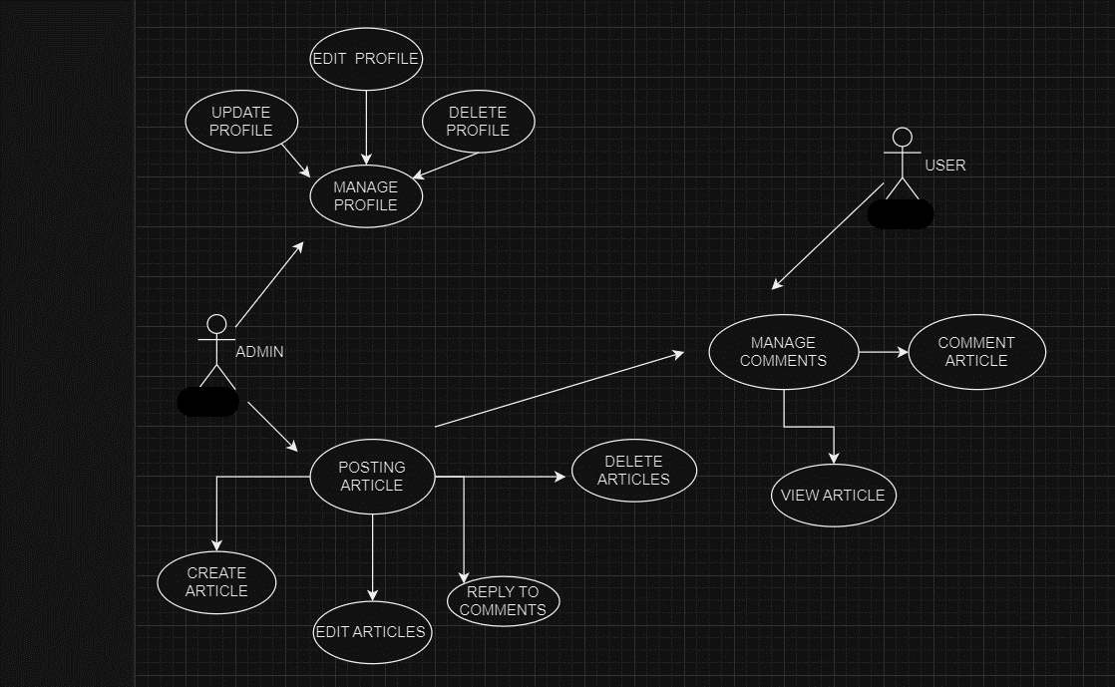

This is a broad level diagram of the project showing a basic overview. The user is an administrator or a blogger who gives solutions for the issues which peoples are facing. This System will provide a search functionality to facilitate the search of resources. This search will be based on various categories like savings, credits or debits. Further the blogger can add/update the resources and the resource users from the system.

## Product Function

Entity Relationship Diagram for Personal Finance Blog :

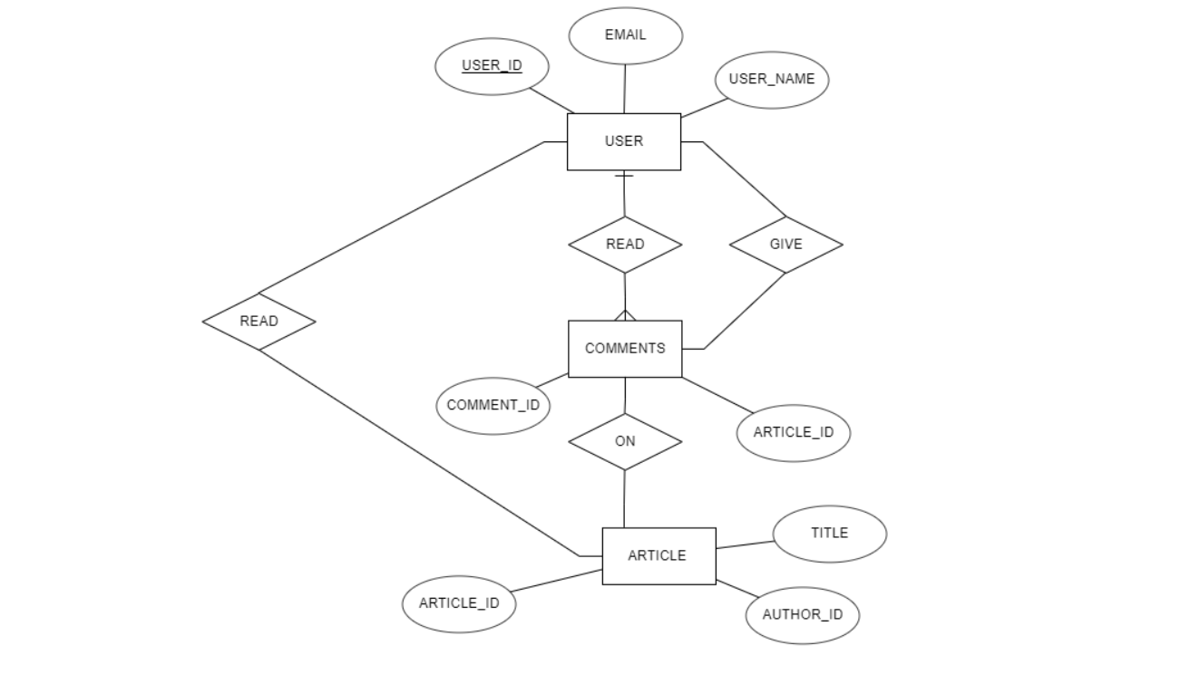

The Personal Finance Blog provides the real time information about the credits, debits and savings uses in The Personal Finance Blog. The main purpose of this project is to help the end users how to use or save the money efficiently. This software is capable of managing and solving the issues which are faced by the end users like saving money, managing credits and debits. The Blogger will act as the administrator to solve the issues and manage to answer for the users based on their quries. The user’s status of post/comment/Articles is maintained in the Administrator database. The user’s details can be fetched by the Blogger from the database as and when required. The valid members are also allowed to view their account information.

## User Classes and Characteristics

Finance bloggers have access to a diverse set of features to enhance their personal finance blogs. A robust Content Management System (CMS) allows for easy creation and publishing of content, ensuring a seamless user experience.

The features that are available to the finance blogger are:

* + - Mobile responsiveness ensures accessibility across devices, reaching a broader audience.
    - Educational content, ranging from articles to multimedia resources, helps disseminate financial knowledge.
    - Interactive tools, such as budget calculators, engage users in practical financial planning.
    - Social media integration facilitates content sharing and expands the blog's reach.
    - User engagement features like comment sections foster a sense of community, while analytics tools provide insights into user behavior.
    - Monetization options, such as affiliate marketing and ad placements, offer revenue streams. Security features, backup systems, and customizable designs contribute to a secure and visually appealing blog.
    - These features collectively empower finance bloggers to deliver valuable content, build community engagement, and establish a strong online presence in the personal finance sphere.

The features that are available to the Members are:

* + - Members of a personal finance blog enjoy personalized profiles, exclusive budgeting tools, and member-only content.
    - They participate in interactive forums, benefit from priority Q&A sessions, and receive curated newsletters.
    - Challenges and goal tracking, member surveys, and financial event invitations enhance engagement.
    - Special discounts, promotions, and secure member areas round out the personalized and valuable experience for members on the personal finance blog.
    - Members of a personal finance blog enjoy personalized profiles, exclusive budgeting tools, and member-only content.
    - They participate in interactive forums, benefit from priority Q&A sessions, and receive curated newsletters.
    - Challenges and goal tracking, member surveys, and financial event invitations enhance engagement.

## Operating Environment

## A personal finance blog operates in a dynamic online environment, relying on a robust web hosting service, secure content management systems, and responsive designs for user accessibility. Analytics tools aid in performance monitoring, while social media integration broadens reach. Compliance with legal and financial regulations is crucial, and regular backups ensure data security. Continuous adaptation to industry trends and user feedback is essential for a successful and user-friendly operating environment.

## Assumptions and Dependencies

The assumptions are:

* + - The coding should be error free
    - The system should be user-friendly so that it is easy to use for the users
    - The information of all users, finance savings, debits must be stored in a database that is accessible by the website
    - The system should have more storage capacity and provide fast access to the database
    - The system should provide search facility and support quick transactions
    - The personal finance blog System is running 24 hours a day

Users may access from any computer that has Internet browsing capabilities and an

Internet connection

* + - Users must have their correct usernames and passwords to enter into their online accounts and do actions

The dependencies are:

* + - The specific hardware and software due to which the product will be run
    - On the basis of listing requirements and specification the project will be developed and run
    - The end users (admin) should have proper understanding of the product
    - The system should have the general report stored
    - The information of all the users must be stored in a database that is accessible by the personal finance blog System
    - Any update regarding the finance from the personal finance is to be recorded to the database and the data entered should be correct

## Requirement

Software Configuration:

This software package is developed using java as front end which is supported by sun micro system. Microsoft SQL Server and Ecllipse as the back end to store the database and code.

Operating System: Windows NT, windows 98, Windows XP Language: Java Runtime Environment, Net beans 7.0.1 (front end) Database: MS SQL Server (back end)

## Data Requirement

For a personal finance blog, essential data requirements include user profiles with usernames and email addresses for personalized engagement. Content management relies on data such as text, images, and videos for informative posts. Interactive tools, like budget calculators, need user inputs. Financial data keeps users updated on market trends. Analytics data aids in optimizing performance, and user comments foster engagement. Email marketing requires user email addresses, and social media integration involves account data. Monetization data supports revenue generation, security data ensures user protection, and compliance data is crucial for legal adherence.

# External Interface Requirement

## GUI

The software provides good graphical interface for the user and the administrator can operate on the system, performing the required task such as create, update, viewing the details of the finance blog.

* + - It allows user to view quick reports like savings/debits in between particular time.
    - It provides stock verification and search facility based on different criteria.
    - The user interface must be customizable by the administrator.
    - All the modules provided with the software must fit into this graphical user interface and accomplish to the standard defined
    - The design should be simple and all the different interfaces should follow a standard

template

* + - The user interface should be able to interact with the user management module and a part of the interface must be dedicated to the login/logout module

Login Interface:

In case the user is not yet registered, he can enter the details and register to create his account. Once his account is created he can ‘Login’ which asks the user to type his username and password. If the user entered either his username or password incorrectly then an error message appears.

Search:

The member or blogger can enter the type of finance he is looking for and the title he is interested in, then he can search for the required finance criteria ( savings ,debits ,loses) by entering the finance name.

Categories View:

Categories view shows the categories of finance criteria available and provides ability to the blogger to add/edit or delete category from the list.

Personal finance blog Control Panel:

A personal finance blog's control panel manages content, users, analytics, monetization, SEO, security, backups, social integration, email marketing, tools, design, accessibility, and compliance, ensuring effective blog operation and user engagement.

# System Features

The users of the system should be provided the surety that their account is secure. This is possible by providing:

* User authentication and validation of members using their unique member ID
* Proper monitoring by the blogger which includes updating account status, showing a popup if the member attempts to issue category of blog that exceed the limit provided by the blogger, helping the members who can’t handle the credits and debits.
* Proper accountability which includes not allowing a member to see other member’s account. Only administrator will see and manage all member accounts.

# Other Non-functional Requirements

## Performance Requirement

## The finance blog must prioritize swift page loads, scalability for growth, and robust security measures. It needs a responsive design for mobile users, efficient database operations, and effective SEO practices.

## Regular user feedback and iterative improvements are essential to maintain high performance and user satisfaction over time.

* + - Integrating analytics ensures ongoing optimization. Content delivery networks, caching, and image optimization enhance load times.
    - Browser compatibility, adherence to web standards, and reliable hosting contribute to a seamless user experience.

## Safety Requirement

## Implement robust security measures for the finance blog, including encryption, secure user authentication, and adherence to data protection laws. Regularly update security protocols, utilize firewalls, and conduct assessments to safeguard user data and maintain the integrity of the blog.

## Security Requirement

* + - System will use secured database
    - Normal users can just read information but they cannot edit or modify anything except their personal and some other information.
    - System will have different types of users and every user has access constraints
    - Proper user authentication should be provided
    - No one should be able to hack users’ password
    - There should be separate accounts for admin and members such that no member can access the database and only admin has the rights to update the database.

## Requirement attributes

* + - The finance blog's requirement attributes encompass scalability for growth, fast page load times, secure user authentication, compliance with data protection laws, and effective SEO practices.
    - The project should be open source
    - The Quality of the database is maintained in such a way so that it can be very user friendly to all the users of the database
    - The user be able to easily download and install the system

## Business Rules

A business rule is anything that captures and implements business policies and practices. A rule can enforce business policy, make a decision, or infer new data from existing data. This includes the rules and regulations that the System users should abide by. This includes the cost of the project and the discount offers provided. The users should avoid illegal rules and protocols. Neither admin nor member should cross the rules and regulations.

## User Requirement

## Users seek a comprehensive finance blog that meets diverse needs. They expect an intuitive interface, easy navigation, and interactive tools like budget calculators. Comprehensive content covering budgeting, investing, and financial planning is crucial. Users demand secure transactions, personalized profiles, and timely updates on financial trends. Mobile responsiveness, quick load times, and accessibility features are paramount for a seamless experience. Members desire exclusive content, community engagement, and event notifications. A reliable, user-friendly platform that enhances financial knowledge with up-to-date information, interactive features, and personalized elements is essential for user satisfaction and informed decision-making. A dynamic blog, meeting evolving user needs, fosters an engaged financial community.

The admin provides certain facilities to the users in the form of:-

* + - Backup and Recovery
    - Forgot Password
    - Data migration i.e. whenever user registers for the first time then the data is stored in the server
    - Data replication i.e. if the data is lost in one branch, it is still stored with the server
    - Auto Recovery i.e. frequently auto saving the information
    - Maintaining files i.e. File Organization
    - The server must be maintained regularly and it has to be updated from time to time

# Other Requirements

## Data and Category Requirement

There are different categories of users namely Blogger, User1, Admin, User2 etc. Depending upon the category of user the access rights are decided.It means if the user is an administrator then he can be able to modify the data,delete, append etc. All other users except the Blogger only have the rights to retrieve the information about database. Similarly there will be different categories of finance problems are there. According to the categories of finance problem their relevant data should be displayed. The categories and the data related to each category should be coded in the particular format.

## Appendix

A: Admin, Abbreviation, Acronym, Assumptions; B: Books, Business rules; C: Class, Client, Conventions; D: Data requirement, Dependencies; G: GUI; K: Key; L: Library, Librarian; M: Member; N: Non-functional Requirement; O: Operating environment; P: Performance, Perspective, Purpose; R: Requirement, Requirement attributes; S: Safety, Scope, Security, System features; U: User, User class and characteristics, User requirement;

## Glossary

The following are the list of conventions and acronyms used in this document and the project as well:

* + - Administrator: A login id representing a user with user administration privileges to the software
    - User: A general login id assigned to most users
    - Client: Intended users for the software
    - SQL: Structured Query Language; used to retrieve information from a database
    - SQL Server: A server used to store data in an organized format
    - Layer: Represents a section of the project
    - User Interface Layer: The section of the assignment referring to what the user interacts with directly
    - Application Logic Layer: The section of the assignment referring to the Web Server. This is where all computations are completed
    - Data Storage Layer: The section of the assignment referring to where all data is recorded
    - Use Case: A broad level diagram of the project showing a basic overview
    - Class diagram: It is a type of static structure diagram that describes the structure of a system by showing the system’s cases, their attributes, and the relationships between the classes
    - Interface: Something used to communicate across different mediums
    - Unique Key: Used to differentiate entries in a database

## Class Diagram

A class is an abstract, user-defined description of a type of data. It identifies the attributes of the data and the operations that can be performed on instances (i.e. objects) of the data. A class of data has a name, a set of attributes that describes its characteristics, and a set of operations that can be performed on the objects of that class. The classes’ structure and their relationships to each other frozen in time represent the static model. In this project there are certain main classes

which are related to other classes required for their working. There are different kinds of relationships between the classes as shown in the diagram like normal association, aggregation, and generalization. The relationships are depicted using a role name and multiplicities. Here ‘Librarian’, ‘Member’ and ‘Books’ are the most important classes which are related to other classes.

