SOFTWARE REQUIREMENTS SPECIFICATION

**For**

**Job portal System**

**Prepared by:-**

*THE WOLVES*

*Jaya Prakash N*

*Arun Prasaath G*

*Britto C*

# Introduction

## Purpose

The main objective of this document is to illustrate the requirements of the project Job Portal system. The document gives the detailed description of the both functional and non-functional requirements proposed by the candidates. The purpose of this project is to promote their job postings in search of a candidate, or a candidate can apply to find the right job. The main purpose of this project is to maintain easy circulation system using app. This project describes the hardware and software interface requirements using ER diagrams and UML diagrams.

## Document Conventions

* + - Entire document should be justified.
    - Convention for Main title

Font face: Times New Roman Font style: Bold

Font Size: 14

* + - Convention for Sub title

Font face: Times New Roman Font style: Bold

Font Size: 12

* + - Convention for body

Font face: Times New Roman Font Size: 12

## Scope of Development Project

The scope for a job portal system is quite extensive, as it plays a crucial role in connecting job seekers with employers. Below are some key features and functionalities that can be included in the scope of a job portal system:

* + - User Registration and Profile Management:
    - Job Search and Filters
    - Job Listings
    - Resume Database
    - Application and Recruitment Process
    - Notifications and Alerts
    - User Reviews and Ratings
    - User Reviews and Ratings
    - Messaging and Communication
    - Career Resources
    - Analytics and Reporting
    - Mobile Responsiveness
    - Integration with Social Media
    - Security and Privacy
    - Multi-language Support
    - Feedback and Support

**Definitions, Acronyms and Abbreviations**

JAVA -> platform independence SQL-> Structured query Language ER-> Entity Relationship

UML -> Unified Modeling Language

IDE-> Integrated Development Environment SRS-> Software Requirement Specification

## References

* + - Books:
      * Conallen, J. (2003). Building Web Applications with UML, Inc.Firth, R. (2005).
      * High Powered CVs. How to Books Publishing.Maier, M. & Rechtin, E. (2000).
      * Sams Teach Yourself UML in 24 Hours, Third Edition. Sams Publishing
    - Websites:
      * [**http://www.jobsonline.com.ph**](http://www.jobsonline.com.ph)
      * [**http://www.jobstreet.com.ph**](http://www.jobstreet.com.ph)

# Overall Descriptions

## Product Perspective

Use Case Diagram of Job Portal Management System

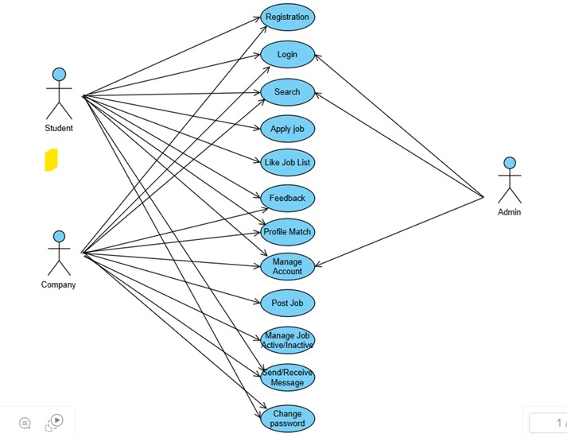

The Job Portal Entity-Relationship Diagram (ERD) is a visual representation of the data model that captures the relationships and interactions among the main entities in a job portal system. The Job Portal Entity-Relationship Diagram (ERD) is a visual representation of the data model that captures the relationships and interactions among the main entities in a job portal system.

## Product Function

Entity Relationship Diagram of Job Portal System

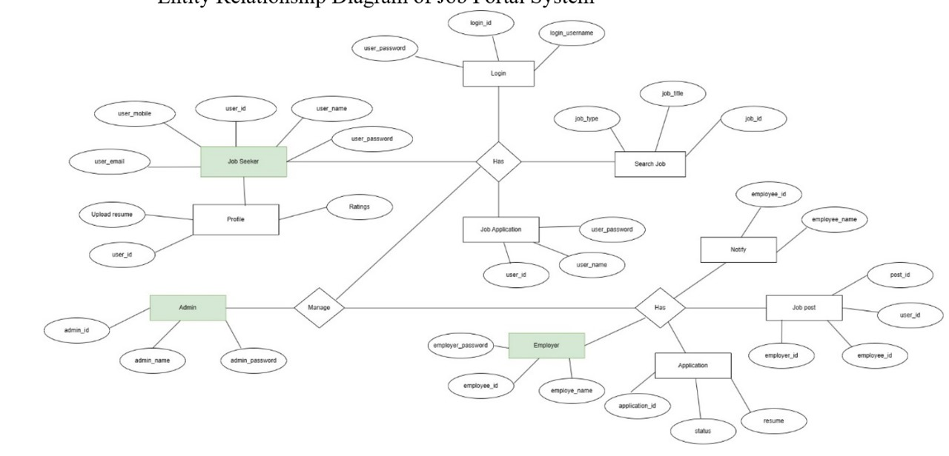

A job portal system serves as a pivotal platform for both job seekers and employers, streamlining the recruitment process and fostering efficient connections in the job market. For job seekers, it provides a centralized hub for discovering diverse job opportunities, submitting applications seamlessly, and managing their professional profiles. Employers benefit from a wide pool of potential candidates, with features like resume databases, advanced search functionalities, and applicant tracking systems facilitating efficient candidate selection. Additionally, job portals often offer resources for skill development and training, contributing to the continuous growth of job seekers in a competitive workforce. Overall, job portal systems play a crucial role in modern recruitment, offering convenience, accessibility, and efficiency to the dynamic job market.

## User Classes and Characteristics

In a job portal system, there are different types of users, each with specific roles. Job seekers can search for jobs, apply, and manage their profiles. Employers can post jobs, search for candidates, and communicate with applicants. System administrators oversee the overall functioning of the system. Customer support helps users with questions and issues. Optional user classes may include educational institutions, career counselors, and freelancers, each contributing to the platform in various ways. Understanding these user classes is essential for creating a user-friendly job portal system that meets the needs of both job seekers and employers..

**The features that are available to the recruiters are:-**

* + - Job Posting and Management
    - Resume DataBase Access
    - Advanced Search and Filtering
    - Applicant Tracking System
    - Communication tools
    - Job Application Review
    - Candidate Profiles
    - Interview Scheduling
    - Collaboration Tools
    - Analytics and Reporting
    - Customized Recruitment Workflows

**The features that are available to the candidates are:-**

* + - Online Application Platforms
    - Job Search filters
    - Resume Upload and parsing
    - Application Tracking systems
    - Profile Creation
    - Customized job Alerts
    - Video Interviews
    - Skill and personality Assessments
    - Communication Tools
    - Interview scheduling
    - Feedback and Status Updates
    - Virtual Job Fairs

## Operating Environment

## The operating environment for a job portal system includes the necessary hardware and software components, as well as external factors. This involves servers, databases, networking equipment, and security measures to ensure proper functioning. The system relies on web technologies for the user interface and integrates with external services like payment gateways. It should be scalable, comply with regulations, and include monitoring tools for performance tracking. User support, documentation, and mobile compatibility are also essential considerations for an effective job portal system.

## Assumptions and Dependencies

**The assumptions are**:-

* Internet Access
* Device Compatibility
* User Skills
* Data Accuracy
* Security Measures
* Legal Compliance
* Third -Party Integrations
* Scalability
* User Engagement
* Job Availability
* Communication Responsiveness
* Feedback and Reviews
* Mobile Application Usage
* Payment Processing

**The dependencies are:-**

* + - Internet Connection
    - Web Browser
    - Database Management System
    - Server Infrastructure
    - Third – Party APIs and Integrations
    - Security protocols
    - Operating System
    - Email Services
    - Mobile Platforms
    - Human Resources and recruiting Trends

## Requirement

Software Configuration:-

Creating a job portal system involves setting up different software components. This includes choosing a web server (like Apache or Nginx), a database system (such as MySQL or PostgreSQL), and a scripting language (like PHP or Python). Security measures, like SSL/TLS and firewalls, are important for protecting user data. Other setups include a Content Management System, secure user logins, email services, and connections with third-party tools using APIs

Hardware Configuration:- Processor: Pentium(R)Dual-core CPU Hard Disk: 40GB

RAM: 256 MB or more

## Data Requirement

A good job portal system relies on important data like user profiles for job seekers and employers, job listings, and application records. User preferences customize the job search, and there's data about skills, analytics, security, feedback, and system settings. Regular maintenance and following data protection rules are vital for the system's effectiveness and security.

# External Interface Requirement

## GUI

When it comes to the graphical user interface (GUI) of a job portal system, it's crucial to create an intuitive, visually appealing, and user-friendly design. Here are some key considerations for the GUI of a job portal system:

* + - Include a search bar prominently for job seekers to initiate job searches.
    - create user-friendly registration and login forms with clear instructions
    - Implement a clean and intuitive messaging system with threaded conversations
    - Provide access to a help or support section with FAQs and contact information.
    - Use progressive disclosure to present information gradually, avoiding overwhelming users with too much information at once.

**Login Interface:-**

Create a user-friendly login interface for the job portal. Keep it simple with clear fields for username/email and password. Add a "Remember Me" option and a "Forgot Password" link for user convenience. Consider social media login for ease of use. Clearly display error messages for login issues and ensure secure password input. Use a prominent "Login" button, incorporate branding, and make it responsive across devices. Include security measures like CAPTCHA, provide links to policies, and thoroughly test for a smooth user experience.

Search:-

Create an easy-to-use search function for the job portal. Keep it simple with clear criteria and filters for job title, location, and industry. Make sure it works well on different devices. Test thoroughly to ensure it provides accurate job listings for a user-friendly experience.

# Other Non-functional Requirements

## Performance Requirement

The job portal system must provide a fast and responsive experience, with a 2-second maximum response time for job searches and a 5-second duration for submitting applications. It should handle 10,000 job listings simultaneously, support 5,000 concurrent user sessions, and manage 1,000 new registrations per hour. The system needs to scale for a 50% user base growth in a year and a 30% increase in job listings in six months. Resource usage should be kept below 70% CPU and 80% memory. Network performance should maintain speeds above 1 Mbps and latency under 100 milliseconds globally. Load balancing and caching strategies are essential for even server distribution and faster page loads. Database queries must complete within 100 milliseconds, and error recovery should occur within 15 minutes with an error rate below 1%. Mobile responsiveness includes a 3-second load time on 4G networks and compatibility with popular devices and browsers.

## Safety Requirement

## The job portal system prioritizes user data security through encryption, access controls, and multi-factor authentication. Privacy protection includes regulatory compliance and explicit user consent. Continuous monitoring, intrusion detection, and a robust incident response plan ensure swift security resolution. Secure communication protocols, regular audits, and vulnerability management enhance system resilience. User account security measures include lockout and careful management of inactive accounts. Regular data backups maintain integrity and aid recovery. Legal compliance underscores adherence to security standards, ensuring a trustworthy job portal environment.

## Security Requirement

* + - System will use secured database
    - Normal users can just read information but they cannot edit or modify anything except their personal and some other information.
    - System will have different types of users and every user has access constraints
    - Proper user authentication should be provided
    - No one should be able to hack users’ password
    - There should be separate accounts for admin and members such that no member can access the database and only admin has the rights to update the database.

## Requirement attributes

* + - There may be multiple admins creating the project, all of them will have the right to create changes to the system. But the members or other users cannot do changes
    - The project should be open source
    - The Quality of the database is maintained in such a way so that it can be very user friendly to all the users of the database
    - The user be able to easily download and install the system

## Business Rules

A business rule is anything that captures and implements business policies and practices. A rule can enforce business policy, make a decision, or infer new data from existing data.This includes the rules and regulations that the System users should abide by. This includes the cost of the project and the discount offers provided. The users should avoid illegal rules and protocols. Neither admin nor member should cross the rules and regulations.

## User Requirement

The job portal system prioritizes user experience with features like easy registration, customizable profiles, and seamless job search. Users benefit from personalized job recommendations, company insights, and communication tools for networking and interviews. Mobile accessibility ensures on-the-go convenience, and skill development resources contribute to continuous growth. A feedback mechanism enhances user engagement, while robust security and privacy controls instill trust. The system also emphasizes accessibility and inclusivity, catering to diverse user needs. Overall, the user-centric design aims to simplify the job search process and foster a positive and inclusive professional environment.

**The admin provides certain facilities to the users in the form of:-**

* + - User Account Management
    - Job Listings and Content Moderation
    - Communication Facilitation
    - Performance Monitoring
    - Security and Compliance
    - User Support and Issue Resolution
    - Platform Updates and Enhancements
    - Verification and Authentication
    - Community Guidelines Enforcement
    - Data Analytics and Reporting

# Other Requirements

## Data and Category Requirement

The job portal system should offer payment integration, a resume builder, and interview resources. It needs language support, advanced job filters, and social media integration. Analytics for job postings, mobile wallet options, and remote work features are essential. A feedback system, gamification, and career guidance enhance user engagement. The platform should showcase company culture, allow notification customization, and provide real-time chat support. Learning pathways, dynamic job recommendations, and event hosting features enrich user experience. GDPR compliance, user surveys, and continuous improvements ensure a comprehensive and user-friendly job portal environment.

## Appendix

A: Admin, Abbreviation, Acronym, Assumptions; B: Books, Business rules; C: Class, Client, Conventions; D: Data requirement, Dependencies; G: GUI; K: Key; L: Library, Librarian; M: Member; N: Non-functional Requirement; O: Operating environment; P: Performance, Perspective, Purpose; R: Requirement, Requirement attributes; S: Safety, Scope, Security, System features; U: User, User class and characteristics, User requirement;

## Glossary

The following are the list of conventions and acronyms used in this document and the project as well:

* + - Administrator: A login id representing a user with user administration privileges to the software
    - User: A general login id assigned to most users
    - Client: Intended users for the software
    - SQL: Structured Query Language; used to retrieve information from a database
    - SQL Server: A server used to store data in an organized format
    - Layer: Represents a section of the project
    - User Interface Layer: The section of the assignment referring to what the user interacts with directly
    - Application Logic Layer: The section of the assignment referring to the Web Server. This is where all computations are completed
    - Data Storage Layer: The section of the assignment referring to where all data is recorded
    - Use Case: A broad level diagram of the project showing a basic overview
    - Class diagram: It is a type of static structure diagram that describes the structure of a system by showing the system’s cases, their attributes, and the relationships between the classes
    - Interface: Something used to communicate across different mediums
    - Unique Key: Used to differentiate entries in a database

## Class Diagram

For a job portal system, a class diagram would include classes representing key entities such as "User," "Job listing," and "Employer." Attributes within these classes may include user details, job information, and employer profiles. Associations would illustrate relationships between users and job listings, possibly denoting a "UserApplication" class to represent job applications. Inheritance might be utilized for different user roles, such as "JobSeeker" and "Employer," inheriting from a common "User" class. Dependency arrows could indicate relationships like an employer's dependency on job listings. Multiplicity notations might signify the number of applicants for a specific job. The diagram would also incorporate associations for features like user interactions, messaging, and notifications, contributing to a comprehensive depiction of the job portal system's static structure.

