SOFTWARE REQUIREMENTS SPECIFICATION

**For**

**Hotel Reservation System**

**Prepared by:-**

*Viking Bloodlines*

# Introduction

## Purpose

The main objective of this document is to illustrate the requirements of the project Hotel Reservation system. The document gives the detailed description of the both functional and non-functional requirements proposed by the client. The purpose of this project is to streamline and automate the process of hotel room bookings. By providing an efficient platform for customers to reserve accommodations, it enhances user experience, reduces manual workload for hotel staff, minimizes errors in bookings, improves room occupancy management, facilitates online payment options, and ultimately contributes to the overall operational efficiency of the hotel industry. This project describes the hardware and software interface requirements using ER diagrams and UML diagrams.

## Document Conventions

* + - Entire document should be justified.
    - Convention for Main title

Font face: Times New Roman Font style: Bold

Font Size: 14

* + - Convention for Sub title

Font face: Times New Roman Font style: Bold

Font Size: 12

* + - Convention for body

Font face: Times New Roman Font Size: 12

## Scope of Development Project

The Hotel Reservation System project aims to modernize and streamline the hotel booking process by implementing a user-friendly platform. This system will provide real-time updates on room availability, facilitating instant and accurate bookings.Reservation management features will empower hotel staff to efficiently handle check-ins, check-outs, and room assignments.Integration with external systems will create a cohesive operational environment, while customer support features will contribute to overall satisfaction and loyalty. In summary, the Hotel Reservation System project encompasses a comprehensive approach to elevate the efficiency and user experience in the hotel booking domain.

The project can be easily implemented under various situations. We can add new features as and when we require, making reusability possible as there is flexibility in all the modules.

The language used for developing the project is Java as it is quite advantageous than other languages in terms of performance, tools available, cross platform compatibility, libraries, cost (freely available), and development process.

## Definitions, Acronyms and Abbreviations

JAVA -> platform independence SQL-> Structured query Language ER-> Entity Relationship

UML -> Unified Modeling Language

IDE-> Integrated Development Environment SRS-> Software Requirement Specification

## References

* + - Books

 Software Requirements and Specifications: A Lexicon of Practice, Principles and Prejudices (ACM Press) by Michael Jackson

Software Requirements (Microsoft) Second EditionBy Karl E. Wiegers

Software Engineering: A Practitioner’s Approach Fifth Edition By Roger S. Pressman

* + - Websites

https://library.essex.ac.uk/hotel/referencing-rms

https://opus.govst.edu/cgi/viewcontent.cgi?article=1199&context=capstones

1. **Overall Descriptions**
   1. **Product Perspective**

Use Case Diagram of Hotel Reservation System

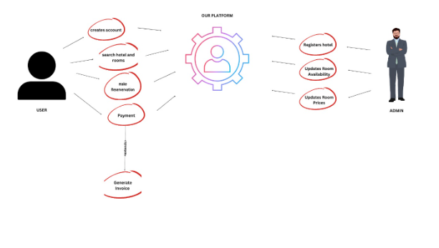

This diagram provides a high-level overview of the hotel reservation system, highlighting key functionalities and interactions between users and the system components.

## Product Function

Entity Relationship Diagram of Hotel Reservation System

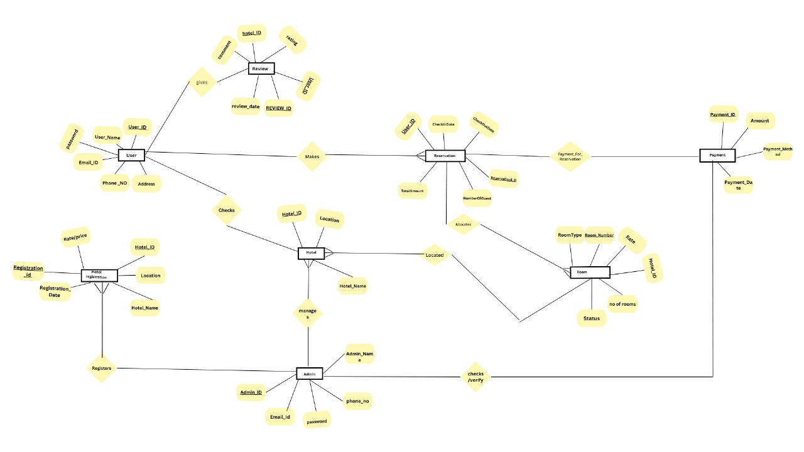

The Hotel Reservation System functions as a comprehensive solution for streamlined hotel management. It efficiently manages the reservation process, ensuring real-time updates on room availability and preventing overbookings. The system enhances the guest experience by allowing users to create profiles with personal preferences, facilitating tailored services and recommendations. With secure payment integration, the booking process becomes seamless and trustworthy. Sturdy reporting and analytics systems give hotel management information about booking patterns to help with strategic decision-making.. The system's multi-platform accessibility ensures convenient reservations across various devices, while integration with external systems creates a cohesive operational environment. Overall, the Hotel Reservation System optimizes hotel operations, from reservation handling to personalized guest services, contributing to enhanced efficiency and customer satisfaction.

## User Classes and Characteristics

In the Hotel Reservation System, two primary user categories are identified: Hotel Administrators and Guests. The system provides tailored features to each category to optimize their respective experiences.

The features that are available are:-

* + - Can Access a User-Friendly Booking Interface
    - Can filter the hotels and price based on the customer requirements
    - Can Manage Customer Profiles
    - Can View Room Information
    - Can Track Booking History
    - Can Provide Feedback and Reviews
    - Can Access Multi-Platform Convenience

## Operating Environment

The product will be operating in windows environment. The Hotel MSystem is a website and shall operate in all famous browsers, for a model we are taking Microsoft Internet Explorer,Google Chrome,and Mozilla Firefox.Also it will be compatible with the IE 6.0. Most of the features will be compatible with the Mozilla Firefox & Opera 7.0 or higher version. The only requirement to use this online product would be the internet connection.

The hardware configuration include Hard Disk: 40 GB, Monitor: 15” Color monitor, Keyboard: 122 keys. The basic input devices required are keyboard, mouse and output devices are monitor, printer etc.

## Assumptions and Dependencies

The assumptions are:-

* + - The coding should be error free
    - The system should be user-friendly so that it is easy to use for the users.
    - The reservation system should be error-free to ensure accurate booking information.
    - All information related to hotels, room availability, and reservations should be stored in a secure and accessible database.
    - The system should have more storage capacity and provide fast access to the database.
    - Quick transaction processing is essential to support a seamless booking process. The reservation system is available 24/7 to accommodate bookings at any time.
    - Users must have their correct usernames and passwords to enter into their online accounts and do actions

The dependencies are:-

* + - The system is dependent on specific hardware and software configurations for optimal performance. Compatibility with web browsers, server infrastructure, and database management systems is crucial.
    - The end users (admin) should have proper understanding of the product
    - he development and execution of the project rely on accurately listing and adhering to requirements and specifications.
    - Any update regarding the book from the library is to be recorded to the database and the data entered should be correct
    - Any updates or changes to hotel reservations should be recorded accurately in the database in real-time to ensure the data integrity of the system.
  1. **Requirement**

Software Configuration:- This software package is developed using java as front end which is supported by sun micro system. Microsoft SQL Server as the back end to store the database.

Operating System: Windows NT, windows 98, Windows XP

Language: Java Runtime Environment, Net beans 7.0.1 (front end)

Database: MS SQL Server (back end)

Hardware Configuration:-

Processor: Pentium(R)Dual-core CPU

Hard Disk: 40GB

RAM: 256 MB or more

* 1. **Data Requirement**

Certain essential data needs must be taken into account for our application, which allows users to find and reserve rooms and hotel managers to register hotels. Comprehensive information about the hotel, such as its name, address, phone number, and a description of the amenities offered, is required for hotel registration. Data pertaining to rooms includes details about the types of rooms, their features, their availability, and their prices. The administrator's name, contact information, and secure login credentials are essential for overseeing the hotel's account.

# External Interface Requirement

## GUI

The software provides good graphical interface for the user and the administrator can operate on the system, performing the required task such as select, update,viewing the details of the Hotel.

* + - It allows user to view quick reports like Hotel Reserved in a particular time.
    - It provides room availability and search facility based on different criteria.
    - The user interface must be customizable by the administrator
    - All the modules provided with the software must fit into this graphical user interface and accomplish to the standard defined
    - The design should be simple and all the different interfaces should follow a standard Template
    - The user interface should be able to interact with the user management module and a part of the interface must be dedicated to the login/logout module

Login Interface:-

In case the user is not yet registered, he can enter the details and register to create his account. Once his account is created he can ‘Login’ which asks the user to type his username and password. If the user entered either his username or password incorrectly then an error message appears.

Search:-

The user or guest can enter the type of hotel he is looking for and the room he is interested in,then he can search for the required book by entering the hotel name.

Categories View:-

Categories view shows the categories of rooms available.

# System Features

The users of the system should be provided the surety that their account is secure. This is possible by providing:-

* User authentication and validation of members using their unique member ID
* Proper accountability which includes not allowing a member to see other member’s account. Only administrator will see and manage all member accounts

# Other Non-functional Requirements

## Performance Requirement

The proposed system that we are going to develop will be used as Hotel Reservation System will serve as the main platform for interactions between students and university officials on different campuses. All of the functional requirements that the university has defined should be easily fulfilled by the system. Specifically, the system's performance needs to demonstrate both accuracy and speed of operation. To guarantee a smooth and fulfilling user experience, quick response times and accurate reservation processing are essential.

## Safety Requirement

The database may get crashed at any certain time due to virus or operating system failure. Therefore, it is required to take the database backup so that the database is not lost. Proper UPS/inverter facility should be there in case of power supply failure.

## Security Requirement

* + - System will use secured database
    - Normal users can just read information but they cannot edit or modify anything except their personal and some other information.
    - System will have different types of users and every user has access constraints
    - Proper user authentication should be provided
    - No one should be able to hack users’ password
    - There should be separate accounts for admin and members such that no member can access the database and only admin has the rights to update the database.

## Requirement attributes

* + - There may be multiple admins creating the project, all of them will have the right to create changes to the system. But the members or other users cannot do changes
    - The project should be open source
    - The Quality of the database is maintained in such a way so that it can be very user friendly to all the users of the database
    - The user be able to easily download and install the system

## 5.5 Business Rules

A business rule is anything that captures and implements business policies and practices. A rule can enforce business policy, make a decision, or infer new data from existing data. This includes the rules and regulations that the System users should abide by. This includes the cost of the project and the discount offers provided. The users should avoid illegal rules and protocols. Neither admin nor member should cross the rules and regulation.

## 5.6 User Requirement

Members and hotel employees functioning as administrators make up the users of the hotel reservation system. While administrators are expected to have a deeper understanding of the system's internals in order to address technological issues that may occur due to unforeseen events, members are expected to have basic computer and internet browsing skills. To guarantee that users can manage the system with ease, it must include an easy-to-understand user interface, a comprehensive user manual, online assistance, and installation instructions.

provides certain facilities to the users in the form of:-

-> Backup and Recovery: Regular backup mechanisms and easy recovery options. -> Forgot Password: Password recovery functionality for administrators. -> Data Migration: Seamless data migration for new user registrations. ->Data Replication: Implementation of data replication to safeguard against local data loss. ->Auto Recovery: Frequent auto-saving features to prevent data loss during reservations. ->File Organization: Efficient organization of files for easy data retrieval. ->Server Maintenance: Regular server maintenance for optimal performance and security. -> System Updates: Regular updates to incorporate new features and security patches.

# 6.Other Requirements

## 6.1 Data and Category Requirement

There are different categories of users namely teaching user, Guests, Admin etc. Depending upon the category of user the access rights are decided. It means if the user is an administrator, then he can be able to modify the data, delete, append etc. All other users except the Librarian only have the rights to retrieve the information about database. Similarly, there will be different categories of books available. According to the categories of books their relevant data should be displayed. The categories and the data related to each category should be coded in the particular format.

## Appendix

A: Admin, Abbreviation, Acronym, Assumptions; B: Books, Business rules; C: Class, Client, Conventions; D: Data requirement, Dependencies; G: GUI; K: Key; L: Library, Librarian; M: Member; N: Non-functional Requirement; O: Operating environment; P: Performance,Perspective,Purpose; R: Requirement, Requirement attributes; S: Safety, Scope, Security, System features; U: User, User class and characteristics, User requirement.

## 6.3Glossary

The following are the list of conventions and acronyms used in this document and the project as well:

* + - Administrator: A login id representing a user with user administration privileges to the software
    - User: A general login id assigned to most users
    - Client: Intended users for the software
    - SQL: Structured Query Language; used to retrieve information from a database
    - SQL Server: A server used to store data in an organized format
    - Layer: Represents a section of the project
    - User Interface Layer: The section of the assignment referring to what the user interacts with directly
    - Application Logic Layer: The section of the assignment referring to the Web Server. This is where all computations are completed
    - Data Storage Layer: The section of the assignment referring to where all data is recorded
    - Use Case: A broad level diagram of the project showing a basic overview
    - Class diagram: It is a type of static structure diagram that describes the structure of a system by showing the system’s cases, their attributes, and the relationships between the classes
    - Interface: Something used to communicate across different mediums
    - Unique Key: Used to differentiate entries in a database

## 6.4Class Diagram

A class is an abstract, user-defined description of a type of data. It identifies the attributes of the data and the operations that can be performed on instances (i.e. objects) of the data. A class of data has a name, a set of attributes that describes its characteristics, and a set of operations that can be performed on the objects of that class. The classes’ structure and their relationships to each other frozen in time represent the static model. In this project there are certain main classeswhich are related to other classes required for their working. are the most important classes which are related 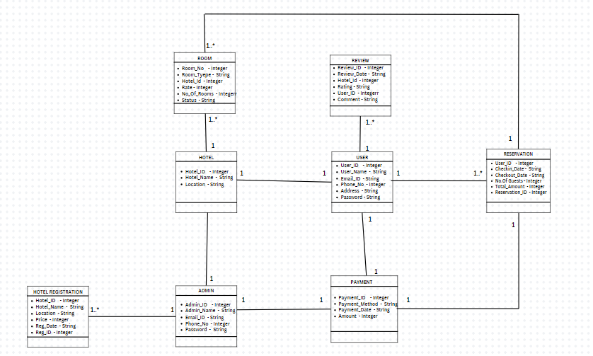to other classes.