SOFTWARE REQUIREMENTS SPECIFICATION

**For**

**Customer Relationship Management System**

**Prepared by:-**

*TEAM 8*

# Introduction

## Purpose

The main objective of this document is to illustrate the requirements of the project Customer Relationship Management system. The document gives the detailed description of the both functional and non-functional requirements proposed by the client.The purpose of this project is to provide a system for managing customer information, interactions, and support requests. It facilitates sales and support teams in maintaining customer records.This project describes the hardware and software interface requirements using ER diagrams and UML diagrams.

## Document Conventions

* + - Entire document should be justified.
    - Convention for Main title

Font face: Times New Roman Font style: Bold

Font Size: 14

* + - Convention for Sub title

Font face: Times New Roman Font style: Bold

Font Size: 12

* + - Convention for body

Font face: Times New Roman Font Size: 12

## Scope of Development Project

CRM is a term that refers to the various methods and technologies used to manage customer interactions. In recent years, CRM has become an increasingly important aspect of business, as companies seek to improve their relationships with customers and better understand their needs.

The scope of CRM includes a wide range of activities, from managing customer contact information to developing personalized marketing campaigns. In order to be effective, CRM must be tailored to the specific needs of each business. As such, the scope of CRM can vary greatly from one company to the next.

However, there are certain core elements that are essential for all successful CRM initiatives. These include the ability to capture and store customer data, the ability to track and analyze customer interactions, and the ability to automate customer-facing processes.

By understanding the scope of CRM, businesses can be better equipped to develop strategies that will improve their relationship with customers and help them grow their businesses.

## Definitions, Acronyms and Abbreviations

JAVA -> platform independence SQL-> Structured query Language ER-> Entity Relationship

UML -> Unified Modeling Language

IDE-> Integrated Development Environment SRS-> Software Requirement Specification

## References

* + - Websites

[**http://www.slideshare.net/**](http://www.slideshare.net/)

[**https://codebun.com/customer-relationship-management-system-in-java-using-jsp-and-servlet-with-source-code/**](https://codebun.com/customer-relationship-management-system-in-java-using-jsp-and-servlet-with-source-code/)

[**https://www.scribd.com/document/453886041/CRM-SRS-docx**](https://www.scribd.com/document/453886041/CRM-SRS-docx)

# Overall Descriptions

## Product Perspective

Use Case Diagram of Customer Relationship Management System

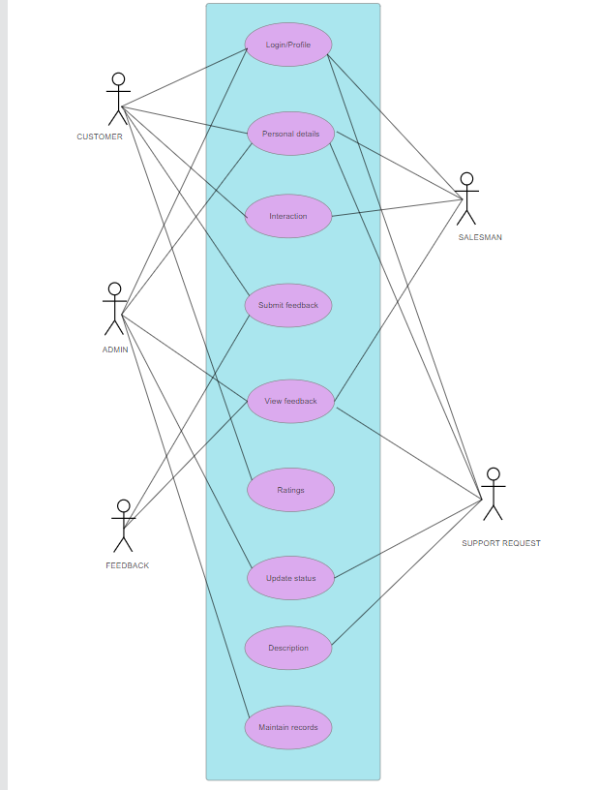

This is an overview diagram of the CRM system, outlining its fundamental structure. The users are categorized as either staff or customers. The system incorporates a search feature to enable resource exploration based on different parameters, such as customer name or identification number.

System users, which include both sales and support teams, can initiate and manage customer interactions, requests, and feedback. Specific criteria and protocols are in place for customers to request services, such as initiating a support request or providing feedback.

The CRM system acts as a comprehensive tool for managing customer relationships, ensuring efficient communication, and facilitating various customer-related processes within the organization.

## 2.2 Product Function

Entity Relationship Diagram of Customer Relationship Management System

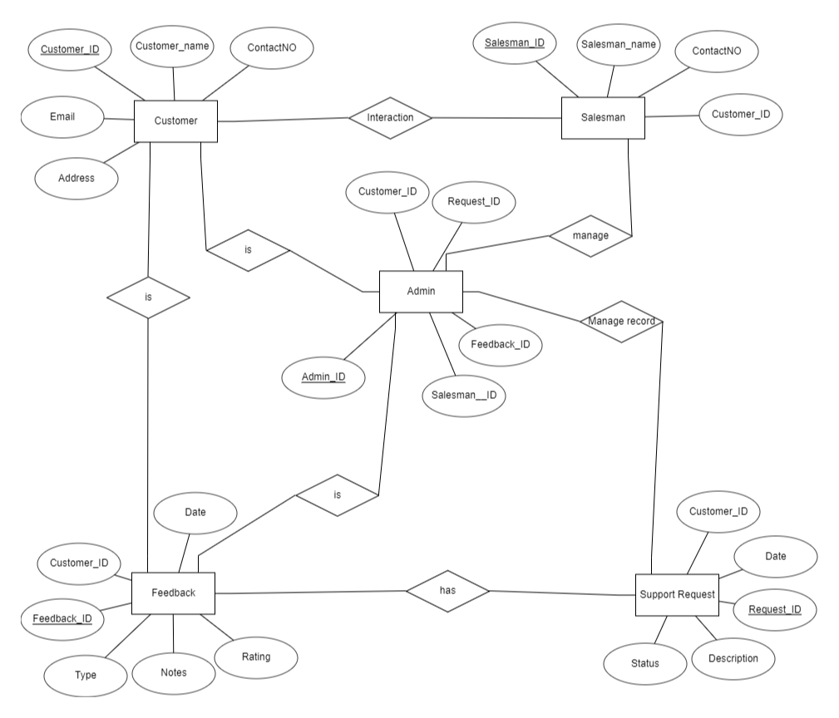

The Customer Relationship Management (CRM) System provides real-time information about customer interactions and support requests. The primary goal of this system is to automate and streamline manual processes, enhancing efficiency. It effectively manages customer interactions, tracks support requests, calculates and manages service metrics, and generates customized reports for record-keeping based on user preferences. The administrator, typically a support manager, oversees user roles and system functionalities. The system maintains detailed records of customer interactions, support request status, and team assignments. Users, including sales and support teams, can retrieve customer details from the database as needed. Valid customers have the capability to access and view their account information through a user-friendly interface. The CRM system acts as a centralized hub for customer-related activities, fostering efficient communication, support, and record-keeping within the organization.

## User Classes and Characteristics

The system provides different types of services based on the type of users [Customer/Salesman/Admin]. The Admin will be acting as the controller and he will have all the privileges of an administrator.

The features that are available to the Admin are:-

* + - Configuration and customization of the CRM system.
    - User management, including creating, modifying, and deactivating accounts.
    - Implementation and enforcement of security measures.
    - Integration with other tools and systems.
    - Oversight of system performance and addressing technical issues.
    - Communication of system updates and important information to users.

The features that are available to the Salesman are:-

* Management of leads, contacts, and opportunities in the CRM system.
* Logging and tracking customer interactions and sales activities.
* Utilization of CRM analytics for performance evaluation.
* Collaboration with other team members for effective sales strategies.
* Follow-up on leads and communication with customers.
* Utilization of automated workflows for efficient task management.

The features that are available to the Customer are:-

* + - Interaction with the CRM system to access product or service information.
    - Logging support requests and tracking their status.
    - Providing feedback and participating in customer surveys.
    - Accessing self-service features for account management.
    - Viewing and updating personal information within the CRM.
    - Engaging in communication with the Sales team for inquiries or purchases.

## Operating Environment

## The CRM system will operate within the Windows environment, ensuring compatibility with widely used browsers such as Microsoft Internet Explorer, Google Chrome, and Mozilla Firefox. Specifically, compatibility is maintained with Internet Explorer 6.0, while most features will seamlessly function on Mozilla Firefox and Opera 7.0 or higher versions. The system, being web-based, requires only an internet connection for access. Hardware configuration specifications include a minimum 40 GB hard disk, a 15” color monitor, and a standard 122-key keyboard. Essential input devices encompass a keyboard and mouse, while monitors and printers serve as output devices. This configuration guarantees versatile functionality across different browsers and hardware setups, facilitating efficient customer relationship management.

## Assumptions and Dependencies

The assumptions are:-

* + - The coding should be error free
    - The system should be user-friendly so that it is easy to use for the users
    - Assumes that data entered into the system by users is accurate and up-to-date.The system should have more storage capacity and provide fast access to the database
    - The system should provide search facility and support quick transactions
    - Users adhere to their assigned roles and responsibilities.
    - Ongoing user feedback for system improvement
    - Users must have their correct usernames and passwords to enter into their online accounts and do actions

The dependencies are:-

* + - The specific hardware and software due to which the product will be run
    - System functionality relies on accurate data for effective customer relationship management.The end users (admin) should have proper understanding of the product
    - The system should have the general report stored
    - System effectiveness depends on users' understanding and utilization of its features.
    - Data integrity and system stability depend on reliable backup and recovery processes.

## Requirement

Software Configuration:-

This software package is developed using java as front end which is supported by sun micro system. Microsoft SQL Server as the back end to store the database.

Operating System: Windows NT, windows 98, Windows XP Language: Java Runtime Environment, Eclipse (front end) Database: MS SQL Server (back end)

Hardware Configuration:- Processor: Pentium(R)Dual-core CPU Hard Disk:40GB

RAM: 256 MB or more

## Data Requirement

The inputs consist of the query to the database and the output consists of the solutions for the query. The output also includes the user receiving the details of their accounts. In this project the inputs key data requirements include customer information (contact details, preferences), interaction history (calls, emails, support tickets), and lead management data (qualification criteria, statuses). The output of a Customer Relationship Management (CRM) system encompasses various outcomes that contribute to enhanced customer relationships, streamlined business processes, and informed decision-making.

# External Interface Requirement

## GUI

The CRM system boasts an intuitive graphical interface catering to both users and administrators. Admins can efficiently perform tasks such as creating, updating, and viewing customer details.

* + Users can generate quick reports, such as customer interactions or requests, within specific time
  + Frames.
  + Stock verification and search functionalities are available based on various criteria for efficient data retrieval.
  + Administrators can customize the user interface to align with organizational preferences and requirements.
  + All software modules seamlessly integrate into the graphical user interface, ensuring adherence to defined standards.
  + The design prioritizes simplicity, maintaining a standard template across all interfaces for a cohesive user experience.

Login Interface:-

For secure access, the system offers a robust login interface. Users, whether customers or sales staff, can register by entering necessary details. After registration, users can log in with a username and password. Incorrect entries prompt an error message for accurate credential verification.

Search:-

Customers and sales personnel can effortlessly search for relevant information within the CRM system by entering specific criteria such as customer names or interactions.

Categories View:-

The system presents a categories view, allowing users to explore and manage various categories related to customer interactions, preferences, and sales data.

Admin Control Panel:-

This control panel will allow admin to add/remove users; add, edit, or remove a resource. And manage lending options.

# System Features

The users of the system should be provided the surety that their account is secure. This is possible by providing:-

* User authentication and validation of members using their unique member ID
* Proper contact and lead management, centralized customer data storage, interaction history tracking, and a support ticketing system.
* The system accommodates document management, lead scoring, and seamless integration with other tools. User training and support resources, along with customization options, ensure adaptability.
* Proper accountability which includes not allowing a member to see other member’s account. Only administrator will see and manage all member accounts

# Other Non-functional Requirements

## Performance Requirement

The proposed customer management system is a comprehensive solution designed to streamline and enhance the management of customer information, interactions, and support requests. At its core, the system prioritizes efficiency and user-friendliness, offering a range of key features to support sales and support teams in maintaining accurate and up-to-date customer records.

* The performance of the system should be fast and accurate
  + - The system should support at least 100 concurrent users.
    - Concurrent user count will be monitored during peak usage periods.
* The system should be able to handle large amount of data.

## Safety Requirement

The database may get crashed at any certain time due to virus or operating system failure. Therefore, it is required to take the database backup so that the database is not lost. Proper UPS/inverter facility should be there in case of power supply failure.

## Security Requirement

* + - System will use secured database
    - Use strong authentication methods, encryption for sensitive data, and regular access audits.
    - System will have different types of users and every user has access constraints
    - Proper user authentication should be provided
    - No one should be able to hack users’ password
    - There should be separate accounts for admin and members such that no member can access the database and only admin has the rights to update the database.

## Requirement attributes

* + - Ensure that each requirement is traceable to specific business goals, user needs, or regulatory requirements.
    - The project should be open source
    - The Quality of the database is maintained in such a way so that it can be very user friendly to all the users of the database
    - The user be able to easily download and install the system

## Business Rules

A business rule is anything that captures and implements business policies and practices. A rule can enforce business policy, make a decision, or infer new data from existing data.This includes the rules and regulations that the System users should abide by. This includes the cost of the project and the discount offers provided. The users should avoid illegal rules and protocols. Neither admin nor member should cross the rules and regulations.

## User Requirement

The primary users are customers and sales representatives. The system serves as a central hub for managing and enhancing these interactions. The members are assumed to have basic knowledge of the computers and internet browsing. The administrators of the system should have more knowledge of the internals of the system and is able to rectify the small problems that may arise due to disk crashes, power failures and other catastrophes to maintain the system. The proper user interface, user manual, online help and the guide to install and maintain the system must be sufficient to educate the users on how to use the system without any problems.

The admin provides certain facilities to the users in the form of:-

* + - Backup and Recovery
    - Forgot Password
    - Data migration i.e. whenever user registers for the first time then the data is stored in the server
    - Data replication i.e. if the data is lost in one branch, it is still stored with the server
    - Auto Recovery i.e. frequently auto saving the information
    - Maintaining files i.e. File Organization
    - The server must be maintained regularly and it has to be updated from time to time

# Other Requirements

## Data and Category Requirement

There are different categories of users namely teaching staff, Librarian, Admin, students etc. Depending upon the category of user the access rights are decided.It means if the user is an administrator then he can be able to modify the data,delete, append etc. All other users except the Librarian only have the rights to retrieve the information about database. Similarly there will be different categories of books available. According to the categories of books their relevant data should be displayed. The categories and the data related to each category should be coded in the particular format.

## Appendix

A: Admin, Abbreviation, Acronym, Assumptions; B: Books, Business rules; C: Class, Client, Customers, Conventions; D: Data requirement, Dependencies; G: GUI; K: Key; N: Non-functional Requirement; O: Operating environment; P: Performance,Perspective,Purpose; R: Requirement, Requirement attributes; S: Safety, Scope, Security, System features; U: User, User class and characteristics, User requirement;

## Glossary

The following are the list of conventions and acronyms used in this document and the project as well:

* + - Administrator: A login id representing a user with user administration privileges to the software
    - User: A general login id assigned to most users
    - Client: Intended users for the software
    - SQL: Structured Query Language; used to retrieve information from a database
    - SQL Server: A server used to store data in an organized format
    - Layer: Represents a section of the project
    - User Interface Layer: The section of the assignment referring to what the user interacts with directly
    - Application Logic Layer: The section of the assignment referring to the Web Server. This is where all computations are completed
    - Data Storage Layer: The section of the assignment referring to where all data is recorded
    - Use Case: A broad level diagram of the project showing a basic overview
    - Class diagram: It is a type of static structure diagram that describes the structure of a system by showing the system’s cases, their attributes, and the relationships between the classes
    - Interface: Something used to communicate across different mediums
    - Unique Key: Used to differentiate entries in a database

## Class Diagram

A class in the CRM system serves as an abstract, user-defined blueprint for a specific type of data. It outlines the attributes defining the data and enumerates the operations applicable to instances, or objects, of that data type. Each class possesses a distinctive name, a set of attributes characterizing its features, and a collection of operations that can be executed on objects belonging to that class. The static model of the CRM system encapsulates the structure of these classes and their interrelationships. Various relationships between classes are represented in the diagram, including standard associations, aggregations, and generalizations. The connections are illustrated using role names and multiplicities. In this project, pivotal classes such as 'Administrator,' 'User,' and 'Customer' hold central roles, forming associations with other classes to enable comprehensive functionalities within the CRM system.

