**TASK MANAGEMENT SYSTEM**

**ER DIAGRAM :**

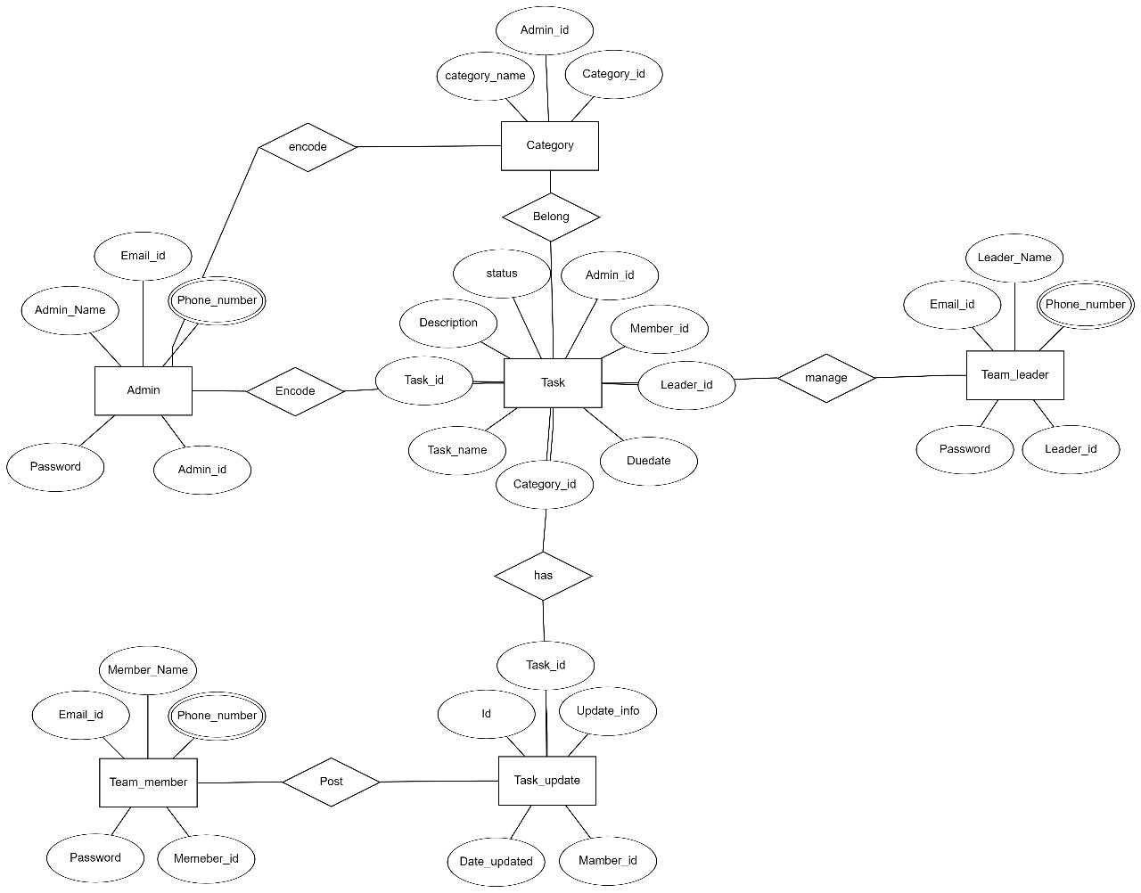

**CLASS DIAGRAM :**

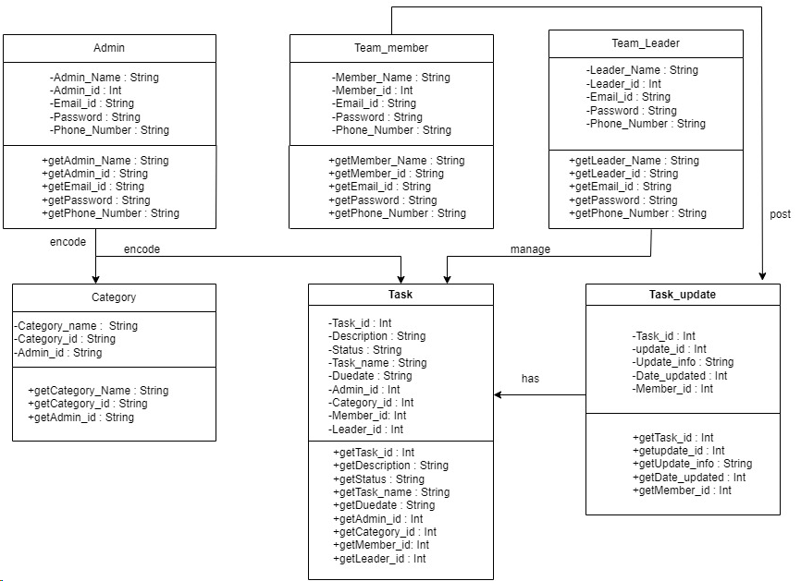

**DATABASE DESIGN:**

