**EGERTON UNIVERSITY**

**SECURITY DEPARTMENT**

**SYSTEM**

**USER MANUAL**

**September 2018**

Table of Contents

1. SYSTEM SUMMARY 3

1.1 System Configuration 3

1.2 Data Flows 3

1.3User Access levels 3

**2.** **Getting Started** 3

2.1 Logging On 3

2.2 System Menu 4

2.3 User Functions 5

2.4 Changing Password 7

2.5 Exiting the System 7

# SYSTEM SUMMARY

The Egerton University Security Department System was developed to automate the manual processes of recording, storing, sharing of information which includes statements, reports, and complaints. In general, the system is meant to enable the receptionist to record complaints, the administrator views the complaints and allocates them; the officers view their allocated cases then investigate and upload the relevant files. The administrator then makes the final choice of resolving the complaint after it has been dealt with.

## 1.1 System Configuration

Egerton University Security Department System has login page which is the default page in order to access the system. After the users login they are directed to their specific welcome pages and the get access to the product features according to their access features. After the user is done, he or she can then log out.

## 1.2 Data Flows

Users input text-using keyboard either on screen virtual keyboard or on the physical keyboard. Spell checking is supported in some of the pages of the system such when inserting comments and details. Word prediction is however not supported by the system.

## 1.3User Access levels

The administrator is the highest user level in the system, having capabilities of adding and removing a specific user from using the system. The administrator can also allocate cases but cannot create them. The next access is the officer, who can upload reports and statements view their allocated complaints. The last level is the receptionist who can only create new complaint and view the complaints only.

# **Getting Started**

This section takes you through the whole system, stating from its initiation to Logging out of the given user. It enables the functional personnel to understand the sequence and flow of the system. Diagrams will be used where necessary.

## Logging On

A user Name ID specific to each user and password is required to log onto the system. See the following Login page screenshot.

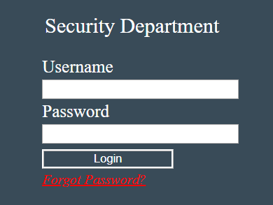

***Fig1 Login screenshot***

In case the user has forgotten the password, he/she can reset it using the reset password link, shown above in red, where he/she will be requested for the relevant email that was used during user creation. See below screenshot;

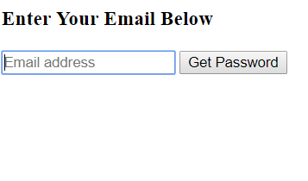

***Fig2 password reset screenshot***

## System Menu

The system contains three main users. They include;

1. Admin User
2. Receptionist User and
3. Officer User

Each user above has their own specific welcome pages with specific links to their specific functions on the Dashboard.

The following screenshots for each user shows the welcome page details:

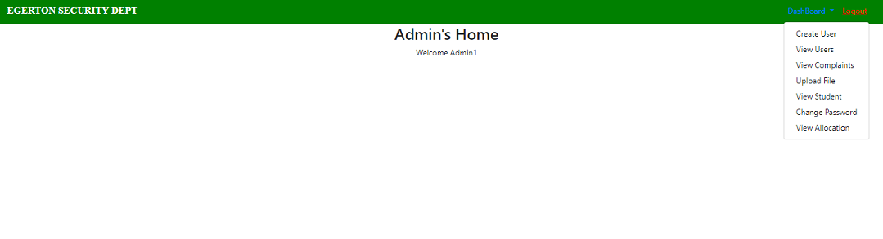

***Fig3 Admin User Welcome Page***

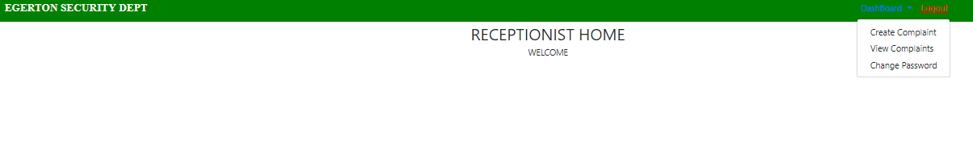

***Fig4 Receptionist User Welcome Page***

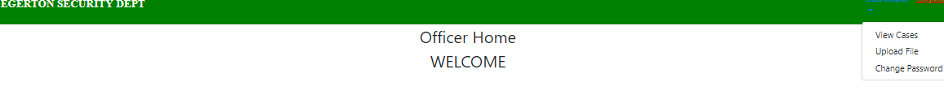

***Fig5 Officer Use Welcome Page***

## User Functions

1. Admin User functions with relevant images are as follows;

An Admin user can:

1. Create a new user for the system with specified user role or category, as below;

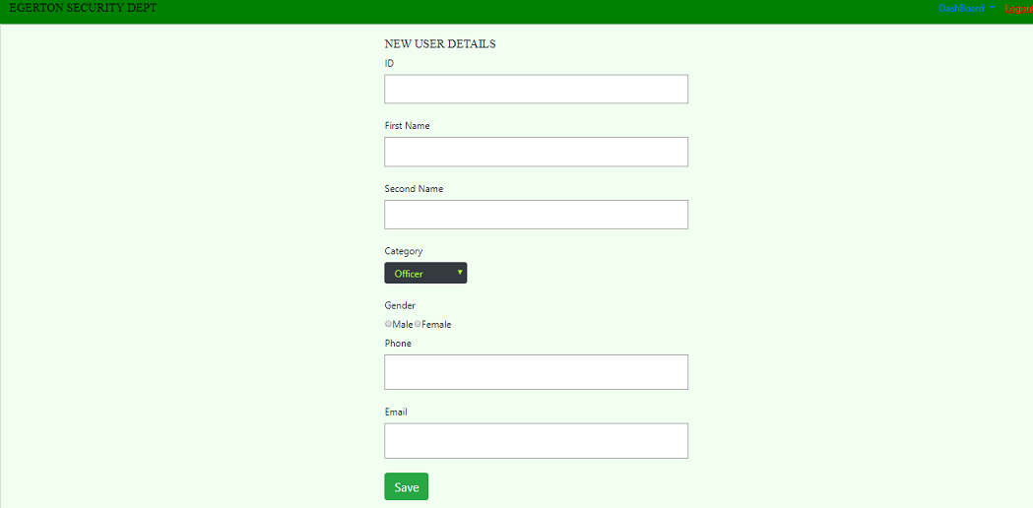

***Fig6 Admin Create User Page Screenshot***

1. Allocate cases to the different officer users and resolve them under the view cases page as below;

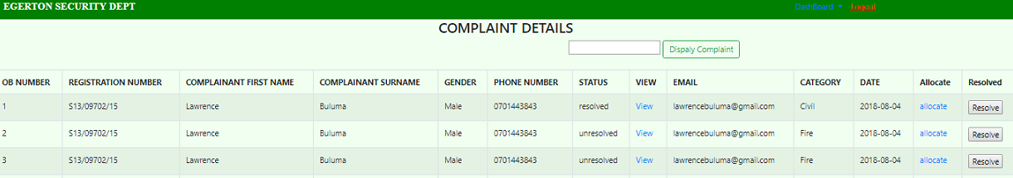

***Fig7 Admin Allocate and Resolve Buttons Page***

1. Delete users from the system and reset their passwords to default under the view users page as show below;

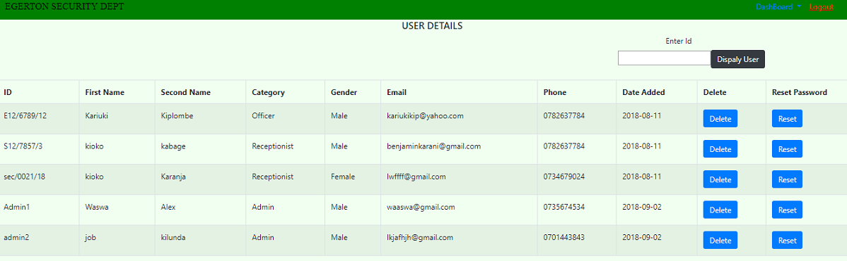

***Fig8 Admin User Delete and Password Reset Page***

1. Receptionist User functions and images;

The Receptionist user can:

1. Create a complaint and view the complaints as shown below;

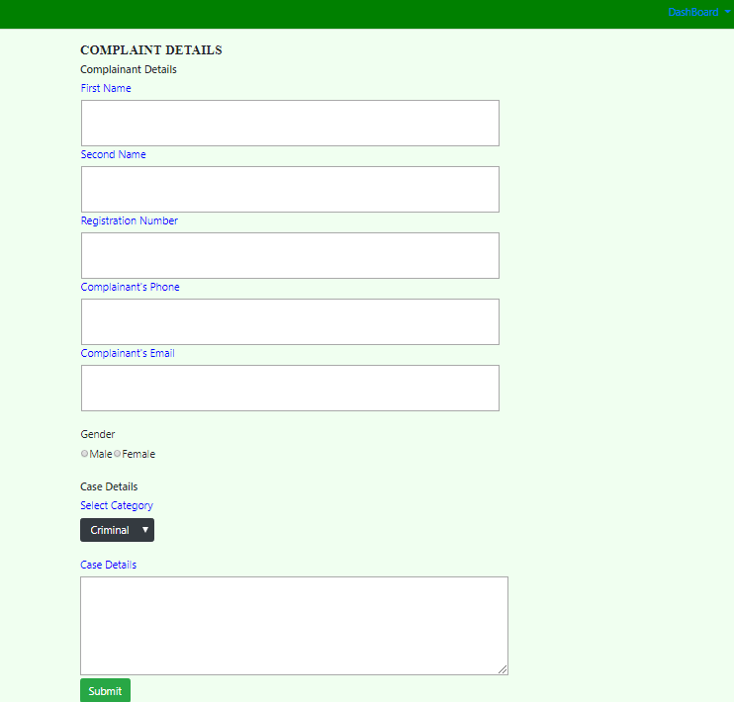

***Fig9 Receptionist User Complaint Creation Screenshot***

1. Officer User functions and images;

Officer user can:

1. Upload statements and reports about the assigned cases as shown below;

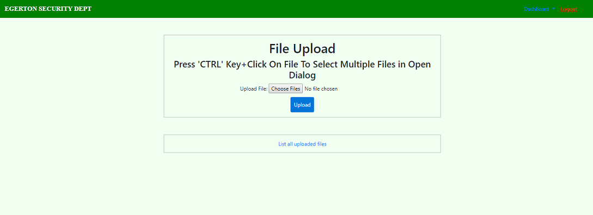

***Fig10 Officer File Upload Screenshot***

## Changing Password

Follow the following directions to the change password functionality shown in the screenshot shown:

* Sign in to the Web Interface.
* Click Settings at the top of the main page, and open the Accounts and Import tab.
* Click on Account settings.
* In the new window, click Change password under the Personal information option.
* Enter your current password and your new password.

## Exiting the System

Each user welcome page has a Logout link at the upper top left corner, as shown in the screenshot below. Click on the link to invalidate your session and go back to the Login page once done using the system.

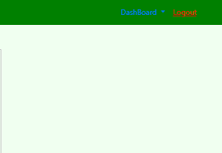

***Fig11 User Logout Link Screenshot***