Metasploitable2 Exploitation
Ifconfig on meta
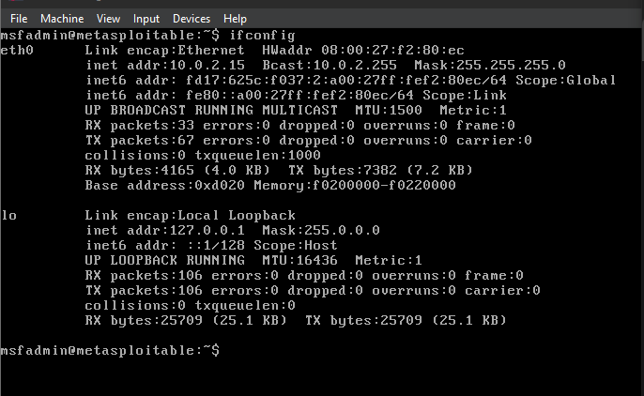
sudo netdicover -r 10.0.2.15 on kali
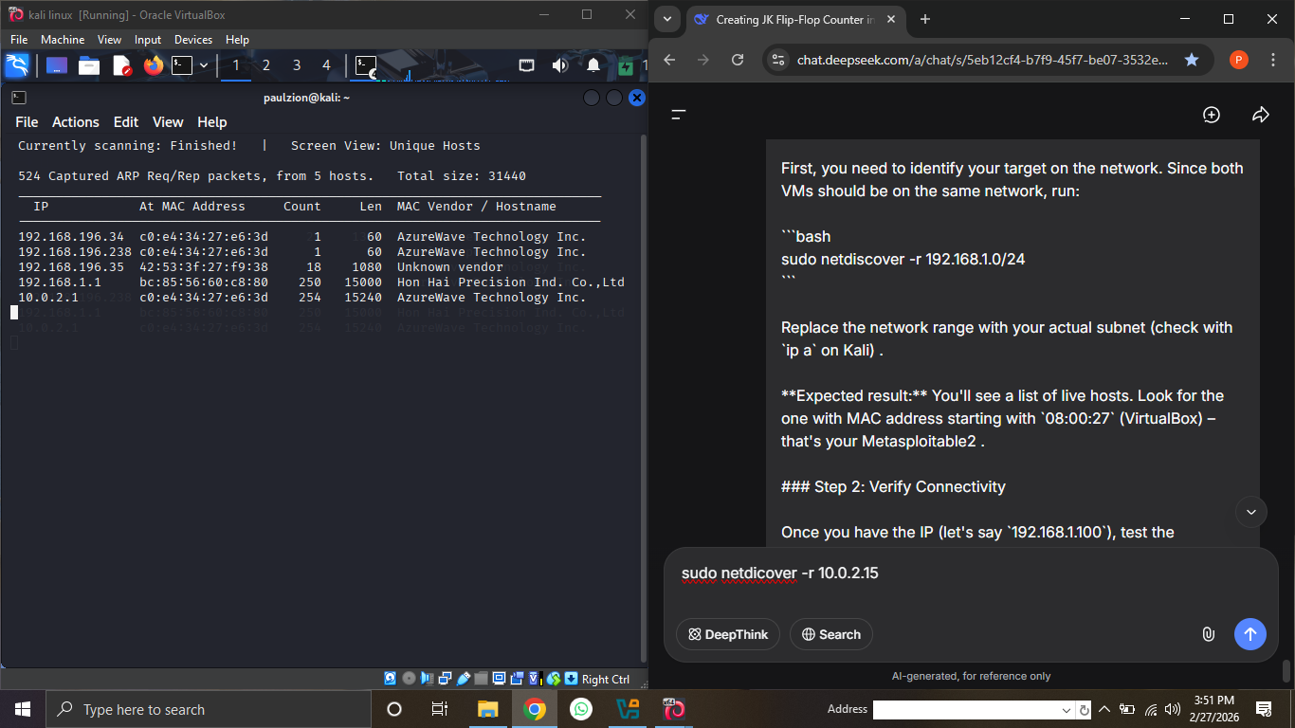
Pinging discovered ip address
