Task.md
- Passive Network Discovery (Netdiscover)
sudo netdiscover -p -i eth0
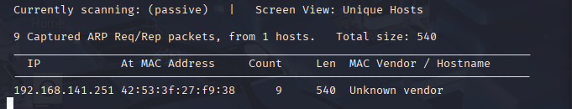
- Protocol Analysis (TShark)
sudo tshark -i eth0 –f
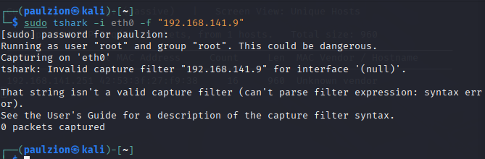
- OS Fingerprinting (Passive)
Sudo tcpdump –ni eth0 –c 100
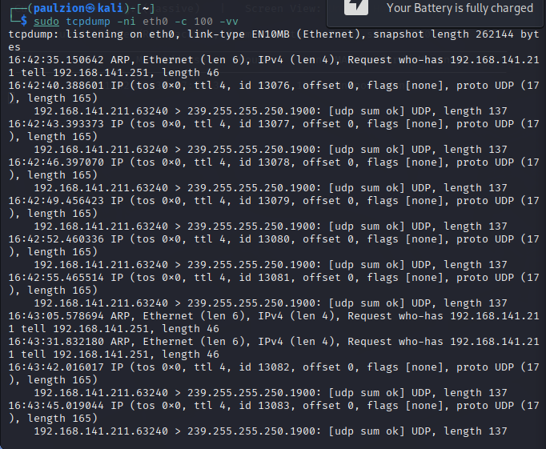
- Automated Evidence Collection (Bettercap)
Sudo bettercap –iface eth0 (not installed)
- Vulnerability Scanning (Active, with Permission)
Sudo nmap –sV 192.168.141.141
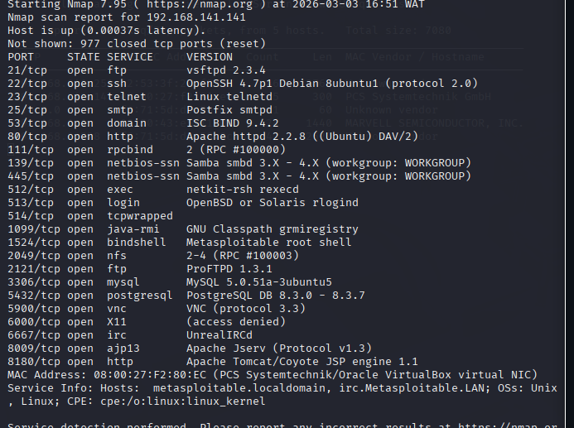
- Searchsploit
Searchsploit ftp
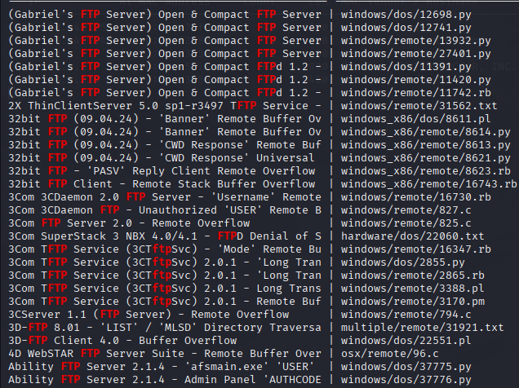

metric | Found value | Tool used | confidence
Target ip | 192.168.141.141 | netdiscover | 80%
MAC address
Operating system | Linux/unix (TTL 64) | tcpdump | 40%
Leaked services | ftp,ssh,exe | Tshark/nmapp | 70%
vulnerabilities | Phpmyadmin | gobuster | 30%
Because netdiscover –p operates in passive mode while nmap operates inactive mode thus, netdiscover only listens to network traffic without sending any packets. This makes it completely undetectable, as it doesn't trigger firewalls, intrusion detection systems, or generate logs. In contrast, nmap -sn actively probes the network, announcing your presence and potentially alerting the target. For an ethical hacker, starting with passive reconnaissance ensures stealth and avoids raising suspicio

