Running reconnaissance on vulnweb.com

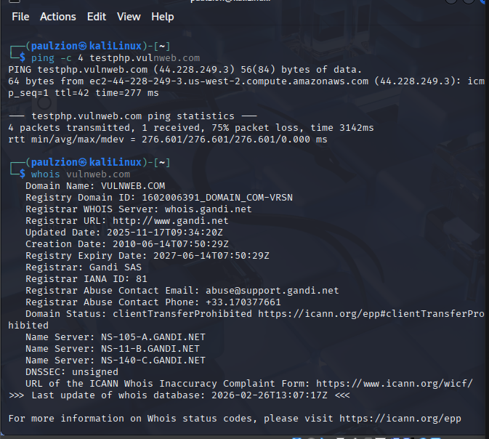

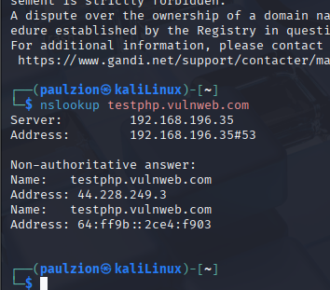
To get the ip address of vulnweb.
Command: whatweb fingerprints web technologies by analyzing HTTP
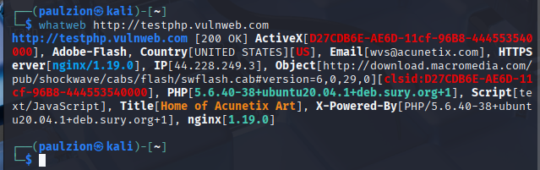
No results for nmap scan “taking too long”
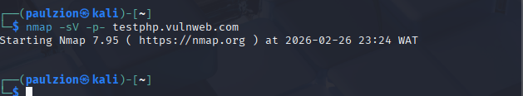
Running nikto –h http://testphp.vulnweb.com I had
Server: nginx/1.19.0
X-Powered-By: PHP/5.6.40-38+ubuntu20.04.1
Nginx 1.19.0 is relatively recent
PHP 5.6.40 is OLD and END OF LIFE! This is vulnerable
Ubuntu 20.04 indicates the OS
Missing Security Headers:
No X-Frame-Options → Vulnerable to clickjacking attacks
No X-Content-Type-Options → Possible MIME type confusion
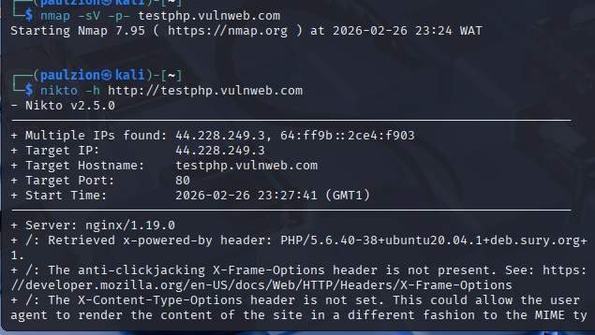

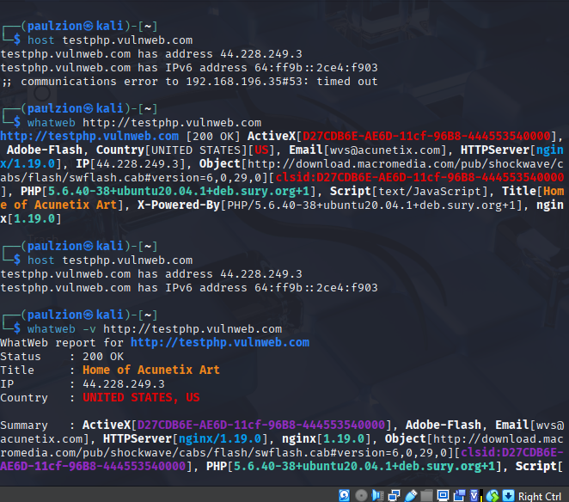
Based on all reconnaissance scans performed on testphp.vulnweb.com, I have discovered that the target is hosted at IP address 44.228.249.3 (with IPv6 address 64:ff9b::2ce4:f903) and is running on an Ubuntu Linux server with conflicting web server information showing both Apache 2.2.16 and nginx 1.19.0, along with PHP versions 5.3.3 and 5.6.40 which are both end-of-life and highly vulnerable. The Nikto web vulnerability scan identified missing security headers (X-Frame-Options and X-Content-Type-Options) making the site susceptible to clickjacking and MIME confusion attacks, while also discovering several interesting files and directories including /login.php, /robots.txt, /cgi-bin/test.cgi (potential Shellshock vulnerability), and /phpinfo.php which exposes sensitive PHP configuration information..

