Kali basics
- “pwd: from my research, pwd is used to show your current directory
- “ls” is used to list all the content of a particular directory
- “cd” is used to change directory. Here we have a couple of ways which include
- “cd ..” to go to previous directory
- “cd ~ or cd” to to go to your home directory
- “cd /” to go to the root directory
- “cd -” to go to the last directory
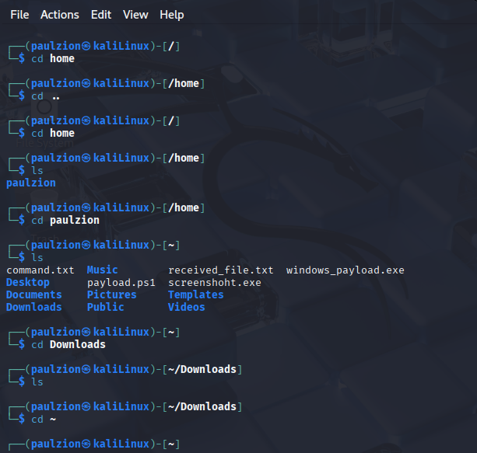
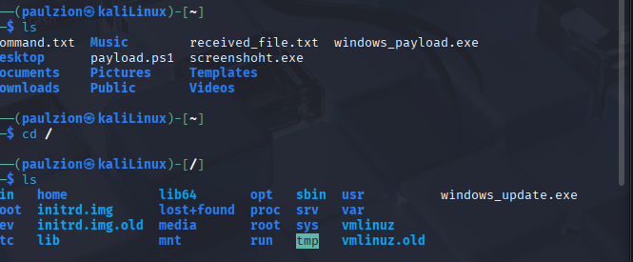
- “mkdir” this is use to create a directory
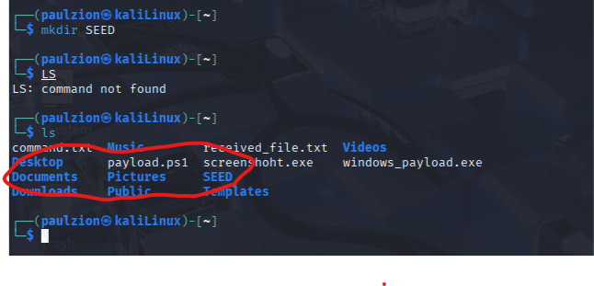
- “rm” use when we want to delete something

- ‘cp’ is used to copy files from one place to another the various ways are
- ‘cp file name new_backupName’ to cop to the same directory
- ‘cd filename /directory’ to copy to a different directory
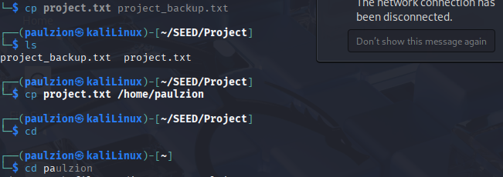

My small pentesting plan

LINUX BASICS
PenTest2026 Plan
I learned this kali basics and decided to come up with a small project that involves what the task expects
Commands used:`pwd`, `mkdir`, `cd`, `ls`, `touch`, `echo`, `ls -la`, redirection operators (`>`)
I started by checking my current directory using `pwd`, which showed I was in `/home/paulzion`. I then created a new directory called `PenTest2026` using `mkdir PenTest2026` and navigated into it with `cd PenTest2026`. To confirm my location, I ran `pwd` again, which output `/home/paulzion/PenTest2026`. Inside this directory, I created two subdirectories, `scans` and `exploits`, using `mkdir scans exploits`, and verified their creation with `ls`, which listed both folders. Next, I created an empty file named `targets.txt` using `touch targets.txt`. I tested the `echo` command by typing `echo 192.168.150.211`, which displayed the IP address on the screen. I then redirected this output into `targets.txt` using `echo 192.168.150.211 > targets.txt`. I then overwrote the file's content by running `echo 1 2 3 > targets.txt`, which replaced the IP address with the numbers 1, 2, and 3.
Continuing my session, I listed the contents of the `PenTest2026` directory again using `ls`, which showed the existing `exploits` and `scans` folders along with the `targets.txt` file. I then overwrote the content of `targets.txt` by running `echo "penetration plan" > targets.txt`, followed immediately by another overwrite using `echo "date time" > targets.txt`, which left the file containing only the text "date time". To verify the file's content and size, I ran `ls -la`, which displayed the detailed directory listing showing `targets.txt` with a size of 10 bytes, along with the timestamps of all files and folders. Next, I created a new file called `notes.txt` by redirecting the output of `echo "date time"` into it using `echo "date time" > notes.txt`. Finally, I ran `ls -la` again to confirm the creation of `notes.txt`, and the output showed both `targets.txt` and `notes.txt` present in the directory, each with 10 bytes and timestamps from my session.

