LNTB
Leading Next-Gen Tomato Business
Software Requirements Specification
លក្ខខណ្ឌតម្រូវប្រព័ន្ធ និងកម្មវិធី
PLC & SDLC Documentation Pack
Document ID | LNTB-SRS-001 | Version | 1.0
Status | Baseline for implementation | Date | 2026-07-11
Owner | Business Analyst / Product Owner | Reviewer | Technical Lead / QA Lead
Approver | Project Sponsor / Academic Supervisor | Classification | Project Internal

Document purpose — This controlled document defines the approved baseline for the LNTB pilot. Changes are managed through the Change Register and must preserve traceability to requirements, design, tests and acceptance evidence.

Document Control
Version | Date | Author/Owner | Change Summary | Status
0.1 | 2026-07-11 | LNTB Project Team | Initial controlled draft | Draft
1.0 | 2026-07-11 | LNTB Project Team | PLC/SDLC baseline for implementation | Baseline

Approvals
Role | Name | Decision | Date | Signature / Evidence
Project Sponsor / Supervisor | TBD | Pending | TBD | Meeting minutes or signed copy
Project Manager | TBD | Pending | TBD | Change/approval record
Technical Lead | TBD | Pending | TBD | Architecture review record
QA Lead | TBD | Pending | TBD | Quality gate record

1. Purpose, Scope and Product Vision
This Software Requirements Specification (SRS) defines the verifiable product baseline for the LNTB pilot. It covers sensor and camera firmware, Laravel backend services, Flutter Android application, AI inference, data, interfaces and cross-cutting quality attributes. “Shall” indicates a mandatory requirement. Targets remain targets until supported by test or pilot evidence.
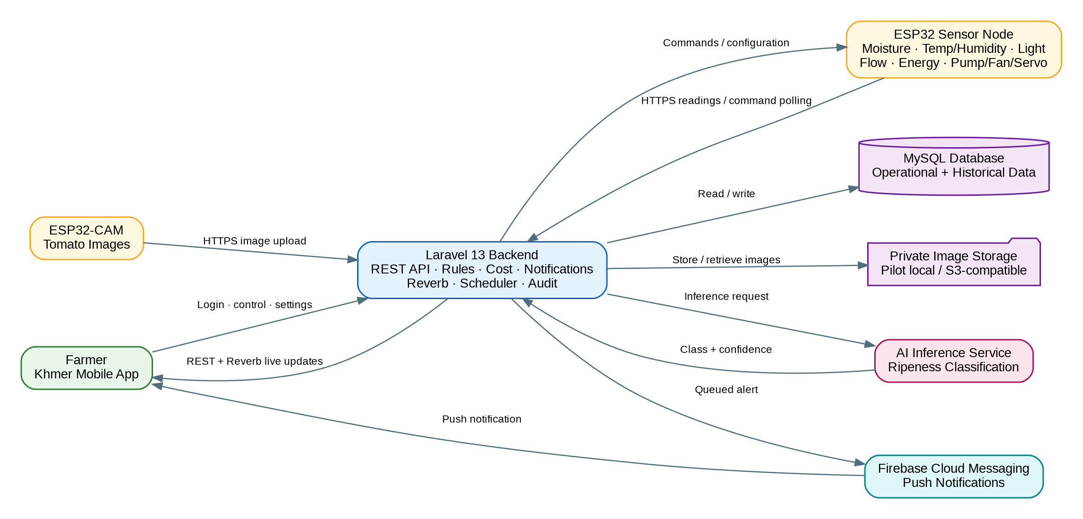
Figure 1 — LNTB system context and external interactions

2. Users and Operating Context
Actor | Primary Goals | Constraints
Farmer / Net-house Operator | Check status, irrigate safely, view ripeness, costs and history | Khmer-first, limited technical literacy, intermittent connectivity, low-end Android
Farm Manager / Product Owner | Configure thresholds/tariffs, review outcomes and accept pilot | Needs traceability and clear exceptions
Device Node | Collect data, execute commands and remain safe offline | Limited memory/power/network; humid environment
Project Administrator | Manage users, farms, devices and operational settings | Requires least privilege and audit trail
Operations / Support | Monitor services, restore data and troubleshoot devices | Requires health data, logs, runbooks and controlled access
AI Reviewer | Curate dataset and validate model performance | Requires versioned labels, representative data and privacy controls

3. Product Assumptions and Constraints
- Pilot UX targets one active farm per account, while the schema and authorization model support multiple farms.
- Backend-side inference is the MVP baseline; on-device inference is a future optimization only after benchmark evidence.
- Actual usage claims require calibrated meters. Runtime × nominal rate is an estimate and must be labelled as such.
- One ESP32-CAM samples selected views and does not provide complete fruit inventory or 100% coverage.
- Commands may be delayed by weak connectivity; the UI must distinguish queued, delivered, executed and failed states.
- No automatic control action may bypass firmware safety limits or a physical isolation mechanism.

4. Functional Requirements — Device and Firmware
ID | Mandatory Requirement
FR-HW-01 | Read soil moisture at a configurable interval; default 60 seconds.
FR-HW-02 | Read air temperature and humidity using DHT22 or approved equivalent.
FR-HW-03 | Read ambient light using the LDR channel and calibrated mapping.
FR-HW-04 | Submit timestamped readings to the device API as JSON over HTTPS.
FR-HW-05 | Poll pending commands at a configurable interval; default 10 seconds.
FR-HW-06 | Execute pump_on and pump_off through an electrically isolated, rated relay.
FR-HW-07 | Execute servo_open and servo_close within configured mechanical limits.
FR-HW-08 | Acknowledge command receipt, execution outcome and device timestamp.
FR-HW-09 | Use a locally stored safe moisture threshold if the backend is unreachable beyond the configured timeout.
FR-HW-10 | Capture a tomato image on schedule or approved trigger.
FR-HW-11 | Upload compressed image and capture metadata to the backend inference endpoint.
FR-HW-12 | Store Wi-Fi/API configuration outside application source and protect credentials.
FR-HW-13 | Reconnect after Wi-Fi loss without manual reset.
FR-HW-14 | Measure irrigation flow with a calibrated flow meter and accumulate actual volume.
FR-HW-15 | Measure pump electrical energy with an isolated, calibrated energy meter.
FR-HW-16 | Buffer at least 24 hours of readings/events and synchronize with stable idempotency keys.
FR-HW-17 | Enforce pump maximum runtime, sensor plausibility checks and fail-off safety behavior.

5. Functional Requirements — Laravel Backend
ID | Mandatory Requirement
FR-BE-01 | Authenticate device telemetry ingestion and validate payloads.
FR-BE-02 | Return only authorized pending commands for a device.
FR-BE-03 | Receive idempotent command acknowledgements and execution results.
FR-BE-04 | Receive camera images, queue inference and store controlled results.
FR-BE-05 | Calculate event water m³, electricity kWh and costs from metered data; label estimates explicitly.
FR-BE-06 | Roll up daily usage and cost using a scheduled, repeatable job.
FR-BE-07 | Broadcast authorized live farm updates through Laravel Reverb.
FR-BE-08 | Send push notifications for ready-to-harvest results.
FR-BE-09 | Send threshold, pump safety and device-offline alerts.
FR-BE-10 | Provide Laravel Sanctum token authentication for the mobile application.
FR-BE-11 | Provide paginated and filterable logbook/history APIs.
FR-BE-12 | Allow authorized manual irrigation start/stop subject to safety interlocks.
FR-BE-13 | Record trigger source, user/device, timestamps, duration, measurements and outcome for each irrigation event.
FR-BE-14 | Maintain configurable farm tariffs and operational thresholds with audit history.
FR-BE-15 | Register, rotate, revoke and audit device credentials.
FR-BE-16 | Deduplicate ingestion and command acknowledgements using client event IDs/idempotency keys.
FR-BE-17 | Store images privately, use signed access and enforce retention/deletion rules.
FR-BE-18 | Expose health, queue, scheduler and device freshness information for operations.

6. Functional Requirements — Flutter Mobile Application
ID | Mandatory Requirement
FR-APP-01 | Authenticate users and securely persist/revoke the Sanctum token.
FR-APP-02 | Display latest moisture, temperature, humidity, light and freshness status.
FR-APP-03 | Use text, icon and color together for normal/warning/critical status.
FR-APP-04 | Allow authorized users to start or stop irrigation after confirmation.
FR-APP-05 | Display automatic/manual mode, active event, last irrigation and safety timeout.
FR-APP-06 | Display ripeness image, class, confidence and capture time with farmer-verification guidance.
FR-APP-07 | Display daily/monthly water, electricity and cost; distinguish measured from estimated values.
FR-APP-08 | Provide a paginated digital logbook filterable by type and date.
FR-APP-09 | Receive push notifications and open the relevant app destination.
FR-APP-10 | Render all farmer-facing production text from Khmer localization resources.
FR-APP-11 | Operate acceptably on supported low-end Android devices.
FR-APP-12 | Cache last-known state and retry safe operations during intermittent connectivity.
FR-APP-13 | Provide settings for thresholds, tariffs, notification preferences and profile subject to authorization.
FR-APP-14 | Show offline, stale-data, synchronization and command-pending states explicitly.
FR-APP-15 | Provide an accessible sign-out and token revocation flow.

7. Non-Functional Requirements
ID | Category | Verifiable Requirement
NFR-01 | Usability | A trained farmer shall identify farm status within 5 seconds using icon, label and color cues.
NFR-02 | Performance | 95% of online telemetry shall appear in the dashboard within 5 seconds of backend receipt.
NFR-03 | Reliability | Basic automatic irrigation safety shall continue during backend/network outage.
NFR-04 | Availability | Pilot services shall be monitored and restored under the operational RTO; no formal commercial SLA is claimed.
NFR-05 | Security | All network traffic uses TLS; users and devices use separate revocable credentials and least privilege.
NFR-06 | Scalability | Data and authorization design shall support multiple farms/devices per user without schema redesign.
NFR-07 | Localization | All farmer-facing strings shall come from Khmer ARB resources and pass localization review.
NFR-08 | Cost | Revised pilot BOM and contingency require sponsor approval; the original approximately $105 target is treated as an estimate.
NFR-09 | Maintainability | Firmware, backend, app and AI are modular, documented, tested and independently deployable where practical.
NFR-10 | Retention | Operational records remain retrievable for at least one growing season, subject to policy.
NFR-11 | Measurement | Calibrated flow and energy measurements target ±5% under pilot conditions.
NFR-12 | AI Quality | The pilot model targets at least 85% macro F1 on a held-out representative set; results include confidence and model version.
NFR-13 | Safety | Pump control is fail-off, maximum-runtime protected and manually isolatable.
NFR-14 | Continuity | Target RPO is 24 hours and target RTO is 4 hours for pilot backend data/services.
NFR-15 | Accessibility | Core flows support scalable text, semantics, touch targets and non-color status cues.
NFR-16 | Observability | Services expose structured logs, correlation IDs, health checks and alertable operational metrics.
NFR-17 | Privacy | Personal data and farm images are minimized, access-controlled and removed according to retention decisions.

8. Key Use Cases
ID | Use Case | Primary Actor | Precondition | Success Outcome
UC-01 | Sign in and view farm status | Farmer | Valid account/device association | Authenticated session; latest cached/live state shown; freshness visible
UC-02 | Automatic irrigation | Firmware / Backend | Auto mode; valid threshold; safe hardware | Pump operates within limits; event and measured usage recorded
UC-03 | Manual irrigation | Farmer | Authorized; device available; no safety lock | Confirmed command progresses queued→executed or fails clearly
UC-04 | Offline safe operation | Device | Backend unreachable beyond timeout | Local threshold controls pump safely; data buffered and later reconciled
UC-05 | Ripeness detection | Camera / AI | Capture trigger; model available | Image processed; class/confidence/model version stored; farmer notified if ready
UC-06 | Review costs and logbook | Farmer | Usage data available | Measured/estimated origin shown; records filterable and reproducible
UC-07 | Configure farm settings | Manager | Authorized role | Validated threshold/tariff version saved and audited
UC-08 | Provision/revoke device | Administrator | Physical device ID and farm exist | Credential issued once, stored securely, and revocable

9. Business Rules
Rule | Statement
BR-01 | A pump_on command must include or resolve to a maximum runtime; firmware stops the pump when the limit expires.
BR-02 | Manual control requires confirmation and authorization; automatic mode status remains visible.
BR-03 | When measurement data is unavailable or invalid, the system shall not present an estimate as actual usage.
BR-04 | A reading/event is unique by device ID plus client event ID; replays return the existing result.
BR-05 | Stale data thresholds are configurable; the app shall show last update time and stale status.
BR-06 | AI classifications are decision support. Confidence, image and model version remain reviewable.
BR-07 | Ready-to-harvest notification threshold is configurable and must not be described as certainty.
BR-08 | Threshold/tariff changes are versioned and effective-dated; historical cost remains reproducible.
BR-09 | Only authorized farm members can view, command or receive events for that farm.
BR-10 | Images are private by default and removed after the approved retention period unless retained for a documented dataset purpose.

10. Data Requirements and Retention
Data Class | Minimum Fields | Retention / Control
Sensor reading | device, client_event_id, metrics, units, recorded_at, received_at, quality flags | At least one growing season; partition/archive as volume grows
Irrigation event | device/farm, trigger, user, start/end, duration, flow, energy, costs, status | At least one growing season; immutable event evidence
Command | device, type, parameters, requester, status timestamps, failure reason | At least one growing season; audit-sensitive
Ripeness result | image reference, class, confidence, model version, timestamps, reviewer outcome | Result retained for season; image per approved shorter retention
Configuration | thresholds, tariffs, safety limits, effective dates, changed by | Retain versions required to reproduce decisions/costs
Security / audit | auth events, credential changes, privileged actions, correlation ID | Minimum 12 months for pilot, access restricted

11. External Interfaces
Interface | Protocol / Format | Requirements
Device → Laravel | HTTPS JSON / multipart image | TLS, device token, schema validation, size limits, idempotency, time tolerance
Flutter → Laravel | HTTPS JSON | Sanctum bearer token, authorization, pagination, consistent errors
Laravel → Flutter realtime | WSS / Reverb | Private farm channels, authorization, reconnect and no secret payloads
Laravel → FCM | Provider API | Minimal payload, token lifecycle, deep-link destination, retry/queue
Laravel → AI inference | Internal queue/service contract | Versioned request/response, timeout, retry, model version and confidence
Hardware actuation | GPIO/relay/servo | Rated components, fail-off, debounce, isolation and physical manual cutoff

12. Acceptance Baseline
- Every mandatory requirement is linked to at least one design element and test case in the RTM.
- All safety/security release tests pass and no critical defect remains open.
- End-to-end telemetry, manual/automatic irrigation, offline recovery, usage measurement, ripeness and logbook workflows pass in the pilot environment.
- Khmer localization, accessibility and low-end Android checks meet the UX acceptance criteria.
- Measurement and AI targets are reported transparently with datasets, methods, limitations and observed values.
- Product Owner and Sponsor sign the acceptance record or record conditional acceptance with due dates.

Authoritative References
ID | Source | Use
SRC-01 | LNTB Khmer proposal | Goals, scope, BOM and timeline
SRC-02 | LNTB requirements | Functional/non-functional baseline
SRC-03 | LNTB project structure | Initial architecture, data and APIs
SRC-04 | Official Laravel docs | Backend implementation baseline
SRC-05 | Official Flutter docs | Mobile architecture/quality baseline
SRC-06 | Official Espressif docs | ESP32 hardware/network constraints

