LNTB
Leading Next-Gen Tomato Business
System Architecture, Data and API Design
ស្ថាបត្យកម្មប្រព័ន្ធ ការរចនាទិន្នន័យ និង API
PLC & SDLC Documentation Pack
Document ID | LNTB-ARC-001 | Version | 1.0
Status | Baseline for implementation | Date | 2026-07-11
Owner | Technical Lead / Solution Architect | Reviewer | Technical Lead / QA Lead
Approver | Project Sponsor / Academic Supervisor | Classification | Project Internal

Document purpose — This controlled document defines the approved baseline for the LNTB pilot. Changes are managed through the Change Register and must preserve traceability to requirements, design, tests and acceptance evidence.

Document Control
Version | Date | Author/Owner | Change Summary | Status
0.1 | 2026-07-11 | LNTB Project Team | Initial controlled draft | Draft
1.0 | 2026-07-11 | LNTB Project Team | PLC/SDLC baseline for implementation | Baseline

Approvals
Role | Name | Decision | Date | Signature / Evidence
Project Sponsor / Supervisor | TBD | Pending | TBD | Meeting minutes or signed copy
Project Manager | TBD | Pending | TBD | Change/approval record
Technical Lead | TBD | Pending | TBD | Architecture review record
QA Lead | TBD | Pending | TBD | Quality gate record

1. Architecture Drivers
- Safety and continued local irrigation control under network/backend outage.
- Intermittent connectivity with lossless, duplicate-safe synchronization.
- Khmer-first mobile usability and low-end Android performance.
- Clear authorization boundaries among user, farm and device identities.
- Accurate, reproducible water/energy/cost records and auditable configuration.
- Independent evolution of firmware, backend, mobile and AI components.

2. Component Responsibilities
Component | Responsibilities | Must Not Own
Sensor/Actuator ESP32 | Sample sensors/meters, local safety logic, command execution, event buffer, synchronization | User authorization, tariffs, historical reporting
ESP32-CAM | Capture/compress image, metadata and upload retry | Final model lifecycle or public image access
Laravel API | Authentication/authorization, validation, ingestion, farm APIs and command state | GPIO timing or physical safety enforcement
Laravel workers/scheduler | AI inference, notifications, rollups, offline detection, retention jobs | Request-thread blocking for long work
MySQL | Transactional source of truth, indexes and constraints | Binary image storage at scale
Private object storage | Controlled image objects and signed access | User/farm authorization logic
Reverb | Authorized transient live events | Durable source of truth
Flutter app | Presentation, user interaction, local cache, retry and notification navigation | Safety-critical autonomous control

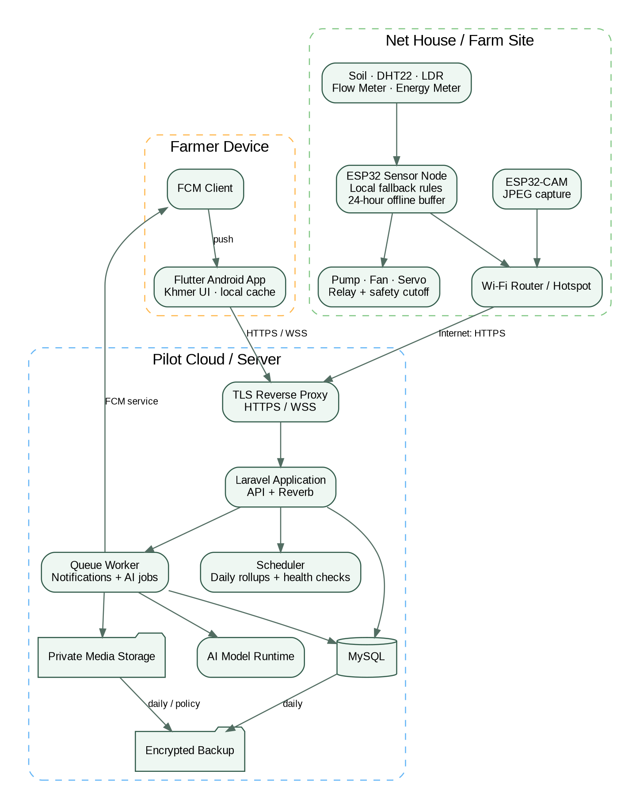
Figure 1 — Logical deployment architecture

3. Backend and Mobile Structure
Layer / Module | Laravel Baseline | Flutter Baseline
Presentation / Interface | Versioned routes, controllers, Form Requests, API Resources | Feature screens/widgets with GoRouter routes
Application | Use-case services/actions, policies, jobs and notifications | Riverpod notifiers/controllers and immutable UI state
Domain | Farm/device/irrigation/ripeness/usage rules and value objects | Domain models and repository contracts
Infrastructure | Eloquent repositories, Reverb, FCM, storage, queues, cache | Dio clients, Echo/Reverb client, secure token store, local database/cache
Testing | Pest feature/unit/architecture tests | Unit, widget and integration tests

4. Core Data Model
Entity | Purpose | Key Constraints / Indexes
users | Identity, role and account state | email/phone unique; password hash; status
farms | Owned/accessible net houses | owner_id; timezone; default tariffs; active
farm_user | Membership and role | unique farm/user; role
devices | Sensor/camera identity and status | hardware_uid unique; type; last_seen; credential version
device_credentials | Hashed/rotatable device secrets | device; prefix/hash; issued/revoked timestamps
sensor_readings | Time-series telemetry | device + client_event_id unique; recorded_at index; quality flags
irrigation_commands | Requested device actions | idempotency_key; requester; desired parameters; status
irrigation_events | Executed pump activity and measurements | device + client_event_id unique; measured/estimated flags
ripeness_captures | Private image metadata and processing status | object key; checksum; captured_at; status
ripeness_results | Model output and optional farmer review | capture; class; confidence; model_version
farm_settings | Versioned thresholds/tariffs/safety settings | farm; version; effective_at; changed_by
usage_daily | Reproducible daily aggregates | farm/date unique; water/energy/cost; source version
device_sync_cursors | Sync acknowledgement and health | device; last sequence/client event; last sync
notifications | Delivery and read status | user; type; payload reference; sent/read
audit_logs | Security/business sensitive actions | actor; farm/device; action; before/after; correlation ID

5. Data Integrity and Time
- Persist timestamps in UTC and render in the farm/user timezone. Store both device recorded_at and server received_at.
- Use decimal units: moisture %, temperature °C, humidity %, light lux/raw with calibration type, volume m³, energy kWh, cost USD.
- Use unique(device_id, client_event_id) for offline replay; return a stable response for duplicate submissions.
- Use database transactions for command transitions and irrigation completion/usage aggregation.
- Keep raw measurements and calculation inputs so costs can be reproduced after tariff changes.

6. API Conventions
Concern | Convention
Base/version | /api/v1; additive-compatible changes within v1; breaking changes require v2 or negotiated migration
Authentication | Sanctum bearer tokens for users; separately scoped hashed device tokens for devices
Authorization | Laravel policies/gates enforce farm membership and role on every resource
Validation | Form Requests; reject unknown/invalid units, ranges, timestamps and unsafe command parameters
Response | API Resources; JSON envelope with data/meta; stable machine-readable error code and correlation_id
Pagination | Cursor pagination for high-volume time-series; page pagination acceptable for bounded admin lists
Idempotency | Idempotency-Key for user commands; client_event_id for device data/events
Concurrency | Command state transitions use optimistic checks/transactions; only one active pump event per device
Rate/size limits | Per token/device; stricter image size/frequency limits; 429 with retry guidance
Observability | X-Correlation-ID propagated to logs, jobs and events

7. Endpoint Catalogue
Method | Path | Identity | Purpose
POST | /api/v1/auth/login | User | Issue user token after validated credentials
POST | /api/v1/auth/logout | User | Revoke current token
GET | /api/v1/farms/{farm}/dashboard | User | Latest authorized status and freshness
GET | /api/v1/farms/{farm}/readings | User | Cursor-paginated telemetry
POST | /api/v1/farms/{farm}/irrigation/commands | User | Create safe manual command with idempotency key
GET | /api/v1/farms/{farm}/irrigation/events | User | Event history and measured usage
GET | /api/v1/farms/{farm}/ripeness-results | User | Capture/result history with signed thumbnail access
GET | /api/v1/farms/{farm}/usage | User | Daily/monthly water, energy and costs
GET/PUT | /api/v1/farms/{farm}/settings | Manager | Read/update validated versioned settings
POST | /api/v1/devices/{uid}/telemetry | Device | Idempotent sensor/meter upload
GET | /api/v1/devices/{uid}/commands | Device | Lease authorized pending commands
POST | /api/v1/devices/{uid}/commands/{command}/ack | Device | Acknowledge receipt/execution/failure
POST | /api/v1/devices/{uid}/irrigation-events | Device | Upload completed event with measurements
POST | /api/v1/devices/{uid}/captures | Camera | Upload controlled image and capture metadata
GET | /health/live | /health/ready | Ops | Process and dependency readiness

8. Event Contracts
Event | Audience | Minimum Payload
sensor.reading.updated | Private farm channel | farm_id, device_id, reading summary, recorded_at, received_at, stale_after
irrigation.command.updated | Private farm/user channel | command_id, device_id, status, requested/executed timestamps, failure code
irrigation.event.completed | Private farm channel | event_id, duration, water_m3, energy_kwh, measurement flags, costs
ripeness.result.created | Private farm channel | result_id, class, confidence, model_version, detected_at, signed thumbnail reference
device.status.changed | Private farm channel | device_id, online/offline/stale, last_seen_at
alert.created | Private user/farm channel + FCM | alert_id, type, severity, safe summary, destination

Figure 2 — Manual irrigation command and acknowledgement sequence

9. Resilience and Scaling
- Device ingestion is stateless and horizontally scalable; MySQL remains the transaction source of truth.
- Queues isolate image inference, notification delivery, rollups and retention from API response latency.
- Reverb events are derived notifications; clients recover authoritative state through HTTP after reconnect.
- Time-series indexes and retention/archival prevent unbounded query degradation.
- Device buffer uses sequence numbers, checksums where practical and an acknowledged sync cursor.
- Graceful degradation: app shows cached data; firmware uses safe fallback; backend queues non-critical work.

10. Architecture Acceptance
Check | Acceptance Evidence
Security boundaries | User/device authentication and farm authorization tests pass
Offline recovery | 24-hour buffer replay produces no loss or duplicate logical records
Safety | Local maximum runtime and fail-off behavior pass with server/network removed
Performance | Telemetry latency and API load target pass under pilot workload
Operability | Health checks, logs, queue/scheduler monitoring and backup restore demonstrated
Traceability | Architecture components link to SRS and test cases

Authoritative References
ID | Source | Use
SRC-01 | LNTB Khmer proposal | Goals, scope, BOM and timeline
SRC-02 | LNTB requirements | Functional/non-functional baseline
SRC-03 | LNTB project structure | Initial architecture, data and APIs
SRC-04 | Official Laravel docs | Backend implementation baseline
SRC-05 | Official Flutter docs | Mobile architecture/quality baseline
SRC-06 | Official Espressif docs | ESP32 hardware/network constraints

