Block Diagram

1. Introduction
The block diagram illustrates the overall architecture of the FPGA-Based Digital Voting Machine. It shows the flow of information from the user inputs through the FPGA processing modules to the final output displayed on the 7-segment display. Each functional block performs a dedicated operation, resulting in a modular and reliable system design.

2. Block Diagram

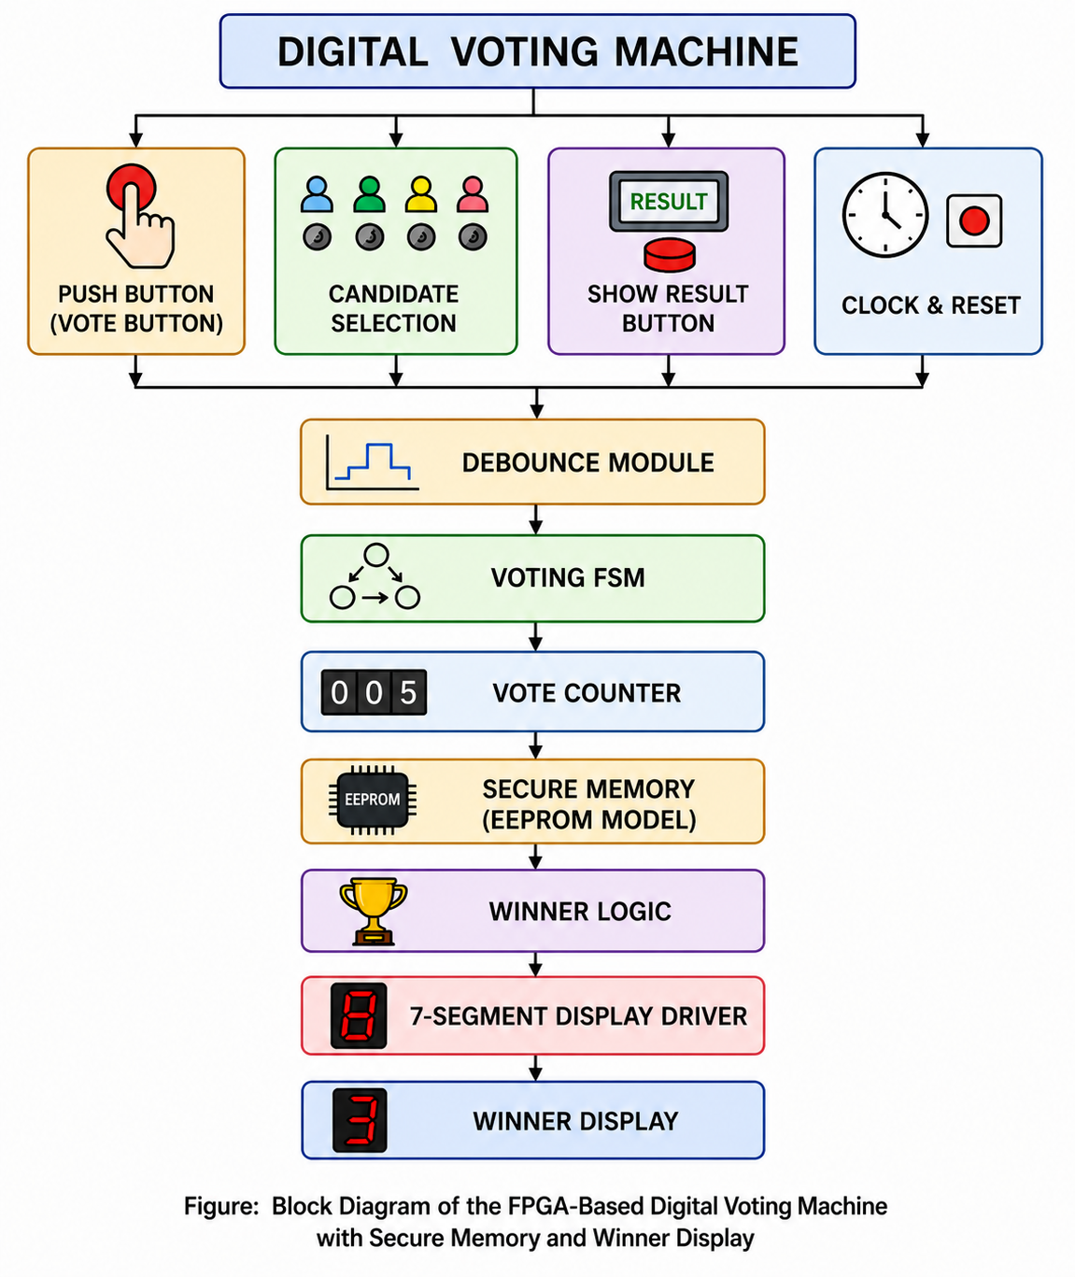

3. Description of Functional Blocks

Input Interface
The input interface consists of the Vote Button, Candidate Selection, Show Result Button, and Clock & Reset signals used to operate the voting system.

Debounce Module
The debounce module filters switch bouncing and ensures that only one valid vote is registered for each button press.

Voting FSM
The Finite State Machine (FSM) controls vote acceptance, storage, waiting for the next voter, and result display.

Vote Counter
The vote counter maintains separate vote counts for each candidate and increments the selected candidate after every valid vote.

Secure Memory
The secure memory module simulates EEPROM/Flash memory and stores the updated vote counts securely during simulation.

Winner Logic
The winner logic compares all vote counts and identifies the candidate with the highest number of votes.

7-Segment Display Driver
The display driver converts the winner information into the required signals for the 7-segment display.

Output Interface
The winner is displayed on the 7-segment display, while vote count signals remain available for simulation and verification.

4. Working Principle
After the user selects a candidate and presses the vote button, the debounce module validates the button press. The FSM controls the voting sequence, the vote counter updates the selected candidate's count, secure memory stores the result, winner logic determines the winning candidate, and the 7-segment display driver presents the winner.

5. Conclusion
The block diagram demonstrates a modular FPGA implementation of a digital voting machine. The separation of functional blocks improves readability, maintainability, and scalability.

