FSM State Diagram

1. Introduction
The Finite State Machine (FSM) controls the complete operation of the FPGA-Based Digital Voting Machine. It coordinates vote acceptance, vote storage, waiting for additional votes, and displaying the final result.

2. FSM State Diagram

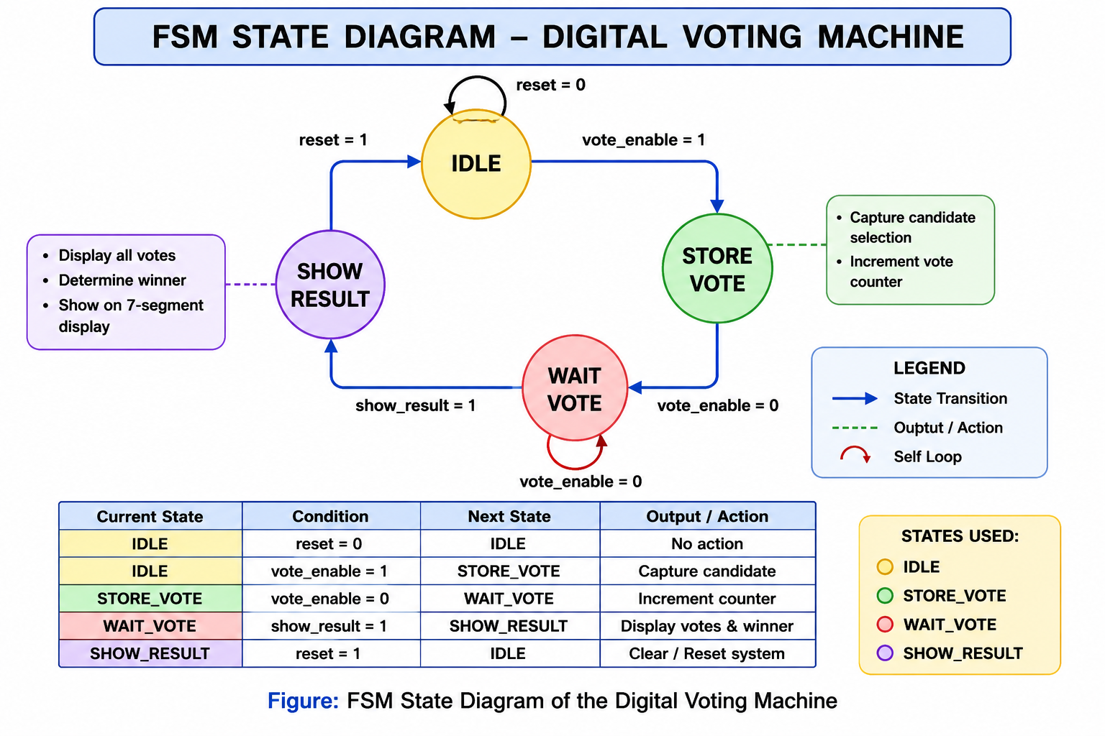

3. FSM States

IDLE
Initial state after reset. The system waits for a valid vote request.

STORE_VOTE
Stores the selected candidate's vote and updates the vote counter.

WAIT_VOTE
Waits for the next vote or the Show Result command.

SHOW_RESULT
Determines the winning candidate and drives the 7-segment display.

4. State Transitions
The FSM transitions from IDLE to STORE_VOTE when a valid debounced vote is detected. After storing the vote, it moves to WAIT_VOTE. While in WAIT_VOTE, additional votes return the FSM to STORE_VOTE, whereas the Show Result command transfers the FSM to SHOW_RESULT. A system reset returns the FSM to the IDLE state.

5. Advantages of FSM Control
- Provides deterministic system behavior.
- Prevents invalid voting sequences.
- Separates control logic from datapath modules.
- Improves modularity and maintainability.

6. Conclusion
The FSM provides reliable control of the voting process by ensuring that votes are accepted, stored, and displayed in the correct sequence.

