System Architecture

1. Introduction
The system architecture illustrates the complete organization of the FPGA-Based Digital Voting Machine. It shows how user inputs are processed through the FPGA modules to produce the final voting result.

2. System Architecture Diagram

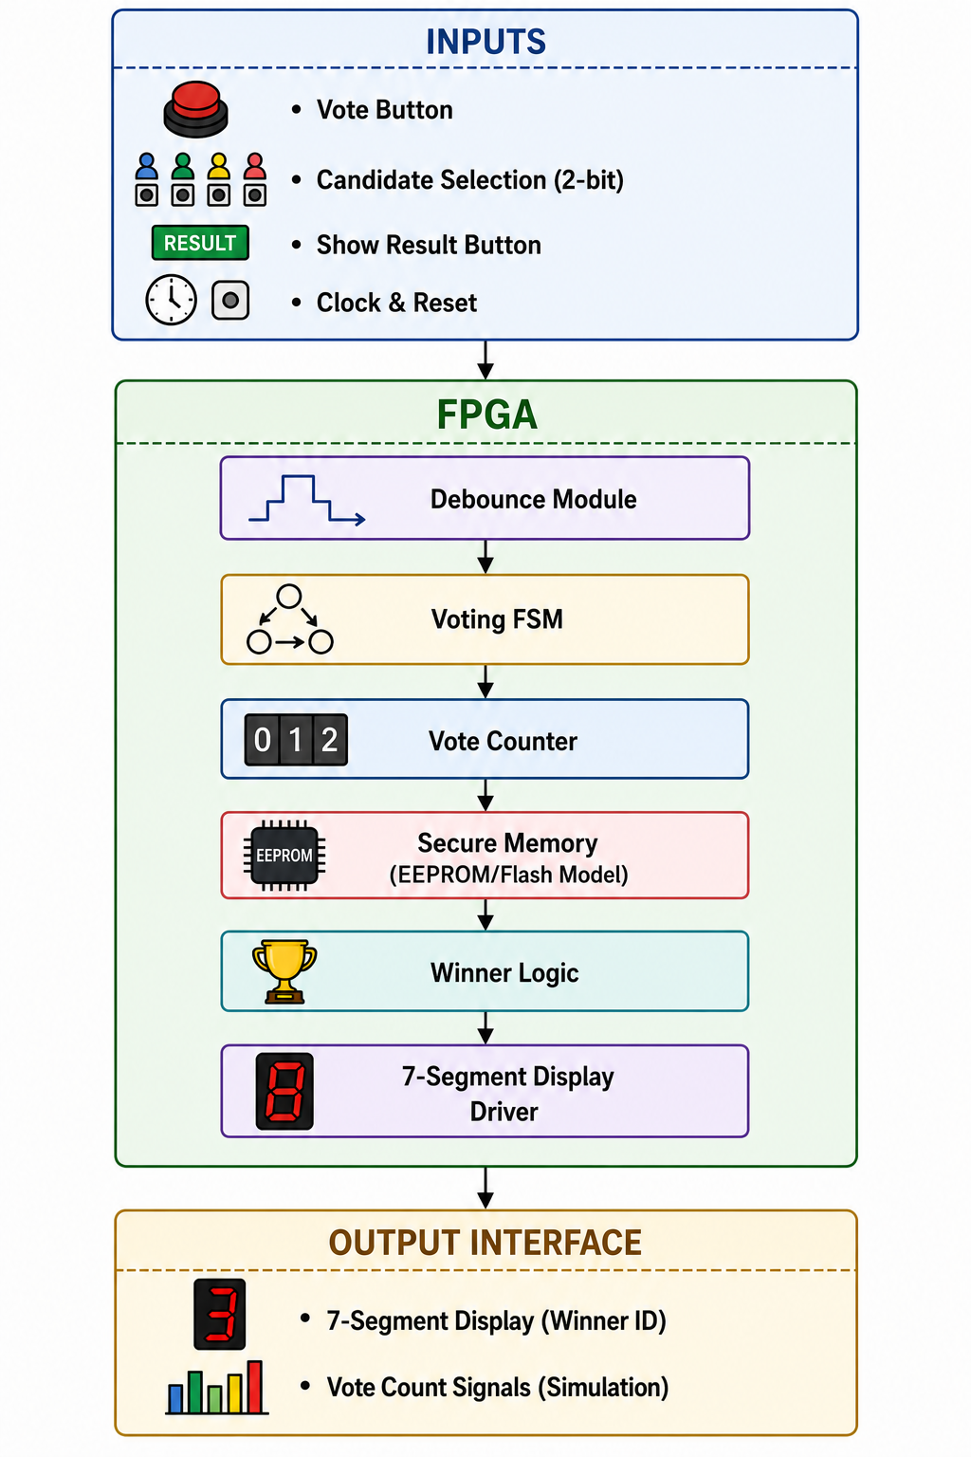

3. Architecture Overview
The architecture consists of an Input Interface, an FPGA implementing all processing modules, and an Output Interface. The FPGA contains the Debounce Module, Voting FSM, Vote Counter, Secure Memory (EEPROM/Flash Model), Winner Logic, and 7-Segment Display Driver.

4. Functional Description

Input Interface
Receives the vote button, candidate selection, show result command, clock, and reset signals.

Debounce Module
Removes switch bouncing and generates a clean vote pulse.

Voting FSM
Controls the complete voting sequence and coordinates all modules.

Vote Counter
Maintains separate counters for each candidate.

Secure Memory
Stores vote counts in a simulated EEPROM/Flash memory model.

Winner Logic
Compares vote counts and identifies the winning candidate.

7-Segment Display Driver
Converts the winner information into display signals.

Output Interface
Displays the winning candidate on the 7-segment display and exposes vote counts during simulation.

5. Advantages of the Architecture
- Modular FPGA implementation.
- Easy verification and debugging.
- Efficient resource utilization.
- Scalable design for future enhancements.
- Reliable operation through FSM-based control.

6. Conclusion
The proposed architecture provides a structured and modular implementation of the Digital Voting Machine. Each module performs a dedicated task, enabling reliable vote processing and accurate result generation.

