Analyses to support the Dolphinfish Management Strategy Evaluation in the U.S. Atlantic
Mandy Karnauskas
Table of contents

1. Introduction
Here we will be displaying various data summaries and analyses related to dolphin management in the U.S. South Atlantic.

1.1 Details
The documentation of this data exploration was developed in R, using R Studio and Quarto.

2. NOAA Fisheries recreational landings data
Here we will partition recreational landings data from NOAA Fisheries’ Marine Recreational Information Program (MRIP), a standardized, peer-reviewed suite of recreational fishing surveys used to produce catch and effort estimates for quota monitoring and stock assessment in the United States. MRIP is a standardized survey suite that employs a complex statistical sampling design stratified across time, regions of the coast, and different fishing modes, which allows the intercept data to be scaled up by effort estimates to calculate total landings.

2.1 Data access and upload
Data are downloaded directly from the Miami server using the files provided to SERO for ACL monitoring. The current location is: M://SFD/SECM-SFD/ACL/2025_Aug19_MRIP_FES/. The landings are in FES MRIP and the units are in pounds whole weight.
# clear workspace
rm(list = ls())
# read in data file
load("data/mrip_fes_rec81_25wv2_23June25.RData") # most recent file on SFD server
head(dat)
REC_ACL_MRIP_FES_ID YEAR MONTH WAVE SUB_REG NEW_ST NEW_STA NEW_MODE NEW_MODEN
1 73407425 1989 NA 4 6 9 NC 4 Priv
2 73407426 1989 NA 4 6 9 NC 4 Priv
3 73407427 1989 NA 4 6 9 NC 4 Priv
4 73407428 1989 NA 4 6 9 NC 4 Priv
5 73407429 1989 NA 4 6 9 NC 4 Priv
6 73407430 1989 NA 4 6 9 NC 4 Priv
AREA_X NEW_AREA NEW_AREAN FL_REG NC_REG DS NEW_SCI
1 5 5 Inshore NA S MRIP Centropristis striata
2 5 5 Inshore NA N MRIP Centropristis striata
3 2 2 Ocean>3mi NA N MRIP Centropristis striata
4 2 2 Ocean>3mi NA S MRIP Centropristis striata
5 1 1 Ocean<=3mi NA N MRIP Centropristis striata
6 1 1 Ocean<=3mi NA S MRIP Centropristis striata
NEW_COM SP_CODE SPECIES_ITIS SPECIES AB1 B2
1 black sea bass 8835020301 167687 34181.4033 121019.1368
2 black sea bass 8835020301 167687 795.8612 4445.0527
3 black sea bass 8835020301 167687 549.5390 2919.4840
4 black sea bass 8835020301 167687 71823.2390 24548.2535
5 black sea bass 8835020301 167687 415.7642 87.5928
6 black sea bass 8835020301 167687 48728.5632 11859.6428
A B1 LBSEST_SECWWT LBSEST_SECSOURCE SAMPLE_SIZE_USED
1 31761.4755 2419.9278 11457.8425 srysmwa 41
2 584.4155 211.4457 266.7782 srysmwa 41
3 549.5390 0.0000 484.4319 srysmwa 119
4 33343.1844 38480.0546 63313.9276 srysmwa 119
5 415.7642 0.0000 294.0623 srysmwa 71
6 40585.0152 8143.5480 34464.8156 srysmwa 71
AVG_LEN AVG_WGT SRYSMWA_AVG_LEN SRYSMWA_AVG_WGT SRYSMWA_SAMPLE_SIZE
1 203.4572 0.3352069 203.4572 0.3352069 41
2 203.4572 0.3352069 203.4572 0.3352069 41
3 296.2590 0.8815243 296.2590 0.8815243 119
4 296.2590 0.8815243 296.2590 0.8815243 119
5 261.9949 0.7072816 261.9949 0.7072816 71
6 261.9949 0.7072816 261.9949 0.7072816 71
SRYSMWA_FLAGGED SRYSMW_AVG_LEN SRYSMW_AVG_WGT SRYSMW_SAMPLE_SIZE
1 NA 269.2563 0.7310037 231
2 NA 269.2563 0.7310037 231
3 NA 269.2563 0.7310037 231
4 NA 269.2563 0.7310037 231
5 NA 269.2563 0.7310037 231
6 NA 269.2563 0.7310037 231
SRYSMW_FLAGGED SRYSM_AVG_LEN SRYSM_AVG_WGT SRYSM_SAMPLE_SIZE SRYSM_FLAGGED
1 NA 259.7694 0.6948228 556 NA
2 NA 259.7694 0.6948228 556 NA
3 NA 259.7694 0.6948228 556 NA
4 NA 259.7694 0.6948228 556 NA
5 NA 259.7694 0.6948228 556 NA
6 NA 259.7694 0.6948228 556 NA
SRYS_AVG_LEN SRYS_AVG_WGT SRYS_SAMPLE_SIZE SRYS_FLAGGED SRY_AVG_LEN
1 270.955 0.8099641 982 NA 269.1276
2 270.955 0.8099641 982 NA 269.1276
3 270.955 0.8099641 982 NA 269.1276
4 270.955 0.8099641 982 NA 269.1276
5 270.955 0.8099641 982 NA 269.1276
6 270.955 0.8099641 982 NA 269.1276
SRY_AVG_WGT SRY_SAMPLE_SIZE SRY_FLAGGED SR_AVG_LEN SR_AVG_WGT SR_SAMPLE_SIZE
1 0.8085211 1703 NA 303.6871 1.050403 46055
2 0.8085211 1703 NA 303.6871 1.050403 46055
3 0.8085211 1703 NA 303.6871 1.050403 46055
4 0.8085211 1703 NA 303.6871 1.050403 46055
5 0.8085211 1703 NA 303.6871 1.050403 46055
6 0.8085211 1703 NA 303.6871 1.050403 46055
SR_FLAGGED S_AVG_LEN S_AVG_WGT S_SAMPLE_SIZE S_FLAGGED VAR_B2 VAR_AB1
1 NA 344.4373 1.364082 305089 NA 4072492794 310099094
2 NA 344.4373 1.364082 305089 NA 2866289 258947
3 NA 344.4373 1.364082 305089 NA 0 0
4 NA 344.4373 1.364082 305089 NA 105731413 534702898
5 NA 344.4373 1.364082 305089 NA 0 0
6 NA 344.4373 1.364082 305089 NA 22265768 286196169
SA_LABEL GOM_LABEL REC_ACL MIGRA_GRP AGG_MODEN JURISDICTION PS_REG
1 Snapper Grouper 1 Private State 6
2 Snapper Grouper 1 Private State 5
3 Snapper Grouper 1 Private Federal 5
4 Snapper Grouper 1 Private Federal 6
5 Snapper Grouper 1 Private State 5
6 Snapper Grouper 1 Private State 6
COUNCILREG GFMC_FMP SAFMC_FMU LBSEST_SECGWT AGGR_AREA AREA FIRST_MONTH
1 6 Y 9710.0360 NA NA
2 5 Y 226.0832 NA NA
3 5 Y 410.5355 NA NA
4 6 Y 53655.8708 NA NA
5 5 Y 249.2054 NA NA
6 6 Y 29207.4709 NA NA
LAST_MONTH ALT_FLAG CHTS_CL CHTS_H CHTS_RL CHTS_WAB1C CHTS_WAB1H MODE_FX
1 NA 0 0 0 0 0 0 7
2 NA 0 0 0 0 0 0 7
3 NA 0 0 0 0 0 0 7
4 NA 0 0 0 0 0 0 7
5 NA 0 0 0 0 0 0 7
6 NA 0 0 0 0 0 0 7
NEW_SEASN SEASON
1 NA
2 NA
3 NA
4 NA
5 NA
6 NA
#apply(dat[2:18], 2, table, useNA = "always")
# confirm nomenclature for dolphin and subset by species --------------------------
table(dat$NEW_COM[grep("dolphin", dat$NEW_COM)])
dolphin
9377
table(dat$NEW_SCI[grep("dolphin", dat$NEW_COM)])
Coryphaena hippurus
9377
d <- dat[which(dat$NEW_COM == "dolphin"), ]
#apply(d[2:18], 2, table, useNA = "always")
d <- d[which(d$YEAR < 2025), ] # take out 2025 because incomplete year

2.2 Separate Gulf and Atlantic recreational landings
Now we filter the data set to separate out the Gulf versus Atlantic landings.
# codes for WFL regions: 1 (NW FL Panhandle- Escambia to Dixie co.), 2 (SW FL Peninsula- Levy to Collier co), 3 (FL Keys- Monroe co.)
table(d$FL_REG, useNA = "always")
1 2 3 4 5 <NA>
387 110 568 1022 312 6943
# subregional codes: 6 is Atlantic and 7 is Gulf
table(d$FL_REG, d$SUB_REG, useNA = "always")
4 5 6 7 <NA>
1 0 0 0 387 0
2 0 0 0 110 0
3 0 0 0 568 0
4 0 0 1022 0 0
5 0 0 312 0 0
<NA> 96 585 3836 2426 0
unique(d$NEW_STA)
[1] "NC" "FLE" "FLW" "SC" "GA" "MS" "AL" "LA"
[9] "TX" "FLE/GA" "RI" "VA" "DE" "MD" "NJ" "CT"
[17] "MA" "NY" "LA/MS" "AL/FLW"
lis <- c("TX", "LA", "LA/MS", "MS", "AL", "AL/FLW") # filter out the Gulf states
d1 <- d[-which(d$NEW_STA %in% lis), ]
unique(d1$NEW_STA)
[1] "NC" "FLE" "FLW" "SC" "GA" "FLE/GA" "RI" "VA"
[9] "DE" "MD" "NJ" "CT" "MA" "NY"
table(d1$FL_REG, d1$NEW_STA, useNA = "always")
CT DE FLE FLE/GA FLW GA MA MD NC NJ NY RI SC VA
1 0 0 0 0 387 0 0 0 0 0 0 0 0 0
2 0 0 0 0 110 0 0 0 0 0 0 0 0 0
3 0 0 0 0 568 0 0 0 0 0 0 0 0 0
4 0 0 1022 0 0 0 0 0 0 0 0 0 0 0
5 0 0 312 0 0 0 0 0 0 0 0 0 0 0
<NA> 14 114 0 1794 174 54 20 125 1344 108 73 62 644 165
<NA>
1 0
2 0
3 0
4 0
5 0
<NA> 0
dim(d1)
[1] 7090 83
d1 <- d1[-which(d1$FL_REG == 1 | d1$FL_REG == 2), ] # filter out FL regions 1 and 2 but retain 3 (FL Keys)
dim(d1)
[1] 6593 83
d1 <- d1[-which(is.na(d1$FL_REG) & d1$NEW_STA == "FLW"), ] # filter out FLW with unknown FL region
dim(d1)
[1] 6419 83
table(d1$FL_REG, d1$NEW_STA, useNA = "always") # retained are all Atlantic states plus region 3 of Florida
CT DE FLE FLE/GA FLW GA MA MD NC NJ NY RI SC VA
3 0 0 0 0 568 0 0 0 0 0 0 0 0 0
4 0 0 1022 0 0 0 0 0 0 0 0 0 0 0
5 0 0 312 0 0 0 0 0 0 0 0 0 0 0
<NA> 14 114 0 1794 0 54 20 125 1344 108 73 62 644 165
<NA>
3 0
4 0
5 0
<NA> 0
Now we can summarize the total dolphin landings in weight for the U.S. Atlantic, and compare to previous values sent for quota monitoring. We see that the values are almost identical.
# summarize by year and compare --------------------------
tot1 <- tapply(d1$LBSEST_SECWWT, d1$YEAR, sum, na.rm = T)
head(tot1)
1981 1982 1983 1984 1985 1986
9952644 10701659 11325575 8303073 10236339 9047438
old <- read.csv("data/RecreationalDolphinLandings_SAandGOM_MLarkin.csv", skip = 6)
plot(old$Year, old$ATL, type = "l", xlab = "year", ylab = "total catch (pounds)", lwd = 4,
xlim = c(1980, 2025), ylim = c(7*10^6, 3.3*10^7))
lines(as.numeric(names(tot1)), tot1, lwd = 2, col = 2, lty = 2)
legend("topright", c("previous data", "new data"), col = c(1, 2), lwd = c(4, 2), lty = c(1, 2))
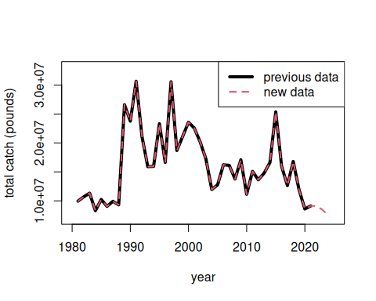

2.3 Partition catches by area and sector
Now we will partition out the total catches according to the dolphin MSE areas. The areas are as follows:
- FLK: Florida Keys to Indian River County County (FL)
- NCFL: Brevard (FL) to Southern NC (South of Hatteras)
- NNC: Northern NC (North of Hatteras to NC/VA border)
- VBM: Virginia to Maine
# separate out 4 regions --------------------------
d1$region <- "VBM"
# select for FLK
# FL_REG codes: 4: SE FL- Miami-Dade to Indian River County.; 5: NE FL- Brevard to Nassau County
table(d1$FL_REG, d1$NEW_STA, useNA = "always")
CT DE FLE FLE/GA FLW GA MA MD NC NJ NY RI SC VA
3 0 0 0 0 568 0 0 0 0 0 0 0 0 0
4 0 0 1022 0 0 0 0 0 0 0 0 0 0 0
5 0 0 312 0 0 0 0 0 0 0 0 0 0 0
<NA> 14 114 0 1794 0 54 20 125 1344 108 73 62 644 165
<NA>
3 0
4 0
5 0
<NA> 0
d1$region[which(d1$FL_REG == 3 | d1$FL_REG == 4)] <- "FLK"
# select for NCFL
d1$region[which(d1$FL_REG == 5)] <- "NCFL"
lis <- c("SC", "GA", "FLE/GA") # NCFL states
d1$region[which(d1$NEW_STA %in% lis)] <- "NCFL"
# NC_REG codes: N: North of Cape Hatteras; S: South of Cape Hatteras
table(d1$NC_REG, d1$NEW_STA, useNA = "always")
CT DE FLE FLE/GA FLW GA MA MD NC NJ NY RI SC VA
14 114 1334 1794 568 54 20 125 586 108 73 62 644 165
N 0 0 0 0 0 0 0 0 420 0 0 0 0 0
S 0 0 0 0 0 0 0 0 338 0 0 0 0 0
<NA> 0 0 0 0 0 0 0 0 0 0 0 0 0 0
<NA>
0
N 0
S 0
<NA> 0
d1$region[which(d1$NC == "S")] <- "NCFL"
# select for NNC
d1$region[which(d1$NC == "N")] <- "NNC"
table(d1$FL_REG, d1$NEW_STA, d1$region)
, , = FLK
CT DE FLE FLE/GA FLW GA MA MD NC NJ NY RI SC VA
3 0 0 0 0 568 0 0 0 0 0 0 0 0 0
4 0 0 1022 0 0 0 0 0 0 0 0 0 0 0
5 0 0 0 0 0 0 0 0 0 0 0 0 0 0
, , = NCFL
CT DE FLE FLE/GA FLW GA MA MD NC NJ NY RI SC VA
3 0 0 0 0 0 0 0 0 0 0 0 0 0 0
4 0 0 0 0 0 0 0 0 0 0 0 0 0 0
5 0 0 312 0 0 0 0 0 0 0 0 0 0 0
, , = NNC
CT DE FLE FLE/GA FLW GA MA MD NC NJ NY RI SC VA
3 0 0 0 0 0 0 0 0 0 0 0 0 0 0
4 0 0 0 0 0 0 0 0 0 0 0 0 0 0
5 0 0 0 0 0 0 0 0 0 0 0 0 0 0
, , = VBM
CT DE FLE FLE/GA FLW GA MA MD NC NJ NY RI SC VA
3 0 0 0 0 0 0 0 0 0 0 0 0 0 0
4 0 0 0 0 0 0 0 0 0 0 0 0 0 0
5 0 0 0 0 0 0 0 0 0 0 0 0 0 0
table(d1$NC_REG, d1$NEW_STA, d1$region) # check classification
, , = FLK
CT DE FLE FLE/GA FLW GA MA MD NC NJ NY RI SC VA
0 0 1022 0 568 0 0 0 0 0 0 0 0 0
N 0 0 0 0 0 0 0 0 0 0 0 0 0 0
S 0 0 0 0 0 0 0 0 0 0 0 0 0 0
, , = NCFL
CT DE FLE FLE/GA FLW GA MA MD NC NJ NY RI SC VA
0 0 312 1794 0 54 0 0 0 0 0 0 644 0
N 0 0 0 0 0 0 0 0 0 0 0 0 0 0
S 0 0 0 0 0 0 0 0 338 0 0 0 0 0
, , = NNC
CT DE FLE FLE/GA FLW GA MA MD NC NJ NY RI SC VA
0 0 0 0 0 0 0 0 0 0 0 0 0 0
N 0 0 0 0 0 0 0 0 420 0 0 0 0 0
S 0 0 0 0 0 0 0 0 0 0 0 0 0 0
, , = VBM
CT DE FLE FLE/GA FLW GA MA MD NC NJ NY RI SC VA
14 114 0 0 0 0 20 125 586 108 73 62 0 165
N 0 0 0 0 0 0 0 0 0 0 0 0 0 0
S 0 0 0 0 0 0 0 0 0 0 0 0 0 0
Now we will separate out the catches by recreational sector and plot the totals by region and sector.
# separate out by for hire vs. private rec --------------------------
d1$sector <- "ForHire"
d1$sector[which(d1$NEW_MODEN == "Shore")] <- "Rec"
d1$sector[which(d1$NEW_MODEN == "Priv")] <- "Rec"
table(d1$sector, d1$NEW_MODEN, useNA = "always") # check classification
Cbt Cbt/Hbt Hbt Priv Shore <NA>
ForHire 1616 119 2912 0 0 0
Rec 0 0 0 1750 22 0
<NA> 0 0 0 0 0 0
tot <- tapply(d1$LBSEST_SECWWT, list(d1$YEAR, d1$region, d1$sector), sum, na.rm = T)
head(tot)
, , ForHire
FLK NCFL NNC VBM
1981 354639.5 74702.50 256755.24 1400.247
1982 347458.2 92271.42 27578.44 2749.224
1983 1020005.8 41784.04 88690.53 5379.177
1984 1021086.8 74658.81 NA 4203.048
1985 717523.0 172989.65 58514.13 8880.857
1986 1562354.0 63555.89 817192.26 61658.193
, , Rec
FLK NCFL NNC VBM
1981 8942641 322505.7 NA NA
1982 8422673 1711834.7 78367.161 18727.290
1983 10000662 119370.4 44226.032 5456.237
1984 6717044 486079.7 NA 0.000
1985 7925301 1162708.4 77477.096 112944.274
1986 5699311 736872.0 2549.586 103945.134
fin <- data.frame(cbind(tot[, , 1], tot[, , 2]))
names(fin) <- c("Hire_FLK", "Hire_NCFL", "Hire_NNC", "Hire_VBM", "Rec_FLK", "Rec_NCFL", "Rec_NNC", "Rec_VBM")
head(fin)
Hire_FLK Hire_NCFL Hire_NNC Hire_VBM Rec_FLK Rec_NCFL Rec_NNC
1981 354639.5 74702.50 256755.24 1400.247 8942641 322505.7 NA
1982 347458.2 92271.42 27578.44 2749.224 8422673 1711834.7 78367.161
1983 1020005.8 41784.04 88690.53 5379.177 10000662 119370.4 44226.032
1984 1021086.8 74658.81 NA 4203.048 6717044 486079.7 NA
1985 717523.0 172989.65 58514.13 8880.857 7925301 1162708.4 77477.096
1986 1562354.0 63555.89 817192.26 61658.193 5699311 736872.0 2549.586
Rec_VBM
1981 NA
1982 18727.290
1983 5456.237
1984 0.000
1985 112944.274
1986 103945.134
matplot(rownames(fin), fin, lty = c(rep(2, 4), rep(1, 4)), col = rep(1:4, 2), type = "l", lwd = 2,
xlab = "year", ylab = "total catch (pounds)")
legend("topright", colnames(fin), lty = c(rep(2, 4), rep(1, 4)), col = rep(1:4, 2), lwd = 2, ncol = 2, bty = "n")
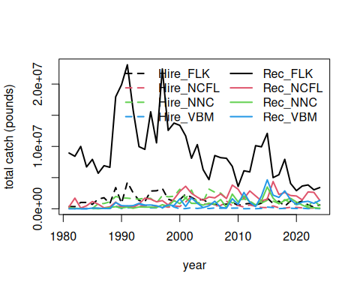
# check that totals match
cor(rowSums(fin, na.rm = T), tot1)
[1] 1
mean(rowSums(fin, na.rm = T) - tot1) # very tiny differences
[1] 4.233284e-11
Here are the catches (in pounds) for years 1981 to 2024.
fin
Hire_FLK Hire_NCFL Hire_NNC Hire_VBM Rec_FLK Rec_NCFL Rec_NNC
1981 354639.5 74702.50 256755.24 1400.247 8942641 322505.7 NA
1982 347458.2 92271.42 27578.44 2749.224 8422673 1711834.7 78367.161
1983 1020005.8 41784.04 88690.53 5379.177 10000662 119370.4 44226.032
1984 1021086.8 74658.81 NA 4203.048 6717044 486079.7 NA
1985 717523.0 172989.65 58514.13 8880.857 7925301 1162708.4 77477.096
1986 1562354.0 63555.89 817192.26 61658.193 5699311 736872.0 2549.586
1987 1774558.7 61243.58 848994.25 24967.877 6913585 161627.1 79540.365
1988 826480.6 62392.87 1114627.05 94676.212 6655923 321023.1 202768.950
1989 3398703.5 405140.01 1970776.23 451477.768 17965047 1079951.5 339371.567
1990 868572.6 277783.17 1749965.55 31079.442 19900865 312333.3 118539.960
1991 4268773.7 225552.64 1706751.50 159172.855 23093044 457667.1 277389.646
1992 2548407.4 189514.34 1619685.06 161149.703 15788853 245395.8 89160.860
1993 1343093.6 391254.33 1555850.09 741955.369 9967356 742741.8 296399.199
1994 1131831.7 437642.72 1713981.98 573551.716 9532763 1708942.1 264907.193
1995 2848691.7 667475.30 1673435.48 145798.587 15558489 1550136.0 271442.073
1996 2892436.3 309604.42 923128.81 141976.431 10574454 1121937.8 196579.537
1997 3271271.6 466891.67 2129471.46 110115.485 22423256 1316502.7 660257.843
1998 1532460.0 252620.73 1921834.08 779364.855 12578694 619824.1 412304.292
1999 1238462.0 457880.10 2014752.29 288625.130 13745135 1548217.4 1314805.374
2000 1471481.3 369553.33 3139555.98 3016.589 13379647 2784424.2 826980.337
2001 2361751.6 1090421.00 1638707.54 34335.241 11690170 3614370.3 1760721.144
2002 1828918.7 1993778.99 3005172.92 168406.810 8105262 2483946.6 871930.660
2003 1342339.1 958997.12 928894.01 55690.419 10294918 1860435.4 868200.254
2004 1509660.5 771820.65 1116373.11 155510.796 6281794 1354303.7 593257.716
2005 858090.6 734896.20 3153480.89 38020.553 4681210 1898945.9 904360.210
2006 700089.5 483337.12 2656240.22 136715.477 8540432 1751853.5 749541.413
2007 718651.9 506776.30 2518430.49 84908.300 8200488 2383417.1 1483630.590
2008 736213.2 1235299.71 1620865.87 113592.877 8100550 1648662.2 223565.185
2009 1016583.6 458562.82 928419.86 106262.915 6809447 3805127.7 2359177.817
2010 552080.9 534671.06 1384434.93 120050.410 3579591 3139199.6 1110479.730
2011 768597.7 275546.65 1577019.96 17844.729 6097050 1651096.4 2063315.642
2012 856261.4 615430.34 1236410.76 21887.318 5916144 2867599.1 1082607.063
2013 614150.1 394570.11 640465.60 16064.763 10124799 2064256.6 540676.961
2014 897508.4 210198.76 916695.96 56760.758 9940020 1272477.3 1289704.416
2015 1729825.9 196326.97 1374908.91 277867.986 12093928 1548428.5 3505194.743
2016 841662.5 454053.51 1236565.76 195837.854 5002273 4372622.6 1704661.669
2017 1227827.8 161188.31 835080.86 31185.061 5464893 2297930.0 801324.151
2018 401703.0 105328.49 1465087.58 72211.785 7935729 2606091.5 1347724.203
2019 1261827.1 250624.40 998102.45 93718.699 4064867 2132483.1 1687239.863
2020 910431.4 225493.79 667501.79 51621.152 2906913 2052222.0 1089245.171
2021 1244842.2 146893.15 871760.94 100997.979 3652596 1428508.3 596672.480
2022 627020.6 90504.71 427953.34 18514.133 3828113 2701619.8 211394.537
2023 274532.5 118528.80 1281254.55 72728.020 3045801 2639445.1 175189.224
2024 629327.2 85572.19 506558.07 18752.239 3404227 1358519.1 106307.278
Rec_VBM
1981 NA
1982 18727.290
1983 5456.237
1984 0.000
1985 112944.274
1986 103945.134
1987 52139.772
1988 33566.163
1989 996945.390
1990 509424.981
1991 464786.733
1992 509297.261
1993 871948.601
1994 594467.414
1995 609302.619
1996 486106.187
1997 197871.963
1998 606769.298
1999 523623.688
2000 1608478.920
2001 372623.273
2002 1732356.036
2003 904780.558
2004 186538.567
2005 489236.451
2006 1214497.040
2007 236769.123
2008 96818.461
2009 1607919.004
2010 717410.858
2011 2626410.052
2012 1041694.282
2013 364492.286
2014 2040329.550
2015 4645796.249
2016 2186126.672
2017 1826822.849
2018 2871124.410
2019 1440420.940
2020 689099.471
2021 1083268.811
2022 1206278.324
2023 872490.886
2024 1346606.842

2.4 Looking at extent of discarding
Discard estimates (known as B2 estimates) are provided in numbers by the MRIP survey but are not available in the Southeast Region Headboat Survey. We can look at the overall numbers of dolphinfish caught versus reported released from the MRIP survey to get an understanding of the extent of discarding.
d1$perdis <- d1$B2 / (d1$AB1 + d1$B2) # percent discarded is B2 (fish released alive) / total
# calculate mean discard rate by year, region, sector ----------------
dis <- tapply(d1$perdis, list(d1$YEAR, d1$region, d1$sector), mean, na.rm = T)
disr <- tapply(d1$perdis, list(d1$region, d1$sector), mean, na.rm = T)
matplot(rownames(dis), cbind(dis[, , 1], dis[, , 2]), lty = c(rep(2, 4), rep(1, 4)), col = rep(1:4, 2),
type = "l", lwd = 2, xlab = "year", ylab = "proportion dolphin discarded", ylim = c(0, 0.5))
legend("top", c(paste("For hire - ", colnames(dis)), paste("Private - ", colnames(dis))),
lty = c(rep(2, 4), rep(1, 4)), col = rep(1:4, 2), lwd = 2, ncol = 2, bty = "n")
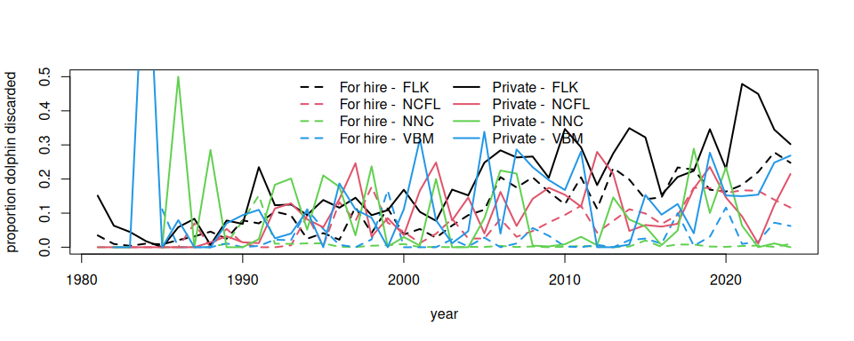
round(disr * 100, 2) # discarding rates by region and sector
ForHire Rec
FLK 10.79 18.76
NCFL 9.44 11.23
NNC 0.94 9.62
VBM 2.94 12.69
According to the MRIP survey and the reported numbers, discarding generally increases over time, excluding some highly anomalous estimates from the early years which are driven by low sample sizes. Discarding is generally higher in the private sector compared to the for-hire sector, and is highest in the Florida Keys region.

2.5 Split the catches by season
The dolphin MSE operates on a seasonal time step and thus the catches and discards must by parsed apart by individual season and year. This is not straightforward because MRIP estimates are reported in two-month waves (Jan - Feb, Mar - Apr, May - Jun, etc.), and the seasons are 3-month periods (Dec - Feb, Mar - May, Jun - Aug, Sep - Nov). For the two waves that have to be split into seasons (e.g., December is lumped with January and February; June is lumped with July and August), we split the wave 50/50%, i.e, we make the assumption that half of the catch in that wave occurs in one season and the other half occurs in the next season.
# define seasons -----------------------------
table(d1$WAVE, useNA = "always")
0 1 2 3 4 5 6 <NA>
5 407 718 1230 1439 1095 581 944
d1$YRWAVE <- paste0(d1$YEAR, "_", d1$WAVE)
totw <- tapply(d1$LBSEST_SECWWT, list(d1$YRWAVE, d1$region, d1$sector), sum, na.rm = T)
f <- data.frame(cbind(totw[, , 1], totw[, , 2]))
names(f) <- c("Hire_FLK", "Hire_NCFL", "Hire_NNC", "Hire_VBM", "Rec_FLK", "Rec_NCFL", "Rec_NNC", "Rec_VBM")
head(f)
Hire_FLK Hire_NCFL Hire_NNC Hire_VBM Rec_FLK Rec_NCFL Rec_NNC
1981_2 NA NA NA NA 2793285.5 270968.46 NA
1981_3 300873.764 NA 254049.420 NA 3915698.3 NA NA
1981_4 50017.460 NA 2705.821 NA 905621.2 51537.26 NA
1981_5 3748.301 NA NA NA 479834.0 NA NA
1981_6 NA NA NA NA 848201.5 NA NA
1981_NA NA 74702.5 NA 1400.247 NA NA NA
Rec_VBM
1981_2 NA
1981_3 NA
1981_4 NA
1981_5 NA
1981_6 NA
1981_NA NA
f$YEAR <- as.numeric(substr(rownames(f), 1, 4))
f$WAVE <- as.numeric(substr(rownames(f), 6, 8))
head(f) # table with catches separated by wave and year
Hire_FLK Hire_NCFL Hire_NNC Hire_VBM Rec_FLK Rec_NCFL Rec_NNC
1981_2 NA NA NA NA 2793285.5 270968.46 NA
1981_3 300873.764 NA 254049.420 NA 3915698.3 NA NA
1981_4 50017.460 NA 2705.821 NA 905621.2 51537.26 NA
1981_5 3748.301 NA NA NA 479834.0 NA NA
1981_6 NA NA NA NA 848201.5 NA NA
1981_NA NA 74702.5 NA 1400.247 NA NA NA
Rec_VBM YEAR WAVE
1981_2 NA 1981 2
1981_3 NA 1981 3
1981_4 NA 1981 4
1981_5 NA 1981 5
1981_6 NA 1981 6
1981_NA NA 1981 NA
f[is.na(f)] <- 0
f <- f[which(f$YEAR >= 1985), ]
f <- f[which(f$YEAR <= 2024), ]
table(f$YEAR)
1985 1986 1987 1988 1989 1990 1991 1992 1993 1994 1995 1996 1997 1998 1999 2000
7 7 7 7 7 7 7 7 7 7 7 7 6 6 6 6
2001 2002 2003 2004 2005 2006 2007 2008 2009 2010 2011 2012 2013 2014 2015 2016
6 6 6 6 6 6 6 6 6 6 6 6 7 7 7 6
2017 2018 2019 2020 2021 2022 2023 2024
6 6 6 6 6 6 6 6
table(f$WAVE)
0 1 2 3 4 5 6
15 40 40 40 40 40 40
# deal with NAs in many locations ---------------
# calculate percentages of catch by wave, for each region and fleet
avw <- tapply(d1$LBSEST_SECWWT, list(d1$WAVE, d1$region, d1$sector), sum, na.rm = T)
avw <- avw[-1, , ]
avw <- data.frame(cbind(avw[, , 1], avw[, , 2]))
names(avw) <- c("Hire_FLK", "Hire_NCFL", "Hire_NNC", "Hire_VBM", "Rec_FLK", "Rec_NCFL", "Rec_NNC", "Rec_VBM")
avwp <- apply(avw, 2, function (x) x / sum(x, na.rm = T))
#colSums(avwp)
# go through each column, find NAs and fill in waves by percentages
pre_colsum <- colSums(f, na.rm = T) # column sums to check later
lis <- which(f$WAVE == 0) # list of rows with NA wave data
for (i in 1:8) { # loop through each column
for(j in lis) { # loop through list of NA waves
if (f[j, i] > 0) { # if there are NA wave catches, split by known proportion from other years
miscatch <- avwp[, i] * f[j, i] # missing catch is known proportion * NA wave catch
f[which(f$YEAR == f$YEAR[j] & f$WAVE != 0), i] <- f[which(f$YEAR == f$YEAR[j] & f$WAVE != 0), i] + miscatch # add in missing catch
f[j, i] <- 0 # set to zero after catch is attributed to waves
}
}
}
f[lis, 1:8] # should be all zeros now
Hire_FLK Hire_NCFL Hire_NNC Hire_VBM Rec_FLK Rec_NCFL Rec_NNC Rec_VBM
1985_NA 0 0 0 0 0 0 0 0
1986_NA 0 0 0 0 0 0 0 0
1987_NA 0 0 0 0 0 0 0 0
1988_NA 0 0 0 0 0 0 0 0
1989_NA 0 0 0 0 0 0 0 0
1990_NA 0 0 0 0 0 0 0 0
1991_NA 0 0 0 0 0 0 0 0
1992_NA 0 0 0 0 0 0 0 0
1993_NA 0 0 0 0 0 0 0 0
1994_NA 0 0 0 0 0 0 0 0
1995_NA 0 0 0 0 0 0 0 0
1996_NA 0 0 0 0 0 0 0 0
2013_0 0 0 0 0 0 0 0 0
2014_0 0 0 0 0 0 0 0 0
2015_0 0 0 0 0 0 0 0 0
pos_colsum <- colSums(f, na.rm = T)
pre_colsum[1:8] == pos_colsum[1:8] # check that catch was parsed correctly - column sums should be identical
Hire_FLK Hire_NCFL Hire_NNC Hire_VBM Rec_FLK Rec_NCFL Rec_NNC Rec_VBM
TRUE TRUE TRUE TRUE TRUE TRUE TRUE TRUE
f <- f[which(f$WAVE != 0), ] # remove NA waves which now contain no catch
# split waves 3 and 6 50/50% to parse into seasons ------------------
lis <- which(f$WAVE == 3 | f$WAVE == 6) # list of 3 and 6 waves for all years
for (i in lis) { # go through list of waves
temp <- f[i, ] / 2 # split catch in half
temp[9] <- f$YEAR[i] # reformat year and wave data columns
temp[10] <- f$WAVE[i]
temp <- rbind(temp, temp) # create two half-waves and relabel with new wave reference number
temp[1, 10] <- temp[1, 10] - 0.5
temp[2, 10] <- temp[2, 10] + 0.5
f <- rbind(f, temp) # concatenate with main data table
}
f <- f[-lis, ] # remove waves that have been split in half
pos_colsum <- colSums(f, na.rm = T)
pre_colsum[1:8] == pos_colsum[1:8] # check that catch was parsed correctly - column sums should be identical
Hire_FLK Hire_NCFL Hire_NNC Hire_VBM Rec_FLK Rec_NCFL Rec_NNC Rec_VBM
TRUE TRUE TRUE TRUE TRUE TRUE TRUE TRUE
f <- f[order(f$YEAR, f$WAVE), ] # reorder table in chronological order
f$YEAR[which(f$WAVE == 6.5)] <- f$YEAR[which(f$WAVE == 6.5)] + 1 # add year to December wave so it gets summed with following year
f$WAVE[which(f$WAVE == 6.5)] <- 0.5 # change December wave to small number so it gets summed with Jan/Feb
table(f$WAVE)
0.5 1 2 2.5 3.5 4 5 5.5
40 40 40 40 40 40 40 40
f$seas <- cut(f$WAVE, breaks = c(0, 1.5, 3, 4.5, 6))
#table(f$seas)
f$seas1 <- NA
f$seas1[which(f$seas == "(0,1.5]")] <- "DJF" # Dec Jan Feb is 0.5 and 1
f$seas1[which(f$seas == "(1.5,3]")] <- "MAM" # Mar Apr May is 2 and 2.5
f$seas1[which(f$seas == "(3,4.5]")] <- "JJA" # Jun Jul Aug is 3.5 and 4
f$seas1[which(f$seas == "(4.5,6]")] <- "SON" # Sep Oct Nov is 5 and 5.5
temp <- tapply(f[, 1], list(f$seas1, f$YEAR), sum, na.rm = T)
temp1 <- matrix(temp)
for (i in 2:8) {
temp2 <- matrix(tapply(f[, i], list(f$seas1, f$YEAR), sum, na.rm = T))
temp1 <- cbind(temp1, temp2)
}
findat <- data.frame(sort(rep(as.numeric(colnames(temp)), 4)),
rep(rownames(temp), ncol(temp)), temp1)
names(findat) <- c("year", "season", names(f)[1:8])
colSums(f[, 1:8], na.rm = T) == colSums(findat[, 3:10], na.rm = T) # check that total catch is equal before and after parsing
Hire_FLK Hire_NCFL Hire_NNC Hire_VBM Rec_FLK Rec_NCFL Rec_NNC Rec_VBM
TRUE TRUE TRUE TRUE TRUE TRUE TRUE TRUE
We plot the results by region and sector, over the time series of year and season. We can clearly see the seasonality in the catch by region.
findat$yrseas <- findat$year + as.numeric(as.factor(findat$season))/4-0.125
matplot(findat$yrseas, findat[, 3:10]/10^6, lty = c(rep(2, 4), rep(1, 4)), col = rep(1:4, 2), type = "l", lwd = 2,
xlab = "year", ylab = "total catch (millions of pounds)")
legend("topright", colnames(findat[, 3:10]), lty = c(rep(2, 4), rep(1, 4)), col = rep(1:4, 2), lwd = 2, ncol = 2, bty = "n")
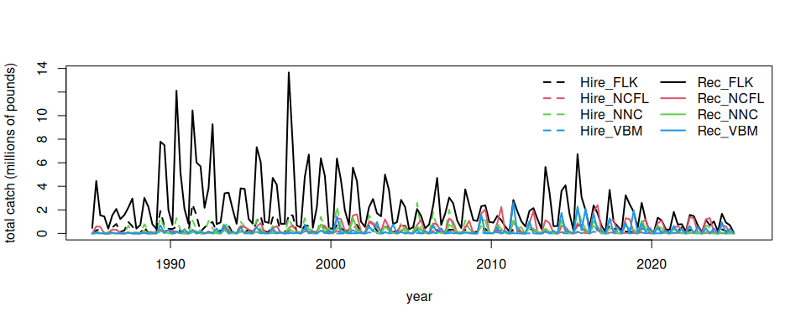
# check that totals match
cbind(colSums(findat[, 3:10], na.rm = T), colSums(fin[-c(1:5), ], na.rm = T))
[,1] [,2]
Hire_FLK 55604999 54887476
Hire_NCFL 16909916 16736926
Hire_NNC 57944903 57886388
Hire_VBM 5836953 5828072
Rec_FLK 371462933 363537632
Rec_NCFL 70803866 69641157
Rec_NNC 32556596 32479119
Rec_VBM 40081529 39968585
# the values should be close but slightly >1 because the last data set includes December 1985 data as part of 1986
colSums(findat[, 3:10], na.rm = T) / colSums(fin[-c(1:5), ], na.rm = T)
Hire_FLK Hire_NCFL Hire_NNC Hire_VBM Rec_FLK Rec_NCFL Rec_NNC Rec_VBM
1.013073 1.010336 1.001011 1.001524 1.021800 1.016696 1.002385 1.002826
write.csv(findat, file = "data/MRIP_catch_by_season_4_areas.csv", row.names = FALSE)

3. Analysis of international landings estimates from Sea Around Us database
Here we will explore commercial and recreational landings data as estimated by the Sea Around Us Project. This data set includes reported data for fisheries worldwide as well as reconstructed estimates for unreported landings. For each country, project scientists assemble available data on landings and use additional sociological and fishing data plus expert information and opinion, to produce their best estimates of total landings from all fishing sectors and for all species globally.

3.1 Data access and upload
For catches within each country’s exclusive economic zones, data are downloaded download data from the Sea Around Us site(Pauly, Zeller, and Palomares, 2020.). In the Biodiversity by Taxon Tools and Data, we filter by EEZ for All regions, and then filter by Taxon at the Species level for Common dolphinfish (Coryphaena hippurus). After clicking “View graphs” one can access the full data set using the “Download Data” button. The high seas data are accessed in the Basic Search High seas section of the site. The individual regions can be clicked on (e.g., Atlantic, Western Central) and then the data are dowloaded using the Download Data button.
The current version of data in use is version 50.1, accessed June 2024 (the data files can be found on github in the SEFSC-dolphin-analyses/data /SAU/ folder). This was still the most recent version of data available as of June 2025.

3.2 Read in the high seas landings
First we read in the high seas landings for the Western Central Atlantic and Northwest Atlantic zones. These are equivalent to FAO areas 21 and 31.
# clear workspace
rm(list = ls())
if(!require("pals")) install.packages("pals")
library(pals)
# find data files
hslis <- dir("data/SAU/")[grep("HighSeas", dir("data/SAU/"))]
# identify areas 21 and 31
hslis[1]; hslis[3]
[1] "SAU HighSeas 21 v50-1.csv"
[1] "SAU HighSeas 31 v50-1.csv"
#download data
h1 <- read.csv(paste0("data/SAU/", hslis[1]))
h3 <- read.csv(paste0("data/SAU/", hslis[3]))
# confirm correct areas
#unique(h1$area_name)
#unique(h3$area_name)
hs <- rbind(h1, h3)
We extract the data for dolphinfish and look at the characteristics of the landings. Most of the landings are in the Western Central Atlantic, and the primary fishing entities are Venezuela and Saint Lucia. The fishing sector is all industrial, and the vast majority of the catch is reported landings, with only a tiny fraction of discards or unreported landings listed in the database. The gear type is primarily long line.
# check species name and filter out dolphinfish
unique(hs$common_name)[grep("dolphin", unique(hs$common_name))]
[1] "Common dolphinfish"
hs <- hs[which(hs$common_name == "Common dolphinfish"), ]
# look at the categories within each column of data
apply(hs[1:13], 2, table)
$area_name
Atlantic, Northwest Atlantic, Western Central
113 160
$area_type
high_seas
273
$year
1985 1986 1999 2000 2001 2002 2003 2004 2005 2006 2007 2008 2009 2010 2011 2012
1 1 1 1 1 1 1 6 4 1 5 10 5 8 10 12
2013 2014 2015 2016 2017 2018 2019
24 22 30 33 33 29 34
$scientific_name
Coryphaena hippurus
273
$common_name
Common dolphinfish
273
$functional_group
Large pelagics (>=90 cm)
273
$commercial_group
Perch-likes
273
$fishing_entity
Barbados Belize
6 3
Brazil Canada
19 18
Guyana Panama
1 1
Saint Lucia Saint Vincent & the Grenadines
5 28
Spain Suriname
80 1
Trinidad & Tobago USA
14 74
Venezuela
23
$fishing_sector
Industrial
273
$catch_type
Discards Landings
5 268
$reporting_status
Reported Unreported
253 20
$gear_type
artisanal fishing gear bottom trawl gillnet
7 9 11
hand lines longline mixed gear
17 187 1
pole and line pots or traps unknown by source
19 9 13
$end_use_type
Direct human consumption Fishmeal and fish oil
5 194 37
Other
37
# convert from metric tonnes to pounds
hs$pounds <- hs$tonnes * 1000 * 2.20462
# produce barplot of key data fields
par(mar = c(3, 20, 3, 1), mfrow = c(3, 2), mex = 0.5)
barplot(tapply(hs$pounds/10^6, hs$area_name, sum, na.rm = T), las = 2, xlab = "millions of pounds", main = "Area name", horiz = T)
#barplot(tapply(hs$pounds/10^6, hs$area_type, sum, na.rm = T), las = 2, ylab = "millions of pounds", main = "Area type")
#barplot(tapply(hs$pounds/10^6, hs$year, sum, na.rm = T), las = 2, ylab = "millions of pounds", main = "Year")
barplot(tapply(hs$pounds/10^6, hs$fishing_entity, sum, na.rm = T), las = 2, xlab = "millions of pounds", main = "Fishing entity", horiz = T)
barplot(tapply(hs$pounds/10^6, hs$fishing_sector, sum, na.rm = T), las = 2, xlab = "millions of pounds", main = "Fishing sector", horiz = T)
barplot(tapply(hs$pounds/10^6, hs$catch_type, sum, na.rm = T), las = 2, xlab = "millions of pounds", main = "Catch type", horiz = T)
barplot(tapply(hs$pounds/10^6, hs$reporting_status, sum, na.rm = T), las = 2, xlab = "millions of pounds", main = "Reporting status", horiz = T)
barplot(tapply(hs$pounds/10^6, hs$gear_type, sum, na.rm = T), las = 2, xlab = "millions of pounds", main = "Gear type", horiz = T)
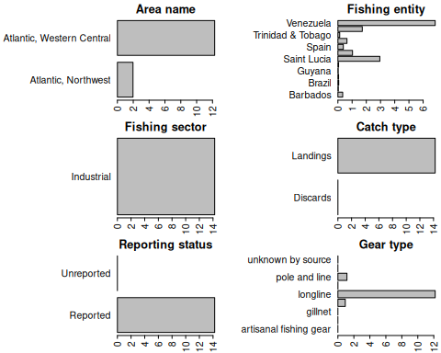

3.3 Summarize the high seas landings
We plot the annual catches by fishing entity to look at trends over time.
hs$fishing_entity <- as.factor(hs$fishing_entity)
hs$fishing_entity <- droplevels(hs$fishing_entity)
par(mar = c(5, 5, 3, 1), mfrow = c(1, 1))
tab <- tapply(hs$pounds, list(hs$year, hs$fishing_entity), sum, na.rm = T)
matplot(as.numeric(rownames(tab)), tab/10^6, type = "l", col = glasbey(ncol(tab)), lty = 1, lwd = 2, xlab = "year", ylab = "total catch (millions of pounds)",
main = "High seas Western Central Atlantic dolphin catch")
legend("topleft", colnames(tab), col = glasbey(ncol(tab)), lty = 1, lwd = 2, cex = 0.8, bty = "n")
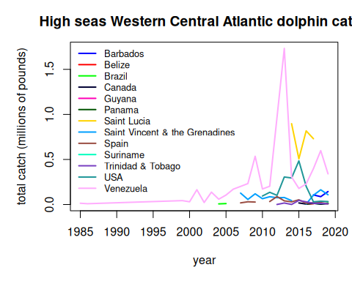
Finally we output the subset of high seas dolphin catch for the two areas. Because we have already accounted for the USA landings in our national reporting and are aiming to only summarize international landings here, we filter out the USA landings from the Sea Around Us database.
hs <- hs[which(hs$fishing_entity != "USA"), ]
hs$year <- factor(hs$year, levels = 1950:2019)
tab <- tapply(hs$pounds, list(hs$year, hs$area_name), sum, na.rm = T)
tab[is.na(tab)] <- 0
tail(tab, 40)
Atlantic, Northwest Atlantic, Western Central
1980 0.000 0.000
1981 0.000 0.000
1982 0.000 0.000
1983 0.000 0.000
1984 0.000 0.000
1985 0.000 14037.129
1986 0.000 8748.399
1987 0.000 0.000
1988 0.000 0.000
1989 0.000 0.000
1990 0.000 0.000
1991 0.000 0.000
1992 0.000 0.000
1993 0.000 0.000
1994 0.000 0.000
1995 0.000 0.000
1996 0.000 0.000
1997 0.000 0.000
1998 0.000 0.000
1999 0.000 43168.296
2000 0.000 30284.627
2001 0.000 164272.223
2002 0.000 22147.477
2003 0.000 137103.181
2004 0.000 66058.258
2005 0.000 115171.863
2006 0.000 170522.101
2007 14687.527 330838.620
2008 28552.636 340863.719
2009 18719.121 662720.661
2010 4510.085 232093.837
2011 21589.424 300498.224
2012 72398.812 1059210.392
2013 34741.604 2471791.396
2014 27922.953 1247462.983
2015 90313.638 710059.125
2016 15319.433 1094893.891
2017 34806.933 1374259.739
2018 29328.358 885814.754
2019 21870.621 632747.157
# write summary to merge with EEZ data
write.csv(tab, file = "data/SAU/high_seas_by_year.csv")

3.4 Read in the landings within excluzive economic zones (EEZs)
Now we read in the landings reported by each country or jurisdiction’s respective EEZ. Because we have extracted dolphin landings for EEZs worldwide, we need to separate out the landings for the Atlantic Ocean basin.
rm(list = ls())
d <- read.csv("data/SAU/SAU Taxa 600006 v50-1.csv", header = T, sep = ",") # v. 50.1 - June 2024
head(d)
area_name area_type year scientific_name common_name
1 Australia eez 1950 Coryphaena hippurus Common dolphinfish
2 Australia eez 1950 Coryphaena hippurus Common dolphinfish
3 Australia eez 1950 Coryphaena hippurus Common dolphinfish
4 Bahamas eez 1950 Coryphaena hippurus Common dolphinfish
5 Barbados eez 1950 Coryphaena hippurus Common dolphinfish
6 Bermuda (UK) eez 1950 Coryphaena hippurus Common dolphinfish
functional_group commercial_group fishing_entity fishing_sector
1 Large pelagics (>=90 cm) Perch-likes Australia Industrial
2 Large pelagics (>=90 cm) Perch-likes Australia Industrial
3 Large pelagics (>=90 cm) Perch-likes Australia Industrial
4 Large pelagics (>=90 cm) Perch-likes Bahamas Recreational
5 Large pelagics (>=90 cm) Perch-likes Barbados Recreational
6 Large pelagics (>=90 cm) Perch-likes Bermuda (UK) Artisanal
catch_type reporting_status gear_type
1 Landings Reported longline
2 Landings Reported longline
3 Landings Reported longline
4 Landings Unreported recreational fishing gear
5 Landings Unreported recreational fishing gear
6 Landings Reported small scale lines
end_use_type tonnes landed_value
1 Fishmeal and fish oil 0.003373202 3.438170e-05
2 Direct human consumption 6.739657104 1.040254e+04
3 Other 0.003373202 3.438170e-05
4 Direct human consumption 48.665105143 8.262728e+00
5 Direct human consumption 0.009158559 4.846886e-04
6 Direct human consumption 1.511085514 3.199403e+03
#dim(d)
#apply(d[1:13], 2, table)
# convert tonnes to pounds
d$lbs <- d$tonnes * 1000 * 2.20462
We look at the characteristics of the landings within EEZs. These are largely industrial and artisanal in nature. Landings are the majority of the catch but discards are also present. There are more unreported landings than reported landings and a variety of gear types are used.
# look at characteristics of data
par(mfrow = c(2, 2), mar = c(12, 7, 3, 1), mex = 0.5, mgp = c(5, 1, 0))
barplot(tapply(d$lbs, d$fishing_sector, sum, na.rm = T)/10^6, las = 2, ylab = "millions of pounds", main = "Fishing sector")
barplot(tapply(d$lbs, d$catch_type, sum, na.rm = T)/10^6, las = 2, ylab = "millions of pounds", main = "Catch type")
barplot(tapply(d$lbs, d$reporting_status, sum, na.rm = T)/10^6, las = 2, ylab = "millions of pounds", main = "Reporting status")
barplot(tapply(d$lbs, d$gear_type, sum, na.rm = T)/10^6, las = 2, ylab = "millions of pounds", main = "Gear type")
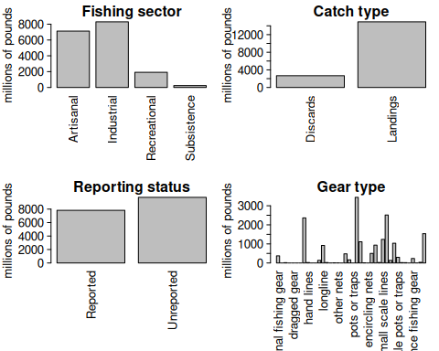

3.5 Separating the EEZs by area
Now we have to manually assign the different EEZs to respective areas. We separate the geographical areas within the Atlantic Ocean (North and South) and lump all other EEZs into “other oceans.” This latter category is largely the Pacific Ocean and to a lesser extent the Indian Ocean. We remove the high seas catch from this database as it is not ocean-specific and we have extracted the ocean-specific high seas catch previously.
# remove the high seas catch from this database
d <- d[which(d$area_type != "high_seas"), ]
d$fishing_entity <- as.factor(d$fishing_entity)
d$fishing_entity <- droplevels(d$fishing_entity)
table(d$area_type) # this should be all "eez"
eez
63056
# Western Central Atlantic EEZs
WCA <- c("Bahamas", "Barbados", "Cayman Isl. (UK)", "Dominica", "Dominican Republic", "Grenada",
"Aruba (Netherlands)", "Haiti", "Guadeloupe (France)", "Jamaica", "Martinique (France)",
"Montserrat (UK)", "Nicaragua (Caribbean)", "Puerto Rico (USA)", "Saint Kitts & Nevis",
"Saint Lucia", "Saint Vincent & the Grenadines", "Trinidad & Tobago", "US Virgin Isl.",
"St Barthelemy (France)", "St Martin (France)", "Curaçao (Netherlands)", "Bonaire (Netherlands)",
"Saba and Sint Eustatius (Netherlands)", "Sint Maarten (Netherlands)", "Honduras (Caribbean)",
"Colombia (Caribbean)", "Mexico (Atlantic)", "Turks & Caicos Isl. (UK)", "Guyana", "Venezuela",
"Antigua & Barbuda", "Belize", "British Virgin Isl. (UK)", "French Guiana", "Cuba",
"Anguilla (UK)", "Suriname", "Costa Rica (Caribbean)", "Guatemala (Caribbean)",
"Panama (Caribbean)", "Bermuda (UK)", "CuraÃ§ao (Netherlands)")
# Brazil
Bra <- c("Brazil (mainland)", "Fernando de Noronha (Brazil)",
"St Paul and St. Peter Archipelago (Brazil)")
# Canada
Can <- c("Canada (East Coast)", "Saint Pierre & Miquelon (France)")
# United States
USA <- c("USA (East Coast)", "USA (Gulf of Mexico)")
# Northeast Atlantic EEZs
NEA <- c("Canary Isl. (Spain)", "Spain (mainland; Med and Gulf of Cadiz)", "Spain (Northwest)",
"Spain (mainland, Med and Gulf of Cadiz)",
"France (Atlantic Coast)", "Portugal (mainland)", "Azores Isl. (Portugal)")
# Eastern Central Atlantic EEZs
ECA <- c("Madeira Isl. (Portugal)", "Cape Verde", "Equatorial Guinea", "Benin",
"Sao Tome & Principe ", "Sao Tome & Principe", "Morocco (Central)", "Ghana",
"Côte d'Ivoire", "CÃ´te d'Ivoire", "Guinea", "Liberia", "Sierra Leone", "Nigeria", "Togo",
"Guinea-Bissau", "Senegal", "Cameroon", "Gambia", "Mauritania", "Morocco (South)",
"Gabon", "Congo; R. of", "Congo, R. of", "Congo (ex-Zaire)")
# Southeastern Atlantic EEZs
SEA <- c("Angola", "Namibia", "South Africa (Atlantic and Cape)",
"Ascension Isl. (UK)", "Saint Helena (UK)", "Tristan da Cunha Isl. (UK)")
# Southwest Atlantic EEZs
SWA <- c("Trindade & Martim Vaz Isl. (Brazil)", "Uruguay")
# Mediterranean EEZs
Med <- c("Italy (mainland)", "Libya", "Malta", "Syria", "Sicily (Italy)","Sardinia (Italy)",
"Balearic Islands (Spain)", "Cyprus (North)", "Cyprus (South)",
"Gaza Strip", "Greece (without Crete)", "Crete (Greece)", "Lebanon",
"Turkey (Mediterranean Sea)", "Egypt (Mediterranean)", "Israel (Mediterranean)", "Tunisia",
"Algeria", "Albania", "Croatia", "Montenegro", "Morocco (Mediterranean)",
"France (Mediterranean)", "Corsica (France)")
# add variable to specify region
d$reg <- "other oceans"
d$reg[which(d$area_name %in% WCA)] <- "Western Central Atlantic EEZs"
d$reg[which(d$area_name %in% Bra)] <- "Brazil EEZ"
d$reg[which(d$area_name %in% Can)] <- "Canadian EEZ"
d$reg[which(d$area_name %in% USA)] <- "United States EEZ"
d$reg[which(d$area_name %in% NEA)] <- "Northeast Atlantic EEZs"
d$reg[which(d$area_name %in% ECA)] <- "Eastern Central Atlantic EEZs"
d$reg[which(d$area_name %in% SEA)] <- "Southeast Atlantic EEZs"
d$reg[which(d$area_name %in% SWA)] <- "Southwest Atlantic EEZs"
d$reg[which(d$area_name %in% Med)] <- "Mediterranean Sea EEZs"
Now we will check that we have classified the regions correctly.
# check region designation
othlis <- unique(d$area_name[which(d$reg == "other oceans")])
print("EEZs of all other oceans: ")
[1] "EEZs of all other oceans: "
othlis
[1] "Australia" "China"
[3] "Taiwan" "Mayotte (France)"
[5] "French Polynesia" "Hong Kong (China)"
[7] "Andaman & Nicobar Isl. (India)" "Indonesia (Eastern)"
[9] "Japan (main islands)" "Japan (Daito Islands)"
[11] "Korea (South)" "Hawaii Northwest Islands (USA)"
[13] "Nauru" "Niue (New Zealand)"
[15] "Northern Marianas (USA)" "Micronesia (Federated States of)"
[17] "Marshall Isl." "Palau"
[19] "Pakistan" "Papua New Guinea"
[21] "Philippines" "Seychelles"
[23] "Viet Nam" "Tokelau (New Zealand)"
[25] "Tonga" "Hawaii Main Islands (USA)"
[27] "USA (West Coast)" "Wake Isl. (USA)"
[29] "Wallis & Futuna Isl. (France)" "Samoa"
[31] "Guatemala (Pacific)" "Kiribati (Gilbert Islands)"
[33] "Mexico (Pacific)" "Japan (Ogasawara Islands)"
[35] "Korea (North, Yellow Sea)" "Korea (North, Sea of Japan)"
[37] "Mauritius" "Solomon Isl."
[39] "Christmas Isl. (Australia)" "Johnston Atoll (USA)"
[41] "Timor Leste" "Palmyra Atoll & Kingman Reef (USA)"
[43] "Jarvis Isl. (USA)" "Howland & Baker Isl. (USA)"
[45] "Indonesia (Central)" "Indonesia (Indian Ocean)"
[47] "Kiribati (Line Islands)" "Kiribati (Phoenix Islands)"
[49] "New Caledonia (France)" "Vanuatu"
[51] "Lord Howe Isl. (Australia)" "Myanmar"
[53] "Ecuador (mainland)" "El Salvador"
[55] "Fiji" "Malaysia (Peninsula West)"
[57] "Norfolk Isl. (Australia)" "Peru"
[59] "Pitcairn (UK)" "Colombia (Pacific)"
[61] "Costa Rica (Pacific)" "Nicaragua (Pacific)"
[63] "Panama (Pacific)" "Thailand (Andaman Sea)"
[65] "Thailand (Gulf of Thailand)" "Cook Islands"
[67] "Kermadec Isl. (New Zealand)" "Tuvalu"
[69] "Honduras (Pacific)" "American Samoa"
[71] "Galapagos Isl. (Ecuador)" "New Zealand"
[73] "Brunei Darussalam" "Malaysia (Sabah)"
[75] "Malaysia (Sarawak)" "Guam (USA)"
[77] "Clipperton Isl. (France)" "South Africa (Indian Ocean Coast)"
[79] "Singapore" "Easter Isl. (Chile)"
[81] "Madagascar" "Réunion (France)"
[83] "Chagos Archipelago (UK)" "Comoros Isl."
[85] "Mozambique Channel Isl. (France)" "Kenya"
[87] "Mozambique" "Somalia"
[89] "Tanzania" "Glorieuse Islands (France)"
[91] "Yemen (Socotra)" "Oman"
[93] "St Paul & Amsterdam Isl. (France)" "Iran (Sea of Oman)"
[95] "Desventuradas Isl. (Chile)" "India (mainland)"
[97] "Maldives" "Tromelin Isl. (France)"
[99] "Cambodia" "Sri Lanka"
[101] "Malaysia (Peninsula East)" "Bangladesh"
print("U.S. EEZs outside the Atlantic Ocean: ")
[1] "U.S. EEZs outside the Atlantic Ocean: "
othlis[grep("USA", othlis)]
[1] "Hawaii Northwest Islands (USA)" "Northern Marianas (USA)"
[3] "Hawaii Main Islands (USA)" "USA (West Coast)"
[5] "Wake Isl. (USA)" "Johnston Atoll (USA)"
[7] "Palmyra Atoll & Kingman Reef (USA)" "Jarvis Isl. (USA)"
[9] "Howland & Baker Isl. (USA)" "Guam (USA)"
print("French EEZs outside the Atlantic Ocean: ")
[1] "French EEZs outside the Atlantic Ocean: "
othlis[grep("France", othlis)]
[1] "Mayotte (France)" "Wallis & Futuna Isl. (France)"
[3] "New Caledonia (France)" "Clipperton Isl. (France)"
[5] "Réunion (France)" "Mozambique Channel Isl. (France)"
[7] "Glorieuse Islands (France)" "St Paul & Amsterdam Isl. (France)"
[9] "Tromelin Isl. (France)"
unique(d$area_name[which(d$reg == "Western Central Atlantic EEZs")]) # Western Central EEZs:
[1] "Bahamas"
[2] "Barbados"
[3] "Bermuda (UK)"
[4] "Cayman Isl. (UK)"
[5] "Dominica"
[6] "Dominican Republic"
[7] "Grenada"
[8] "Guadeloupe (France)"
[9] "Haiti"
[10] "Jamaica"
[11] "Martinique (France)"
[12] "Montserrat (UK)"
[13] "Puerto Rico (USA)"
[14] "Saint Kitts & Nevis"
[15] "Saint Lucia"
[16] "Saint Vincent & the Grenadines"
[17] "Trinidad & Tobago"
[18] "US Virgin Isl."
[19] "St Barthelemy (France)"
[20] "St Martin (France)"
[21] "Curaçao (Netherlands)"
[22] "Bonaire (Netherlands)"
[23] "Saba and Sint Eustatius (Netherlands)"
[24] "Sint Maarten (Netherlands)"
[25] "Honduras (Caribbean)"
[26] "Colombia (Caribbean)"
[27] "Mexico (Atlantic)"
[28] "Turks & Caicos Isl. (UK)"
[29] "Costa Rica (Caribbean)"
[30] "Panama (Caribbean)"
[31] "Antigua & Barbuda"
[32] "Belize"
[33] "British Virgin Isl. (UK)"
[34] "Cuba"
[35] "French Guiana"
[36] "Guyana"
[37] "Anguilla (UK)"
[38] "Suriname"
[39] "Venezuela"
[40] "Guatemala (Caribbean)"
[41] "Aruba (Netherlands)"
[42] "Nicaragua (Caribbean)"
unique(d$area_name[which(d$reg == "Brazil EEZ")]) # Brazil EEZs:
[1] "Brazil (mainland)"
[2] "Fernando de Noronha (Brazil)"
[3] "St Paul and St. Peter Archipelago (Brazil)"
unique(d$area_name[which(d$reg == "Canadian EEZ")]) # Canadian EEZs:
[1] "Canada (East Coast)" "Saint Pierre & Miquelon (France)"
unique(d$area_name[which(d$reg == "United States EEZ")]) # United States EEZs:
[1] "USA (East Coast)" "USA (Gulf of Mexico)"
unique(d$area_name[which(d$reg == "Northeast Atlantic EEZs")]) # Northeast Atlantic EEZs:
[1] "Azores Isl. (Portugal)"
[2] "Spain (mainland, Med and Gulf of Cadiz)"
[3] "Canary Isl. (Spain)"
[4] "Portugal (mainland)"
[5] "France (Atlantic Coast)"
[6] "Spain (Northwest)"
unique(d$area_name[which(d$reg == "Eastern Central Atlantic EEZs")]) # Eastern Central Atlantic EEZs:
[1] "Cape Verde" "Equatorial Guinea"
[3] "Sao Tome & Principe" "Madeira Isl. (Portugal)"
[5] "Togo" "Ghana"
[7] "Guinea" "Liberia"
[9] "Guinea-Bissau" "Senegal"
[11] "Sierra Leone" "Morocco (Central)"
[13] "Morocco (South)" "Côte d'Ivoire"
[15] "Gabon" "Benin"
[17] "Gambia" "Mauritania"
[19] "Nigeria" "Cameroon"
[21] "Congo, R. of" "Congo (ex-Zaire)"
unique(d$area_name[which(d$reg == "Southeast Atlantic EEZs")]) # Southeast Atlantic EEZs:
[1] "Ascension Isl. (UK)" "South Africa (Atlantic and Cape)"
[3] "Saint Helena (UK)" "Angola"
[5] "Namibia" "Tristan da Cunha Isl. (UK)"
unique(d$area_name[which(d$reg == "Southwest Atlantic EEZs")]) # Southwest Atlantic EEZs:
[1] "Trindade & Martim Vaz Isl. (Brazil)" "Uruguay"
unique(d$area_name[which(d$reg == "Mediterranean Sea EEZs")]) # Mediterranean Sea EEZs:
[1] "Italy (mainland)" "Libya"
[3] "Malta" "Syria"
[5] "Sicily (Italy)" "Sardinia (Italy)"
[7] "Balearic Islands (Spain)" "Tunisia"
[9] "Algeria" "Morocco (Mediterranean)"
[11] "France (Mediterranean)" "Corsica (France)"
[13] "Croatia" "Lebanon"
[15] "Albania" "Greece (without Crete)"
[17] "Crete (Greece)" "Cyprus (South)"

3.6 Summarize catch by regional EEZs
Now we will summarize the catch by region by grouping the catch across the EEZs by region and plot the results. The U.S. landings should be very close to what is reported in Section 2 because the majority of U.S. catch is reported through the various data collection systems that are compiled within Sea Around Us.
# summarize EEZ catch by region
tab <- tapply(d$lbs, list(d$year, d$reg), sum, na.rm = T)
#head(tab)
tab2 <- t(tab)
tab3 <- tab2[order(rowSums(tab2, na.rm = T), decreasing = T), ]
tab_glob <- t(tab3)
#head(tab_glob)
yrs <- as.numeric(rownames(tab))
par(mar = c(5, 4, 4, 3), mgp = c(3, 1, 0))
matplot(yrs, tab_glob/10^6, las = 2, type = "l", lty = c(3, rep(1, 9)), lwd = 3, col = glasbey(ncol(tab_glob)),
xlab = "", ylab = "total catch (millions of pounds)",
main = "Global dolphin catches within EEZs (commercial + recreational)")
legend("topleft", colnames(tab_glob), col = glasbey(ncol(tab_glob)),
lty = c(3, rep(1, 9)), lwd = 3, bty = "n")
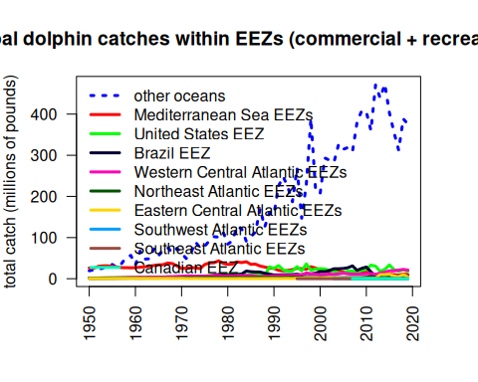
We can see that the EEZ catches globally are dominated by areas outside of the Atlantic (“other oceans”) so we will replot the data after moving this category. Here we can see that most of the catches historically were coming from the Mediterranean Sea, though these catches have been declining drastially since the 1970s. Catches in the United States have showed an opposite pattern, with low historical catches that increased in the 1980s (largely due to the introduction of recreational monitoring). Catches in the Western Central EEZs have increased gradually over time.
# remove other oceans
#head(tab_glob)
tab <- tab_glob[, -which(colnames(tab_glob) == "other oceans")]
#head(tab)
matplot(yrs, tab/10^6, las = 2, type = "b", pch = 19, cex = 0.5, lty = 1, col = glasbey(ncol(tab)+1)[-1],
xlab = "", ylab = "total catch (millions of pounds)", axes = F,
main = "Dolphin catches from the Atlantic EEZs (commercial + recreational)")
matplot(yrs, tab/10^6, las = 2, type = "l", pch = 19, lty = 1, lwd = 2, add = T, col = glasbey(ncol(tab)+1)[-1])
axis(1, at = yrs[seq(1, 90, 2)], las = 2); axis(2); box()
legend(1952, 25, colnames(tab), col = glasbey(ncol(tab)+1)[-1], pch = 19, lty = 1, lwd = 2, bty = "n", cex = 0.6)
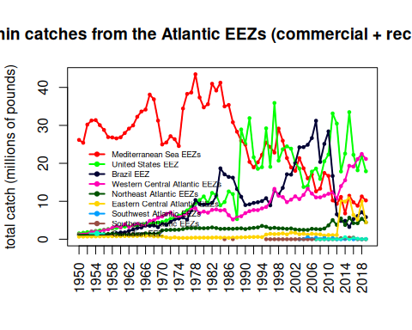

3.7 Merge high seas with catch with exclusive economic zones
Now we will merge in the high seas catch from the steps above into the EEZ catches to get a better picture of total catch in FAO zones 31 and 21. Recall that the U.S. Gulf and Atlantic catches are not necessarily parsed apart correctly in the public databases which get compiled into Sea Around Us, so these will have the same deficiencies as noted in Section 2. Later we will merge in the corrected data.
hs <- read.csv("data/SAU/high_seas_by_year.csv")
names(hs)[1] <- "year"
# check that columns match
#head(tab)
#head(hs)
table(rownames(tab) == hs$year)
TRUE
70
tab[which(is.na(tab))] <- 0
tab_atl <- cbind(tab, hs[2:3])
# check the merge
head(tab_atl)
Mediterranean Sea EEZs United States EEZ Brazil EEZ
1950 26162262 1548245 1127242
1951 25410830 1721403 1060734
1952 30206350 1871779 1128992
1953 31275619 2024535 1111008
1954 31383840 2177865 1090492
1955 30056210 2309815 1190424
Western Central Atlantic EEZs Northeast Atlantic EEZs
1950 1345027 1173441
1951 1467925 1187386
1952 1510406 1193045
1953 2001465 1141504
1954 2069754 1269523
1955 2130341 1405543
Eastern Central Atlantic EEZs Southwest Atlantic EEZs
1950 677552.5 0
1951 693004.4 0
1952 708466.7 0
1953 723939.4 0
1954 739422.5 0
1955 754915.9 0
Southeast Atlantic EEZs Canadian EEZ Atlantic..Northwest
1950 0 0 0
1951 0 0 0
1952 0 0 0
1953 0 0 0
1954 0 0 0
1955 0 0 0
Atlantic..Western.Central
1950 0
1951 0
1952 0
1953 0
1954 0
1955 0
# separate all WCA catches
unique(d$reg) # use Western Central, U.S. and Canada
[1] "other oceans" "Western Central Atlantic EEZs"
[3] "Brazil EEZ" "Eastern Central Atlantic EEZs"
[5] "Mediterranean Sea EEZs" "Northeast Atlantic EEZs"
[7] "United States EEZ" "Southeast Atlantic EEZs"
[9] "Southwest Atlantic EEZs" "Canadian EEZ"
dwc <- d[which(d$reg == "Western Central Atlantic EEZs" | d$reg == "United States EEZ" | d$reg == "Canadian EEZ"),]
#unique(dwc$area_name[which(dwc$reg == "United States EEZ")])
#unique(dwc$area_name[which(dwc$reg == "Canadian EEZ")])
#unique(dwc$area_name[which(dwc$reg == "Western Central Atlantic EEZs")])
# relabel U.S. by area
dwc$reg[which(dwc$area_name == "USA (East Coast)")] <- "United States East Coast"
dwc$reg[which(dwc$area_name == "USA (Gulf of Mexico)")] <- "United States Gulf"
dwc$reg[which(dwc$area_name == "Puerto Rico (USA)")] <- "United States Caribbean"
dwc$reg[which(dwc$area_name == "US Virgin Isl.")] <- "United States Caribbean"
#table(dwc$area_name, dwc$reg)
tab_wc <- tapply(dwc$lbs, list(dwc$year, dwc$reg), sum, na.rm = T)
#head(tab_wc)
# reorder S to N
tab_wc <- tab_wc[, c(5, 2, 4, 3, 1)]
head(tab_wc)
Western Central Atlantic EEZs United States Caribbean United States Gulf
1950 1202464 142562.8 309225.3
1951 1299559 168365.6 339921.3
1952 1341943 168463.5 370512.4
1953 1839330 162135.2 400578.5
1954 1901095 168659.3 433479.6
1955 1954511 175830.1 463752.0
United States East Coast Canadian EEZ
1950 1239020 NA
1951 1381482 NA
1952 1501267 NA
1953 1623956 NA
1954 1744386 NA
1955 1846063 NA
# merge in the high seas catch - check years match
#head(hs)
table(rownames(tab_wc) == hs$year)
TRUE
70
high_seas <- hs$Atlantic..Western.Central + hs$Atlantic..Northwest
high_seas[high_seas == 0] <- NA
tab_wc <- cbind(tab_wc, high_seas)
head(tab_wc)
Western Central Atlantic EEZs United States Caribbean United States Gulf
1950 1202464 142562.8 309225.3
1951 1299559 168365.6 339921.3
1952 1341943 168463.5 370512.4
1953 1839330 162135.2 400578.5
1954 1901095 168659.3 433479.6
1955 1954511 175830.1 463752.0
United States East Coast Canadian EEZ high_seas
1950 1239020 NA NA
1951 1381482 NA NA
1952 1501267 NA NA
1953 1623956 NA NA
1954 1744386 NA NA
1955 1846063 NA NA

3.8 Plot Western Atlantic catches
Now we plot the total Western Atlantic catches – both within the EEZs and the high seas – separating by U.S., Canada, and the Western Central Atlantic (i.e., the Wider Caribbean). Most of the catch is coming from the United States and the 40 combined Caribbean jurisdictions which comprise the Western Central Atlantic.
par(mar = c(5, 4, 4, 3), mgp = c(3, 1, 0))
matplot(yrs, tab_wc/10^6, las = 2, type = "l", lty = 1, lwd = 3, col = c(1, 3:7),
xlab = "", ylab = "total catch (millions of pounds)",
main = "Western Atlantic dolphin catches (commercial + recreational)")
legend("topleft", colnames(tab_wc), col = c(1, 3:7), lty = 1, lwd = 3, bty = "n")
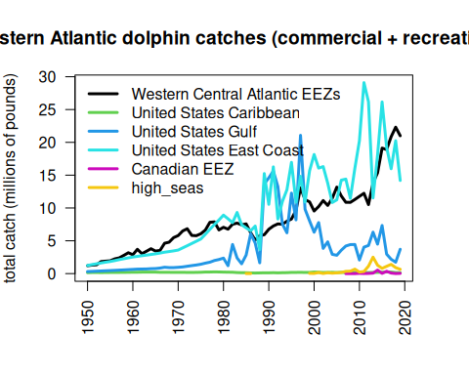
Separating out the mainland United States catches, here are the international and domestic (mainland) catches plotted over time.
tab_int <- tab_wc[, c(1, 2, 5, 6)]
head(tab_int)
Western Central Atlantic EEZs United States Caribbean Canadian EEZ
1950 1202464 142562.8 NA
1951 1299559 168365.6 NA
1952 1341943 168463.5 NA
1953 1839330 162135.2 NA
1954 1901095 168659.3 NA
1955 1954511 175830.1 NA
high_seas
1950 NA
1951 NA
1952 NA
1953 NA
1954 NA
1955 NA
int_catch <- round(rowSums(tab_int, na.rm = T), 2)
dom_catch <- rowSums(tab_wc[, c(3, 4)], na.rm = T)
matplot(yrs, cbind(int_catch, dom_catch)/10^6, las = 2, type = "l", lty = 1, lwd = 3, col = c(2, 4),
xlab = "", ylab = "total catch (millions of pounds)",
main = "Western Atlantic dolphin catches in international vs domestic waters\n(FAO areas 21 and 31, commercial + recreational)")
legend("topleft", c("international", "United States mainland"), col = c(2, 4), lty = 1, lwd = 3, bty = "n")
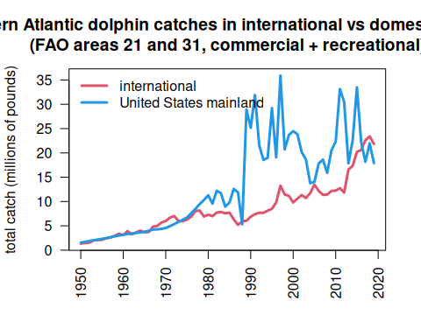
# output international catches
write.csv(data.frame(int_catch), file = "data/international_catches.csv", row.names = T)

3.9 Look at Venezuela catches in detail
Note in the plot above a rapid increase in international catches within the Western Atlantic. This is driven by a sudden increase in catches reported within Sea Around Us within the EEZ. We investigate these catches in detail as it seems odd that a relatively small fleet would be able to ramp up effort so rapidly. Data can be downloaded on a country-specific basis, the catches by taxon in the waters of Venezuela are accessed here.
rm(list = ls()) # clear the workspace
# download the data for waters of Venezuela
ven <- read.csv("data/SAU/SAU EEZ 862 v50-1.csv")
# subset dolphinfish from the data
v <- ven[which(ven$common_name == "Common dolphinfish"), ]
#apply(v[1:13], 2, table)
#convert to pounds
v$pounds <- v$tonnes * 1000 * 2.20462
# look at the characteristics of the data
par(mar = c(5, 10, 1, 1), mfrow = c(3, 2), mex = 0.5)
#barplot(tapply(v$pounds/10^6, v$area_name, sum, na.rm = T), las = 2, xlab = "millions of pounds", main = "Area name", horiz = T)
#barplot(tapply(v$pounds/10^6, v$area_type, sum, na.rm = T), las = 2, xlab = "millions of pounds", main = "Area type", horiz = T)
barplot(tapply(v$pounds/10^6, v$year, sum, na.rm = T), las = 2, xlab = "millions of pounds", main = "Fishing entity", horiz = T)
barplot(tapply(v$pounds/10^6, v$fishing_entity, sum, na.rm = T), las = 2, xlab = "millions of pounds", main = "Fishing entity", horiz = T)
barplot(tapply(v$pounds/10^6, v$fishing_sector, sum, na.rm = T), las = 2, xlab = "millions of pounds", main = "Fishing sector", horiz = T)
barplot(tapply(v$pounds/10^6, v$catch_type, sum, na.rm = T), las = 2, xlab = "millions of pounds", main = "Catch type", horiz = T)
barplot(tapply(v$pounds/10^6, v$reporting_status, sum, na.rm = T), las = 2, xlab = "millions of pounds", main = "Reporting status", horiz = T)
barplot(tapply(v$pounds/10^6, v$gear_type, sum, na.rm = T), las = 2, xlab = "millions of pounds", main = "Gear type", horiz = T)
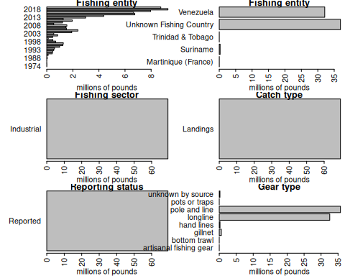
Note that a large portion of the catch in the database is listed as coming from an “Unknown Fishing Country.” We extract these catches and further investigate the characteristics.
# extract the Unknown Fishing Country catch
v1 <- v[which(v$fishing_entity == "Unknown Fishing Country"), ]
apply(v1[1:15], 2, table)
$area_name
Venezuela
39
$area_type
eez
39
$data_layer
Assigned Tuna RFMO catch
39
$uncertainty_score
< table of extent 0 >
$year
2013 2014 2015 2016 2017 2018 2019
5 5 5 6 7 5 6
$scientific_name
Coryphaena hippurus
39
$common_name
Common dolphinfish
39
$functional_group
Large pelagics (>=90 cm)
39
$commercial_group
Perch-likes
39
$fishing_entity
Unknown Fishing Country
39
$fishing_sector
Industrial
39
$catch_type
Landings
39
$reporting_status
Reported
39
$gear_type
artisanal fishing gear bottom trawl gillnet
1 5 7
hand lines longline pole and line
3 4 7
pots or traps unknown by source
5 7
$end_use_type
Direct human consumption
39
# look at characteristics
par(mar = c(3, 10, 1, 5), mfrow = c(2, 2), mex = 0.6)
barplot(tapply(v1$pounds/10^6, v1$year, sum, na.rm = T), las = 2, xlab = "millions of pounds", main = "Year", horiz = T)
barplot(tapply(v1$pounds/10^6, v1$fishing_entity, sum, na.rm = T), las = 2, xlab = "millions of pounds", main = "Fishing entity", horiz = T)
barplot(tapply(v1$pounds/10^6, v1$reporting_status, sum, na.rm = T), las = 2, xlab = "millions of pounds", main = "Reporting status", horiz = T)
barplot(tapply(v1$pounds/10^6, v1$gear_type, sum, na.rm = T), las = 2, xlab = "millions of pounds", main = "Gear type", horiz = T)
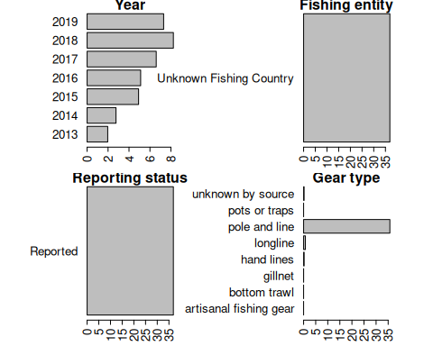
Here is another look at the catches within the venezuelan EEZ, separated by fishing entity.
# summarize Venezuela EEZ catches by fishing entity
tab <- tapply(v$pounds, list(v$year, v$fishing_entity), sum, na.rm = T)
head(tab)
Martinique (France) Suriname Trinidad & Tobago Unknown Fishing Country
1974 7320.429 NA NA NA
1976 12814.641 NA NA NA
1985 NA NA NA NA
1986 NA NA NA NA
1987 NA NA NA NA
1988 NA NA NA NA
Venezuela
1974 NA
1976 NA
1985 4699.563
1986 2229.484
1987 4585.610
1988 39960.149
matplot(rownames(tab), tab/10^6, las = 2, type = "b", lty = 1, lwd = 2, pch = 19, col = 1:5,
xlab = "", ylab = "total catch (millions of pounds)", axes = F,
main = "Total dolphinfish catches in the Venezuelan EEZ")
axis(1, at = seq(1950, 2020, 5)); axis(2, las = 2); box()
legend("topleft", colnames(tab), col = 1:5, pch = 19, lty = 1, lwd = 3, bty = "n", title = "Fishing entity")
text(2004, 6, cex = 0.8,
"These Unknown Fishing Country\ncatches appear in the database as an\nindustrial fleet using pole and line gear\nand are all listed as reported data\n('Assigned Tuna RFMO catch')")
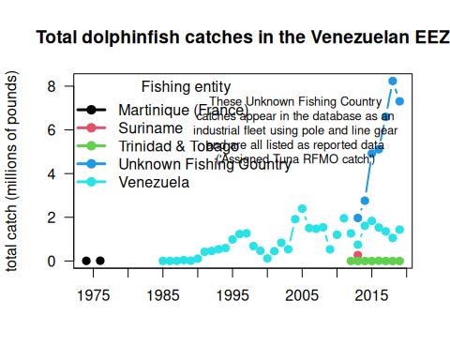
The very substantial increase in international Western Atlantic dolphin catches can be attributed solely to this Unknown Fishing Country catches which appear in the database beginning in 2013. The documentation of the catch reconstruction can be found in the Sea Around Us documentation files (see Mendoza et al. 2015). We spoke to Jeremy Mendoza and other experts who were involved in the reconstruction of domestic catches in Venezuela, and they noted that the “Assigned tuna RFMO catch” actually emerge from spatially reshuffled landing reports to ICCAT, according to the methods of Coulter et al. (2020). In this work, the Sea Around Us team developed a global spatial reallocation of landings of tunas and associated species that were reported to ICCAT. In short, this work uses the fraction of reported spatially disaggregated data to reallocate all data reported to ICCAT. This step is necessary because there are not many countries that report spatial data to ICCAT in the region, and this method may lead to a significant reallocation of landings from the Caribbean to the Venezuelan EEZ, where the local pole and line fishery is significant (J. Mendoza, personal communication). Thus, it is likely that landings from other EEZs, that were included in the reconstructed catch data layer, could have been reassigned to the Venezuelan EEZ.
Because there may be some overlap between the reconstructed data used in the national EEZ estimates, and the ICCAT reporting that was reassigned, there could potentially be a “double counting” of these catch estimates in the Sea Around Us database. These Unknown Fishing Country catches that lead to a large increase in total estimated catches within the Venezuelan EEZ should be treated with caution at this time, until we can verify with Sea Around Us database managers that the spatial disaggregation method used has not led to an overestimate.

3.10 References
Pauly D., Zeller D., Palomares M.L.D. (Editors), 2020. Sea Around Us Concepts, Design and Data (seaaroundus.org).

4. NOAA Fisheries landings data
Here we will explore commercial and recreational landings data accessed through the FOSS (Fisheries One Stop Shop) data portal. The advantage of this portal is that commercial and recreational data are available side-by-side in the same units (pounds landed).

4.1 Data access and upload
Data are downloaded from the NOAA Fisheries FOSS site. For the Data Set, we choose both commercial and recreational. For the Years, we select all years from 1980 to the present. For NMFS Region, we select the “NMFS Regions” button and then select the Gulf, South Atlantic, Middle Atlantic and New England from the box. For the Species, we select “Dolphinfish” and “Dolphinfish**.” For Report Format, we choose TOTALS BY YEAR/REGION. Hitting the “RUN REPORT” button then generates the data needed for the subsequent analysis, which can be downloaded as a .csv file under the “Actions” button.
We then read in the data file and clean it for analysis (removing the commas from the numbers so that R recognizes the values as numbers). We output the file header to make sure it was read in and that the numbers were converted correctly.
# clear workspace
rm(list = ls())
# read in data file
d <- read.table("data/FOSS_landings.csv", header = T, sep = ",", skip = 1)
head(d)
Year Region.Name Pounds Dollars Collection Metric.Tons
1 1980 Gulf 94,984 55,676 Commercial 43
2 1980 Middle Atlantic 400 256 Commercial 0
3 1980 New England 200 54 Commercial 0
4 1980 South Atlantic 76,042 45,852 Commercial 34
5 1981 Gulf 73,075 46,951 Commercial 33
6 1981 Gulf 1,559,544 Recreational 707
# take commas out of file --------------------------
d$Pounds <- as.numeric(gsub(",", "", d$Pounds))
d$Dollars <- as.numeric(gsub(",", "", d$Dollars))
d$Metric.Tons <- as.numeric(gsub(",", "", d$Metric.Tons))
head(d)
Year Region.Name Pounds Dollars Collection Metric.Tons
1 1980 Gulf 94984 55676 Commercial 43
2 1980 Middle Atlantic 400 256 Commercial 0
3 1980 New England 200 54 Commercial 0
4 1980 South Atlantic 76042 45852 Commercial 34
5 1981 Gulf 73075 46951 Commercial 33
6 1981 Gulf 1559544 NA Recreational 707

4.2 Summarize the landings
We then summarize the landings (in pounds) by year, sector, and region. The result is a new data frame with each row representing a year and each column representing the total landings for each region and sector.
# compile by year for sectors and regions ---------------
d$Collection <- factor(d$Collection, levels = c("Recreational", "Commercial"))
tab <- tapply(d$Pounds, list(d$Year, d$Collection, d$Region.Name), sum, na.rm = T)
tab[is.na(tab)] <- 0
#head(tab)
dat <- data.frame(cbind(tab[, , "Gulf"], tab[, , "South Atlantic"],
tab[, , "Middle Atlantic"], tab[, , "New England"]))
names(dat) <- c("rec_Gulf", "com_Gulf", "rec_SA", "com_SA", "rec_MA", "com_MA", "rec_NE", "com_NE")
dat
rec_Gulf com_Gulf rec_SA com_SA rec_MA com_MA rec_NE com_NE
1980 0 94984 0 76042 0 400 0 200
1981 1559544 73075 8421898 59037 0 0 0 0
1982 4197503 162457 7573035 143960 2097 200 0 0
1983 2162936 190808 9134022 127986 45927 1400 0 400
1984 1189573 282976 7265430 158901 0 1700 0 400
1985 2542089 269477 6684821 142684 113666 5000 0 4800
1986 5540003 492212 6190187 189747 125653 4200 0 200
1987 4209638 403703 6883546 212905 121433 13400 0 1100
1988 1014312 491610 3134070 212709 130240 26600 2196 17800
1989 12551461 1029628 13273504 426392 1386752 81700 437 15300
1990 13389540 1098819 9283973 514980 624928 69106 2714 14233
1991 13760600 1674124 14756442 650333 722090 90722 6294 9816
1992 12481422 714369 5893700 326831 860112 74423 1411 10315
1993 6873820 596967 7077105 520512 3001335 99420 200927 27069
1994 5448709 679903 10554836 618614 1400635 101044 12586 12328
1995 11142952 1177325 14318412 1164608 1096473 198425 24061 13811
1996 7086006 1047020 9128895 548682 1077364 43581 0 7788
1997 19958088 989648 12284366 877303 1422057 105559 0 13265
1998 9324186 422501 7312090 406368 2920384 86502 120322 11553
1999 7329953 612445 13973364 504263 1005852 98927 4458 5990
2000 5641491 582576 16049049 537077 1433991 36048 0 6545
2001 7355385 368503 14945284 470897 477081 51342 5189 29134
2002 3513226 290601 13794853 436472 1295470 83534 600948 14836
2003 4481937 310836 12112718 459351 929763 46851 129513 21275
2004 2402315 435341 9707678 555973 427145 31916 0 29042
2005 2537132 207695 10299670 376989 437472 19703 0 19982
2006 3290474 224668 12805952 433121 887684 27724 0 19645
2007 3754513 370397 13164377 740255 241212 79832 19542 44707
2008 3937153 384954 10417536 627939 264017 57764 0 16328
2009 3860527 496701 13251102 1007355 1538112 55271 0 92010
2010 1216198 111790 8543542 572031 813738 35869 0 14939
2011 3023914 309324 10774812 543811 2173136 15376 187289 26587
2012 3229090 146256 9983276 704240 755558 44918 26892 46171
2013 5425636 187966 8483569 583556 302421 41936 226988 18564
2014 3074373 201943 11925345 1041856 2129222 58868 183673 61505
2015 6286577 154133 14821772 920454 4501793 36190 1198628 37808
2016 1777348 37411 12357817 828133 2212513 61336 16499 15747
2017 2064106 65141 9457460 532973 1820541 16179 48607 30969
2018 1626095 56188 11713866 435059 3104018 20514 97107 12667
2019 3567170 83956 7967978 563132 1518629 48224 66 16918
2020 1952241 26332 5653294 260311 679556 14040 0 1880
2021 2893817 26570 6061024 178822 1051785 25318 123038 11421
2022 1664771 15906 6845573 182798 708494 17360 466897 9131
2023 1427518 13305 6630236 125302 734866 28467 122550 8310

4.3 Plot the summary
Now we plot the data, using similar color schemes by region. Because the recreational data have high imprecision prior to the 1990s we plot from 1990 to the last year of data.
# select years ---------------------
dat <- dat[which(rownames(dat) > 1990), ]
# define colors and plot -------------------
cols <- c("#0000FF30", 4, "#FF000030", 2, "#00FF0030", 3, "#00000030", 1)
par(mar = c(4, 4, 1, 0), mgp = c(2.5, 1, 0))
yrs <- as.numeric(rownames(dat))
b <- barplot(t(dat)/10^6, names.arg = yrs, col = cols, ylim = c(0, 43),
border = NA, las = 2, ylab = "total landings (millions of pounds)",
main = "Dolphin landings in the U.S. EEZ")
legend("top", c("New England - commercial", "New England - recreational",
"Mid-Atlantic - commercial", "Mid-Atlantic - recreational",
"South Atlantic - commercial", "South Atlantic - recreational",
"Gulf of Mexico - commercial", "Gulf of Mexico - recreational"),
col = cols[8:1], pch = 15, pt.cex = 1.5, bty = "n", y.intersp = 0.9, cex = 0.85)
axis(1, at = b, lab = rep("", length(b)), pos = 0)
abline(h=0)
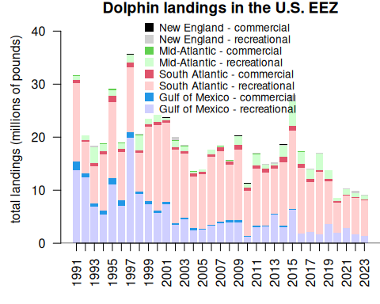

4.4 Updated Gulf/Atlantic parsing of data
There are some issues with the way that the FOSS system splits out Gulf and Atlantic catches by Monroe County, which is on the border between the two jurisdictions. We received data from Mike Larkin (SERO) which has the correct split out of data for Monroe County between the Gulf and Atlantic. We compare the total recreational catch for the Gulf and Atlantic between the FOSS data and the updated data. The numbers are very close; the average difference from the FOSS data is 2%.
ml <- read.table("data/RecreationalDolphinLandings_SAandGOM_MLarkin.csv", header = T, sep = ",", skip = 6)
ml <- ml[which(ml$Year > 1990), ]
# select same years for FOSS data set
dat <- dat[which(yrs <= max(ml$Year)), ]
# check that years match
summary(rownames(dat) == ml$Year)
Mode TRUE
logical 31
yrs <- as.numeric(rownames(dat))
# check that totals match
old <- dat$rec_Gulf + dat$rec_SA + dat$rec_MA + dat$rec_NE
new <- ml$GOM + ml$ATL
# plot totals
par(mar = c(4, 6, 2, 1), mgp = c(2.5, 1, 0))
matplot(yrs, cbind(old, new), xlab = "", lty = 1, col = c(2, 4), type = "b", pch = 19,
ylab = "total recreational landings\n(Gulf + Atlantic, in pounds)",
main = "Comparison of FOSS data with data corrected for Monroe County")
legend("topright", c("FOSS data", "corrected data"), col = c(2, 4), pch = 19, lty = 1)
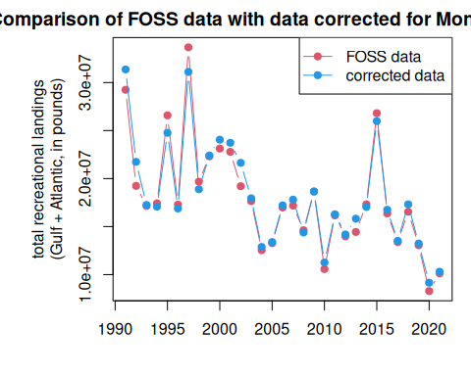
# average % difference between FOSS and updated data
mean((old - new)/old*100)
[1] -2.023886
# min and max % difference between FOSS and updated data
range((old - new)/old*100)
[1] -13.008552 7.587789
hist((old - new)/old*100, main = "Histogram of percent difference from FOSS data", breaks = 10,
xlab = "(FOSS - update) / FOSS")
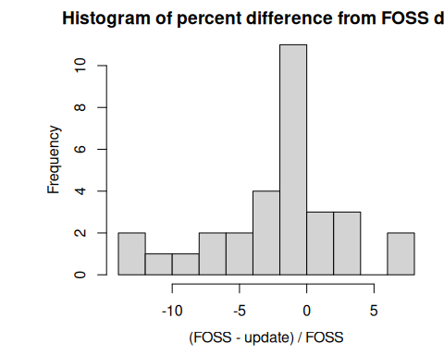
# replace FOSS data with update data
datnew <- dat
datnew$rec_Gulf <- ml$GOM
datnew$rec_SA <- ml$ATL - (datnew$rec_MA + datnew$rec_NE)
# old data set
tail(dat)
rec_Gulf com_Gulf rec_SA com_SA rec_MA com_MA rec_NE com_NE
2016 1777348 37411 12357817 828133 2212513 61336 16499 15747
2017 2064106 65141 9457460 532973 1820541 16179 48607 30969
2018 1626095 56188 11713866 435059 3104018 20514 97107 12667
2019 3567170 83956 7967978 563132 1518629 48224 66 16918
2020 1952241 26332 5653294 260311 679556 14040 0 1880
2021 2893817 26570 6061024 178822 1051785 25318 123038 11421
# updated data set
tail(datnew)
rec_Gulf com_Gulf rec_SA com_SA rec_MA com_MA rec_NE com_NE
2016 751499 37411 13766851 828133 2212513 61336 16499 15747
2017 868489 65141 10777104 532973 1820541 16179 48607 30969
2018 508570 56188 13603875 435059 3104018 20514 97107 12667
2019 1304865 83956 10410599 563132 1518629 48224 66 16918
2020 555695 26332 7916891 260311 679556 14040 0 1880
2021 1174412 26570 7950716 178822 1051785 25318 123038 11421

4.5 Plots with updated data
We replace the FOSS values for Gulf and South Atlantic recreational catches with these new values and re-plot the full data set. We can also plot the landings as a line graph so that the relative magnitudes of catch across region and sector are more easily compared.
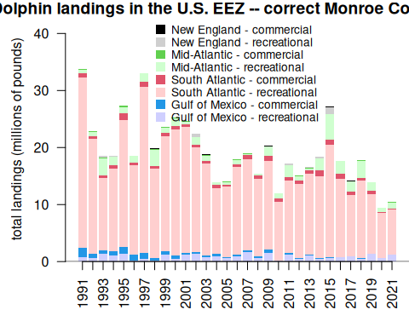
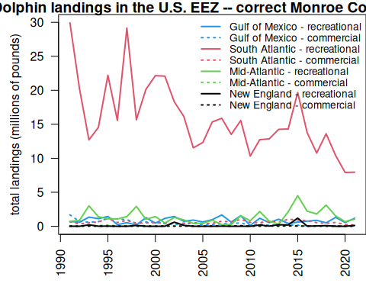

5. SST

6. Analysis of ocean temperature trends
Coming soon

