Analyses to support the Dolphinfish Management Strategy Evaluation in the U.S. Atlantic
Mandy Karnauskas
Table of contents

1. Introduction
Here we will be displaying various data summaries and analyses related to dolphin management in the U.S. South Atlantic.

1.1 Details
The documentation of this data exploration was developed in R, using R Studio and Quarto.

2. Defining the regions for the operating model
Here we define the different regions to be used in the operating model, based on the areas that were defined in the industry working groups. The operating model is intended to encompass the Western Central Atlantic dolphin population and include international waters (FAO areas 21 and 31) which are thought to be connected with the stock that is exploited by U.S. fisheries.
We use the U.S. exclusive economic zone (EEZ) to differentiate between national and international waters. Note that some U.S. commercial activity occurs in high seas waters and we will account for those catches in the summaries.

2.1 Data download for the U.S. EEZ
We download the U.S. Atlantic EEZ from Marineregions.org.
# clear workspace and load the libraries
if (!requireNamespace("maps", quietly = TRUE)) {
install.packages("maps") }
library(maps)
rm(list = ls())
# read in the shapefile downloaded from Marineregions.org
#library(sf)
#shp_data <- st_read("data/eez/eez.shp")
#coords <- st_coordinates(shp_data)
#co <- as.data.frame(coords)
#save(co, file = "data/eez/Marineregions_EEZ.RData")
load("data/eez/Marineregions_EEZ.RData")
head(co)
X Y L1 L2 L3
1 -67.28403 45.19125 1 1 1
2 -67.28400 45.19126 1 1 1
3 -67.28387 45.19125 1 1 1
4 -67.28383 45.19125 1 1 1
5 -67.28372 45.19125 1 1 1
6 -67.28365 45.19125 1 1 1
map("usa", xlim = c(-130, -63), ylim = c(22, 50))
axis(1); axis(2); box()
points(co$X, co$Y, pch = 19, col = 2)
# remove points that are not in the U.S. South Atlantic
co <- co[which(co$X > (-82)), ]
co <- co[-which(co$X < (-81) & co$Y > 25 & co$Y < 28), ]
#plot(co$X, co$Y, col = 0)
#text(co$X, co$Y, 1:nrow(co), cex = 0.7)
#plot(co$X, co$Y, col = 0, xlim = c(-85, -80), ylim = c(22, 25))
#text(co$X, co$Y, 1:nrow(co), cex = 0.7)
# identify the northernmost and southernmost points along the Atlantic EEZ
co1 <- co[2100:3727, ]
points(co1$X, co1$Y, col = 4, pch = 19)
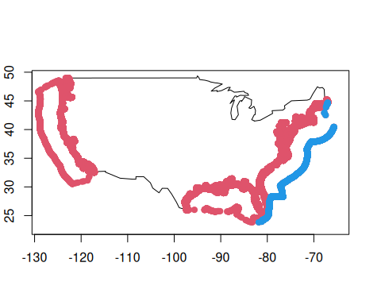

2.2 Construct the U.S. EEZ
We simplify the shapefile along the U.S. coast in order to simplify computations later in the process.
# subset points N and S of 35N for later delineation
co2 <- co[-c(2100:3727), ]
co3 <- co2[which(co2$Y > 35), ]
co4 <- co2[which(co2$Y <= 35), ]
# reduce number of points along the coast to make computation easier
co3 <- co3[seq(1, nrow(co3), 1100), ]
co4 <- co4[seq(1, nrow(co4), 800), ]
map("usa", xlim = c(-100, -60), ylim = c(23, 50))
mtext(side = 1, "degrees W", line = 2); mtext(side = 2, "degrees N", line = 3)
mtext(side = 1, "degrees W", line = 2); mtext(side = 2, "degrees N", line = 3)
axis(1); axis(2); box()
points(co3$X, co3$Y, col = 2, pch = 19)
points(co4$X, co4$Y, col = 4, pch = 19)
co2 <- rbind(co3, co4)
co2 <- co2[order(co2$Y), ]
cofin <- rbind(co1, co2)
polygon(cofin$X, cofin$Y, border = 5, lwd = 3)
# make the polygon along the coast line a bit more linear
abline(h = 37.5)
abline(v = -74)
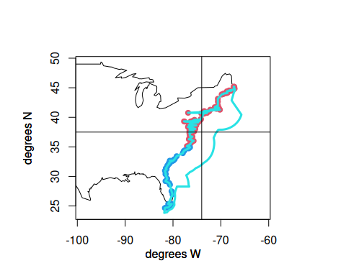
cofin <- cofin[-which(cofin$X < (-74) & cofin$Y > 37.6), ]
#text(cofin$X, cofin$Y, 1:nrow(cofin), cex = 0.9)
lis <- c(1634, 1639, 1688, 1710, 1711, 1712)
cofin <- cofin[-lis, ]
map(database = "usa", xlim = c(-70, -65), ylim = c(43, 47), col = 8)
mtext(side = 1, "degrees W", line = 2); mtext(side = 2, "degrees N", line = 3)
axis(1); axis(2, las = 2); box()
polygon(cofin$X, cofin$Y, border = 2, lwd = 2)
text(cofin$X, cofin$Y, 1:nrow(cofin), cex = 0.9)
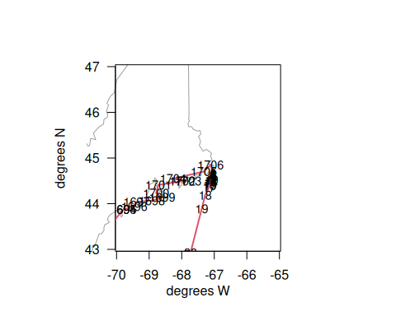
map(database = "usa", xlim = c(-72, -71), ylim = c(34.8, 35.1))
mtext(side = 1, "degrees W", line = 2); mtext(side = 2, "degrees N", line = 3)
axis(1); axis(2, las = 2); box()
polygon(cofin$X, cofin$Y, border = 2)
text(cofin$X, cofin$Y, 1:nrow(cofin), cex = 0.6)
abline(h=35)
abline(v = -60)
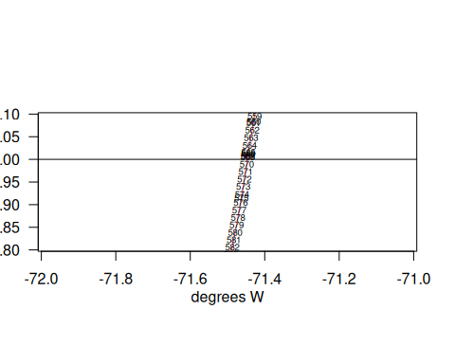
cofin <- cofin[, 1:2]
map(database = "usa", xlim = c(-83, -60), ylim = c(23, 47), col = 0)
map(database = "usa", xlim = c(-83, -60), ylim = c(23, 47), add = T)
mtext(side = 1, "degrees W", line = 2); mtext(side = 2, "degrees N", line = 3)
axis(1); axis(2, las = 2); box()
polygon(cofin$X, cofin$Y, border = 2)
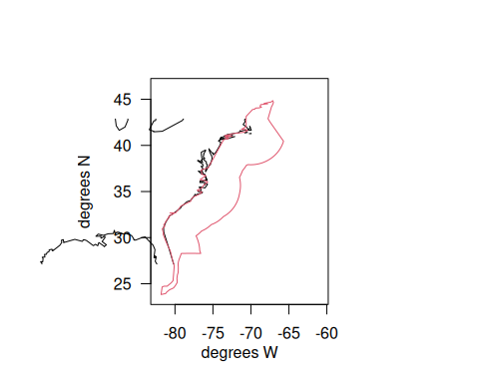
# change the southernmost tip to exactly 24N so that it alighs with Caribbean polygon
cofin <- cofin[-which(cofin$Y < 24), ]
cofin[1624, 2] <- 24
USeez <- cofin
#write.csv(USeez, file = "eez.csv")
Here is a final U.S. South Atlantic EEZ polygon, with a simplified coastline to reduce computational time when subsetting data points.

2.3 Define the Caribbean region
Now we define the boundaries of the Caribbean region. Its northernmost boundary aligns with the EEZ along Florida’s coast up to 28.3 degrees N, at which point the boundary cuts southeast until it intersects with the 24N boundary just east of the Bahamas, approximating the Bahamas EEZ. Its western boundary is -90 degrees W and its southern boundary is 8 degrees N (essentially the land boundary of the Caribbean Sea). Its eastern boundary is -71.1 degrees W.
which.min(cofin$Y)
[1] 1624
cofin[1624, ]
X Y
3723 -81.16148 24
map(database = "usa", xlim = c(-77, -76.4), ylim = c(28, 28.9))
mtext(side = 1, "degrees W", line = 2); mtext(side = 2, "degrees N", line = 3)
axis(1); axis(2, las = 2); box()
polygon(cofin$X, cofin$Y, border = 2)
text(cofin$X, cofin$Y, 1:nrow(cofin), cex = 0.6)
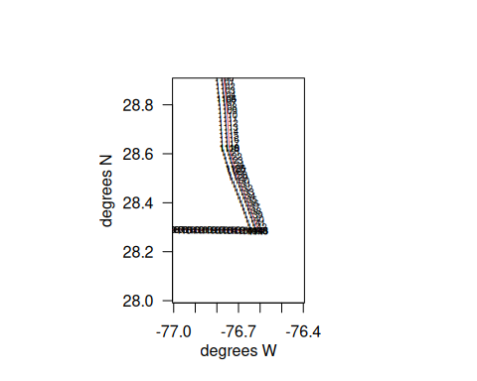
car1 <- cofin[1143:1624, ]
car2 <- data.frame(cbind(c(-90, -90, -60, -60, -71.1), c(24, 8, 8, 24, 24)))
names(car2) <- c("X", "Y")
CAR <- rbind(car1, car2)
names(CAR) <- c("X", "Y")
map(database = "usa", xlim = c(-95, -60), ylim = c(5, 36))
mtext(side = 1, "degrees W", line = 2); mtext(side = 2, "degrees N", line = 3)
axis(1); axis(2, las = 2); box()
polygon(CAR$X, CAR$Y, col = 2)
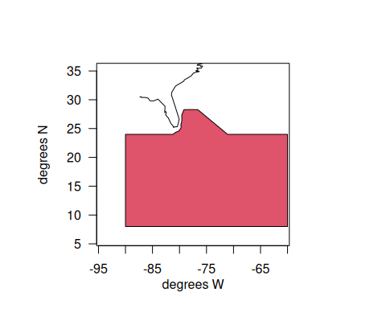

3. Define the NCA region
The North Central Atlantic (NCA) region, otherwise known as the Western Central Atlantic, is defined according to the boundaries of FAO area 31, but excluding the U.S. EEZ and Caribbean territorial seas to the West.
nca1 <- cofin[569:1143, ] # subset points along EEZ
nca2 <- data.frame(cbind(c(-71.1, -60, -60, -40, -40), c(24, 24, 13, 13, 35))) # define boundaries according to FAO
names(nca2) <- c("X", "Y")
NCA <- rbind(nca1, nca2)
names(NCA) <- c("X", "Y")
map(database = "usa", xlim = c(-85, -30), ylim = c(10, 36))
mtext(side = 1, "degrees W", line = 2); mtext(side = 2, "degrees N", line = 3)
axis(1); axis(2, las = 2); box()
polygon(NCA$X, NCA$Y, col = 3)
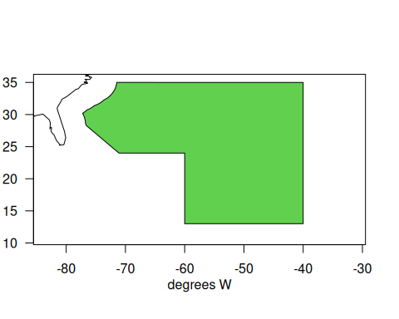

4. Define the NED region
The Northeast Distant Waters (NED) region, otherwise known as the Northwesetern Atlantic, is defined according to the boundaries of FAO area 21, but excluding the U.S. EEZ territorial seas to the West. It does include Canadian and French territorial EEZs. The northern boundary is 60 degrees north, as dolphin are not caught above this latitude.
which.max(cofin$Y) # find northernmost point of U.S. EEZ
[1] 1702
cofin[1702, ]
X Y
77844 -67.11553 44.84764
ned1 <- cofin[1:569, ] # subset points along EEZ
ned2 <- data.frame(cbind(c(-42, -42, -67.1), c(35, 55, 55))) # define boundaries according to FAO
names(ned2) <- c("X", "Y")
NED <- rbind(ned1, ned2)
names(NED) <- c("X", "Y")
map(database = "usa", xlim = c(-85, -30), ylim = c(30, 60))
mtext(side = 1, "degrees W", line = 2); mtext(side = 2, "degrees N", line = 3)
axis(1); axis(2, las = 2); box()
polygon(NED$X, NED$Y, col = 4)
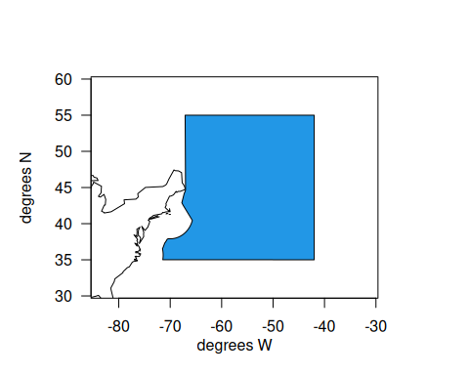

5. Define the Florida Keys region
The southernmost region of the U.S. EEZ is called the FLK region, and includes waters within the EEZ boundary, north up to 28 degrees N. The boundary of 28N is chosen because it aligns with commercial logbook reporting boundaries and aligns roughly with the Brevard - Indian River County border. This is convenient because U.S. recreational statistics are summarized as groups of counties, with SE FL encompassing Miami-Dade to Indian River County and NE FL encompassing Brevard to Nassau County.
which.min(abs(co1$Y - 28)) # find the southernmost point
[1] 1289
map(database = "usa", xlim = c(-81, -78), ylim = c(27.5, 28.9))
mtext(side = 1, "degrees W", line = 2); mtext(side = 2, "degrees N", line = 3)
axis(1); axis(2, las = 2); box()
polygon(cofin$X, cofin$Y, border = 2)
text(cofin$X, cofin$Y, 1:nrow(cofin), cex = 0.6) # find points falling at 28N
points(-80.46, 28)
cofin[1632, ] <- c(-80.46, 28)
abline(h = 28)
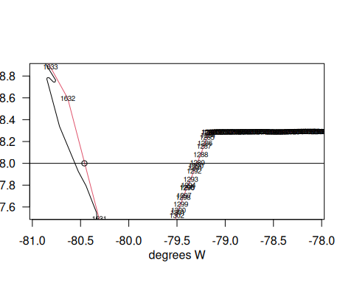
FLK <- cofin[1289:1632, ] # subset points along EEZ
map(database = "usa", xlim = c(-85, -75), ylim = c(20, 30))
mtext(side = 1, "degrees W", line = 2); mtext(side = 2, "degrees N", line = 3)
axis(1); axis(2, las = 2); box()
polygon(FLK$X, FLK$Y, col = 4)
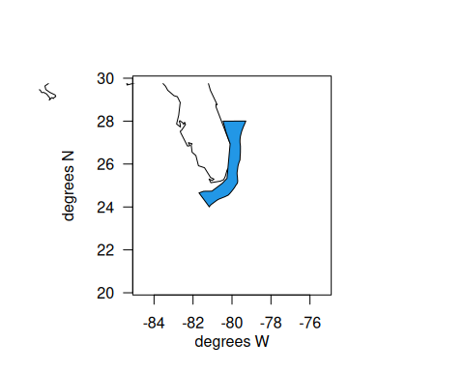

6. Define the North Florida - South NC region
The second area that was decided upon to be defined within the operating model was northern Florida to Southern North Carolina. We form a boundary at 35 degrees north because this is the delineation between the NED and NCA regions. Also, 35N is just south of Cape Hatteras, which is a boundary for NMFS recreational data collection, as well as a boundary of commercial logbook data reporting. Therefore, all sources of data (international, U.S. commercial, and U.S. recreational) can be easily parsed along this boundary.
map(database = "usa", xlim = c(-72, -70), ylim = c(34.5, 35.4))
mtext(side = 1, "degrees W", line = 2); mtext(side = 2, "degrees N", line = 3)
axis(1); axis(2, las = 2); box()
polygon(cofin$X, cofin$Y, border = 2)
text(cofin$X, cofin$Y, 1:nrow(cofin), cex = 0.6) # find points that fall at 35N
abline(h = 35)
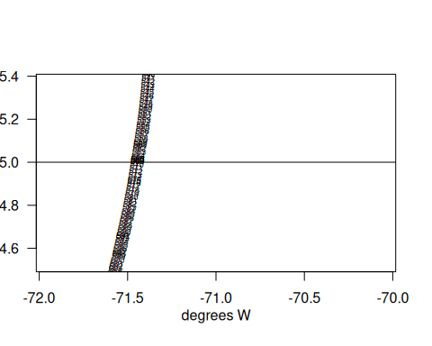
cofin[1663, 2] <- 35
NCFL <- rbind(cofin[1632:1663, ], cofin[569:1289, ]) # subset along EEZ
map(database = "usa", xlim = c(-85, -70), ylim = c(25, 40))
mtext(side = 1, "degrees W", line = 2); mtext(side = 2, "degrees N", line = 3)
axis(1); axis(2, las = 2); box()
polygon(NCFL$X, NCFL$Y, col = 4)
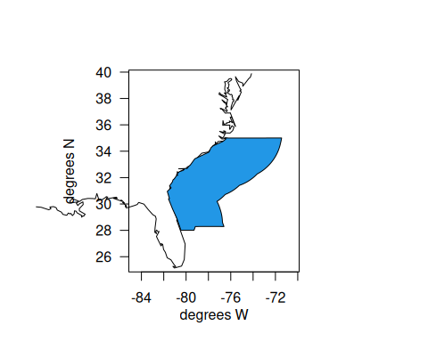

7. Define the northern North Carolina region
The third U.S. area that was decided upon to be defined within the operating model was northern North Carolina, which was intended to encompass the northern part of the state up to the Virginia border. We form a boundary at 37 degrees north because this is a boundary for commercial logbook data reporting and roughly aligns with the latitude of the state boundary between North Carolina and Virginia. Note there is a slight misalignment between this boundary and the way that U.S. recreational statistics are reported (by state), so the commercial and recreational data will be subset along slightly different boundaries for this region.
map(database = "usa", xlim = c(-72, -70), ylim = c(36.5, 37.4))
mtext(side = 1, "degrees W", line = 2); mtext(side = 2, "degrees N", line = 3)
axis(1); axis(2, las = 2); box()
polygon(cofin$X, cofin$Y, border = 2)
text(cofin$X, cofin$Y, 1:nrow(cofin), cex = 0.6)
abline(h = 37)
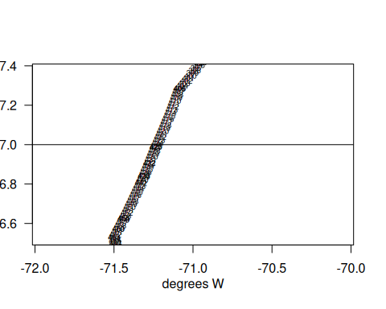
cofin[425, 2] <- 37
NNC <- rbind(cofin[1663:1673, ], cofin[425:569, ])
map(database = "usa", xlim = c(-85, -70), ylim = c(25, 40))
mtext(side = 1, "degrees W", line = 2); mtext(side = 2, "degrees N", line = 3)
axis(1); axis(2, las = 2); box()
polygon(NNC$X, NNC$Y, col = 4)
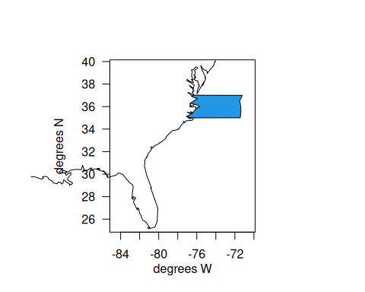

8. Define the Virginia and north region
The fourth region within the U.S. EEZ is the remainder of the area, which encompasses national waters from Virginia up to Maine.
VBM <- rbind(cofin[1673:1702, ], cofin[1:425, ])
map(database = "usa", xlim = c(-80, -60), ylim = c(30, 50))
mtext(side = 1, "degrees W", line = 2); mtext(side = 2, "degrees N", line = 3)
axis(1); axis(2, las = 2); box()
polygon(VBM$X, VBM$Y, col = 4)
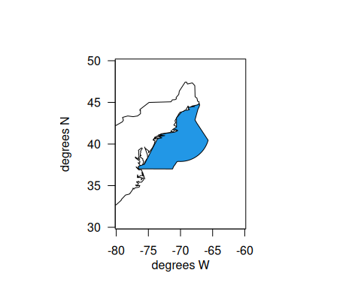

8.1 Plot all of the regions
Now we will put all of the regions on a single map and check that the boundaries align.
png(filename = "data/eez/new_spatial_zones1.png", width= 800, height = 900)
map(database = "world", xlim = c(-92, -38), ylim = c(5, 55), col = 8)
mtext(side = 1, "degrees W", line = 2); mtext(side = 2, "degrees N", line = 3)
axis(1); axis(2, las = 2); box()
polygon(CAR$X, CAR$Y, border = 1)
polygon(NCA$X, NCA$Y, border = 1)
polygon(NED$X, NED$Y, border = 1)
polygon(FLK$X, FLK$Y, border = 1)
polygon(NCFL$X, NCFL$Y, border = 1)
polygon(NNC$X, NNC$Y, border = 1)
polygon(VBM$X, VBM$Y, border = 1)
map(database = "world", add = T, col = 8, lwd = 2)
text(-75, 15, "CAR", cex = 1.2)
text(-57, 28, "NCA", cex = 1.2)
text(-57, 42, "NED", cex = 1.2)
text(mean(FLK$X), mean(FLK$Y), "FLK", cex = 1.2)
text(-79.3, mean(NCFL$Y), "NCFL", cex = 1.2)
text(-73.8, mean(NNC$Y), "NNC", cex = 1.2)
text(-71.5, mean(VBM$Y), "VBM", cex = 1.2)
dev.off()
png
2
#class(CAR)
CAR$region <- "CAR"
FLK$region <- "FLK"
NCFL$region <- "NCFL"
NNC$region <- "NNC"
VBM$region <- "VBM"
NCA$region <- "NCA"
NED$region <- "NED"
zones <- rbind(FLK, NCFL, NNC, VBM, NED, NCA, CAR)
# plot(zones$X, zones$Y, col = as.numeric(as.factor(zones$region)))
# output the coordinates to a .csv file
write.csv(zones, file = "data/eez/dolphin_OM_areas.csv", row.names = FALSE)
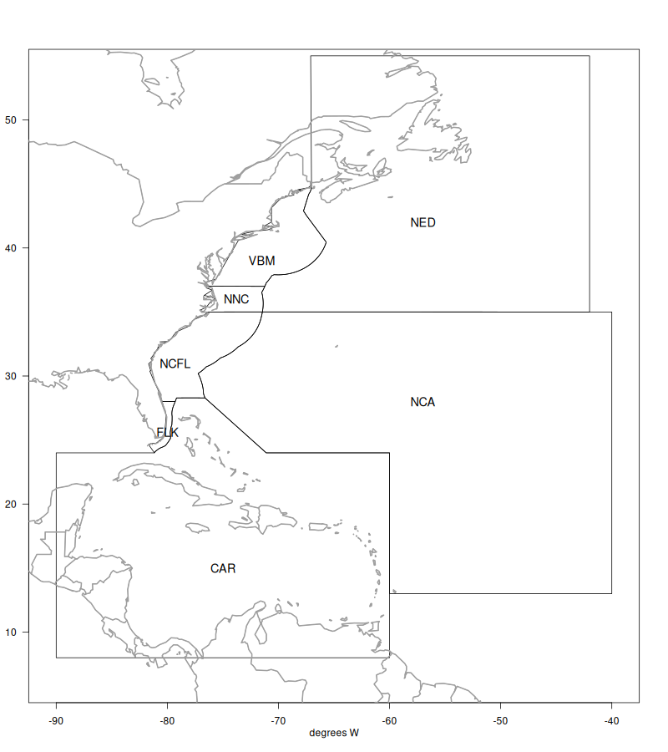
Areas defined in the operating model.

9. NOAA Fisheries recreational landings data
Here we will partition recreational landings data from NOAA Fisheries’ Marine Recreational Information Program (MRIP), a standardized, peer-reviewed suite of recreational fishing surveys used to produce catch and effort estimates for quota monitoring and stock assessment in the United States. MRIP is a standardized survey suite that employs a complex statistical sampling design stratified across time, regions of the coast, and different fishing modes, which allows the intercept data to be scaled up by effort estimates to calculate total catches.

9.1 Data access and upload
Data are downloaded directly from the Miami server using the files provided to SERO for ACL monitoring. The current location is: M://SFD/SECM-SFD/ACL/2025_Jun23_MRIP_MRFSS/. The landings are in FES MRIP and the units are in pounds whole weight.
# clear workspace
rm(list = ls())
# libraries
#library(ROracle)
#con = dbConnect(dbDriver("Oracle"), username = keyring::key_list("SECPR")[1,2],
# password = keyring::key_get("SECPR", keyring::key_list("SECPR")[1,2]), dbname = "SECPR")
#dat <- dbGetQuery(con, "SELECT *
# FROM rdi.V_REC_ACL_MRIP_FES_IMP@secapxdv_dblk.sfsc.noaa.gov")
# read in data file
load("data/mrip_fes_rec81_25wv2_23June25.RData") # most recent file on SFD server
head(dat)
REC_ACL_MRIP_FES_ID YEAR MONTH WAVE SUB_REG NEW_ST NEW_STA NEW_MODE NEW_MODEN
1 73407425 1989 NA 4 6 9 NC 4 Priv
2 73407426 1989 NA 4 6 9 NC 4 Priv
3 73407427 1989 NA 4 6 9 NC 4 Priv
4 73407428 1989 NA 4 6 9 NC 4 Priv
5 73407429 1989 NA 4 6 9 NC 4 Priv
6 73407430 1989 NA 4 6 9 NC 4 Priv
AREA_X NEW_AREA NEW_AREAN FL_REG NC_REG DS NEW_SCI
1 5 5 Inshore NA S MRIP Centropristis striata
2 5 5 Inshore NA N MRIP Centropristis striata
3 2 2 Ocean>3mi NA N MRIP Centropristis striata
4 2 2 Ocean>3mi NA S MRIP Centropristis striata
5 1 1 Ocean<=3mi NA N MRIP Centropristis striata
6 1 1 Ocean<=3mi NA S MRIP Centropristis striata
NEW_COM SP_CODE SPECIES_ITIS SPECIES AB1 B2
1 black sea bass 8835020301 167687 34181.4033 121019.1368
2 black sea bass 8835020301 167687 795.8612 4445.0527
3 black sea bass 8835020301 167687 549.5390 2919.4840
4 black sea bass 8835020301 167687 71823.2390 24548.2535
5 black sea bass 8835020301 167687 415.7642 87.5928
6 black sea bass 8835020301 167687 48728.5632 11859.6428
A B1 LBSEST_SECWWT LBSEST_SECSOURCE SAMPLE_SIZE_USED
1 31761.4755 2419.9278 11457.8425 srysmwa 41
2 584.4155 211.4457 266.7782 srysmwa 41
3 549.5390 0.0000 484.4319 srysmwa 119
4 33343.1844 38480.0546 63313.9276 srysmwa 119
5 415.7642 0.0000 294.0623 srysmwa 71
6 40585.0152 8143.5480 34464.8156 srysmwa 71
AVG_LEN AVG_WGT SRYSMWA_AVG_LEN SRYSMWA_AVG_WGT SRYSMWA_SAMPLE_SIZE
1 203.4572 0.3352069 203.4572 0.3352069 41
2 203.4572 0.3352069 203.4572 0.3352069 41
3 296.2590 0.8815243 296.2590 0.8815243 119
4 296.2590 0.8815243 296.2590 0.8815243 119
5 261.9949 0.7072816 261.9949 0.7072816 71
6 261.9949 0.7072816 261.9949 0.7072816 71
SRYSMWA_FLAGGED SRYSMW_AVG_LEN SRYSMW_AVG_WGT SRYSMW_SAMPLE_SIZE
1 NA 269.2563 0.7310037 231
2 NA 269.2563 0.7310037 231
3 NA 269.2563 0.7310037 231
4 NA 269.2563 0.7310037 231
5 NA 269.2563 0.7310037 231
6 NA 269.2563 0.7310037 231
SRYSMW_FLAGGED SRYSM_AVG_LEN SRYSM_AVG_WGT SRYSM_SAMPLE_SIZE SRYSM_FLAGGED
1 NA 259.7694 0.6948228 556 NA
2 NA 259.7694 0.6948228 556 NA
3 NA 259.7694 0.6948228 556 NA
4 NA 259.7694 0.6948228 556 NA
5 NA 259.7694 0.6948228 556 NA
6 NA 259.7694 0.6948228 556 NA
SRYS_AVG_LEN SRYS_AVG_WGT SRYS_SAMPLE_SIZE SRYS_FLAGGED SRY_AVG_LEN
1 270.955 0.8099641 982 NA 269.1276
2 270.955 0.8099641 982 NA 269.1276
3 270.955 0.8099641 982 NA 269.1276
4 270.955 0.8099641 982 NA 269.1276
5 270.955 0.8099641 982 NA 269.1276
6 270.955 0.8099641 982 NA 269.1276
SRY_AVG_WGT SRY_SAMPLE_SIZE SRY_FLAGGED SR_AVG_LEN SR_AVG_WGT SR_SAMPLE_SIZE
1 0.8085211 1703 NA 303.6871 1.050403 46055
2 0.8085211 1703 NA 303.6871 1.050403 46055
3 0.8085211 1703 NA 303.6871 1.050403 46055
4 0.8085211 1703 NA 303.6871 1.050403 46055
5 0.8085211 1703 NA 303.6871 1.050403 46055
6 0.8085211 1703 NA 303.6871 1.050403 46055
SR_FLAGGED S_AVG_LEN S_AVG_WGT S_SAMPLE_SIZE S_FLAGGED VAR_B2 VAR_AB1
1 NA 344.4373 1.364082 305089 NA 4072492794 310099094
2 NA 344.4373 1.364082 305089 NA 2866289 258947
3 NA 344.4373 1.364082 305089 NA 0 0
4 NA 344.4373 1.364082 305089 NA 105731413 534702898
5 NA 344.4373 1.364082 305089 NA 0 0
6 NA 344.4373 1.364082 305089 NA 22265768 286196169
SA_LABEL GOM_LABEL REC_ACL MIGRA_GRP AGG_MODEN JURISDICTION PS_REG
1 Snapper Grouper 1 Private State 6
2 Snapper Grouper 1 Private State 5
3 Snapper Grouper 1 Private Federal 5
4 Snapper Grouper 1 Private Federal 6
5 Snapper Grouper 1 Private State 5
6 Snapper Grouper 1 Private State 6
COUNCILREG GFMC_FMP SAFMC_FMU LBSEST_SECGWT AGGR_AREA AREA FIRST_MONTH
1 6 Y 9710.0360 NA NA
2 5 Y 226.0832 NA NA
3 5 Y 410.5355 NA NA
4 6 Y 53655.8708 NA NA
5 5 Y 249.2054 NA NA
6 6 Y 29207.4709 NA NA
LAST_MONTH ALT_FLAG CHTS_CL CHTS_H CHTS_RL CHTS_WAB1C CHTS_WAB1H MODE_FX
1 NA 0 0 0 0 0 0 7
2 NA 0 0 0 0 0 0 7
3 NA 0 0 0 0 0 0 7
4 NA 0 0 0 0 0 0 7
5 NA 0 0 0 0 0 0 7
6 NA 0 0 0 0 0 0 7
NEW_SEASN SEASON
1 NA
2 NA
3 NA
4 NA
5 NA
6 NA
#apply(dat[2:18], 2, table, useNA = "always")
# confirm nomenclature for dolphin and subset by species --------------------------
table(dat$NEW_COM[grep("dolphin", dat$NEW_COM)])
dolphin
9377
table(dat$NEW_SCI[grep("dolphin", dat$NEW_COM)])
Coryphaena hippurus
9377
d <- dat[which(dat$NEW_COM == "dolphin"), ]
#apply(d[2:18], 2, table, useNA = "always")
d <- d[which(d$YEAR < 2025), ] # take out 2025 because incomplete year
tot <- tapply(d$LBSEST_SECWWT, d$YEAR, sum, na.rm = T)

9.2 Separate Gulf and Atlantic recreational landings
Now we filter the data set to separate out the Gulf versus Atlantic landings.
# codes for WFL regions: 1 (NW FL Panhandle- Escambia to Dixie co.), 2 (SW FL Peninsula- Levy to Collier co), 3 (FL Keys- Monroe co.)
# subregional codes: 6 is Atlantic and 7 is Gulf
table(d$FL_REG, d$SUB_REG, useNA = "always")
4 5 6 7 <NA>
1 0 0 0 387 0
2 0 0 0 110 0
3 0 0 0 568 0
4 0 0 1022 0 0
5 0 0 312 0 0
<NA> 96 585 3836 2426 0
unique(d$NEW_STA)
[1] "NC" "FLE" "FLW" "SC" "GA" "MS" "AL" "LA"
[9] "TX" "FLE/GA" "RI" "VA" "DE" "MD" "NJ" "CT"
[17] "MA" "NY" "LA/MS" "AL/FLW"
d1 <- d[which(d$COUNCILREG == 6), ]
dg <- d[which(d$COUNCILREG == 7), ]
table(d1$COUNCILREG)
6
6419
Now we can summarize the total dolphin landings in weight for the U.S. Atlantic, and compare to previous values sent for quota monitoring. We see that the values are almost identical.
# summarize by year and compare --------------------------
tot1 <- tapply(d1$LBSEST_SECWWT, d1$YEAR, sum, na.rm = T)
#head(tot1)
old <- read.csv("data/RecreationalDolphinLandings_SAandGOM_MLarkin.csv", skip = 6)
plot(old$Year, old$ATL, type = "l", xlab = "year", ylab = "total landings (pounds)", lwd = 4,
xlim = c(1980, 2025), ylim = c(7*10^6, 3.3*10^7), bty = "n")
lines(as.numeric(names(tot1)), tot1, lwd = 2, col = 2, lty = 2)
legend("topright", c("previous data", "new data"), col = c(1, 2), lwd = c(4, 2), lty = c(1, 2))
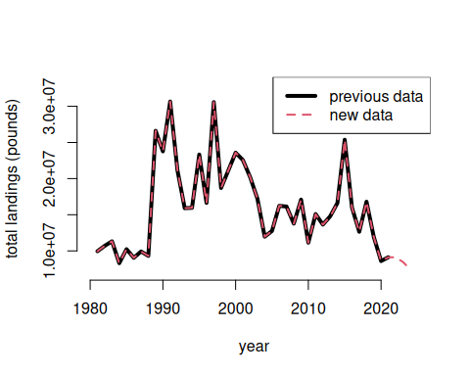

9.3 Partition landings by area and sector
Now we will partition out the total landings according to the dolphin MSE areas. The areas are as follows:
- FLK: Florida Keys to Indian River County County (FL)
- NCFL: Brevard (FL) to Southern NC (South of Hatteras)
- NNC: Northern NC (North of Hatteras to NC/VA border)
- VBM: Virginia to Maine
# separate out 4 regions --------------------------
d1$region <- "VBM"
# select for FLK
# FL_REG codes: 4: SE FL- Miami-Dade to Indian River County.; 5: NE FL- Brevard to Nassau County
table(d1$FL_REG, d1$NEW_STA, useNA = "always")
CT DE FLE FLE/GA FLW GA MA MD NC NJ NY RI SC VA
3 0 0 0 0 568 0 0 0 0 0 0 0 0 0
4 0 0 1022 0 0 0 0 0 0 0 0 0 0 0
5 0 0 312 0 0 0 0 0 0 0 0 0 0 0
<NA> 14 114 0 1794 0 54 20 125 1344 108 73 62 644 165
<NA>
3 0
4 0
5 0
<NA> 0
d1$region[which(d1$FL_REG == 3 | d1$FL_REG == 4)] <- "FLK"
# select for NCFL
d1$region[which(d1$FL_REG == 5)] <- "NCFL"
lis <- c("SC", "GA", "FLE/GA") # NCFL states
d1$region[which(d1$NEW_STA %in% lis)] <- "NCFL"
# NC_REG codes: N: North of Cape Hatteras; S: South of Cape Hatteras
table(d1$NC_REG, d1$NEW_STA, useNA = "always")
CT DE FLE FLE/GA FLW GA MA MD NC NJ NY RI SC VA
14 114 1334 1794 568 54 20 125 586 108 73 62 644 165
N 0 0 0 0 0 0 0 0 420 0 0 0 0 0
S 0 0 0 0 0 0 0 0 338 0 0 0 0 0
<NA> 0 0 0 0 0 0 0 0 0 0 0 0 0 0
<NA>
0
N 0
S 0
<NA> 0
d1$region[which(d1$NC == "S")] <- "NCFL"
# select for NNC
d1$region[which(d1$NC == "N")] <- "NNC"
table(d1$FL_REG, d1$NEW_STA, d1$region)
, , = FLK
CT DE FLE FLE/GA FLW GA MA MD NC NJ NY RI SC VA
3 0 0 0 0 568 0 0 0 0 0 0 0 0 0
4 0 0 1022 0 0 0 0 0 0 0 0 0 0 0
5 0 0 0 0 0 0 0 0 0 0 0 0 0 0
, , = NCFL
CT DE FLE FLE/GA FLW GA MA MD NC NJ NY RI SC VA
3 0 0 0 0 0 0 0 0 0 0 0 0 0 0
4 0 0 0 0 0 0 0 0 0 0 0 0 0 0
5 0 0 312 0 0 0 0 0 0 0 0 0 0 0
, , = NNC
CT DE FLE FLE/GA FLW GA MA MD NC NJ NY RI SC VA
3 0 0 0 0 0 0 0 0 0 0 0 0 0 0
4 0 0 0 0 0 0 0 0 0 0 0 0 0 0
5 0 0 0 0 0 0 0 0 0 0 0 0 0 0
, , = VBM
CT DE FLE FLE/GA FLW GA MA MD NC NJ NY RI SC VA
3 0 0 0 0 0 0 0 0 0 0 0 0 0 0
4 0 0 0 0 0 0 0 0 0 0 0 0 0 0
5 0 0 0 0 0 0 0 0 0 0 0 0 0 0
table(d1$NC_REG, d1$NEW_STA, d1$region) # check classification
, , = FLK
CT DE FLE FLE/GA FLW GA MA MD NC NJ NY RI SC VA
0 0 1022 0 568 0 0 0 0 0 0 0 0 0
N 0 0 0 0 0 0 0 0 0 0 0 0 0 0
S 0 0 0 0 0 0 0 0 0 0 0 0 0 0
, , = NCFL
CT DE FLE FLE/GA FLW GA MA MD NC NJ NY RI SC VA
0 0 312 1794 0 54 0 0 0 0 0 0 644 0
N 0 0 0 0 0 0 0 0 0 0 0 0 0 0
S 0 0 0 0 0 0 0 0 338 0 0 0 0 0
, , = NNC
CT DE FLE FLE/GA FLW GA MA MD NC NJ NY RI SC VA
0 0 0 0 0 0 0 0 0 0 0 0 0 0
N 0 0 0 0 0 0 0 0 420 0 0 0 0 0
S 0 0 0 0 0 0 0 0 0 0 0 0 0 0
, , = VBM
CT DE FLE FLE/GA FLW GA MA MD NC NJ NY RI SC VA
14 114 0 0 0 0 20 125 586 108 73 62 0 165
N 0 0 0 0 0 0 0 0 0 0 0 0 0 0
S 0 0 0 0 0 0 0 0 0 0 0 0 0 0
# summarize by Gulf and Atlantic regions and check against total -----------------------
atl <- tapply(d1$LBSEST_SECWWT, list(d1$YEAR, d1$region), sum, na.rm = T)
GULF <- tapply(dg$LBSEST_SECWWT, dg$YEAR, sum, na.rm = T)
table(rownames(atl) == names(GULF))
TRUE
44
rec <- cbind(GULF, atl)
#plot(rowSums(rec), tot)
rowSums(rec)/tot
1981 1982 1983 1984 1985 1986 1987 1988 1989 1990 1991 1992 1993 1994 1995 1996
1 1 1 NA 1 1 1 1 1 1 1 1 1 1 1 1
1997 1998 1999 2000 2001 2002 2003 2004 2005 2006 2007 2008 2009 2010 2011 2012
1 1 1 1 1 1 1 1 1 1 1 1 1 1 1 1
2013 2014 2015 2016 2017 2018 2019 2020 2021 2022 2023 2024
1 1 1 1 1 1 1 1 1 1 1 1
write.csv(rec, file = "data/recLandings.csv")
Now we will separate out the landings by recreational sector and plot the totals by region and sector.
# separate out by for hire vs. private rec --------------------------
d1$sector <- "Hire"
d1$sector[which(d1$NEW_MODEN == "Shore")] <- "Rec"
d1$sector[which(d1$NEW_MODEN == "Priv")] <- "Rec"
table(d1$sector, d1$NEW_MODEN, useNA = "always") # check classification
Cbt Cbt/Hbt Hbt Priv Shore <NA>
Hire 1616 119 2912 0 0 0
Rec 0 0 0 1750 22 0
<NA> 0 0 0 0 0 0
tot <- tapply(d1$LBSEST_SECWWT, list(d1$YEAR, d1$region, d1$sector), sum, na.rm = T)
head(tot)
, , Hire
FLK NCFL NNC VBM
1981 354639.5 74702.50 256755.24 1400.247
1982 347458.2 92271.42 27578.44 2749.224
1983 1020005.8 41784.04 88690.53 5379.177
1984 1021086.8 74658.81 NA 4203.048
1985 717523.0 172989.65 58514.13 8880.857
1986 1562354.0 63555.89 817192.26 61658.193
, , Rec
FLK NCFL NNC VBM
1981 8942641 322505.7 NA NA
1982 8422673 1711834.7 78367.161 18727.290
1983 10000662 119370.4 44226.032 5456.237
1984 6717044 486079.7 NA 0.000
1985 7925301 1162708.4 77477.096 112944.274
1986 5699311 736872.0 2549.586 103945.134
fin <- data.frame(cbind(tot[, , 1], tot[, , 2]))
names(fin) <- c("Hire_FLK", "Hire_NCFL", "Hire_NNC", "Hire_VBM",
"Rec_FLK", "Rec_NCFL", "Rec_NNC", "Rec_VBM")
head(fin)
Hire_FLK Hire_NCFL Hire_NNC Hire_VBM Rec_FLK Rec_NCFL Rec_NNC
1981 354639.5 74702.50 256755.24 1400.247 8942641 322505.7 NA
1982 347458.2 92271.42 27578.44 2749.224 8422673 1711834.7 78367.161
1983 1020005.8 41784.04 88690.53 5379.177 10000662 119370.4 44226.032
1984 1021086.8 74658.81 NA 4203.048 6717044 486079.7 NA
1985 717523.0 172989.65 58514.13 8880.857 7925301 1162708.4 77477.096
1986 1562354.0 63555.89 817192.26 61658.193 5699311 736872.0 2549.586
Rec_VBM
1981 NA
1982 18727.290
1983 5456.237
1984 0.000
1985 112944.274
1986 103945.134
matplot(rownames(fin), fin/10^6, lty = c(rep(2, 4), rep(1, 4)),
col = rep(1:4, 2), type = "l", lwd = 2,
xlab = "year", ylab = "total landings (millions of pounds)")
legend("topright", colnames(fin), lty = c(rep(2, 4), rep(1, 4)), col = rep(1:4, 2), lwd = 2, ncol = 2, bty = "n")
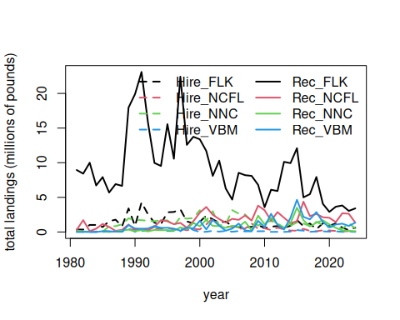
# check that totals match
cor(rowSums(fin, na.rm = T), tot1)
[1] 1
mean(rowSums(fin, na.rm = T) - tot1) # very tiny differences
[1] 4.233284e-11
Here are the landings (in pounds) for years 1981 to 2024.

9.4 Looking at extent of discarding
Discard estimates (known as B2 estimates) are provided in numbers by the MRIP survey but are not available in the Southeast Region Headboat Survey. We can look at the overall numbers of dolphinfish caught versus reported released from the MRIP survey to get an understanding of the extent of discarding.
d1$perdis <- d1$B2 / (d1$AB1 + d1$B2) # percent discarded is B2 (fish released alive) / total
# calculate mean discard rate by year, region, sector ----------------
dis <- tapply(d1$perdis, list(d1$YEAR, d1$region, d1$sector), mean, na.rm = T)
disr <- tapply(d1$perdis, list(d1$region, d1$sector), mean, na.rm = T)
matplot(rownames(dis), cbind(dis[, , 1], dis[, , 2]), lty = c(rep(2, 4), rep(1, 4)), col = rep(1:4, 2),
type = "l", lwd = 2, xlab = "year", ylab = "proportion dolphin discarded alive", ylim = c(0, 0.5))
legend("top", c(paste("For hire - ", colnames(dis)), paste("Private - ", colnames(dis))),
lty = c(rep(2, 4), rep(1, 4)), col = rep(1:4, 2), lwd = 2, ncol = 2, bty = "n")
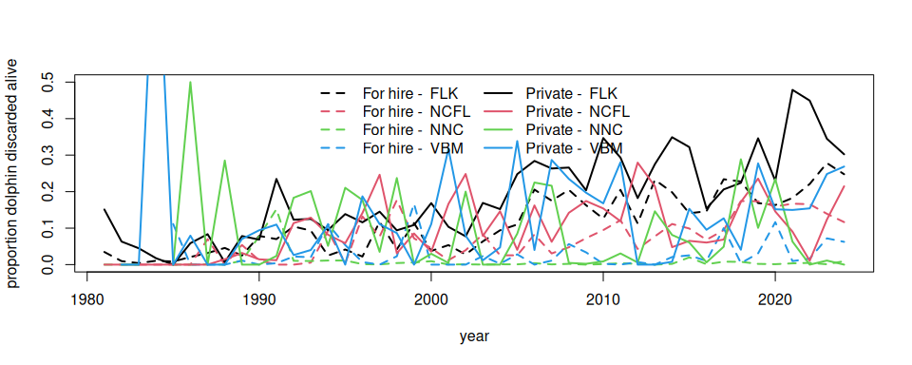
cat("Discarding rates by region and sector - all years:\n")
Discarding rates by region and sector - all years:
round(disr * 100, 2) # discarding rates by region and sector
Hire Rec
FLK 10.79 18.76
NCFL 9.44 11.23
NNC 0.94 9.62
VBM 2.94 12.69
cat("Discarding rates by region and sector - last 5 years:\n")
Discarding rates by region and sector - last 5 years:
round(colMeans(tail(dis, 5)) * 100, 2) # discarding rates by region and sector - last 5 years
Hire Rec
FLK 21.85 36.10
NCFL 14.95 11.69
NNC 0.40 6.17
VBM 5.54 19.45
cat("Discarding rates by region and sector - most recent year:\n")
Discarding rates by region and sector - most recent year:
round(colMeans(tail(dis, 1)) * 100, 2) # discarding rates by region and sector - most recent year
Hire Rec
FLK 24.77 30.23
NCFL 11.65 21.46
NNC 0.94 0.00
VBM 6.24 26.86
# output discarding rates for later use
dismat <- data.frame(rownames(dis), dis[, , 1], dis[, , 2])
names(dismat) <- c("year", paste0(sort(rep(dimnames(dis)[[3]], 4)), "_", rep(dimnames(dis)[[2]], 2)))
head(dismat)
year Hire_FLK Hire_NCFL Hire_NNC Hire_VBM Rec_FLK Rec_NCFL Rec_NNC
1981 1981 0.034610012 NaN 0 NaN 0.15103009 0 NA
1982 1982 0.009591116 NaN 0 NaN 0.06317636 0 0.0
1983 1983 0.004050805 0 0 0.0000000 0.04475684 0 0.0
1984 1984 0.010592562 0 NA NaN 0.01764697 0 NA
1985 1985 0.008499863 0 0 0.1111111 0.00000000 0 0.0
1986 1986 0.020944661 0 0 0.0000000 0.05868540 0 0.5
Rec_VBM
1981 NA
1982 0.00000000
1983 0.00000000
1984 1.00000000
1985 0.00000000
1986 0.07934897
According to the MRIP survey and the reported numbers, discarding generally increases over time, excluding some highly anomalous estimates from the early years which are driven by low sample sizes. Discarding is generally higher in the private sector compared to the for-hire sector, and is highest in the Florida Keys region.

9.5 Split the landings by season
The dolphin MSE operates on a seasonal time step and thus the landings and discards must by parsed apart by individual season and year. This is not straightforward because MRIP estimates are reported in two-month waves (Jan - Feb, Mar - Apr, May - Jun, etc.), and the seasons are 3-month periods (Dec - Feb, Mar - May, Jun - Aug, Sep - Nov). For the two waves that have to be split into seasons (e.g., December is lumped with January and February; June is lumped with July and August), we split the wave 50/50%, i.e, we make the assumption that half of the landings in that wave occurs in one season and the other half occurs in the next season.
# define seasons -----------------------------
table(d1$WAVE, useNA = "always")
0 1 2 3 4 5 6 <NA>
5 407 718 1230 1439 1095 581 944
d1$YRWAVE <- paste0(d1$YEAR, "_", d1$WAVE)
totw <- tapply(d1$LBSEST_SECWWT, list(d1$YRWAVE, d1$region, d1$sector), sum, na.rm = T)
f <- data.frame(cbind(totw[, , 1], totw[, , 2]))
names(f) <- c("Hire_FLK", "Hire_NCFL", "Hire_NNC", "Hire_VBM", "Rec_FLK", "Rec_NCFL", "Rec_NNC", "Rec_VBM")
head(f)
Hire_FLK Hire_NCFL Hire_NNC Hire_VBM Rec_FLK Rec_NCFL Rec_NNC
1981_2 NA NA NA NA 2793285.5 270968.46 NA
1981_3 300873.764 NA 254049.420 NA 3915698.3 NA NA
1981_4 50017.460 NA 2705.821 NA 905621.2 51537.26 NA
1981_5 3748.301 NA NA NA 479834.0 NA NA
1981_6 NA NA NA NA 848201.5 NA NA
1981_NA NA 74702.5 NA 1400.247 NA NA NA
Rec_VBM
1981_2 NA
1981_3 NA
1981_4 NA
1981_5 NA
1981_6 NA
1981_NA NA
f$YEAR <- as.numeric(substr(rownames(f), 1, 4))
f$WAVE <- as.numeric(substr(rownames(f), 6, 8))
head(f) # table with landings separated by wave and year
Hire_FLK Hire_NCFL Hire_NNC Hire_VBM Rec_FLK Rec_NCFL Rec_NNC
1981_2 NA NA NA NA 2793285.5 270968.46 NA
1981_3 300873.764 NA 254049.420 NA 3915698.3 NA NA
1981_4 50017.460 NA 2705.821 NA 905621.2 51537.26 NA
1981_5 3748.301 NA NA NA 479834.0 NA NA
1981_6 NA NA NA NA 848201.5 NA NA
1981_NA NA 74702.5 NA 1400.247 NA NA NA
Rec_VBM YEAR WAVE
1981_2 NA 1981 2
1981_3 NA 1981 3
1981_4 NA 1981 4
1981_5 NA 1981 5
1981_6 NA 1981 6
1981_NA NA 1981 NA
f[is.na(f)] <- 0
f <- f[which(f$YEAR >= 1985), ]
f <- f[which(f$YEAR <= 2024), ]
table(f$YEAR)
1985 1986 1987 1988 1989 1990 1991 1992 1993 1994 1995 1996 1997 1998 1999 2000
7 7 7 7 7 7 7 7 7 7 7 7 6 6 6 6
2001 2002 2003 2004 2005 2006 2007 2008 2009 2010 2011 2012 2013 2014 2015 2016
6 6 6 6 6 6 6 6 6 6 6 6 7 7 7 6
2017 2018 2019 2020 2021 2022 2023 2024
6 6 6 6 6 6 6 6
table(f$WAVE)
0 1 2 3 4 5 6
15 40 40 40 40 40 40
# deal with NAs in many locations ---------------
# calculate percentages of landings by wave, for each region and fleet
avw <- tapply(d1$LBSEST_SECWWT, list(d1$WAVE, d1$region, d1$sector), sum, na.rm = T)
avw <- avw[-1, , ]
avw <- data.frame(cbind(avw[, , 1], avw[, , 2]))
names(avw) <- c("Hire_FLK", "Hire_NCFL", "Hire_NNC", "Hire_VBM", "Rec_FLK", "Rec_NCFL", "Rec_NNC", "Rec_VBM")
avwp <- apply(avw, 2, function (x) x / sum(x, na.rm = T))
#colSums(avwp)
# go through each column, find NAs and fill in waves by percentages
pre_colsum <- colSums(f, na.rm = T) # column sums to check later
lis <- which(f$WAVE == 0) # list of rows with NA wave data
for (i in 1:8) { # loop through each column
for(j in lis) { # loop through list of NA waves
if (f[j, i] > 0) { # if there are NA wave landings, split by known proportion from other years
miscatch <- avwp[, i] * f[j, i] # missing landings are known proportion * NA wave landings
f[which(f$YEAR == f$YEAR[j] & f$WAVE != 0), i] <- f[which(f$YEAR == f$YEAR[j] & f$WAVE != 0), i] + miscatch # add in missing landings
f[j, i] <- 0 # set to zero after landings is attributed to waves
}
}
}
f[lis, 1:8] # should be all zeros now
Hire_FLK Hire_NCFL Hire_NNC Hire_VBM Rec_FLK Rec_NCFL Rec_NNC Rec_VBM
1985_NA 0 0 0 0 0 0 0 0
1986_NA 0 0 0 0 0 0 0 0
1987_NA 0 0 0 0 0 0 0 0
1988_NA 0 0 0 0 0 0 0 0
1989_NA 0 0 0 0 0 0 0 0
1990_NA 0 0 0 0 0 0 0 0
1991_NA 0 0 0 0 0 0 0 0
1992_NA 0 0 0 0 0 0 0 0
1993_NA 0 0 0 0 0 0 0 0
1994_NA 0 0 0 0 0 0 0 0
1995_NA 0 0 0 0 0 0 0 0
1996_NA 0 0 0 0 0 0 0 0
2013_0 0 0 0 0 0 0 0 0
2014_0 0 0 0 0 0 0 0 0
2015_0 0 0 0 0 0 0 0 0
pos_colsum <- colSums(f, na.rm = T)
pre_colsum[1:8] == pos_colsum[1:8] # check that landings were parsed correctly - column sums should be identical
Hire_FLK Hire_NCFL Hire_NNC Hire_VBM Rec_FLK Rec_NCFL Rec_NNC Rec_VBM
TRUE TRUE TRUE TRUE TRUE TRUE TRUE TRUE
f <- f[which(f$WAVE != 0), ] # remove NA waves which now contain no landings
# split waves 3 and 6 50/50% to parse into seasons ------------------
lis <- which(f$WAVE == 3 | f$WAVE == 6) # list of 3 and 6 waves for all years
for (i in lis) { # go through list of waves
temp <- f[i, ] / 2 # split landings in half
temp[9] <- f$YEAR[i] # reformat year and wave data columns
temp[10] <- f$WAVE[i]
temp <- rbind(temp, temp) # create two half-waves and relabel with new wave reference number
temp[1, 10] <- temp[1, 10] - 0.5
temp[2, 10] <- temp[2, 10] + 0.5
f <- rbind(f, temp) # concatenate with main data table
}
f <- f[-lis, ] # remove waves that have been split in half
pos_colsum <- colSums(f, na.rm = T)
pre_colsum[1:8] == pos_colsum[1:8] # check that landings were parsed correctly - column sums should be identical
Hire_FLK Hire_NCFL Hire_NNC Hire_VBM Rec_FLK Rec_NCFL Rec_NNC Rec_VBM
TRUE TRUE TRUE TRUE TRUE TRUE TRUE TRUE
f <- f[order(f$YEAR, f$WAVE), ] # reorder table in chronological order
f$YEAR[which(f$WAVE == 6.5)] <- f$YEAR[which(f$WAVE == 6.5)] + 1 # add year to December wave so it gets summed with following year
f$WAVE[which(f$WAVE == 6.5)] <- 0.5 # change December wave to small number so it gets summed with Jan/Feb
table(f$WAVE)
0.5 1 2 2.5 3.5 4 5 5.5
40 40 40 40 40 40 40 40
f$seas <- cut(f$WAVE, breaks = c(0, 1.5, 3, 4.5, 6))
#table(f$seas)
f$seas1 <- NA
f$seas1[which(f$seas == "(0,1.5]")] <- "DJF" # Dec Jan Feb is 0.5 and 1
f$seas1[which(f$seas == "(1.5,3]")] <- "MAM" # Mar Apr May is 2 and 2.5
f$seas1[which(f$seas == "(3,4.5]")] <- "JJA" # Jun Jul Aug is 3.5 and 4
f$seas1[which(f$seas == "(4.5,6]")] <- "SON" # Sep Oct Nov is 5 and 5.5
temp <- tapply(f[, 1], list(f$seas1, f$YEAR), sum, na.rm = T)
temp1 <- matrix(temp)
for (i in 2:8) {
temp2 <- matrix(tapply(f[, i], list(f$seas1, f$YEAR), sum, na.rm = T))
temp1 <- cbind(temp1, temp2)
}
findat <- data.frame(sort(rep(as.numeric(colnames(temp)), 4)),
rep(rownames(temp), ncol(temp)), temp1)
names(findat) <- c("year", "season", names(f)[1:8])
colSums(f[, 1:8], na.rm = T) == colSums(findat[, 3:10], na.rm = T) # check that total landings are equal before and after parsing
Hire_FLK Hire_NCFL Hire_NNC Hire_VBM Rec_FLK Rec_NCFL Rec_NNC Rec_VBM
TRUE TRUE TRUE TRUE TRUE TRUE TRUE TRUE
We plot the results by region and sector, over the time series of year and season. We can clearly see the seasonality in the landings by region.
findat$yrseas <- findat$year + as.numeric(as.factor(findat$season))/4-0.125
matplot(findat$yrseas, findat[, 3:10]/10^6, lty = c(rep(2, 4), rep(1, 4)), col = rep(1:4, 2), type = "l", lwd = 2,
xlab = "year", ylab = "total landings (millions of pounds)")
legend("topright", colnames(findat[, 3:10]), lty = c(rep(2, 4), rep(1, 4)), col = rep(1:4, 2), lwd = 2, ncol = 2, bty = "n")
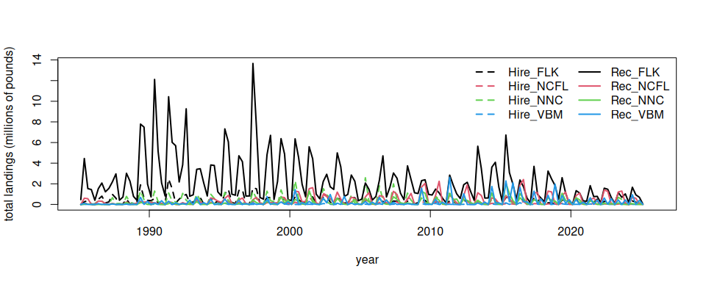
# check that totals match
cbind(colSums(findat[, 3:10], na.rm = T), colSums(fin[-c(1:5), ], na.rm = T))
[,1] [,2]
Hire_FLK 55604999 54887476
Hire_NCFL 16909916 16736926
Hire_NNC 57944903 57886388
Hire_VBM 5836953 5828072
Rec_FLK 371462933 363537632
Rec_NCFL 70803866 69641157
Rec_NNC 32556596 32479119
Rec_VBM 40081529 39968585
# the values should be close but slightly >1 because the last data set includes December 1985 data as part of 1986
colSums(findat[, 3:10], na.rm = T) / colSums(fin[-c(1:5), ], na.rm = T)
Hire_FLK Hire_NCFL Hire_NNC Hire_VBM Rec_FLK Rec_NCFL Rec_NNC Rec_VBM
1.013073 1.010336 1.001011 1.001524 1.021800 1.016696 1.002385 1.002826

9.6 Add the post-release discard mortality
Lastly, we integrate post-release discard mortality into the total catch. MRIP reports dead discards not available for inspection within its B1 category, but there is also mortality in a proportion of fish that are released alive (B2 catch). The percent of fish released alive by year and area was calculated in section 3.4. These B2 catch estimates are only available in numbers, not weight, so in applying these percentages to the landings we must assume that fish released alive are on average the same weight as retained fish. Individual fish may be released alive if they are smaller in size or if they fall under the size limit (only Florida to South Carolina); hence it should be noted that this assumption could bias the post-release mortality estimates in weight high. We use the discard mortality rate of 0.25 as estimated by Rudershausen et al. (2019) and apply it to the percentage of live discards (B2 / total catch).
names(findat)[3:10] == names(dismat)[2:9] # check columns are the same
[1] TRUE TRUE TRUE TRUE TRUE TRUE TRUE TRUE
findat <- findat[which(findat$year < 2025), ]
findat_disc <- findat
# loop through rows and apply discarding rate * 0.25 discard mortality rate
# LRP is Live Release Proportion = B2 / (AB1 + B2)
# solving to isolate B2 (fish released alive)
# B2 = (LRP * AB1) / (1 - LRP)
for (i in 1:nrow(findat)) {
LRP <- dismat[which(dismat$year == findat$year[i]), 2:9] # live release proportion
AB1 <- findat[i, 3:10] # AB1 catch in weight
B2 <- (LRP * AB1) / (1 - LRP) # B2 discards in weight
B2_dead <- B2 * 0.25 # B2 * 0.25 is estimated dead discards in weight
findat_disc[i, 3:10] <- AB1 + B2_dead # total death is AB1 + dead proportion of B2
}
# look at catch with discards
par(mfcol = c(4, 2), mar = c(3, 4, 2, 1), mgp = c(2.5, 1, 0))
for (j in 3:10) {
barplot(rbind(tapply(findat[, j], findat$year, sum), tapply(findat_disc[, j], findat_disc$year, sum))/10^6,
col = c(2:3), border = NA,
beside = T, las = 2, # legend.text = c("without discard mortality", "including discard mortality"),
main = names(findat)[j], ylab = "millions of pounds")
abline(h = 0)
legend("topright", c("without discard mortality", "including discard mortality"), col = 2:3, border = NA, pch = 15, bty = "n")
}
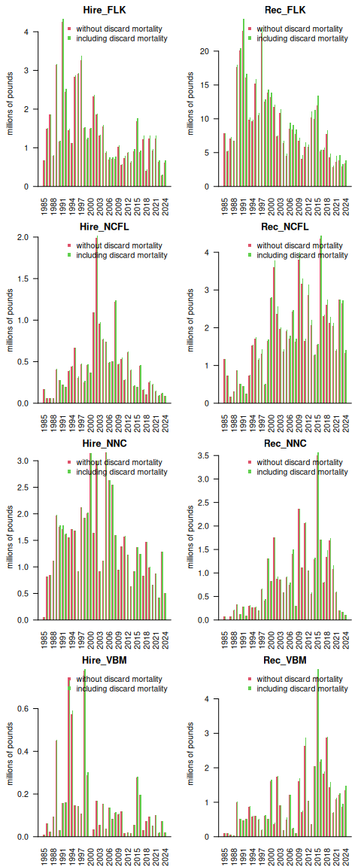
# check calculations - LRP = (B2_dead * 4) / (AB1 + B2_dead * 4)
out <- ((findat_disc[,3:10] - findat[,3:10]) * 4) / (findat[,3:10] + (findat_disc[,3:10] - findat[,3:10]) * 4) # recalc LRP
round(dismat[5, 2:9], 3) == round(out[2, ], 3)
Hire_FLK Hire_NCFL Hire_NNC Hire_VBM Rec_FLK Rec_NCFL Rec_NNC Rec_VBM
1985 TRUE TRUE TRUE TRUE TRUE TRUE TRUE TRUE
round(dismat[nrow(dismat), 2:9], 3) == round(out[nrow(out), ], 3)
Hire_FLK Hire_NCFL Hire_NNC Hire_VBM Rec_FLK Rec_NCFL Rec_NNC Rec_VBM
2024 TRUE TRUE TRUE TRUE TRUE TRUE NA TRUE
# calculate % of post-release dead discards by area
round((colSums(findat_disc[, 3:10]) / colSums(findat[, 3:10]) - 1) * 100, 2)
Hire_FLK Hire_NCFL Hire_NNC Hire_VBM Rec_FLK Rec_NCFL Rec_NNC Rec_VBM
2.78 1.63 0.30 0.98 5.72 3.68 2.38 3.98
# calculate recent % of post-release dead discards by area
round((colSums(findat_disc[149:160, 3:10]) / colSums(findat[149:160, 3:10]) - 1) * 100, 2)
Hire_FLK Hire_NCFL Hire_NNC Hire_VBM Rec_FLK Rec_NCFL Rec_NNC Rec_VBM
8.02 4.12 0.09 1.64 15.10 2.84 0.10 7.32
# calculate overall % of post-release dead discards
round((sum(findat_disc[, 3:10]) / sum(findat[, 3:10]) - 1) * 100, 2)
[1] 4.34
# calculate recent % of post-release dead discards
round((sum(findat_disc[149:160, 3:10]) / sum(findat[149:160, 3:10]) - 1) * 100, 2)
[1] 8.52
Here we will format the data for input to the operating model.
# tab3 <- findat # previous version - this is catch with no post-release discard mortality
tab3 <- findat_disc # this is catch including post-release discard mortality
flt <- c(rep("Hire", nrow(tab3)*4), rep("Rec", nrow(tab3)*4))
yrmon <- as.numeric(tab3$yrseas)
yrs <- floor(yrmon)
qrt <- (yrmon - floor(yrmon)) * 4 + 0.5
area <- c(rep("FLK", nrow(tab3)), rep("NCFL", nrow(tab3)),
rep("NNC", nrow(tab3)), rep("VBM", nrow(tab3)))
area <- rep(area, 2)
findat1 <- data.frame(yrs, qrt, flt, area, matrix(as.matrix(tab3[,3:10])))
names(findat1) <- c("Year", "Quarter", "Fleet", "Area", "Catch_lbs")
head(findat1)
Year Quarter Fleet Area Catch_lbs
1 1985 1 Hire FLK 4471.653
2 1985 2 Hire FLK 254030.649
3 1985 3 Hire FLK 381627.520
4 1985 4 Hire FLK 41558.870
5 1986 1 Hire FLK 40762.254
6 1986 2 Hire FLK 503865.031
#plot(findat1$Catch_lbs, type = "l")
#plot(findat1$Catch_lbs ~ factor(findat1$Area))
#plot(findat1$Catch_lbs ~ factor(findat1$Quarter))
#plot(findat1$Catch_lbs ~ factor(findat1$Year))
findat1 <- findat1[which(findat1$Year <= 2022), ]
findat1 <- findat1[which(findat1$Year >= 1986), ]
#apply(findat1, 2, table)
findat <- findat[which(findat$year >=1986 & findat$year <= 2022), ]
#check that the numbers are exactly the same
tapply(findat1$Catch_lbs, list(findat1$Area, findat1$Fleet), sum, na.rm = T)
Hire Rec
FLK 55478644 377580042
NCFL 16800175 68063202
NNC 56269610 32971138
VBM 5792004 39150014
colSums(findat[3:10], na.rm = T)
Hire_FLK Hire_NCFL Hire_NNC Hire_VBM Rec_FLK Rec_NCFL Rec_NNC Rec_VBM
54012811 16532764 56097190 5736592 357091651 65643193 32197622 37749487
# output final numbers in correct format
write.csv(findat1, file = "data/FINAL_files/rec_catch_TomFormat.csv", row.names = FALSE)

10. NOAA Fisheries commercial data
We do not display the commercial data analysis here because it is based on logbook reporting and trip ticket databases, which both contain confidential data. The code for processing the commercial data can be seen in the file “commercial.R” and the steps are outlined below.

10.1 Analysis of logbook data
We first use the pelagic longline logbook data to understand how the fleet operates in the high seas on a seasonal basis. These numbers are used later to estimate the seasonality of the international landings, because those are only reported on an annual basis but quarterly values are needed.
The steps are as follows:
- Read in the pelagic longline data which contains set level entries including location of fishing, target species, gear used, other details of the fishing trip and number of dolphin caught, discarded alive, discarded dead, and the total pounds of dolphin kept.
- Format the longitude and latitude of the sets into decimal degrees, and find the points that fall within each of the seven polygons representing the areas of the operating model. Check that subsetting was done correctly and add and area identifier.
- Look at the characteristics of the dolphin catch and calculate the discard rates by trip. Dead discarding rate is found to be 1.4% on average and total discard rate is 2.9% on average.
- Standardize date formatting and add identifier for season (quarter). Specify a new year variable to allow December to be grouped with January and February.
- Summarize the total dolphin landings (in pounds) by year, quarter, and area.
- Convert the total pounds by year-quarter and area to proportions such that each year-quarter combination has four seasonal proportions summing to one. Save the matrix of proportions for later analysis.
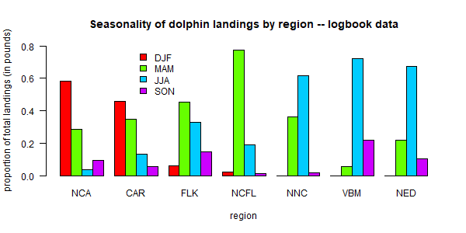
Seasonality of the pelagic longline fleet according to the logbook data. Figure shows the proportion of dolphin landings occurring in each season, for each region of the operating model.

10.2 Analysis of trip ticket data
Not all of the commercial dolphin catch activity is reported in the logbooks because dolphin are targeted via a variety of permits and gear types, not all of which have the same reporting requirements. Therefore, in order to parse the commercial landings by year, area and quarter, we use the commercial trip ticket data compiled by NOAA Fisheries. These are the same data used for quota monitoring and thus are the best representation of the total landings.
The steps are as follows:
- Read in the trip ticket data file, which contains commercial dolphinfish landings for the Atlantic coast from 1986-2023, including all landings by year even if the gear type or area is unknown. The dataset specifies the year and month of landing, an area of fishing, gear, and the state where landed. Pounds are in units of whole weight.
- Read in operating model regions and classify the list of logbook areas into those seven regions. Assign each reported area to an operating model region accordingly.
- Standardize date formatting and add identifier for season (quarter). Specify a new year variable to allow December to be grouped with January and February.
- Summarize the landings by year-quarter, gear (PLL gear vs. other gears) and region.
- For most combinations of year-quarter, region and gear, there are substantial landings for which the area of fishing is unknown and therefore the region cannot be defined. We assume that those landings follow the same distribution with regard to region as the other landings for that year-quarter and gear combination. For each year-quarter/gear combination, we calculate the proportion of landings that occurs in each of the seven regions. The total landings of unknown regions are multiplied by those proportions and then added to the landings from known regions. In cases where none of the areas are known for that year-quarter/gear combination, proportions from the quarter immediately previous to that quarter are used. Sum the landings by gear type to get the total landings for each year-quarter and region.
- Reformat the data according to the specifications needed for input to the operating model (columns specifying the year, quarter, fleet, area and total landings).
- Sum landings by year from the original data file and the final outputs to ensure that data were processed correctly and no landings are missing.
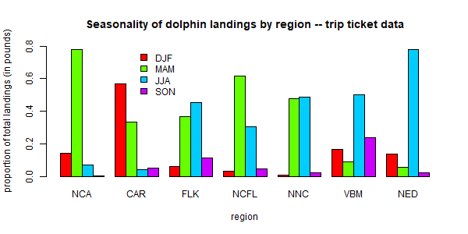
Seasonality of the commercial dolphin landings according to the trip ticket data. Figure shows the proportion of dolphin landings occurring in each season, for each region of the operating model.

11. Analysis of international catches in the high seas
Here we will explore commercial and recreational catch data as estimated by the Sea Around Us Project. This data set includes reported data for fisheries worldwide as well as reconstructed estimates for unreported catches. For each country, project scientists assemble available data on catch and use additional sociological and fishing data plus expert information and opinion, to produce their best estimates of total catch from all fishing sectors and for all species globally.

11.1 Data access and upload
The high seas data are accessed in the Basic Search High seas section of the site. The individual regions can be clicked on (e.g., Atlantic, Western Central) and then the data are downloaded using the Download Data button.
The current version of data in use is version 50.1, accessed June 2024 (the data files can be found on github in the SEFSC-dolphin-analyses/data /SAU/ folder). This was still the most recent version of data available as of September 2025.

11.2 Read in the high seas catches
First we read in the high seas catches for the Western Central Atlantic and Northwest Atlantic zones. These are equivalent to FAO areas 21 and 31.
# clear workspace
rm(list = ls())
if(!require("pals")) install.packages("pals")
library(pals)
# find data files
hslis <- dir("data/SAU/")[grep("HighSeas", dir("data/SAU/"))]
# identify areas 21 and 31
hslis[1]; hslis[3]
[1] "SAU HighSeas 21 v50-1.csv"
[1] "SAU HighSeas 31 v50-1.csv"
#download data
h1 <- read.csv(paste0("data/SAU/", hslis[1]))
h3 <- read.csv(paste0("data/SAU/", hslis[3]))
# confirm correct areas
#unique(h1$area_name)
#unique(h3$area_name)
hs <- rbind(h1, h3)
We extract the data for dolphinfish and look at the characteristics of the catches. Most of the catches are in the Western Central Atlantic, and the primary fishing entities are Venezuela and Saint Lucia. The fishing sector is all industrial, and the vast majority of the catch is reported landings, with only a tiny fraction of discards or unreported landings listed in the database. The gear type is primarily long line.
# check species name and filter out dolphinfish
unique(hs$common_name)[grep("dolphin", unique(hs$common_name))]
[1] "Common dolphinfish"
hs <- hs[which(hs$common_name == "Common dolphinfish"), ]
# look at the categories within each column of data
apply(hs[1:13], 2, table)
$area_name
Atlantic, Northwest Atlantic, Western Central
113 160
$area_type
high_seas
273
$year
1985 1986 1999 2000 2001 2002 2003 2004 2005 2006 2007 2008 2009 2010 2011 2012
1 1 1 1 1 1 1 6 4 1 5 10 5 8 10 12
2013 2014 2015 2016 2017 2018 2019
24 22 30 33 33 29 34
$scientific_name
Coryphaena hippurus
273
$common_name
Common dolphinfish
273
$functional_group
Large pelagics (>=90 cm)
273
$commercial_group
Perch-likes
273
$fishing_entity
Barbados Belize
6 3
Brazil Canada
19 18
Guyana Panama
1 1
Saint Lucia Saint Vincent & the Grenadines
5 28
Spain Suriname
80 1
Trinidad & Tobago USA
14 74
Venezuela
23
$fishing_sector
Industrial
273
$catch_type
Discards Landings
5 268
$reporting_status
Reported Unreported
253 20
$gear_type
artisanal fishing gear bottom trawl gillnet
7 9 11
hand lines longline mixed gear
17 187 1
pole and line pots or traps unknown by source
19 9 13
$end_use_type
Direct human consumption Fishmeal and fish oil
5 194 37
Other
37
# convert from metric tonnes to pounds
hs$pounds <- hs$tonnes * 1000 * 2.20462
# produce barplot of key data fields
par(mar = c(3, 20, 3, 1), mfrow = c(3, 2), mex = 0.5)
barplot(tapply(hs$pounds/10^6, hs$area_name, sum, na.rm = T), las = 2, xlab = "millions of pounds", main = "Area name", horiz = T)
#barplot(tapply(hs$pounds/10^6, hs$area_type, sum, na.rm = T), las = 2, ylab = "millions of pounds", main = "Area type")
#barplot(tapply(hs$pounds/10^6, hs$year, sum, na.rm = T), las = 2, ylab = "millions of pounds", main = "Year")
barplot(tapply(hs$pounds/10^6, hs$fishing_entity, sum, na.rm = T), las = 2, xlab = "millions of pounds", main = "Fishing entity", horiz = T)
barplot(tapply(hs$pounds/10^6, hs$fishing_sector, sum, na.rm = T), las = 2, xlab = "millions of pounds", main = "Fishing sector", horiz = T)
barplot(tapply(hs$pounds/10^6, hs$catch_type, sum, na.rm = T), las = 2, xlab = "millions of pounds", main = "Catch type", horiz = T)
barplot(tapply(hs$pounds/10^6, hs$reporting_status, sum, na.rm = T), las = 2, xlab = "millions of pounds", main = "Reporting status", horiz = T)
barplot(tapply(hs$pounds/10^6, hs$gear_type, sum, na.rm = T), las = 2, xlab = "millions of pounds", main = "Gear type", horiz = T)
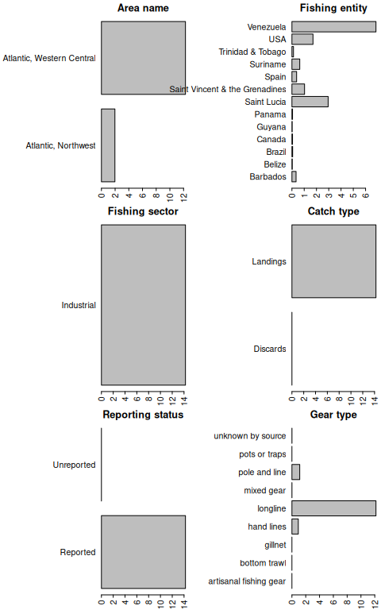
round(tapply(hs$pounds, hs$catch_type, sum, na.rm = T) / sum(hs$pounds) * 100, 2) # << 1% are discards
Discards Landings
0.03 99.97
round(tapply(hs$pounds, hs$reporting_status, sum, na.rm = T) / sum(hs$pounds) * 100, 2) # << 1% are unreported
Reported Unreported
99.97 0.03

11.3 Summarize the high seas landings
We plot the annual landings by fishing entity to look at trends over time.
hs$fishing_entity <- as.factor(hs$fishing_entity)
hs$fishing_entity <- droplevels(hs$fishing_entity)
par(mar = c(5, 5, 3, 1), mfrow = c(1, 1))
tab <- tapply(hs$pounds, list(hs$year, hs$fishing_entity), sum, na.rm = T)
matplot(as.numeric(rownames(tab)), tab/10^6, type = "l", col = glasbey(ncol(tab)), lty = 1, lwd = 2, xlab = "year", ylab = "total landings (millions of pounds)",
main = "High seas Western Central Atlantic dolphin landings")
legend("topleft", colnames(tab), col = glasbey(ncol(tab)), lty = 1, lwd = 2, cex = 0.8, bty = "n")
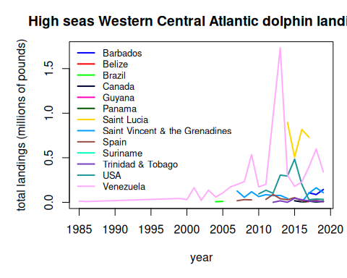
Finally we output the subset of high seas dolphin landings for the two areas. Because we have already accounted for the USA landings in our national reporting and are aiming to only summarize international landings here, we filter out the USA landings from the Sea Around Us database.
hs <- hs[which(hs$fishing_entity != "USA"), ]
hs$year <- factor(hs$year, levels = 1950:2019)
tab <- tapply(hs$pounds, list(hs$year, hs$area_name), sum, na.rm = T)
tab[is.na(tab)] <- 0
tail(tab, 40)
Atlantic, Northwest Atlantic, Western Central
1980 0.000 0.000
1981 0.000 0.000
1982 0.000 0.000
1983 0.000 0.000
1984 0.000 0.000
1985 0.000 14037.129
1986 0.000 8748.399
1987 0.000 0.000
1988 0.000 0.000
1989 0.000 0.000
1990 0.000 0.000
1991 0.000 0.000
1992 0.000 0.000
1993 0.000 0.000
1994 0.000 0.000
1995 0.000 0.000
1996 0.000 0.000
1997 0.000 0.000
1998 0.000 0.000
1999 0.000 43168.296
2000 0.000 30284.627
2001 0.000 164272.223
2002 0.000 22147.477
2003 0.000 137103.181
2004 0.000 66058.258
2005 0.000 115171.863
2006 0.000 170522.101
2007 14687.527 330838.620
2008 28552.636 340863.719
2009 18719.121 662720.661
2010 4510.085 232093.837
2011 21589.424 300498.224
2012 72398.812 1059210.392
2013 34741.604 2471791.396
2014 27922.953 1247462.983
2015 90313.638 710059.125
2016 15319.433 1094893.891
2017 34806.933 1374259.739
2018 29328.358 885814.754
2019 21870.621 632747.157
# write summary to merge with EEZ data
write.csv(tab, file = "data/SAU/high_seas_by_year.csv")

11.4 Distribute the high seas landings across quarters of the year
The international landings are only reported as annual landings and do not have any month or season associated with them. However, the MSE operating model requires seasonal landings. The majority of the international landings are caught by longline, so we will assume that the fleet distribution of the U.S. pelagic longline is representative of the seasonality of the international high seas fleets. Now we parse the annual landings according to the seasonality of the U.S. fleet.
At the time of analysis, the SAU database only contained landings to 2019, so we interpolated the 2019 values to cover years 2020 - 2022.
# read in the percentage of the landings by area and year-quarter combinations from the U.S. PLL
load("data/outputs/per_PLLcatch_by_area_yearquarter.RData")
tab <- tab[which(rownames(tab) >= 1997), ] # PLL data are only available from 1997 on
#tab[nrow(tab), ]
tab <- rbind(tab, tab[nrow(tab), ], tab[nrow(tab), ], tab[nrow(tab), ]) # interpolate 2019 landings for 2020-2022
tail(tab)
Atlantic, Northwest Atlantic, Western Central
2017 34806.93 1374259.7
2018 29328.36 885814.8
2019 21870.62 632747.2
21870.62 632747.2
21870.62 632747.2
21870.62 632747.2
NED <- percatch[, , 1] # create matrices for final landings data
NCA <- percatch[, , 1]
for (i in 1:ncol(percatch)) {
NED[, i] <- percatch[, i, 7] * tab[i, 1] # these are the percentages for the NED (Atlantic Northwest)
NCA[, i] <- percatch[, i, 1] * tab[i, 2] # these are the percentages for the NCA (Western Central Atlantic)
}
# plot the parsed out data by year-quarter
yrs <- sort(rep(as.numeric(colnames(NCA)), 4))
qrt <- rep(1:4, length(yrs)/4)
matplot(yrs + qrt/4, cbind(matrix(NED), matrix(NCA))/10^6, lty = 1, lwd = 2,
col = 2:3, type = "l", main = "International high seas landings by quarter",
xlab = "", ylab = "total landings (millions of pounds)")
legend("topleft", c("NED", "NCA"), lwd = 2, col = 2:3, bty = "n")
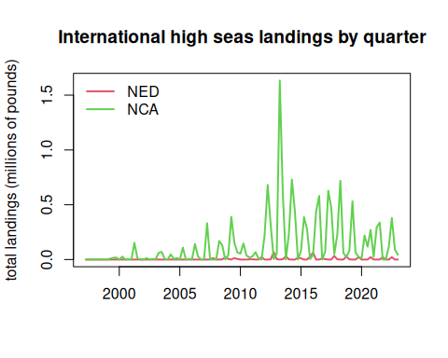
# save NED data in this format because it needs to be combined with Canadian EEZ landings
save(NED, file = "data/outputs/NED_year_quarter.RData")
Finally, we format the data in the format for input into the operating model. We only include NCA here, as the NED high seas landings must be combined with international landings in territorial waters of Canada and France in the NED region.
# format for operating model
flt <- rep("Intl", length(yrs))
are <- rep("NCA", length(yrs))
findat <- data.frame(cbind(yrs, qrt, flt, are, matrix(NCA)))
names(findat) <- c("Year", "Quarter", "Fleet", "Area", "Catch_lbs")
findat$Catch_lbs <- as.numeric(findat$Catch_lbs)
head(findat)
Year Quarter Fleet Area Catch_lbs
1 1997 1 Intl NCA 0
2 1997 2 Intl NCA 0
3 1997 3 Intl NCA 0
4 1997 4 Intl NCA 0
5 1998 1 Intl NCA 0
6 1998 2 Intl NCA 0
#plot(findat$Catch_lbs, type = "l")
#plot(findat$Catch_lbs ~ factor(findat$Area))
#plot(findat$Catch_lbs ~ factor(findat$Quarter))
#plot(findat$Catch_lbs ~ factor(findat$Year))
#apply(findat, 2, table)
#barplot(tapply(findat$Catch_lbs, list(findat$Quarter, findat$Area), sum, na.rm = T), beside = T, col = rainbow(4))
write.csv(findat, file = "data/FINAL_files/NCA_Intl_TomFormat.csv", row.names = FALSE)

12. Analysis of international catches in territorial waters

12.1 Data access and upload
For catches within each country’s exclusive economic zones, data are downloaded from the Sea Around Us site (Pauly, Zeller, and Palomares, 2020.). In the Biodiversity by Taxon Tools and Data, we filter by EEZ for All regions, and then filter by Taxon at the Species level for Common dolphinfish (Coryphaena hippurus). After clicking “View graphs” one can access the full data set using the “Download Data” button.

12.2 Read in the catches within excluzive economic zones (EEZs)
Now we read in the catches reported by each country or jurisdiction’s respective EEZ. Because we have extracted dolphin catches for EEZs worldwide, we need to separate out the catches for the Atlantic Ocean basin.
# load libraries
library(pals)
rm(list = ls())
d <- read.csv("data/SAU/SAU Taxa 600006 v50-1.csv", header = T, sep = ",") # v. 50.1 - June 2024
head(d)
area_name area_type year scientific_name common_name
1 Australia eez 1950 Coryphaena hippurus Common dolphinfish
2 Australia eez 1950 Coryphaena hippurus Common dolphinfish
3 Australia eez 1950 Coryphaena hippurus Common dolphinfish
4 Bahamas eez 1950 Coryphaena hippurus Common dolphinfish
5 Barbados eez 1950 Coryphaena hippurus Common dolphinfish
6 Bermuda (UK) eez 1950 Coryphaena hippurus Common dolphinfish
functional_group commercial_group fishing_entity fishing_sector
1 Large pelagics (>=90 cm) Perch-likes Australia Industrial
2 Large pelagics (>=90 cm) Perch-likes Australia Industrial
3 Large pelagics (>=90 cm) Perch-likes Australia Industrial
4 Large pelagics (>=90 cm) Perch-likes Bahamas Recreational
5 Large pelagics (>=90 cm) Perch-likes Barbados Recreational
6 Large pelagics (>=90 cm) Perch-likes Bermuda (UK) Artisanal
catch_type reporting_status gear_type
1 Landings Reported longline
2 Landings Reported longline
3 Landings Reported longline
4 Landings Unreported recreational fishing gear
5 Landings Unreported recreational fishing gear
6 Landings Reported small scale lines
end_use_type tonnes landed_value
1 Fishmeal and fish oil 0.003373202 3.438170e-05
2 Direct human consumption 6.739657104 1.040254e+04
3 Other 0.003373202 3.438170e-05
4 Direct human consumption 48.665105143 8.262728e+00
5 Direct human consumption 0.009158559 4.846886e-04
6 Direct human consumption 1.511085514 3.199403e+03
#dim(d)
#apply(d[1:13], 2, table)
# convert tonnes to pounds
d$lbs <- d$tonnes * 1000 * 2.20462
We look at the characteristics of the catches within EEZs. These are largely industrial and artisanal in nature. Landings are the majority of the catch but discards are also present. There are more unreported landings than reported landings and a variety of gear types are used.
# look at characteristics of data
par(mfrow = c(2, 2), mar = c(20, 7, 3, 1), mex = 0.5, mgp = c(5.5, 1, 0))
barplot(tapply(d$lbs, d$fishing_sector, sum, na.rm = T)/10^6, las = 2, ylab = "millions of pounds", main = "Fishing sector")
barplot(tapply(d$lbs, d$catch_type, sum, na.rm = T)/10^6, las = 2, ylab = "millions of pounds", main = "Catch type")
barplot(tapply(d$lbs, d$reporting_status, sum, na.rm = T)/10^6, las = 2, ylab = "millions of pounds", main = "Reporting status")
barplot(tapply(d$lbs, d$gear_type, sum, na.rm = T)/10^6, las = 2, ylab = "millions of pounds", main = "Gear type")
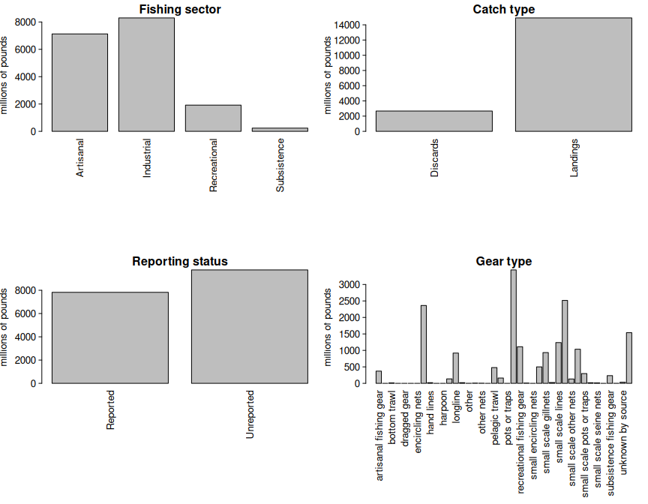
round(tapply(d$lbs, d$catch_type, sum, na.rm = T) / sum(d$lbs) * 100, 2) # 15% are discards
Discards Landings
15.18 84.82
round(tapply(d$lbs, d$reporting_status, sum, na.rm = T) / sum(d$lbs) * 100, 2) # 55% are unreported
Reported Unreported
44.52 55.48

12.3 Separating the EEZs by area
Now we have to manually assign the different EEZs to respective areas. We separate the geographical areas within the Atlantic Ocean (North and South) and lump all other EEZs into “other oceans.” This latter category is largely the Pacific Ocean and to a lesser extent the Indian Ocean. We remove the high seas catch from this database as it is not ocean-specific and we have extracted the ocean-specific high seas catch previously.
# remove the high seas catch from this database
d <- d[which(d$area_type != "high_seas"), ]
d$fishing_entity <- as.factor(d$fishing_entity)
d$fishing_entity <- droplevels(d$fishing_entity)
table(d$area_type) # this should be all "eez"
eez
63056
# Western Central Atlantic EEZs
WCA <- c("Bahamas", "Barbados", "Cayman Isl. (UK)", "Dominica", "Dominican Republic", "Grenada",
"Aruba (Netherlands)", "Haiti", "Guadeloupe (France)", "Jamaica", "Martinique (France)",
"Montserrat (UK)", "Nicaragua (Caribbean)", "Puerto Rico (USA)", "Saint Kitts & Nevis",
"Saint Lucia", "Saint Vincent & the Grenadines", "Trinidad & Tobago", "US Virgin Isl.",
"St Barthelemy (France)", "St Martin (France)", "Curaçao (Netherlands)", "Bonaire (Netherlands)",
"Saba and Sint Eustatius (Netherlands)", "Sint Maarten (Netherlands)", "Honduras (Caribbean)",
"Colombia (Caribbean)", "Mexico (Atlantic)", "Turks & Caicos Isl. (UK)", "Guyana", "Venezuela",
"Antigua & Barbuda", "Belize", "British Virgin Isl. (UK)", "French Guiana", "Cuba",
"Anguilla (UK)", "Suriname", "Costa Rica (Caribbean)", "Guatemala (Caribbean)",
"Panama (Caribbean)", "Bermuda (UK)", "CuraÃ§ao (Netherlands)")
# Brazil
Bra <- c("Brazil (mainland)", "Fernando de Noronha (Brazil)",
"St Paul and St. Peter Archipelago (Brazil)")
# Canada
Can <- c("Canada (East Coast)", "Saint Pierre & Miquelon (France)")
# United States
USA <- c("USA (East Coast)", "USA (Gulf of Mexico)")
# Northeast Atlantic EEZs
NEA <- c("Canary Isl. (Spain)", "Spain (mainland; Med and Gulf of Cadiz)", "Spain (Northwest)",
"Spain (mainland, Med and Gulf of Cadiz)",
"France (Atlantic Coast)", "Portugal (mainland)", "Azores Isl. (Portugal)")
# Eastern Central Atlantic EEZs
ECA <- c("Madeira Isl. (Portugal)", "Cape Verde", "Equatorial Guinea", "Benin",
"Sao Tome & Principe ", "Sao Tome & Principe", "Morocco (Central)", "Ghana",
"Côte d'Ivoire", "CÃ´te d'Ivoire", "Guinea", "Liberia", "Sierra Leone", "Nigeria", "Togo",
"Guinea-Bissau", "Senegal", "Cameroon", "Gambia", "Mauritania", "Morocco (South)",
"Gabon", "Congo; R. of", "Congo, R. of", "Congo (ex-Zaire)")
# Southeastern Atlantic EEZs
SEA <- c("Angola", "Namibia", "South Africa (Atlantic and Cape)",
"Ascension Isl. (UK)", "Saint Helena (UK)", "Tristan da Cunha Isl. (UK)")
# Southwest Atlantic EEZs
SWA <- c("Trindade & Martim Vaz Isl. (Brazil)", "Uruguay")
# Mediterranean EEZs
Med <- c("Italy (mainland)", "Libya", "Malta", "Syria", "Sicily (Italy)","Sardinia (Italy)",
"Balearic Islands (Spain)", "Cyprus (North)", "Cyprus (South)",
"Gaza Strip", "Greece (without Crete)", "Crete (Greece)", "Lebanon",
"Turkey (Mediterranean Sea)", "Egypt (Mediterranean)", "Israel (Mediterranean)", "Tunisia",
"Algeria", "Albania", "Croatia", "Montenegro", "Morocco (Mediterranean)",
"France (Mediterranean)", "Corsica (France)")
# add variable to specify region
d$reg <- "other oceans"
d$reg[which(d$area_name %in% WCA)] <- "Western Central Atlantic EEZs"
d$reg[which(d$area_name %in% Bra)] <- "Brazil EEZ"
d$reg[which(d$area_name %in% Can)] <- "Canadian EEZ"
d$reg[which(d$area_name %in% USA)] <- "United States EEZ"
d$reg[which(d$area_name %in% NEA)] <- "Northeast Atlantic EEZs"
d$reg[which(d$area_name %in% ECA)] <- "Eastern Central Atlantic EEZs"
d$reg[which(d$area_name %in% SEA)] <- "Southeast Atlantic EEZs"
d$reg[which(d$area_name %in% SWA)] <- "Southwest Atlantic EEZs"
d$reg[which(d$area_name %in% Med)] <- "Mediterranean Sea EEZs"
Now we will check that we have classified the regions correctly.
# check region designation
othlis <- unique(d$area_name[which(d$reg == "other oceans")])
print("EEZs of all other oceans: ")
[1] "EEZs of all other oceans: "
othlis
[1] "Australia" "China"
[3] "Taiwan" "Mayotte (France)"
[5] "French Polynesia" "Hong Kong (China)"
[7] "Andaman & Nicobar Isl. (India)" "Indonesia (Eastern)"
[9] "Japan (main islands)" "Japan (Daito Islands)"
[11] "Korea (South)" "Hawaii Northwest Islands (USA)"
[13] "Nauru" "Niue (New Zealand)"
[15] "Northern Marianas (USA)" "Micronesia (Federated States of)"
[17] "Marshall Isl." "Palau"
[19] "Pakistan" "Papua New Guinea"
[21] "Philippines" "Seychelles"
[23] "Viet Nam" "Tokelau (New Zealand)"
[25] "Tonga" "Hawaii Main Islands (USA)"
[27] "USA (West Coast)" "Wake Isl. (USA)"
[29] "Wallis & Futuna Isl. (France)" "Samoa"
[31] "Guatemala (Pacific)" "Kiribati (Gilbert Islands)"
[33] "Mexico (Pacific)" "Japan (Ogasawara Islands)"
[35] "Korea (North, Yellow Sea)" "Korea (North, Sea of Japan)"
[37] "Mauritius" "Solomon Isl."
[39] "Christmas Isl. (Australia)" "Johnston Atoll (USA)"
[41] "Timor Leste" "Palmyra Atoll & Kingman Reef (USA)"
[43] "Jarvis Isl. (USA)" "Howland & Baker Isl. (USA)"
[45] "Indonesia (Central)" "Indonesia (Indian Ocean)"
[47] "Kiribati (Line Islands)" "Kiribati (Phoenix Islands)"
[49] "New Caledonia (France)" "Vanuatu"
[51] "Lord Howe Isl. (Australia)" "Myanmar"
[53] "Ecuador (mainland)" "El Salvador"
[55] "Fiji" "Malaysia (Peninsula West)"
[57] "Norfolk Isl. (Australia)" "Peru"
[59] "Pitcairn (UK)" "Colombia (Pacific)"
[61] "Costa Rica (Pacific)" "Nicaragua (Pacific)"
[63] "Panama (Pacific)" "Thailand (Andaman Sea)"
[65] "Thailand (Gulf of Thailand)" "Cook Islands"
[67] "Kermadec Isl. (New Zealand)" "Tuvalu"
[69] "Honduras (Pacific)" "American Samoa"
[71] "Galapagos Isl. (Ecuador)" "New Zealand"
[73] "Brunei Darussalam" "Malaysia (Sabah)"
[75] "Malaysia (Sarawak)" "Guam (USA)"
[77] "Clipperton Isl. (France)" "South Africa (Indian Ocean Coast)"
[79] "Singapore" "Easter Isl. (Chile)"
[81] "Madagascar" "Réunion (France)"
[83] "Chagos Archipelago (UK)" "Comoros Isl."
[85] "Mozambique Channel Isl. (France)" "Kenya"
[87] "Mozambique" "Somalia"
[89] "Tanzania" "Glorieuse Islands (France)"
[91] "Yemen (Socotra)" "Oman"
[93] "St Paul & Amsterdam Isl. (France)" "Iran (Sea of Oman)"
[95] "Desventuradas Isl. (Chile)" "India (mainland)"
[97] "Maldives" "Tromelin Isl. (France)"
[99] "Cambodia" "Sri Lanka"
[101] "Malaysia (Peninsula East)" "Bangladesh"
print("U.S. EEZs outside the Atlantic Ocean: ")
[1] "U.S. EEZs outside the Atlantic Ocean: "
othlis[grep("USA", othlis)]
[1] "Hawaii Northwest Islands (USA)" "Northern Marianas (USA)"
[3] "Hawaii Main Islands (USA)" "USA (West Coast)"
[5] "Wake Isl. (USA)" "Johnston Atoll (USA)"
[7] "Palmyra Atoll & Kingman Reef (USA)" "Jarvis Isl. (USA)"
[9] "Howland & Baker Isl. (USA)" "Guam (USA)"
print("French EEZs outside the Atlantic Ocean: ")
[1] "French EEZs outside the Atlantic Ocean: "
othlis[grep("France", othlis)]
[1] "Mayotte (France)" "Wallis & Futuna Isl. (France)"
[3] "New Caledonia (France)" "Clipperton Isl. (France)"
[5] "Réunion (France)" "Mozambique Channel Isl. (France)"
[7] "Glorieuse Islands (France)" "St Paul & Amsterdam Isl. (France)"
[9] "Tromelin Isl. (France)"
unique(d$area_name[which(d$reg == "Western Central Atlantic EEZs")]) # Western Central EEZs:
[1] "Bahamas"
[2] "Barbados"
[3] "Bermuda (UK)"
[4] "Cayman Isl. (UK)"
[5] "Dominica"
[6] "Dominican Republic"
[7] "Grenada"
[8] "Guadeloupe (France)"
[9] "Haiti"
[10] "Jamaica"
[11] "Martinique (France)"
[12] "Montserrat (UK)"
[13] "Puerto Rico (USA)"
[14] "Saint Kitts & Nevis"
[15] "Saint Lucia"
[16] "Saint Vincent & the Grenadines"
[17] "Trinidad & Tobago"
[18] "US Virgin Isl."
[19] "St Barthelemy (France)"
[20] "St Martin (France)"
[21] "Curaçao (Netherlands)"
[22] "Bonaire (Netherlands)"
[23] "Saba and Sint Eustatius (Netherlands)"
[24] "Sint Maarten (Netherlands)"
[25] "Honduras (Caribbean)"
[26] "Colombia (Caribbean)"
[27] "Mexico (Atlantic)"
[28] "Turks & Caicos Isl. (UK)"
[29] "Costa Rica (Caribbean)"
[30] "Panama (Caribbean)"
[31] "Antigua & Barbuda"
[32] "Belize"
[33] "British Virgin Isl. (UK)"
[34] "Cuba"
[35] "French Guiana"
[36] "Guyana"
[37] "Anguilla (UK)"
[38] "Suriname"
[39] "Venezuela"
[40] "Guatemala (Caribbean)"
[41] "Aruba (Netherlands)"
[42] "Nicaragua (Caribbean)"
unique(d$area_name[which(d$reg == "Brazil EEZ")]) # Brazil EEZs:
[1] "Brazil (mainland)"
[2] "Fernando de Noronha (Brazil)"
[3] "St Paul and St. Peter Archipelago (Brazil)"
unique(d$area_name[which(d$reg == "Canadian EEZ")]) # Canadian EEZs:
[1] "Canada (East Coast)" "Saint Pierre & Miquelon (France)"
unique(d$area_name[which(d$reg == "United States EEZ")]) # United States EEZs:
[1] "USA (East Coast)" "USA (Gulf of Mexico)"
unique(d$area_name[which(d$reg == "Northeast Atlantic EEZs")]) # Northeast Atlantic EEZs:
[1] "Azores Isl. (Portugal)"
[2] "Spain (mainland, Med and Gulf of Cadiz)"
[3] "Canary Isl. (Spain)"
[4] "Portugal (mainland)"
[5] "France (Atlantic Coast)"
[6] "Spain (Northwest)"
unique(d$area_name[which(d$reg == "Eastern Central Atlantic EEZs")]) # Eastern Central Atlantic EEZs:
[1] "Cape Verde" "Equatorial Guinea"
[3] "Sao Tome & Principe" "Madeira Isl. (Portugal)"
[5] "Togo" "Ghana"
[7] "Guinea" "Liberia"
[9] "Guinea-Bissau" "Senegal"
[11] "Sierra Leone" "Morocco (Central)"
[13] "Morocco (South)" "Côte d'Ivoire"
[15] "Gabon" "Benin"
[17] "Gambia" "Mauritania"
[19] "Nigeria" "Cameroon"
[21] "Congo, R. of" "Congo (ex-Zaire)"
unique(d$area_name[which(d$reg == "Southeast Atlantic EEZs")]) # Southeast Atlantic EEZs:
[1] "Ascension Isl. (UK)" "South Africa (Atlantic and Cape)"
[3] "Saint Helena (UK)" "Angola"
[5] "Namibia" "Tristan da Cunha Isl. (UK)"
unique(d$area_name[which(d$reg == "Southwest Atlantic EEZs")]) # Southwest Atlantic EEZs:
[1] "Trindade & Martim Vaz Isl. (Brazil)" "Uruguay"
unique(d$area_name[which(d$reg == "Mediterranean Sea EEZs")]) # Mediterranean Sea EEZs:
[1] "Italy (mainland)" "Libya"
[3] "Malta" "Syria"
[5] "Sicily (Italy)" "Sardinia (Italy)"
[7] "Balearic Islands (Spain)" "Tunisia"
[9] "Algeria" "Morocco (Mediterranean)"
[11] "France (Mediterranean)" "Corsica (France)"
[13] "Croatia" "Lebanon"
[15] "Albania" "Greece (without Crete)"
[17] "Crete (Greece)" "Cyprus (South)"

12.4 Summarize catch by regional EEZs
Now we summarize the catch by region by grouping the catch across the EEZs by region. We save these data for later analysis, and move on to analyzing only the Western Central and Northwest Atlantic jurisdictions.
# summarize EEZ catch by region
tab <- tapply(d$lbs, list(d$year, d$reg), sum, na.rm = T)
write.csv(data.frame(tab), file = "data/outputs/intl_catches_allAtlantic.csv", row.names = T)
dwest <- d[which(d$reg == "Canadian EEZ" | d$reg == "Western Central Atlantic EEZs"), ]
save(dwest, file = "data/outputs/SAU_EEZs_WCA.RData")
tab <- tapply(dwest$lbs, list(dwest$year, dwest$area_name), sum, na.rm = T)
# eight countries are responsible for vast majority of catch with total catches across all years exceeding 20M pounds
par(mar = c(17, 4, 3, 1))
barplot(sort(colSums(tab, na.rm = T)/10^6, decreasing = T), horiz = F, las = 2,
main = "Total dolphin catch (1950 - 2022) in the Western Atlantic, by EEZ",
ylab = "total catch (millions of pounds)")
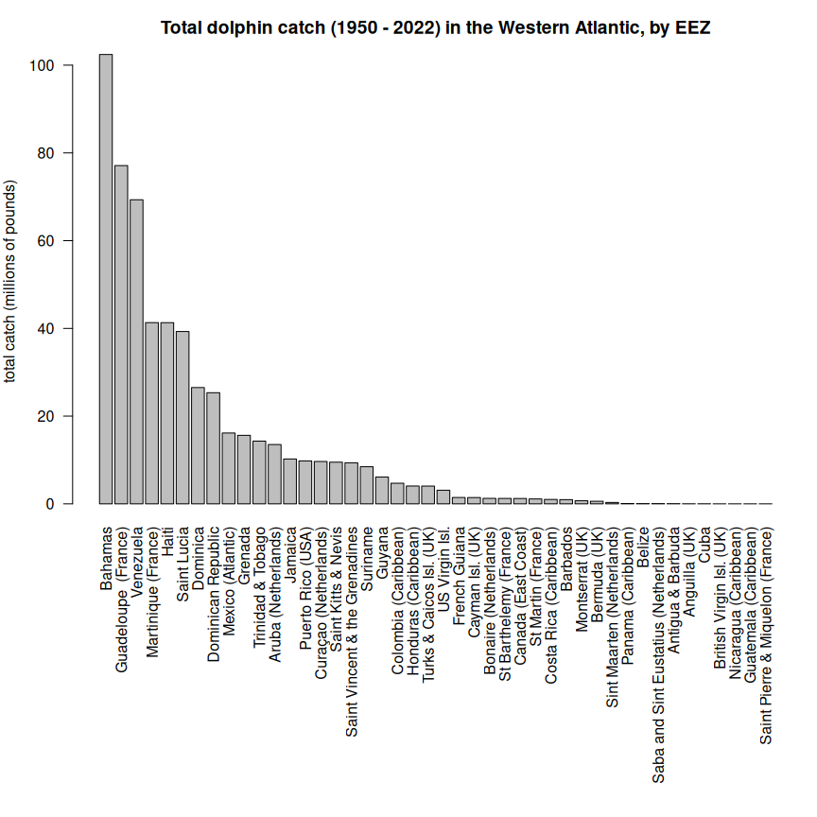
Note that Bermuda is actually in the NCA region and not the Greater Caribbean region. However, its catches constitute 0.1% of the total catch which is essentially negligible, and to avoid complicating the operating model and code unnecessarily we will leave those catches accounted for in the CAR region.
round(colSums(tab, na.rm = T)[7] / sum(colSums(tab, na.rm = T), na.rm = T) * 100, 2)
Bermuda (UK)
0.1
lis <- names(sort(colSums(tab, na.rm = T), decreasing = T)[1:8]) # list of top 8 jurisdictions
tab1 <- tab[, colnames(tab) %in% lis]
par(mar = c(3, 5, 3, 1))
matplot(rownames(tab1), tab1/10^6, las = 2, type = "l", lty = 1, lwd = 2, pch = 19, col = 1:8,
xlab = "", ylab = "total catch (millions of pounds)", axes = F,
main = "Total dolphinfish catches in Caribbean EEZs (top 8 jurisdictions)")
axis(1, at = seq(1950, 2020, 5)); axis(2, las = 2); box()
legend("topleft", colnames(tab1), col = 1:8, lty = 1, lwd = 3, bty = "n", title = "Fishing area name")
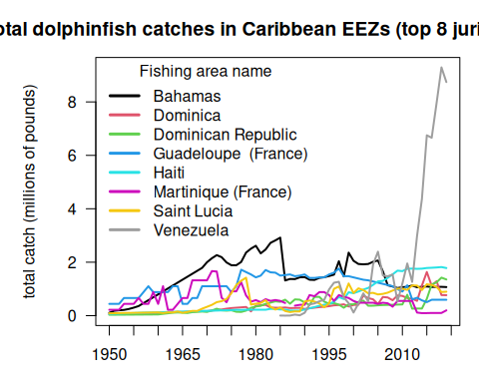
Note the rapid eight-fold increase in catches listed within the Venezuelan EEZ which occurs from 2013 - 2019. This increase is responsible for a rapid increase in estimated international catches within the Western Atlantic.

12.5 Look at Venezuela catches in detail
The figures above indicate that the database shows a rapid increase in international catches within the Western Atlantic, driven by a sudden increase in catches reported within Sea Around Us database within the Venezuelan EEZ. We investigate these catches in detail, as it seems odd that a relatively small fleet from a single country would be able to ramp up effort so rapidly. Data can be downloaded on a country-specific basis, the catches by taxon in the waters of Venezuela are accessed here.
rm(list = ls()) # clear the workspace
# download the data for waters of Venezuela
ven <- read.csv("data/SAU/SAU EEZ 862 v50-1.csv")
# subset dolphinfish from the data
v <- ven[which(ven$common_name == "Common dolphinfish"), ]
#apply(v[1:13], 2, table)
#convert to pounds
v$pounds <- v$tonnes * 1000 * 2.20462
# look at the characteristics of the data
par(mar = c(5, 10, 1, 1), mfrow = c(3, 2), mex = 0.9)
#barplot(tapply(v$pounds/10^6, v$area_name, sum, na.rm = T), las = 2, xlab = "millions of pounds", main = "Area name", horiz = T)
#barplot(tapply(v$pounds/10^6, v$area_type, sum, na.rm = T), las = 2, xlab = "millions of pounds", main = "Area type", horiz = T)
barplot(tapply(v$pounds/10^6, v$year, sum, na.rm = T), las = 2, xlab = "millions of pounds", main = "Year", horiz = T)
barplot(tapply(v$pounds/10^6, v$fishing_entity, sum, na.rm = T), las = 2, xlab = "millions of pounds", main = "Fishing entity", horiz = T)
barplot(tapply(v$pounds/10^6, v$fishing_sector, sum, na.rm = T), las = 2, xlab = "millions of pounds", main = "Fishing sector", horiz = T)
barplot(tapply(v$pounds/10^6, v$catch_type, sum, na.rm = T), las = 2, xlab = "millions of pounds", main = "Catch type", horiz = T)
barplot(tapply(v$pounds/10^6, v$reporting_status, sum, na.rm = T), las = 2, xlab = "millions of pounds", main = "Reporting status", horiz = T)
barplot(tapply(v$pounds/10^6, v$gear_type, sum, na.rm = T), las = 2, xlab = "millions of pounds", main = "Gear type", horiz = T)
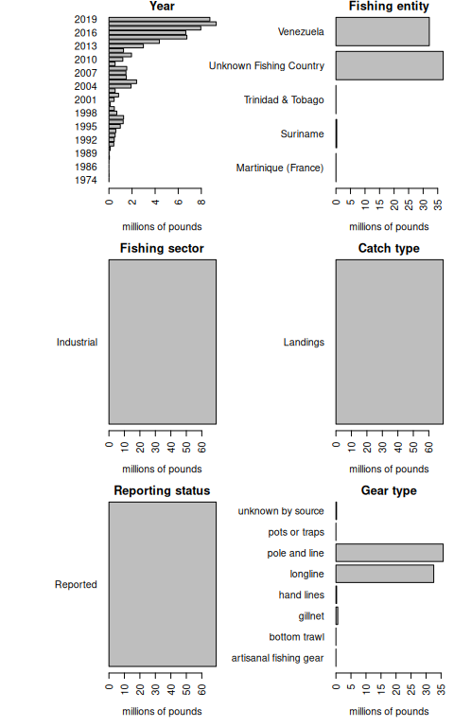
Note that a large portion of the catch in the database is listed as coming from an “Unknown Fishing Country.” We extract these catches and further investigate the characteristics.
# extract the Unknown Fishing Country catch
v1 <- v[which(v$fishing_entity == "Unknown Fishing Country"), ]
#apply(v1[1:15], 2, table)
# look at characteristics
par(mar = c(3, 10, 1, 5), mfrow = c(2, 2), mex = 0.6)
barplot(tapply(v1$pounds/10^6, v1$year, sum, na.rm = T), las = 2, xlab = "millions of pounds", main = "Year", horiz = T)
barplot(tapply(v1$pounds/10^6, v1$fishing_entity, sum, na.rm = T), las = 2, xlab = "millions of pounds", main = "Fishing entity", horiz = T)
barplot(tapply(v1$pounds/10^6, v1$reporting_status, sum, na.rm = T), las = 2, xlab = "millions of pounds", main = "Reporting status", horiz = T)
barplot(tapply(v1$pounds/10^6, v1$gear_type, sum, na.rm = T), las = 2, xlab = "millions of pounds", main = "Gear type", horiz = T)
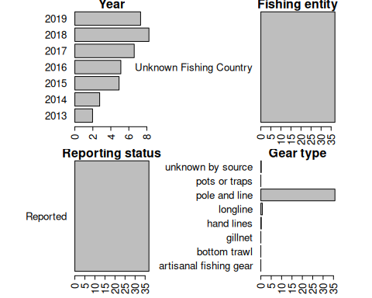
Here is another look at the catches within the venezuelan EEZ, separated by fishing entity.
# summarize Venezuela EEZ catches by fishing entity
tab <- tapply(v$pounds, list(v$year, v$fishing_entity), sum, na.rm = T)
head(tab)
Martinique (France) Suriname Trinidad & Tobago Unknown Fishing Country
1974 7320.429 NA NA NA
1976 12814.641 NA NA NA
1985 NA NA NA NA
1986 NA NA NA NA
1987 NA NA NA NA
1988 NA NA NA NA
Venezuela
1974 NA
1976 NA
1985 4699.563
1986 2229.484
1987 4585.610
1988 39960.149
matplot(rownames(tab), tab/10^6, las = 2, type = "b", lty = 1, lwd = 2, pch = 19, col = 1:5,
xlab = "", ylab = "total catch (millions of pounds)", axes = F,
main = "Total dolphinfish catches in the Venezuelan EEZ")
axis(1, at = seq(1950, 2020, 5)); axis(2, las = 2); box()
legend("topleft", colnames(tab), col = 1:5, pch = 19, lty = 1, lwd = 3, bty = "n", title = "Fishing entity")
text(2004, 6, cex = 0.8,
"These Unknown Fishing Country\ncatches appear in the database as an\nindustrial fleet using pole and line gear\nand are all listed as reported data\n('Assigned Tuna RFMO catch')")
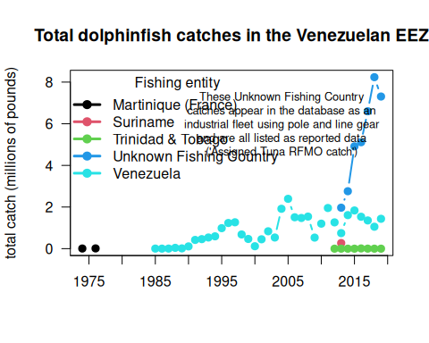
The very substantial increase in international Western Atlantic dolphin catches can be attributed solely to this Unknown Fishing Country catches which appear in the database beginning in 2013. The documentation of the catch reconstruction can be found in the Sea Around Us documentation files (see Mendoza et al. 2015). We spoke to Jeremy Mendoza and other experts who were involved in the reconstruction of domestic catches in Venezuela, and they noted that the “Assigned tuna RFMO catch” actually emerge from spatially reshuffled landing reports to ICCAT, according to the methods of Coulter et al. (2020). In this work, the Sea Around Us team developed a global spatial reallocation of landings of tunas and associated species that were reported to ICCAT. In short, this work uses the fraction of reported spatially disaggregated data to reallocate all data reported to ICCAT. This step is necessary because there are not many countries that report spatial data to ICCAT in the region, and this method may lead to a significant reallocation of landings from the Caribbean to the Venezuelan EEZ, where the local pole and line fishery is significant (J. Mendoza, personal communication). Thus, it is likely that landings from other EEZs, that were included in the reconstructed catch data layer, could have been reassigned to the Venezuelan EEZ.
Because there may be some overlap between the reconstructed data used in the national EEZ estimates, and the ICCAT reporting that was reassigned, there could potentially be a “double counting” of these catch estimates in the Sea Around Us database. We verified with Sea Around Us database managers that their method led to an error resulting in an overestimate of the catch, and they advised us to remove these Unknown Fishing Country catches as they are difficult to trace back to the data source.

12.6 Additional error in Curacao catches
During the MSE review in August 2026, we uncovered a similar error in the database in the catch history for Curacao. Here also, we find catches attributed to a U.S. fleet operating within the EEZ. These catches seem unreasonable given no known commercial U.S. fleets operating in the small island nation and the overall magnitude of the catches given the very small EEZ.
rm(list = ls())
d <- read.csv("data/SAU/SAU Taxa 600006 v50-1.csv", header = T, sep = ",") # v. 50.1 - June 2024
d$pounds <- d$tonnes * 1000 * 2.20462 # convert tonnes to pounds
v <- d[which(d$area_name == "Curaçao (Netherlands)"), ]
# look at the characteristics of the data
par(mar = c(5, 10, 1, 1), mfrow = c(3, 2), mex = 0.9)
barplot(tapply(v$pounds/10^6, v$area_name, sum, na.rm = T), las = 2, xlab = "millions of pounds", main = "Area name", horiz = T)
barplot(tapply(v$pounds/10^6, v$fishing_entity, sum, na.rm = T), las = 2, xlab = "millions of pounds", main = "Fishing entity", horiz = T)
barplot(tapply(v$pounds/10^6, v$fishing_sector, sum, na.rm = T), las = 2, xlab = "millions of pounds", main = "Fishing sector", horiz = T)
barplot(tapply(v$pounds/10^6, v$catch_type, sum, na.rm = T), las = 2, xlab = "millions of pounds", main = "Catch type", horiz = T)
barplot(tapply(v$pounds/10^6, v$reporting_status, sum, na.rm = T), las = 2, xlab = "millions of pounds", main = "Reporting status", horiz = T)
barplot(tapply(v$pounds/10^6, v$gear_type, sum, na.rm = T), las = 2, xlab = "millions of pounds", main = "Gear type", horiz = T)
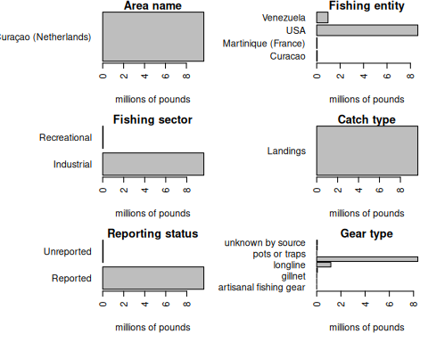
# summarize Curacao EEZ catches by fishing entity
tab <- tapply(v$pounds, list(v$year, v$fishing_entity), sum, na.rm = T)
par(mfrow = c(1, 1), mar = c(4, 4, 2, 1))
matplot(rownames(tab), tab/10^6, las = 2, type = "b", lty = 1, lwd = 2, pch = 19, col = 1:5,
xlab = "", ylab = "total catch (millions of pounds)", axes = F,
main = "Total dolphinfish catches in Curacao's EEZ")
axis(1, at = seq(1950, 2020, 5)); axis(2, las = 2); box()
legend("topleft", colnames(tab), col = 1:5, pch = 19, lty = 1, lwd = 3, bty = "n", title = "Fishing entity")
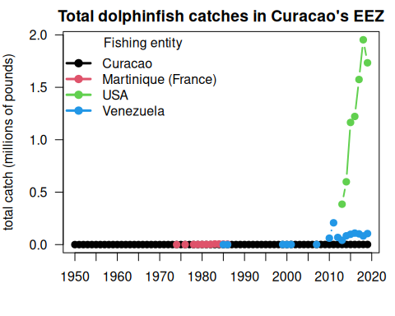
Given the sharp increase appearing in the same year (2013), we suspect that these data also appear in the database due to the spatially reshuffled landing reports to ICCAT from Coulter et al. (2020). We remove these catches from subsequent analysis given the likely error.

12.7 References
Pauly D., Zeller D., Palomares M.L.D. (Editors), 2020. Sea Around Us Concepts, Design and Data (seaaroundus.org).

13. Compilation of international catches from FAO
The Food and Agriculture Organization (FAO) is a specialized agency of the United Nations that monitors global agriculture, forestry, and fisheries. Its fisheries database provides one of the most comprehensive long-term records of international wild-capture fishing, drawing directly from official national reporting and standardized estimation models. Unlike the Sea Around Us (SAU) database, the FAO database contains only data officially declared by member countries and does not apply any catch algorithms to fill in missing data. However, as a transparent and standardized database it offers a useful comparison to the SAU database.
Annual catch data for common dolphinfish (Coryphaena hippurus) were pulled from the FAO Global Capture Production database (FAO, 2024). We filtered the dataset for FAO Fishing Areas 21 (Northwest Atlantic) and 31 (Western Central Atlantic) using the 3-alpha species code DOL. The code for the data pull is in the FAO_access_data.R file; the data are saved and accessed locally here.

13.1 Download FAO data and summarize
rm(list = ls()) # clear the workspace
# libraries
library(pals)
df <- read.csv("data/FAO_dolphin_data.csv") # open the FAO data file
head(df)
JURISDICTION AREA SCIENTIFIC_NAME YEAR
1 Belize 21 Coryphaena hippurus 2022
2 Canada 21 Coryphaena hippurus 2022
3 Spain 21 Coryphaena hippurus 2022
4 United States of America 21 Coryphaena hippurus 2022
5 Venezuela (Bolivarian Republic of) 21 Coryphaena hippurus 2022
6 Antigua and Barbuda 31 Coryphaena hippurus 2022
Landings_Tonnes
1 20.051
2 2.545
3 0.439
4 25.000
5 0.000
6 25.000
apply(df[, 1:4], 2, table)
$JURISDICTION
Antigua and Barbuda Barbados
22 73
Belize Bermuda
84 73
British Virgin Islands Canada
29 73
Costa Rica Cuba
73 52
Dominica Dominican Republic
21 55
France Grenada
72 59
Guadeloupe Martinique
73 73
Mexico Nicaragua
59 1
Other NEI Portugal
70 1
Puerto Rico Saint Kitts and Nevis
24 28
Saint Lucia Saint Vincent and the Grenadines
29 73
Spain Trinidad and Tobago
76 11
United States of America United States Virgin Islands
146 20
Venezuela (Bolivarian Republic of)
39
$AREA
21 31
242 1167
$SCIENTIFIC_NAME
Coryphaena hippurus
1409
$YEAR
1950 1951 1952 1953 1954 1955 1956 1957 1958 1959 1960 1961 1962 1963 1964 1965
13 13 13 13 13 13 13 13 13 13 13 13 13 13 15 15
1966 1967 1968 1969 1970 1971 1972 1973 1974 1975 1976 1977 1978 1979 1980 1981
15 16 16 16 17 17 17 17 17 17 17 17 17 17 17 17
1982 1983 1984 1985 1986 1987 1988 1989 1990 1991 1992 1993 1994 1995 1996 1997
17 17 17 17 17 17 17 17 18 18 18 18 20 21 20 20
1998 1999 2000 2001 2002 2003 2004 2005 2006 2007 2008 2009 2010 2011 2012 2013
19 22 22 22 23 25 25 25 24 25 25 25 25 25 28 28
2014 2015 2016 2017 2018 2019 2020 2021 2022
28 28 28 28 28 28 28 29 28
df$lbs <- df$Landings_Tonnes * 2204.62
We first look at the major countries reporting dolphin catches in the FAO database, for the historical period and the recent period. Note that only commercial catches are included for the United States.
df_recent <- df[which(df$YEAR >= 2015), ]
par(mar = c(15, 4, 1, 1), mfrow = c(2, 1), cex = 0.9)
barplot(sort(tapply(df$lbs/10^6, df$JURISDICTION, mean, na.rm = T)), las = 2, horiz = F, cex.names = 1,
ylab = "millions of pounds", main = "average annual landings (FAO 1950 - 2022)")
barplot(sort(tapply(df_recent$lbs/10^6, df_recent$JURISDICTION, mean, na.rm = T)), las = 2, horiz = F,
ylab = "millions of pounds", main = "average annual recent landings (FAO 2015 - 2022)")
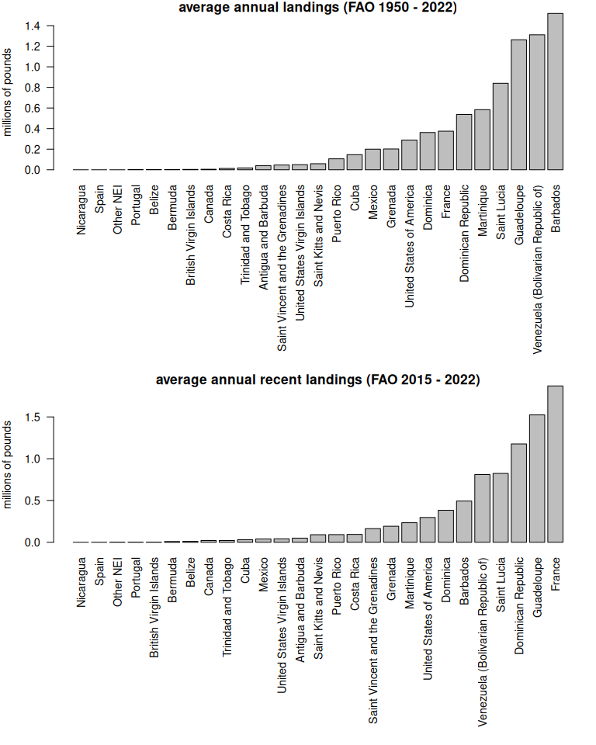

13.2 Compare FAO to SAU database
Now we will compare the international catches from FAO with the SAU catches compiled in the previous section.
df_int <- df[which(df$JURISDICTION != "United States of America"), ]
lis <- names(sort(tapply(df_int$lbs, df_int$JURISDICTION, mean, na.rm = T), decreasing = T))
df_int$JURISDICTION <- factor(df_int$JURISDICTION, levels = lis)
fao <- tapply(df_int$lbs, list(df_int$JURISDICTION, df_int$YEAR), sum, na.rm = T)
fao[is.na(fao)] <- 0
# plot FAO vs SAU
b <- barplot(fao/10^6, names.arg = 1950:2022, col = glasbey(26), border = NA, las = 2, ylim = c(0, 15),
ylab = "millions of pounds", main = "FAO reported landings by jurisdiction")
legend("topleft", ncol = 2, rownames(fao), col = glasbey(26), pch = 15, bty = "n", title = "FAO landings")
abline(h = 0)
# load data
load("data/outputs/SAU_EEZs_WCA.RData") # SAU EEZ data for NED and NCA saved from earlier
ds <- dwest
# remove bad catches from the database prior to summarizing
#dim(ds)
ds <- ds[-which(ds$area_name == "Venezuela" & ds$fishing_entity == "Unknown Fishing Country"), ]
ds <- ds[-which(ds$area_name == "Curaçao (Netherlands)" & ds$fishing_entity == "USA"), ]
#dim(ds)
tot <- tapply(ds$lbs, ds$year, sum, na.rm = T) # total catch from SAU
xs <- b[which(1950:2022 <= 2019)]
tab_ds <- tapply(ds$lbs, list(ds$year, ds$catch_type, ds$reporting_status), sum, na.rm = T)
#tail(tab_ds)
repSAU <- tab_ds[, 2, 1] # reported catch from SAU
#unrepSAU <- tab_ds[, 2, 2] # repSAU + unrepSAU is total - discards (very small)
lines(xs, tot/10^6, lty = 3, col = "#00000070", lwd = 3)
lines(xs, repSAU/10^6, lty = 1, col = 1, lwd = 3)
legend("left", c("reported + unreported", "reported"), title = "SAU landings",
lwd = 3, lty = c(3, 1), col = c("#00000070", 1), bty = "n")
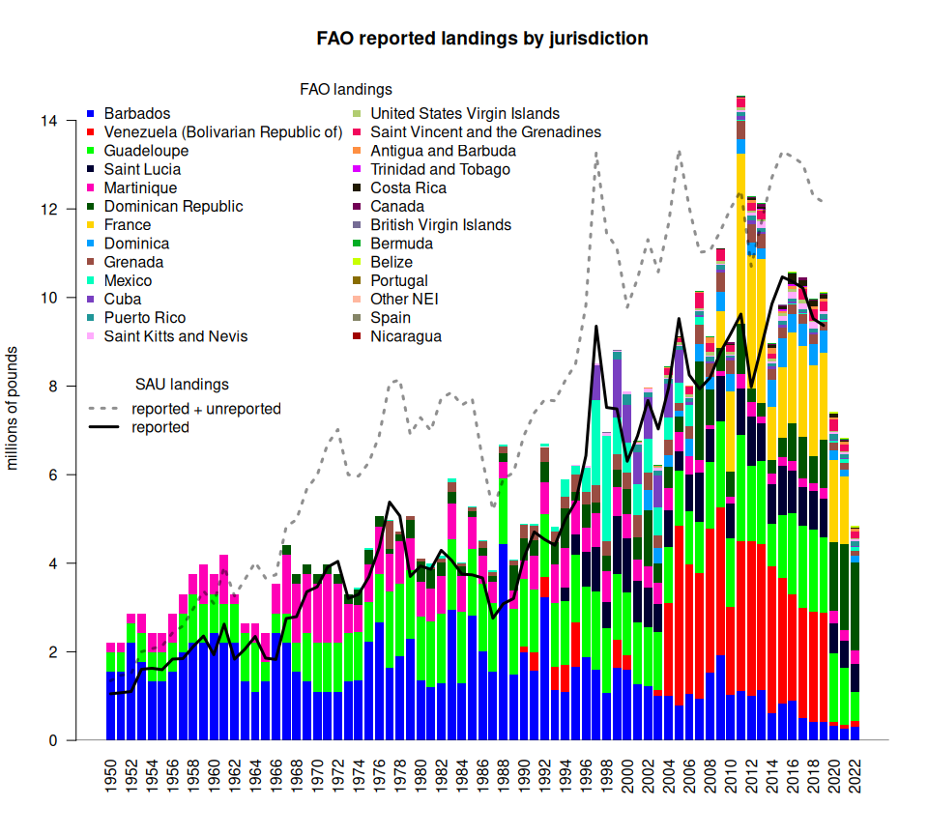
We see that the FAO landings track quite closely with respect to the overall trends in the SAU reported landings, which is what we would expect since the SAU reported landings do not include any reconstructions. In general, the FAO landings are higher than the SAU reported landings, although in some years the SAU reported landings are higher. The total SAU landings (including reconstructions of unreported data) are generally much higher than the FAO estimates, though in some years very high landings in the early 2010s the estimates from FAO exceed SAU. Of note, there is a very steep decline in FAO catches in the last three years of the database (2020 - 2022), driven primarily by a decline in reported catches from Venezuela. As the SAU database only goes up to 2019, we lack the ability to compare these years.
We compare the SAU and FAO estimates at the individual jurisdictional level to better understand the differences between databases.
sau <- tapply(ds$lbs, list(ds$year, ds$reporting_status, ds$area_name), sum, na.rm = T)
sau[is.na(sau)] <- 0
lk <- read.csv("data/FAO_SAU_lookup.csv", fileEncoding = "Windows-1252")
par(mfrow = c(9, 5), mar = c(1, 2.5, 1.5, 0.5), mgp = c(1.5, 0.5, 0))
for (i in 1:dim(sau)[3]) { # for each jurisdicion
b <- barplot(t(sau[, , i])/10^6, col = c(3, 2), # plot reported and unreported SAU data
names.arg = rep(NA, length(1950:2019)),
beside = F, border = NA, space = 0,
xlab = "", ylab = "", ylim = c(0, 4), axes = F)
repunrep <- round(rowMeans(t(sau[, , i])/10^6, na.rm = T), 2)
axis(1, at = b[seq(10, 70, 20)], lab = c("60", "80", "00", "20"), tick = F, pos = 0.2)
axis(2, las = 2, tcl = -0.2, at = 0:4)
maintext <- dimnames(sau)[[3]][i] # shorten main labels
maintext <- gsub("\\band\\b", "&", maintext, ignore.case = TRUE)
maintext <- gsub("\\b(Saint|St\\.)\\b", "St", maintext, ignore.case = TRUE)
mtext(side = 3, maintext, cex = 0.75)
mtch <- lk$FAO[which(lk$SAU == dimnames(sau)[[3]][i])] # match to FAO name with lookup table
if (mtch != "") {
f <- fao[which(rownames(fao) == mtch), 1:70]
lines(b, f/10^6, col = 1)
repunrep[3] <- round(mean(f, na.rm = T) / 10^6, 2)
}
lpos <- "topleft"; if (i == 5) { lpos = "topright"}
legend(lpos, as.character(repunrep)[3:1], text.col = c(1, 2, 3), bty = "n")
}
plot.new()
legend("center", c("FAO", "SAU unreported", "SAU reported"),
col = 1:3, lty = c(1, 0, 0), pch = c(NA, 15, 15))
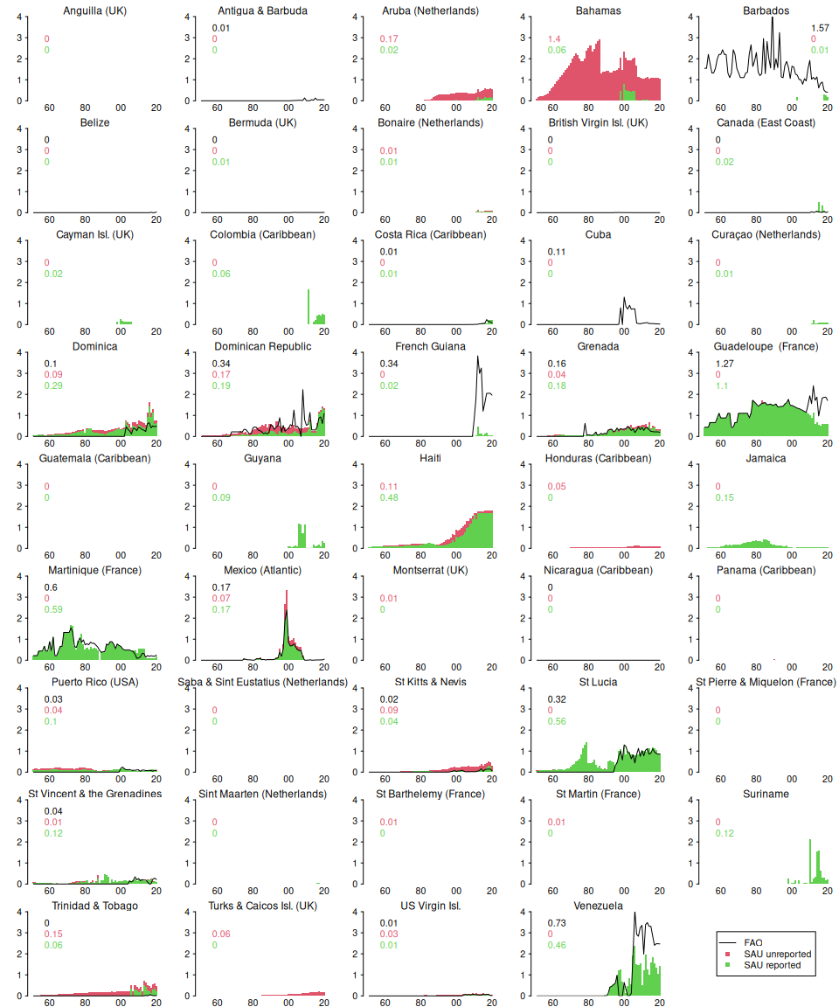
The figure shows a stacked barplot of the reported (in green) and unreported (in red) landings from the SAU database, with the FAO landings overlaid (black line). The numbers in the upper left corner are the average landings over the entire time series (in millions of pounds per year; green = reported SAU, red = unreported SAU, black = FAO); panels with missing numbers indicate that no data were available.
The comparison of FAO versus SAU databases reveals notable differences and some similarities. In a few cases, the SAU reported estimates line up closely or exactly with the FAO estimates for parts of the time series (Guadeloupe, Martinique, Saint Lucia, Venezuela). The majority of the jurisdictions have very small amounts of landings in the SAU database and no FAO reporting. Bahamas has substantial reconstructed catches and Haiti has a high number of “reported” catches in the SAU database, but neither of these countries have any reporting in the FAO database. In some cases, the FAO database contains significant landings that do not appear in the SAU database (Barbados, Cuba, French Guiana, and more recent years in Guadeloupe and Venezuela.)

13.3 Create a new maximum landings scenario dataset
Given the discrepancies revealed by the jurisdiction-level comparison, it seems likely that both SAU and FAO could potentially be missing key aspects of the international fishing. A maximum estimate of total international landings could be compiled by summarizing the maximum reported value of landings for each year, within each jurisdiction. We calculate these maxima at this resolution and recompile the data. At the time of analysis, the SAU database only contained catches to 2019, so we interpolated the 2019 values to cover years 2020 - 2022, prior to calculating the maxima.
SAU <- tapply(ds$lbs, list(ds$year, ds$area_name), sum, na.rm = T) # summary of SAU
maxland <- SAU
# dim(maxland)
maxland[is.na(maxland)] <- 0 # placeholder for maximum landings
# add 2020 - 2022 to SAU data (assume same as 2019 levels)
maxland <- rbind(maxland, maxland[nrow(maxland),], maxland[nrow(maxland),], maxland[nrow(maxland),])
for (i in 1:ncol(maxland)) { # for each jurisdiction in SAU
mtch <- lk$FAO[which(lk$SAU == dimnames(maxland)[[2]][i])] # match names using lookup table
if (mtch != "") { # if there is a match
f <- fao[which(rownames(fao) == mtch), ] # get the FAO data
temp <- cbind(f, maxland[, i])
maxl <- apply(temp, 1, max, na.rm = TRUE) # calculate the maximum value by year
maxland[, i] <- maxl # replace data with the maximum value
}
}
# now plot the maximum landings time series by jurisdiction
par(mfrow = c(9, 5), mar = c(1, 2.5, 1.5, 0.5), mgp = c(1.5, 0.5, 0))
for (i in 1:dim(maxland)[2]) {
plot(1950:2022, maxland[, i]/10^6, type = "l",
xlab = "", ylab = "", ylim = c(0, 4), axes = F)
axis(1, at = seq(1960, 2020, 20), lab = c("60", "80", "00", "20"),
tick = F, pos = 0.2)
axis(2, las = 2, tcl = -0.2, at = 0:4)
maintext <- dimnames(sau)[[3]][i]
maintext <- gsub("\\band\\b", "&", maintext, ignore.case = TRUE)
maintext <- gsub("\\b(Saint|St\\.)\\b", "St", maintext, ignore.case = TRUE)
mtext(side = 3, maintext, cex = 0.75)
}
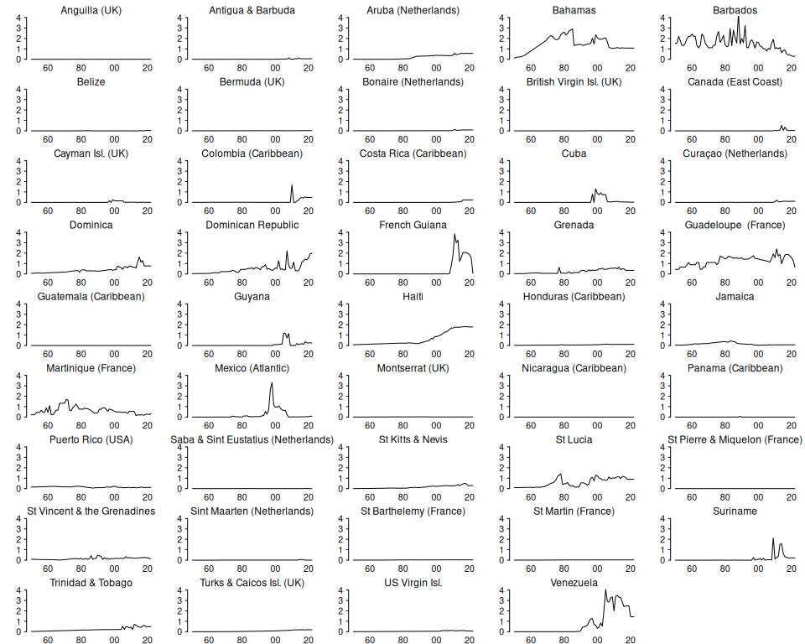
The landings time series plotted here now represent the maximum reported value in either data base.
We look at which jurisdictions are contributing to the landings, for the entire time series and more recent years, based on this new maximum assumption data set.
par(mar = c(15, 4, 1, 1), mfrow = c(2, 1), mgp = c(2.5, 0.75, 0), cex = 0.9)
barplot(sort(colMeans(maxland, na.rm = T)/10^6), las = 2, horiz = F, cex.names = 1,
ylab = "millions of pounds", main = "average annual landings (maximum of FAO or SAU, 1950 - 2022)")
barplot(sort(colMeans(tail(maxland, 8), na.rm = T)/10^6), las = 2, horiz = F,
ylab = "millions of pounds", main = "average annual recent landings (maximum of FAO or SAU, 2015 - 2022)")
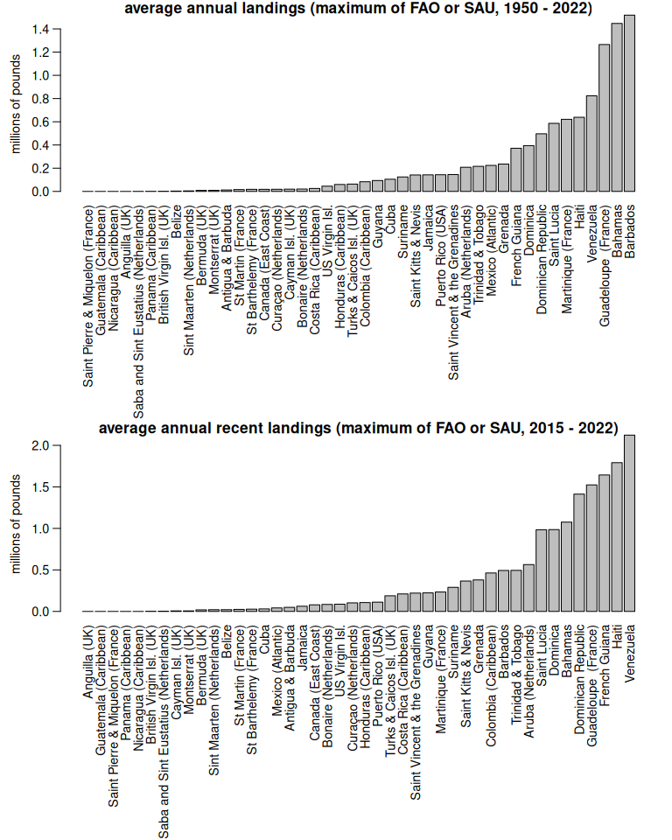
The top contributors to landings overall, according to this new combined data set, are: Barbardos (substantial landings from FAO but limited reported landings from SAU), Bahamas (no FAO data, with mostly unreported reconstructed SAU landings), and Guadeloupe (exactly the same landings reported in SAU and FAO from 1950 - 2007 with significant divergence in recent years).

13.4 Compare landings scenarios
We compare the three different time series: FAO landings, SAU landings, and maximum landings, across the entire time series.
par(mar = c(4, 4, 2, 1), mgp = c(2.2, 1, 0))
plot(1950:2022, rowSums(maxland, na.rm = T)/10^6, type = "l", ylim = c(0, 22), las = 1, lwd = 2,
xlab = "year", ylab = "millions of pounds", col = 3,
main = "Total estimated international dolphin landings from different data sources")
lines(1950:2019, rowSums(SAU, na.rm = T)/10^6, col = 2, lty = 1, lwd = 2)
lines(1950:2022, colSums(fao, na.rm = T)/10^6, col = 4, lty = 1, lwd = 2)
text(2022, round(sum(maxland[nrow(maxland), ])/10^6, 1), round(sum(maxland[nrow(maxland), ])/10^6, 1), pos= 1, col = 3, font = 2)
text(2019, round(sum(SAU[nrow(SAU), ], na.rm = T)/10^6, 1), round(sum(SAU[nrow(SAU), ], na.rm = T)/10^6, 1), pos= 1, col = 2, font = 2)
text(2022, round(sum(fao[, ncol(fao)], na.rm = T)/10^6, 1), round(sum(fao[, ncol(fao)], na.rm = T)/10^6, 1), pos= 1, col = 4, font = 2)
legend("topleft", c("maximum of either SAU or FAO", "SAU (Sea Around Us)", "FAO (Food and Agriculture Organization)"),
col = c(3, 2, 4), lty = 1, lwd = 3)
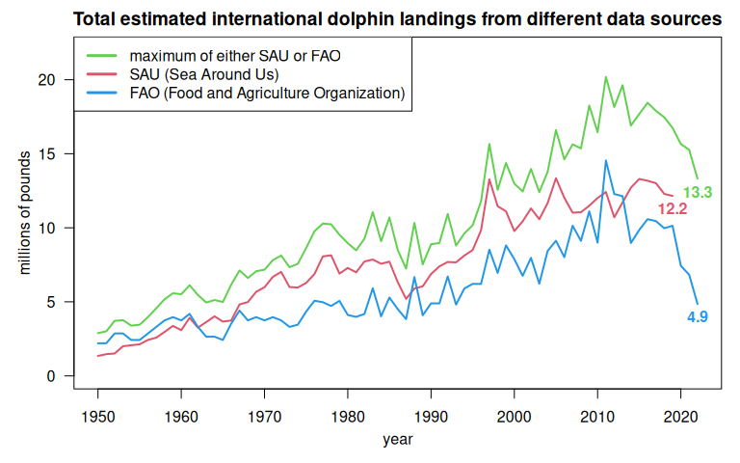
The three different time series are similar in magnitude and trend during the first several decades, and grow increasingly divergent in time. The numbers on the plot show the total landings from each time series in the terminal year of data.
We take a closer look at the years of data used in the dolphin operating model.
par(mar = c(4, 4, 2, 1), mgp = c(2.2, 1, 0))
plot(1986:2022, rowSums(tail(maxland, 37), na.rm = T)/10^6, type = "l", ylim = c(0, 20), las = 1, lwd = 2,
xlab = "year", ylab = "millions of pounds", col = 3,
main = "Total estimated international dolphin landings from different data sources")
lines(1986:2019, rowSums(tail(SAU, 34), na.rm = T)/10^6, col = 2, lty = 1, lwd = 2)
lines(1986:2022, colSums(fao[, 37:73], na.rm = T)/10^6, col = 4, lty = 1, lwd = 2)
abline(h = mean(rowSums(tail(maxland, 37), na.rm = T)/10^6), col = "#00FF0030", lwd = 4, lty = 3)
abline(h = mean(rowSums(tail(SAU, 34), na.rm = T)/10^6), col = "#FF00FF30", lwd = 4, lty = 3)
abline(h = mean(colSums(fao[, 37:73], na.rm = T)/10^6), col = "#00FFFF30", lwd = 4, lty = 3)
legend("bottomright", c("maximum of either SAU or FAO", "SAU (Sea Around Us)",
"FAO (Food and Agriculture Organization)", "average over time series"),
col = c(3, 2, 4, "#00000030"), lty = c(1, 1, 1, 3), lwd = c(2, 2, 2, 3), bty = "n")
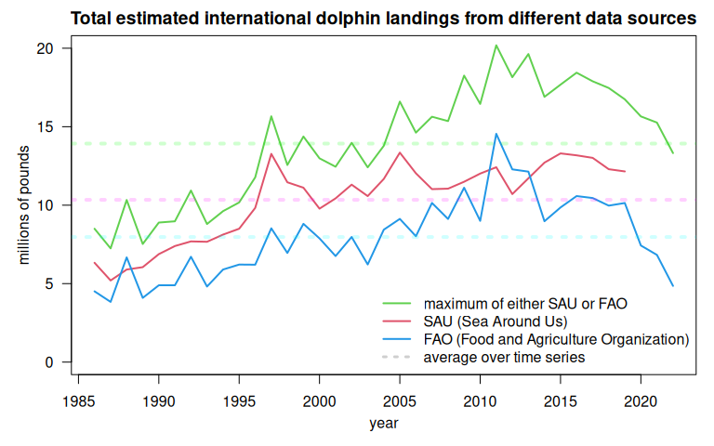
The more recent data show that assumptions regarding levels of international catches vary quite widely depending on the data source. The maximum landings data suggest that catches have increased significantly from 1986 to 2011, followed by a substantial decrease with the most recent landings just below the average of the time series. The SAU data suggest an increase from 1986 to the late 1990s, with relatively stable landings over the last 20 years. Finally, the FAO data suggests an increase in the early years with a large peak in 2011, followed by a significant decline, with the most recent landings falling back to the late 1980s levels.

13.5 Output scenarios
For the management strategy evaluation, we build into the operating model multiple international landings scenarios to account for the wide uncertainty in international removals. The FAO time series (blue) versus the maximum landings scenario (green) provides good contrast in terms of the magnitude of removals as well as recent trends. We acknowledge that the FAO landings, which only include reported data, are likely an underestimate of true landings as there are likely to be unreported landings in this region. However, this scenario provides a more robust test of the management procedures, because lower international landings will result in changes to domestic U.S. fisheries having a greater influence on the stock.
fao1 <- t(fao)
#dim(fao1)
#dim(maxland)
# remove Canada and St. Pierre and Miquelon as these are already accounted for in the NED
fao1 <- fao1[, -grep("Canada", colnames(fao1))]
maxland <- maxland[, -grep("Canada", colnames(maxland))]
maxland <- maxland[, -grep("Pierre", colnames(maxland))]
hi <- rowSums(maxland, na.rm = T)
lo <- rowSums(fao1, na.rm = T)
fin <- data.frame(cbind(1950:2022, lo, hi))
names(fin)[1] <- "year"
head(fin)
year lo hi
1950 1950 2204620 2888241
1951 1951 2204620 3011134
1952 1952 2866006 3714998
1953 1953 2866006 3765129
1954 1954 2425082 3392490
1955 1955 2425082 3453073
# output high and low scenarios for further compilation
write.csv(fin, file = "data/hi_lo_CAR_landings.csv", row.names = FALSE)

13.6 References
FAO. (2024). Fisheries and Aquaculture Division: Global Capture Production 1950–2022 (Release 2024.1.0) [Data set]. Food and Agriculture Organization of the United Nations. https://www.fao.org/fishery/collection/capture/en

14. Compilation of international catches

14.1 Compile catch in CAR and NED jurisdictional waters by discards and reporting type
Now that we have separated the EEZ catch by region, we will summarize it according to the areas used in the dolphin management strategy evaluation operating model. For the Caribbean region, we have the high and low international catch scenarios that we compile for the sensitivity analyses in the operating model.
rm(list = ls()) # clear the workspace
# load data
load("data/outputs/SAU_EEZs_WCA.RData") # SAU EEZ data for NED and NCA saved from earlier
# summarize the catch by area and separate out Canadian landings
tapply(dwest$lbs, dwest$reg, sum, na.rm = T)
Canadian EEZ Western Central Atlantic EEZs
1220146 571673711
dwest$year <- factor(dwest$year, levels = 1950:2019)
dc <- dwest[which(dwest$reg == "Canadian EEZ"), ]
CAN <- tapply(dc$lbs, dc$year, sum, na.rm = T)
#tail(CAN)
# load Caribbean international landings scenarios
car_sc <- read.csv("data/hi_lo_CAR_landings.csv")
car_sc <- car_sc[which(car_sc$year >= 1986), ] # only need data 1986 and onwards
head(car_sc)
year lo hi
37 1986 4508448 8496677
38 1987 3836039 7246145
39 1988 6671180 10331010
40 1989 4091775 7526003
41 1990 4894256 8891365
42 1991 4894256 8971473
# combine CAR reported landings, unreported discards, unreported landings
CARlo <- car_sc$lo
CARhi <- car_sc$hi

14.2 Distribute the territorial international catches across quarters of the year
The international catches are only reported as annual catches and do not have any month or season associated with them. However, the MSE operating model requires seasonal catches. Lacking other information on the seasonality of these fleets, we will assume that the fleet distribution of the U.S. pelagic longline is representative of the seasonality of the jurisdictional fleets. Now we parse the annual catches according to the seasonality of the U.S. fleet.
The pelagic longline logbook data is only available going back to 1997, but there are Caribbean catches extending back to the 1950s. To interpolate the seasonality for 1986 - 1996, we take the average seasonality of the oldest 10 years of logbook data (1997 - 2006) and use those averages for the unknown years.
# read in the percentage of the catch by area and year-quarter combinations from the U.S. PLL
load("data/outputs/per_PLLcatch_by_area_yearquarter.RData")
names(percatch[1, 1, ]) # matrix 2 == Caribbean, matrix 7 == NED (Atlantic Northwest)
[1] "NCA" "CAR" "FLK" "NCFL" "NNC" "VBM" "NED"
# parse Canada data into quarters
CAN <- CAN[which(rownames(CAN) >= 1997)] # PLL data are only available from 1997 on
CAN <- c(CAN, CAN[length(CAN)], CAN[length(CAN)], CAN[length(CAN)]) # interpolate 2019 catches for 2020-2022
CANqrt <- percatch[, , 7] # create matrix for final catch data
for (i in 1:ncol(percatch)) {
CANqrt[, i] <- percatch[, i, 7] * CAN[i] }
percatch_car <- percatch[, , 2] # create matrix for Caribbean percentages
int <- rowMeans(percatch_car[, 1:10]) # calculate the average seasonality using the oldest 10 years of logbook data
percatch_car <- cbind(matrix(rep(int, length(1986:1996)), nrow = 4), percatch_car) # attach those 10-year averages to years 1986:1996
colnames(percatch_car) <- 1986:2022 # full data frame for Caribbean seasonality 1986 - 2022
length(CARlo)
[1] 37
dim(percatch_car)
[1] 4 37
CARlo_qrt <- percatch_car # create matrices for final catch data
CARhi_qrt <- percatch_car
for (i in 1:ncol(percatch_car)) {
CARlo_qrt[, i] <- percatch_car[, i] * CARlo[i]
CARhi_qrt[, i] <- percatch_car[, i] * CARhi[i]
}
# ensure sums are equal after parsing
sum(CARlo_qrt); sum(CARlo)
[1] 294505847
[1] 294505847
sum(CARhi_qrt); sum(CARhi)
[1] 513883150
[1] 513883150
sum(CAN, na.rm = T); sum(CANqrt, na.rm = T)
[1] 1328482
[1] 1328482
The Canada jurisdictional data need to be combined with the NED high seas data calculated in the previous section, because both of these are a component of the international catches in the NED area.
load("data/outputs/NED_year_quarter.RData")
NEDtot <- NED + CANqrt
# ensure sums are correct
sum(NED, na.rm = T) + sum(CANqrt, na.rm = T); sum(NEDtot, na.rm = T)
[1] 1808855
[1] 1808855
NEDtot <- NEDtot[, !is.na(colSums(NEDtot))] # remove NA columns from CAN data
# plot the parsed out data by year-quarter
yrs <- sort(rep(as.numeric(colnames(CARlo_qrt)), 4))
qrt <- rep(1:4, length(yrs)/4)
yrs1 <- sort(rep(as.numeric(colnames(NEDtot)), 4))
qrt1 <- rep(1:4, length(yrs1)/4)
matplot(yrs + qrt/4, cbind(matrix(CARhi_qrt), matrix(CARlo_qrt))/10^6, lty = 1, lwd = 2,
col = 2:3, type = "l", main = "International jurisdictional catches by quarter",
xlab = "", ylab = "total catch (millions of pounds)")
lines(yrs1 + qrt1/4, as.numeric(matrix(NEDtot))/10^6, lwd = 2, col = 4)
legend("topleft", c("Caribbean landings - high scenario",
"Caribbean landings - low scenario", "NED reported landings"),
lwd = 2, col = 2:4, bty = "n")
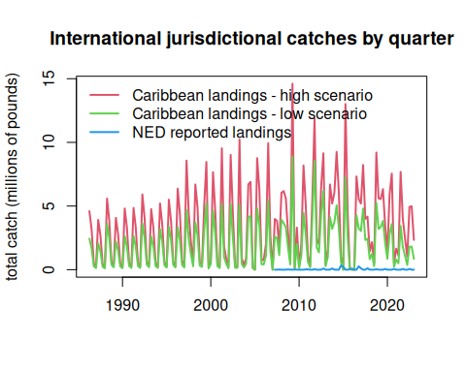
Finally, we format the data in the format for input into the operating model.
# format for operating model - Caribbean
flt <- rep("Intl", length(yrs))
are <- rep("CAR", length(yrs))
# high and low landings scenarios
finhi <- data.frame(cbind(yrs, qrt, flt, are, matrix(CARhi_qrt)))
finlo <- data.frame(cbind(yrs, qrt, flt, are, matrix(CARlo_qrt)))
# format final matrices
names(finhi) <- c("Year", "Quarter", "Fleet", "Area", "Catch_lbs")
finhi$Catch_lbs <- as.numeric(finhi$Catch_lbs)
head(finhi)
Year Quarter Fleet Area Catch_lbs
1 1986 1 Intl CAR 4595149.4
2 1986 2 Intl CAR 3158470.6
3 1986 3 Intl CAR 500827.7
4 1986 4 Intl CAR 242229.6
5 1987 1 Intl CAR 3918839.7
6 1987 2 Intl CAR 2693610.0
names(finlo) <- c("Year", "Quarter", "Fleet", "Area", "Catch_lbs")
finlo$Catch_lbs <- as.numeric(finlo$Catch_lbs)
head(finlo)
Year Quarter Fleet Area Catch_lbs
1 1986 1 Intl CAR 2438246.3
2 1986 2 Intl CAR 1675925.7
3 1986 3 Intl CAR 265745.7
4 1986 4 Intl CAR 128530.2
5 1987 1 Intl CAR 2074595.8
6 1987 2 Intl CAR 1425971.1
#par(mfrow = c(2, 2))
#plot(finhi$Catch_lbs, type = "l")
#plot(finhi$Catch_lbs ~ factor(finhi$Fleet))
#plot(finhi$Catch_lbs ~ factor(finhi$Quarter))
#plot(finhi$Catch_lbs ~ factor(finhi$Year))
#apply(finhi, 2, table)
# write the output files for both scenarios
write.csv(finhi, file = "data/FINAL_files/CAR_Intl_hi_TomFormat.csv", row.names = FALSE)
write.csv(finlo, file = "data/FINAL_files/CAR_Intl_lo_TomFormat.csv", row.names = FALSE)
# format for operating model - NED
flt <- rep("Intl", length(yrs1))
are <- rep("NED", length(yrs1))
fin <- data.frame(cbind(yrs1, qrt1, flt, are, matrix(NEDtot)), stringsAsFactors = FALSE)
names(fin) <- c("Year", "Quarter", "Fleet", "Area", "Catch_lbs")
fin$Catch_lbs <- as.numeric(fin$Catch_lbs)
head(fin)
Year Quarter Fleet Area Catch_lbs
1 2007 1 Intl NED 0.000
2 2007 2 Intl NED 1450.366
3 2007 3 Intl NED 13279.912
4 2007 4 Intl NED 0.000
5 2008 1 Intl NED 0.000
6 2008 2 Intl NED 1312.750
#apply(fin, 2, table)
# write output file
write.csv(fin, file = "data/FINAL_files/NED_Intl_TomFormat.csv", row.names = FALSE)
#barplot(tapply(fin$Catch_lbs, list(fin$Quarter), sum, na.rm = T), col = rainbow(4))

15. Data compilation for all fleets in the operating model
In this last step we will compile all of the output data files from the different data sources (NMFS commercial trip tickets, NMFS recreational statistics, Sea Around Us) and check the files for accuracy.
Recall that there are seven defined areas in the operating model, over which the landings are summed. Four of these areas are within the U.S. EEZ and the other three areas are international waters (high seas and jurisdictional waters of other countries).
** Later due to computational issues in resolving the very fine spatial scales, we collapsed the seven areas into five areas, combining CAR + FLK into one area and NNC + VBM into another area.
Areas defined in the operating model.

15.1 Data upload
First we access all of the final data files from the previous steps.
# clear workspace
rm(list = ls())
# view data files in directory
dir("data/FINAL_files/")
[1] "CAR_Intl_hi_TomFormat.csv"
[2] "CAR_Intl_lo_TomFormat.csv"
[3] "commercial_TomFormat.csv"
[4] "complete_catch_dataset_100526_high.csv"
[5] "complete_catch_dataset_100526_low.csv"
[6] "NCA_Intl_TomFormat.csv"
[7] "NED_Intl_TomFormat.csv"
[8] "rec_catch_TomFormat.csv"
scenario <- "high"
if (scenario == "high") { intc <- read.csv("data/FINAL_files/CAR_Intl_hi_TomFormat.csv") } # high intl scenario
if (scenario == "low") { intc <- read.csv("data/FINAL_files/CAR_Intl_lo_TomFormat.csv") } # low intl scenario
intn <- read.csv("data/FINAL_files/NCA_Intl_TomFormat.csv")
intw <- read.csv("data/FINAL_files/NED_Intl_TomFormat.csv")
com <- read.csv("data/FINAL_files/commercial_TomFormat.csv")
rec <- read.csv("data/FINAL_files/rec_catch_TomFormat.csv")
The “CAR_Intl_hi_TomFormat.csv” file contains all international landings and unreported catches for the greater Caribbean region (jurisdictional waters of all countries). This includes unreported data and discards, which were very small (< 1%). Recall that we consider two scenarios: a high and a low international removals scenario. For the visualization here we use the high catch scenario.
apply(intc[1:4], 2, table, useNA = "always")
$Year
1986 1987 1988 1989 1990 1991 1992 1993 1994 1995 1996 1997 1998 1999 2000 2001
4 4 4 4 4 4 4 4 4 4 4 4 4 4 4 4
2002 2003 2004 2005 2006 2007 2008 2009 2010 2011 2012 2013 2014 2015 2016 2017
4 4 4 4 4 4 4 4 4 4 4 4 4 4 4 4
2018 2019 2020 2021 2022 <NA>
4 4 4 4 4 0
$Quarter
1 2 3 4 <NA>
37 37 37 37 0
$Fleet
Intl <NA>
148 0
$Area
CAR <NA>
148 0
intc$Area <- "FLKCAR"
The “NCA_Intl_TomFormat.csv” file contains all international landings for the NCA region (i.e., FAO region 31), also known as the Western Central Atlantic. There are no territorial waters in this area (except for Bermuda, which as discussed previously is summarized with the CAR region) and there are no unreported catches or discards in the database.
apply(intn[1:4], 2, table, useNA = "always")
$Year
1997 1998 1999 2000 2001 2002 2003 2004 2005 2006 2007 2008 2009 2010 2011 2012
4 4 4 4 4 4 4 4 4 4 4 4 4 4 4 4
2013 2014 2015 2016 2017 2018 2019 2020 2021 2022 <NA>
4 4 4 4 4 4 4 4 4 4 0
$Quarter
1 2 3 4 <NA>
26 26 26 26 0
$Fleet
Intl <NA>
104 0
$Area
NCA <NA>
104 0
The “NED_Intl_TomFormat.csv” file contains all international landings for the NED region (i.e., FAO region 21), also known as the Northwest Atlantic. This includes NED high seas landings, as well as landings from Canadian and French territorial waters which fall in this region. There are no unreported catches or discards for this region in the database.
apply(intw[1:4], 2, table, useNA = "always")
$Year
2007 2008 2009 2010 2011 2012 2013 2014 2015 2016 2017 2018 2019 2020 2021 2022
4 4 4 4 4 4 4 4 4 4 4 4 4 4 4 4
<NA>
0
$Quarter
1 2 3 4 <NA>
16 16 16 16 0
$Fleet
Intl <NA>
64 0
$Area
NED <NA>
64 0
The “commercial_TomFormat.csv” file contains all landings for the U.S. commercial fleet, including landings from U.S. EEZs and high seas. There are no unreported catches in this region. Recall that estimated dead discards were very small (< 2%) and were removed from the summary.
apply(com[1:4], 2, table, useNA = "always")
$Year
1986 1987 1988 1989 1990 1991 1992 1993 1994 1995 1996 1997 1998 1999 2000 2001
28 28 28 28 28 28 28 28 28 28 28 28 28 28 28 28
2002 2003 2004 2005 2006 2007 2008 2009 2010 2011 2012 2013 2014 2015 2016 2017
28 28 28 28 28 28 28 28 28 28 28 28 28 28 28 28
2018 2019 2020 2021 2022 <NA>
28 28 28 28 28 0
$Quarter
1 2 3 4 <NA>
259 259 259 259 0
$Fleet
UScom <NA>
1036 0
$Area
CAR FLK NCA NCFL NED NNC VBM <NA>
148 148 148 148 148 148 148 0
com$Area[which(com$Area == "CAR")] <- "FLKCAR"
com$Area[which(com$Area == "FLK")] <- "FLKCAR"
com$Area[which(com$Area == "NNC")] <- "NNCVBM"
com$Area[which(com$Area == "VBM")] <- "NNCVBM"
table(com$Area, useNA = "always")
FLKCAR NCA NCFL NED NNCVBM <NA>
296 148 148 148 296 0
The “rec_catch_TomFormat.csv” file contains all landings for the U.S. recreational fleet, which are all assumed to occur within the U.S. EEZs. There are no unreported catches in this region. This file also includes dead discards, which were calculated from the database by year and region and added into the total catch.
apply(rec[1:4], 2, table, useNA = "always")
$Year
1986 1987 1988 1989 1990 1991 1992 1993 1994 1995 1996 1997 1998 1999 2000 2001
32 32 32 32 32 32 32 32 32 32 32 32 32 32 32 32
2002 2003 2004 2005 2006 2007 2008 2009 2010 2011 2012 2013 2014 2015 2016 2017
32 32 32 32 32 32 32 32 32 32 32 32 32 32 32 32
2018 2019 2020 2021 2022 <NA>
32 32 32 32 32 0
$Quarter
1 2 3 4 <NA>
296 296 296 296 0
$Fleet
Hire Rec <NA>
592 592 0
$Area
FLK NCFL NNC VBM <NA>
296 296 296 296 0
rec$Area[which(rec$Area == "FLK")] <- "FLKCAR"
rec$Area[which(rec$Area == "NNC")] <- "NNCVBM"
rec$Area[which(rec$Area == "VBM")] <- "NNCVBM"
table(rec$Area, useNA = "always")
FLKCAR NCFL NNCVBM <NA>
296 296 592 0
Now we combine the data files and create some figures with the final composite data file.
d <- rbind(intc, intn, intw, com, rec)
# how many rows contain zeros
#hist(d$Catch_lbs)
table(d$Catch_lbs == 0)
FALSE TRUE
1904 632
# resort levels geographically
d$Area <- factor(d$Area, levels = c("NCA", "FLKCAR", "NCFL", "NNCVBM", "NED"))
d$Fleet <- factor(d$Fleet, levels = c("Rec", "Hire", "UScom", "Intl"))

15.2 Visualizing the final data set
We plot the final data set in a number of different ways to detect any errors that may have occurred during processing.
# plot the total landings by each factor
par(mfrow = c(2, 2), mex = 0.7)
barplot(tapply(d$Catch_lbs, d$Year, sum, na.rm = T)/10^6, las = 2,
main = "Total landings by year", ylab = "total landings (millions of pounds)")
barplot(tapply(d$Catch_lbs, d$Quarter, sum, na.rm = T)/10^6,
ylab = "total landings (millions of pounds)", main = "Total landings by quarter")
barplot(tapply(d$Catch_lbs, d$Fleet, sum, na.rm = T)/10^6,
main = "Total landings by fleet", ylab = "total landings (millions of pounds)")
barplot(tapply(d$Catch_lbs, d$Area, sum, na.rm = T)/10^6,
main = "Total landings by area", ylab = "total landings (millions of pounds)")
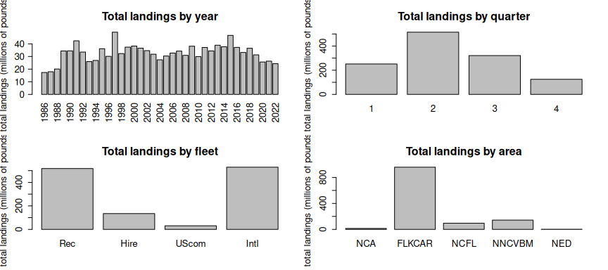
The total landings in the regions analyzed is highly variable but relatively stable over time with a slight decrease in recent years. Most of the landings are caught in quarter 2 (March - May). The largest sector is the U.S. private recreational sector, followed by international fleets (all types), the for-hire fleet and then the U.S. commercial fleet. Most of the fishing activity takes place in the Florida Keys and the Greater Caribbean, with other regions contributing much less.
cols <- c("blue", "deepskyblue", "chartreuse3", "red")
par(mfrow = c(1, 1), mar = c(2, 5, 3, 1))
tab <- tapply(d$Catch_lbs, list(d$Fleet, d$Area), sum, na.rm = T)/10^6
barplot(tab, beside = T, col = cols, legend = rownames(tab),
main = "Total dolphin landings by area and fleet",
ylab = "total landings (millions of pounds)")
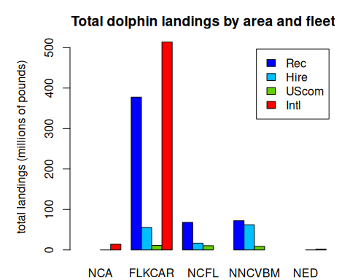
As expected, U.S. recreational fishing (private and for-hire) only takes place in the four U.S. EEZ regions (FLK, NCFL, NNC and VBM). The U.S. commercial fishery operates largely in those four U.S. EEZ regions, with small amounts of landings in the high seas of NCA, CAR and NED regions. International landings occur largely in the Caribbean, with lesser amounts in the NCA and NED high seas regions.
tab <- tapply(d$Catch_lbs, list(d$Quarter, d$Area), sum, na.rm = T)/10^6
tabp <- apply(tab, 2, function(x) x / sum(x, na.rm = T))
par(mar = c(2, 4, 3, 1))
barplot(tabp, beside = T, col = c("#8CD3DF", "#78B781", "#FFC107", "#A33851"),
legend = c("winter (DJF)", "spring (MAM)", "summer (JJA)", "fall (SON)"),
args.legend = list(x = 15, y = 0.7, bty = "n"),
main = "Total dolphin landings by area and season",
ylab = "proportion of landings")
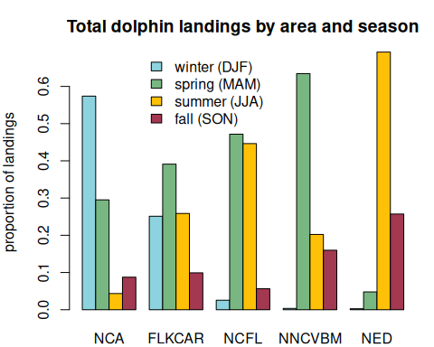
This plot shows the seasonal movements of dolphin across the different regions, as expressed through the proportion of landings that occurs in each quarter within each area. In the NCA and CAR regions, most of the landings occur in winter, whereas in the U.S. South Atlantic regions, most of the landings occur in spring and summer. In the U.S. Mid-Atlantic the landings also occur largely in spring, and also fall. In the NED region most of the landings occur in summer.
tab <- tapply(d$Catch_lbs, list(d$Year, d$Fleet), sum, na.rm = T)/10^6
par(mar = c(2, 4, 3, 1))
matplot(rownames(tab), tab,
col = cols,
type = "l", lwd = 2, lty = c(rep(1, 3), 2, 2),
main = "Total annual dolphin landings by fleet", xlab = "",
ylab = "total landings (millions of pounds)")
legend(2000, 27, lwd = 2, lty = c(rep(1, 3), 2, 2), bty = "n",
c("U.S. private rec", "U.S. for-hire", "U.S. commercial",
"International"),
col = cols)
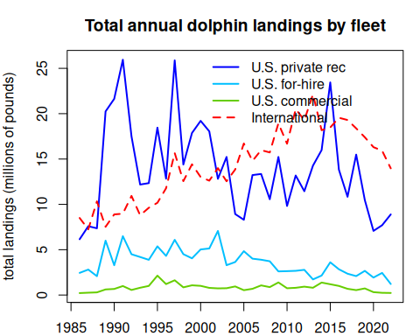
This plot shows the time series of total annual dolphin landings by fleet. We can compare these figures with the plots from the previous chapters to ensure the data were processed correctly. The magnitude and variability of the landings match the expectations.
# output the final concatenated data file
if (scenario == "high") {
write.csv(d, file = "data/FINAL_files/complete_catch_dataset_100526_high.csv", row.names = FALSE) } # high intl scenario
if (scenario == "low") {
write.csv(d, file = "data/FINAL_files/complete_catch_dataset_100526_low.csv", row.names = FALSE) } # low intl scenario
d1 <- d[which(d$Year == 2022), ]
d1$ar2 <- ""
d1$ar2[which(d1$Area == "FLK")] <- "S"
d1$ar2[which(d1$Area == "NCFL")] <- "S"
d1$ar2[which(d1$Area == "NNC")] <- "N"
d1$ar2[which(d1$Area == "VBM")] <- "N"
d1$cat <- paste0(d1$Fleet, d1$ar2)
d1$cat[which(d1$Fleet == "UScom")] <- "UScom"
round(tapply(d1$Catch_lbs, d1$cat, sum, na.rm = T)/10^6/2.205, 3)
Hire HireS Intl Rec RecS UScom
0.509 0.044 6.337 2.784 1.248 0.104

16. Predictive indices of dolphin abundance
Dolphin abundance in South Atlantic waters is driven by a combination of factors that are mostly outside of U.S. fishery management control, including environmental conditions and catch in international waters. In order to create a management procedure for the dolphin management strategy evaluation we need an index that can predict ahead of time whether the abundance of dolphin in U.S. waters is likely to be above or below average in a given year. Ideally this index can capture the dynamics early in the year or a season ahead in order to allow adequate time for management response. In the following sections we explore potential predictive indices of dolphin abundance.

16.1 Recreational landings as a proxy for availability
Because the recreational landings is generally unconstrained by management (the total quota is rarely reached and landings are on average well below the bag limits), the total recreational landings could serve as a proxy for dolphin availability in South Atlantic waters over time. We take the recreational data from Section 3 and summarize according to the areas specified by the management strategy evaluation: Florida Keys to Indian River County County (FLK), Brevard to Southern NC South of Hatteras (NCFL), Northern NC North of Hatteras to NC/VA border (NNC), and Virginia to Maine (VBM). We also include Gulf of America landings because dolphin are not managed in the Gulf region and thus the landings are not constrained by management and is most likely a function of availability.
# clear workspace
rm(list = ls())
# install library
if(!require("readr")) install.packages("readr")
library(readr)
# read in data file
rec <- read.csv("data/recLandings.csv")
names(rec)[1] <- "Year"

16.2 Plot the recreational landings
Plotting the total recreational landings by region and the proportion of landings by region, we can observe that most of the landings in U.S. waters came from the FLK region, particularly in the earlier years. More recently, an increasing proportion of the landings has been coming from NCFL and further north, with FLK composing only about 50% of the landings. Gulf landings have historically been a small proportion of the total landings and have remained small throughout time. Landings in the VBM region were historically very small (~1%) but in recent years have varied between 10-18% of the landings.
# plot landings -------------------------------------------------
matplot(rec$Year, rec[2:6]/10^6, type = "l", lty = 1, lwd = 2, col = 1:5,
xlab = "year", ylab = "total landings (millions of pounds)",
main = "Total recreational landings in U.S. waters by region")
legend("topright", colnames(rec)[2:6], col = 1:5, lty = 1, lwd = 2, bty = "n")
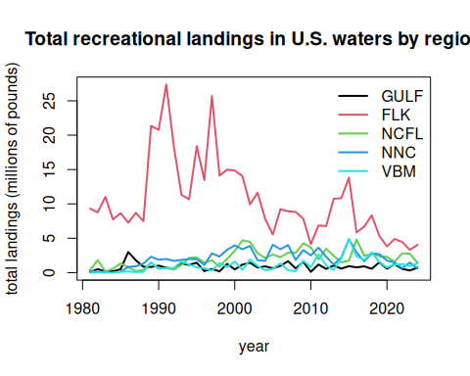
# plot in terms of percentages ---------------------------------
rec1 <- rec[2:6]
rec1 <- as.matrix(rec1/rowSums(rec1, na.rm = T))
rec1[is.na(rec1)] <- 0
b <- barplot(t(rec1), col = 1:5, names.arg = rec$Year, las = 1, ylim = c(0, 1.05),
ylab = "proportion of landings",
main = "Proportion of recreational landings in U.S. waters by region",
legend.text = colnames(rec)[2:6], args.legend = list(x = 45, y = 1.15, horiz = T, bty = "n"))
abline(h=0)
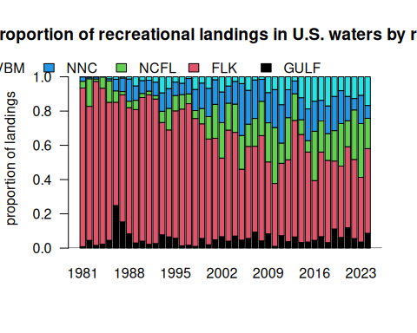
# calculate total landings and South Atlantic landings for later analysis
rec$ATL <- rowSums(rec[3:6], na.rm = T)
rec$ALL <- rec$GULF + rec$ATL
# subset data from 1990 forward
rec <- rec[which(rec$Year >= 1990), ]
Recreational monitoring was first established in 1979 and went through a number of changes in the 1980s, particularly related to monitoring of the for-hire fleet. We can see a very large jump in landings in the late 1980s that we suspect is related to some of these changes in methodology. For our data explorations we will use recreational data from 1990 forward as a reference period in which the monitoring was more standardized.

16.3 Potential influence of El Niño Southern Oscillation
We note that many large peaks in recreational landings have occurred in years where there were severe El Niño events (e.g., 1997-1998, 2015). We first explore the El Niño Southern Oscillation (ENSO) as a potential environmental predictor of dolphin abundace. An index based on El Niño is potentially attractive because there is some ability for seasonal predictions of El Niño (3-6 months ahead of time). As large-scale disruptors of atmospheric conditions across the globe, El Niño events have impacts on the distribution of temperatures in the Atlantic and could trigger changes in fish distributions.
We use the multivariate ENSO index from NOAA’s Physical Sciences Laboratory, which combines the influences of five different variables related to Pacific Ocean state into one index. The index is updated monthly and historical data can be downloaded directly from the site.
#download ENSO index
url <- "https://www.psl.noaa.gov/enso/mei/data/meiv2.data"
download.file(url = url, destfile = "data/enso.txt")
all_lines <- readLines("data/enso.txt")
footer_start <- grep("-999", all_lines)
e <- read.table("data/enso.txt", skip = 1, nrows = footer_start[1] - 2)
names(e) <- c("Year", "DJ", "JF", "FM", "MA", "AM", "MJ", "JJ", "JA", "AS", "SO", "ON", "ND")
ets <- as.vector(as.matrix(t(e[2:13])))
years <- sort(rep(e$Year, 12)) + rep((0:11)/12, length(min(e$Year):max(e$Year)))
barplot(ets, names.arg = floor(years), las = 2,
col = ifelse(ets >= 0, "lightgreen", "red"), border= NA, ylim = c(-3, 3),
main = "multivariate ENSO index", xlab = "Year", ylab = "ENSO index")
abline(h = 0)
text(346, 2, "El Niño events")
text(346, -2, "La Niña events")
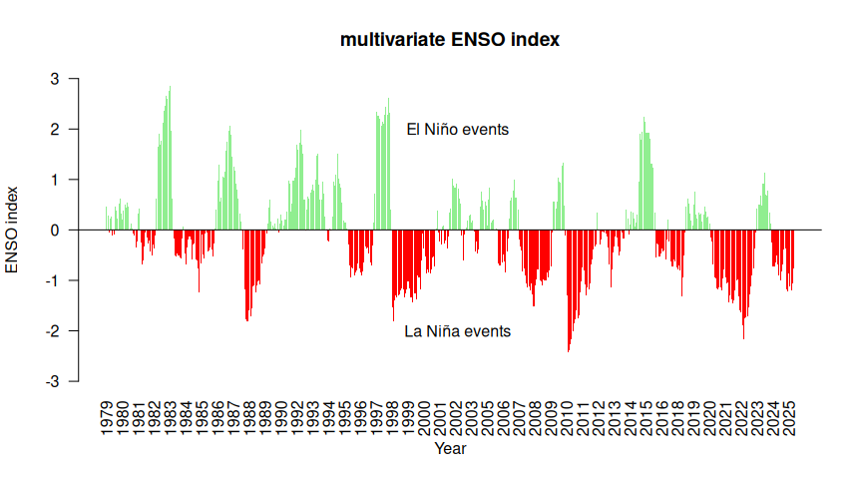
Here is the raw time series, showing positive and negative anomalies in the ENSO state.
Now we will compare the ENSO index to the recreational landings. First we compare the annual average ENSO index to the landings from the different regions. We report adjusted R-squared values and p-values for linear regression of the ENSO index versus the landings; significant relationships are highlighted in blue.
# calculate mean
e$mean <- rowMeans(e[2:13], na.rm = T)
# merge years with recreational landings data
d <- merge(rec, e, by = "Year")
#head(d)
lis <- names(d)[2:7]
par(mfrow = c(2, 3), mex = 0.8, mgp = c(2.5, 1, 0))
for(i in 1:6) {
catch <- d[, which(names(d) == lis[i])]
plot(d$mean, catch, xlab = "annual ENSO index", ylab = "landings (millions of lbs)",
col = 8, main = paste0("region = ", lis[i]))
out <- lm(catch ~ d$mean)
abline(out, col = 8, lty = 2)
r2 <- summary(out)$r.squared
p_val <- summary(out)$coefficients[2, 4]
p_display <- ifelse(p_val < 0.001, "p < 0.001", paste("p =", round(p_val, 3)))
co <- 1
if (p_val < 0.01) { co <- 4 }
if (p_val < 0.001) { co <- 5 }
legend("topleft",
legend = bquote(R^2 == .(round(r2, 2)) ~ "; " ~ p == .(round(p_val, 3))),
bty = "n", cex = 1.2, text.col = co)
}
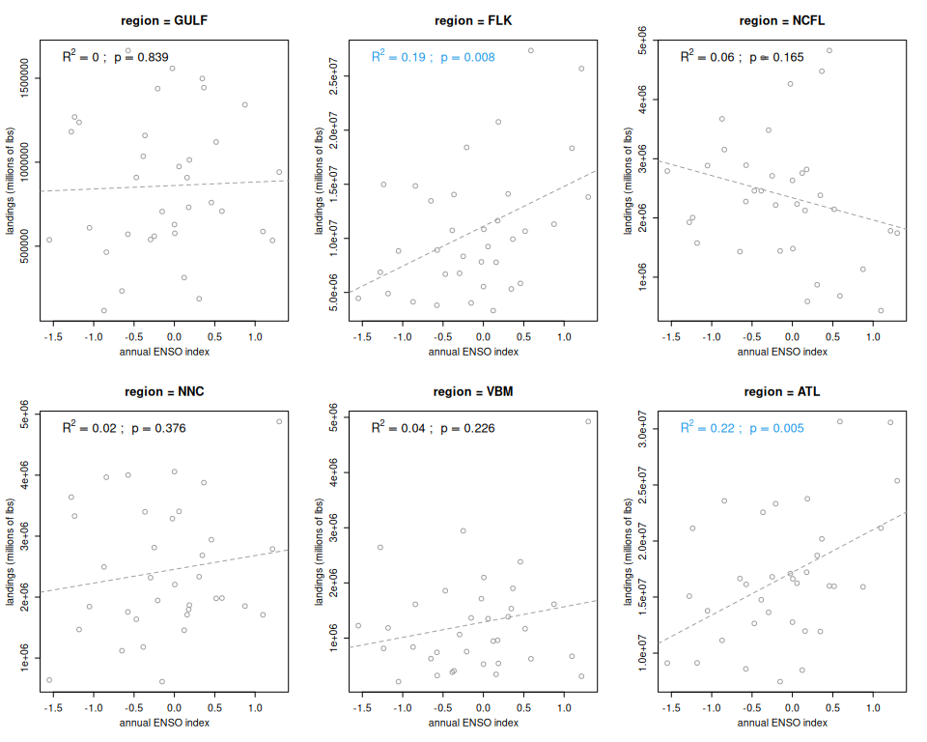
The ENSO index appears to be most closely related to the total recreational landings across the South Atlantic (driven primarily by landings in the FLK region). The relationship is highly significant and the ENSO index explains 19% of the variation in the total landings.

16.4 Seasonal influence of El Niño Southern Oscillation
Now we will consider the seasonal influence of ENSO, looking at correlations between the index during individual months and the landings. Since the strongest relationship occurs with the total South Atlantic landings, we will use these landings in the analysis.
lis <- names(e)[2:13]
par(mfrow = c(3, 4), mex = 0.8)
for(i in 1:12) {
ind <- d[, which(names(d) == lis[i])]
plot(ind, d$ATL/10^6, xlab = paste(lis[i], "ENSO index"), ylab = "landings (millions of lbs)", las = 1)
out <- lm(d$ATL/10^6 ~ ind)
abline(out)
r2 <- summary(out)$r.squared
p_val <- summary(out)$coefficients[2, 4]
p_display <- ifelse(p_val < 0.001, "p < 0.001", paste("p =", round(p_val, 3)))
co <- 1
if (p_val < 0.01) { co <- 4 }
if (p_val < 0.001) { co <- 5 }
legend("topleft",
legend = bquote(R^2 == .(round(r2, 2)) ~ "; " ~ p == .(round(p_val, 3))),
bty = "n", cex = 1.2, text.col = co)
}
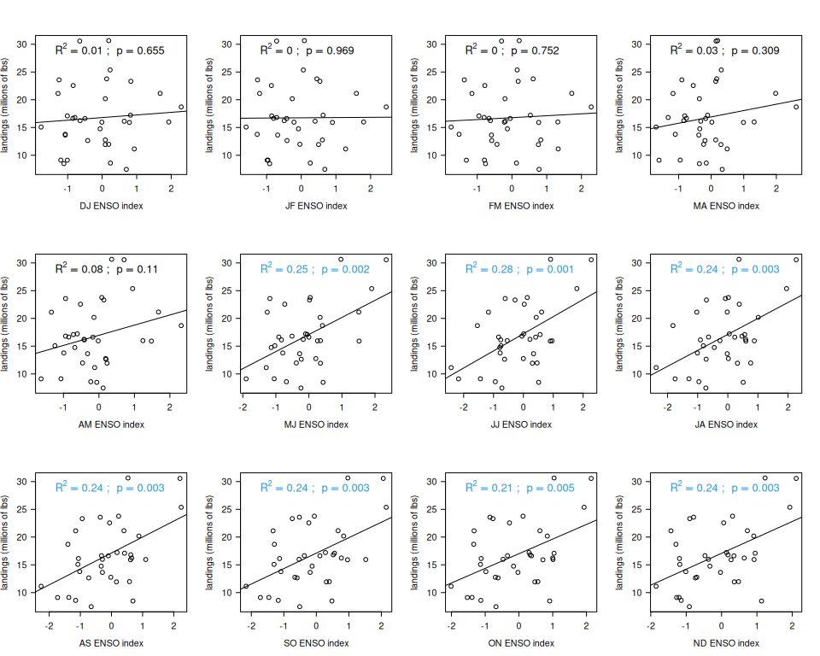
A significant relationship between the monthly ENSO index and total South Atlantic recreational landings occurs with the May-June index, but the strongest relationship occurs in June-July (with 26% of the variance in landings explained by the index in that month). The relationship in the late summer and fall months are also significant, which is expected since the ENSO index is highly correlated from month to month.
We will test the June-July ENSO index in the management procedure as it has the strongest relationship.
par(mfrow = c(1, 1))
plot(d$JJ, d$ATL/10^6, xlab = "June-July ENSO index", ylab = "total U.S. Atlantic coast recreational landings", col = 0, las = 1)
text(d$JJ, d$ATL/10^6, d$Year, col = 8)
out <- lm(d$ATL/10^6 ~ d$JJ)
abline(out, col = 1)
p <- summary(out)$coef[2, 4]
legend("topleft", paste0("R^2 = ", round(summary(out)$adj.r.squared, 2), "; p = ",
round(p, 3)), cex = 1.2, bty = "n", text.col = 1)
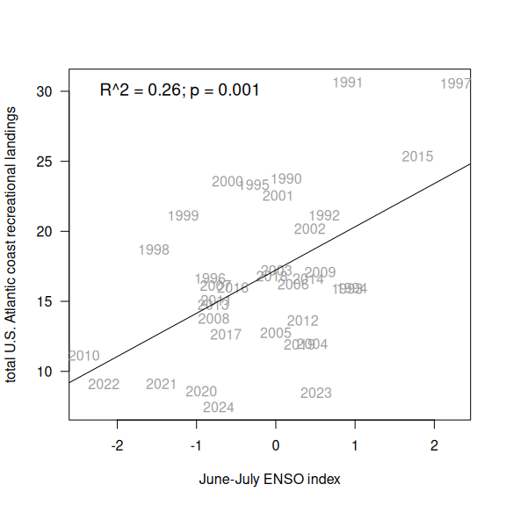
summary(out)
Call:
lm(formula = d$ATL/10^6 ~ d$JJ)
Residuals:
Min 1Q Median 3Q Max
-10.332 -3.886 -0.054 2.320 10.606
Coefficients:
Estimate Std. Error t value Pr(>|t|)
(Intercept) 17.2374 0.8641 19.949 < 2e-16 ***
d$JJ 3.0873 0.8680 3.557 0.00116 **
---
Signif. codes: 0 '***' 0.001 '**' 0.01 '*' 0.05 '.' 0.1 ' ' 1
Residual standard error: 5.046 on 33 degrees of freedom
Multiple R-squared: 0.2771, Adjusted R-squared: 0.2552
F-statistic: 12.65 on 1 and 33 DF, p-value: 0.001161
# save the index to the indices file
ind <- data.frame(cbind(d$Year, d$JJ))
write.csv(ind, file = "indices/enso_index.csv", row.names = F)

17. Wider Atlantic temperature distribution index
Dolphin have a circumtropical distribution, migrating to temperate waters in summer and tropical waters in winter, in a circular pattern around the Atlantic Ocean. Studies using satellite tagging have shown that, similar to other highly migratory species, they prefer waters within a narrow temperature range, of 27-30 degrees Celsius Schlenker et al. 2021. To determine whether shifting temperature distributions across the Atlantic could be impacting the abundance in U.S. waters, we analyzed Atlantic Ocean temperature patterns at the large spatial and temporal scale.

17.1 Accessing temperature data
For this analysis we need a historical temperature record that is available at large spatial (entire Atlantic) and temporal (monthly-yearly) scales. We use NOAA’s Extended Reconstructed Sea Surface Temperature (ERSST) data, provided by the NOAA National Centers for Environmental Information and available through ERDDAP. This temperature record goes back to the mid-1800s, is available at monthly time steps and a 2°x2° grid size resolution, and is suitable for looking at large-scale patterns over decades. We download the data from 1980 - present and subset for the Atlantic Ocean from 100°W - 0°W longitude and 0°N - 70°N latitude.
# clear workspace
rm(list = ls())
# install libraries
if(!require("maps")) install.packages("maps")
# if(!require("ncdf4")) install.packages("ncdf4")
# if(!require("lubridate")) install.packages("lubridate")
# if(!require("rerddap")) install.packages("rerddap")
library(maps)
# library(ncdf4)
# library(lubridate)
# library(rerddap)
# get ERDDAP info
# id <- info('nceiErsstv5') #https://coastwatch.pfeg.noaa.gov/erddap/griddap/nceiErsstv5.html
# download data using griddap - initially takes a long time
# uncomment lines below to update analysis
# sst_grab <- griddap(id, fields = 'sst',
# time = c('1990-01-01', '2025-01-01'),
# longitude = c(260, 358), latitude = c(0, 70))
# open nc file and extract variables
# nc <- nc_open(sst_grab$summary$filename, write=FALSE, readunlim=TRUE, verbose=FALSE)
# v1 <- nc$var[[1]]
# sst <- ncvar_get(nc, v1)
# lon <- v1$dim[[1]]$vals - 360
# lat <- v1$dim[[2]]$vals
# nc_close(nc)
# convert time variable to month and year
#tim <- as.POSIXct(v1$dim[[4]]$vals, origin = "1970-01-01")
#mon <- as.numeric(substr(tim, 6, 7))
#yr <- substr(tim, 1, 4)
#dim(sst)
#save(sst, lon, lat, tim, mon, yr, file = "data/ERSST.RData")
load("data/ERSST.RData")
# check conversions
tim[1:5]
[1] "1990-01-01 UTC" "1990-02-01 UTC" "1990-03-01 UTC" "1990-04-01 UTC"
[5] "1990-05-01 UTC"
table(mon)
mon
1 2 3 4 5 6 7 8 9 10 11 12
36 35 35 35 35 35 35 35 35 35 35 35
table(yr)
yr
1989 1990 1991 1992 1993 1994 1995 1996 1997 1998 1999 2000 2001 2002 2003 2004
1 12 12 12 12 12 12 12 12 12 12 12 12 12 12 12
2005 2006 2007 2008 2009 2010 2011 2012 2013 2014 2015 2016 2017 2018 2019 2020
12 12 11 12 12 12 12 12 12 12 12 12 12 12 12 12
2021 2022 2023 2024 2025
12 12 12 12 1
# plot SST on map for first time step
par(mfrow = c(1, 2))
image(lon, lat, sst[, , 100], las = 1, xlab = "longitude (deg W)", ylab = "latitude (deg N)",
main = "Snapshot of ERSST data"); box()
# fill Pacific Ocean with NAs so values are not included
sst[which(lon <= (-92)), which(lat <= 17.5), ] <- NA
sst[which(lon <= (-85)), which(lat <= 15), ] <- NA
sst[which(lon <= (-83)), which(lat <= 10), ] <- NA
sst[which(lon <= (-77)), which(lat <= 8.5), ] <- NA
sst[which(lon <= (-78) & lon >= (-80)), which(lat <= 9), ] <- NA
image(lon, lat, sst[, , 100], las = 1, xlab = "longitude (deg W)", ylab = "latitude (deg N)",
main = "Snapshot of ERSST data\n(Pacific excluded)"); box()
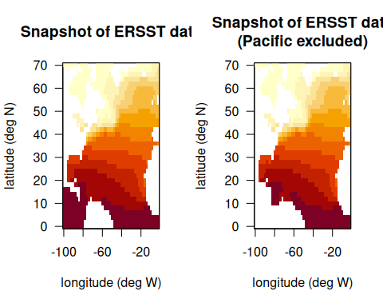

17.2 Analyzing high and low availability years
In order to identify potential temperature patterns that are influential in driving dolphin abundance in the U.S. South Atlantic waters, we identify the years of highest and lowest landings and look at the temperature distributions monthly in those years.
# upload recreational landings
rec <- read.csv("data/recLandings.csv")
names(rec)[1] <- "Year"
# summarize by basin and total
rec$ATL <- rowSums(rec[3:6], na.rm = T)
rec$ALL <- rec$GULF + rec$ATL
# consider 1990 and forward
rec <- rec[which(rec$Year >= 1990), ]
# sort years from lowest to higher landings
sortyr <- rec$Year[order(rec$ALL)]
# cols <- rainbow(100, start = 0.1, end = 0.65)[100:1]
cols <- c(0, rainbow(3, start = 0.4, end = 0.6), 2)
# set up plot
nf <- layout(matrix(c(2:56, rep(1, 11), 57:111), 11, 11, byrow = FALSE),
c(rep(3, 5), 2, rep(3, 5)), c(4, rep(3, 11)))
#layout.show(nf)
#legend
par(mar = c(0, 0, 0, 0))
plot(1, type = "n", axes = FALSE, xlab = "", ylab = "")
legend("center", fill = cols, c("<26", "26-27", "27-28.5", "28.5-30", ">30"),
border = c(1, 0, 0, 0, 0),
pt.cex = 2, bty = "n",
title = "SST\n(deg C)", title.font = 2)
# sort years from lowest to highest landings
yrs <- c(sortyr[1:5], sortyr[(length(sortyr)-4): length(sortyr)])
#yrs
status <- c(rep("low", 5), rep("high", 5))
status[1] <- "lowest"
status[10] <- "highest"
# for lowest and highest years, visualize temperature patterns across the Atlantic
for (j in 1: length(yrs)) {
k <- which(yr == yrs[j])
# print(data.frame(tim[k], yr[k], mon[k]))
par(mex = 0.5, mar = c(2, 2, 2, 2)+1)
plot(rec$Year, rec$ALL/10^6, type = "l", col = 4, ylim = c(0, 32), lwd = 2, ylab = "rec landings",
main = yrs[j])
text(1990, 3, status[j], pos = 4)
abline(v = yrs[j], col = 8, lwd = 3)
# plot months February through November
for (i in k[2:11]) {
par(mex = 0.3, mar = c(2, 3, 2, 0))
map("world", xlim = c(-100, -15), ylim = c(0, 45), col = 0)
axis(1); axis(2, las = 2); box()
image(lon, lat, sst[, , i], add = T, col = cols, breaks = c(-2, 26, 27, 28.5, 30, 32))
text(-33, 40, paste(month.abb[mon[i]]), cex = 1)
map("world", add = T, col = gray(0.5)); box()
contour(lon, lat, sst[, , i], levels = c(30), add = T, col = c(2), lwd = 2, drawlabels = FALSE)
contour(lon, lat, sst[, , i], levels = c(28.5), add = T, col = 1, lwd = 2, drawlabels = FALSE)
}
}
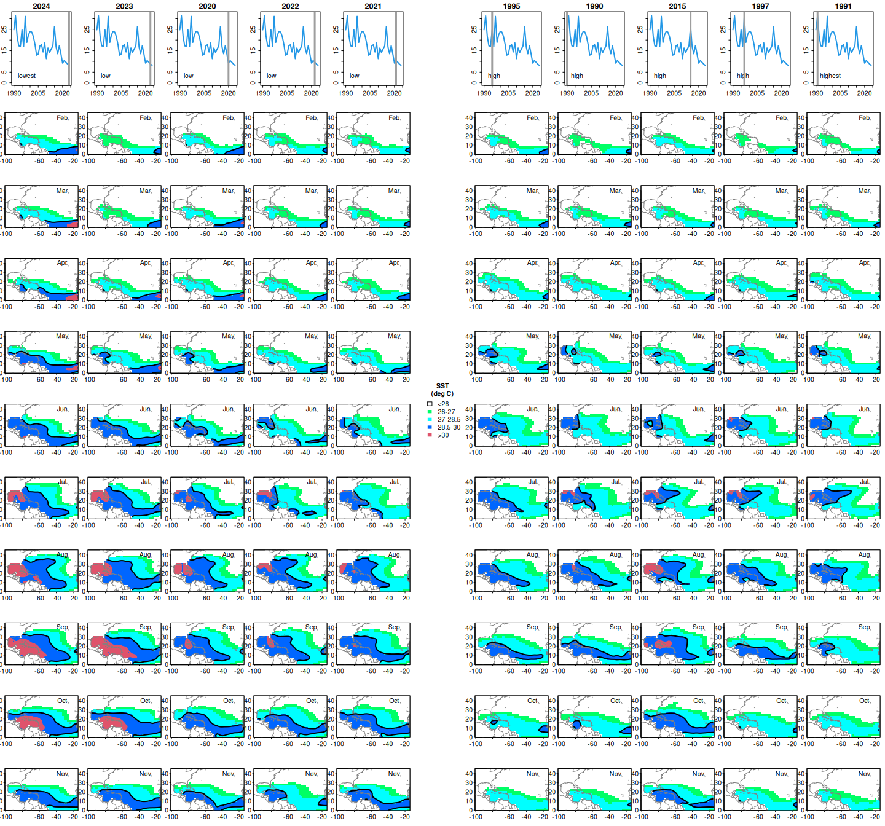
Looking at the set of plots on the left side (low abundance years) versus the right side (high abundance years), there seems to be a particularly notable pattern with respect to temperatures in the range of 28.5° - 30° Celsius. In the low abundance years, temperatures in this range are distributed in a band across the Atlantic near the equator. In the high abundance years, waters near the equator are much cooler and the 28.5° - 30° temperatures appear to be concentrated in a very small area near the Florida Keys. This pattern seems most prominent in the months of May and June.

17.3 May temperature distributions
We will take a closer look at May temperature distributions across the Atlantic for the full time series. Here we display all of the May temperatures from 1990 to present, ordered from lowest to highest years of recreational landings in the U.S. South Atlantic.
# look at May patterns --------------------
par(mfrow = c(6, 6), mex = 0.5, mar = c(2, 2, 2, 0))
for (j in 1: length(sortyr)) {
k <- which(yr == sortyr[j])
for (i in k[5]) {
map("world", xlim = c(-100, -10), ylim = c(0, 50), col = 0)
axis(1); axis(2, las = 2); box()
image(lon, lat, sst[, , i], add = T, col = cols, breaks = c(-2, 26, 27, 28.5, 30, 32))
map("usa", add = T, col = gray(0.5)); box()
mtext(side = 3, line = 0.5, sortyr[j])
contour(lon, lat, sst[, , i], levels = c(30), add = T, col = c(2), lwd = 2, drawlabels = FALSE)
contour(lon, lat, sst[, , i], levels = c(28.5), add = T, col = 1, lwd = 2, drawlabels = FALSE)
rect(-100, 0, -30, 32, col = NA, border = 2, lwd = 1.5)
rect(-99, 18, -78, 31, col = NA, border = 7, lwd = 1.5)
}
}
par(mar = c(0, 0, 0, 0))
plot(1, type = "n", axes = FALSE, xlab = "", ylab = "")
legend("center", fill = cols, c("<26", "26-27", "27-28.5", "28.5-30", ">30"),
border = c(1, 0, 0, 0, 0),
pt.cex = 2, bty = "n",
title = "SST (deg C)", title.font = 2)
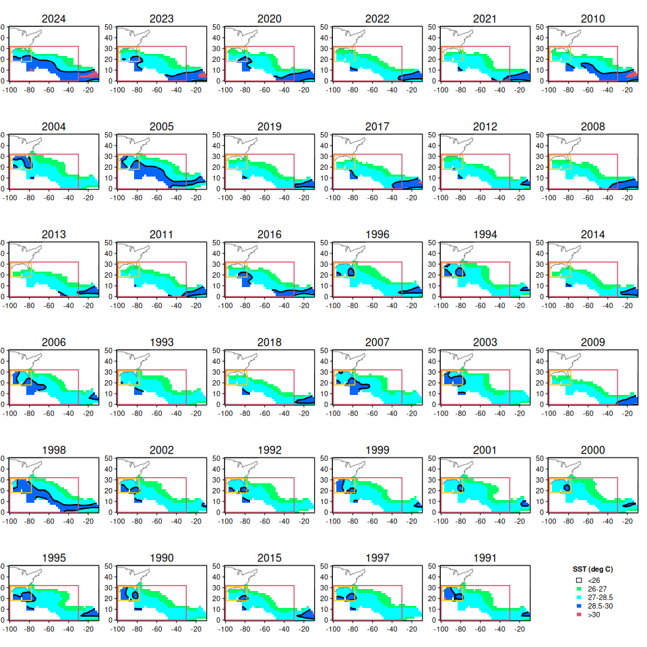
The pattern with 28.5° - 30° C waters seems to hold across all years, with low abundance years (top) tending to have these waters distributed across the Atlantic, and high abundance years (bottom) tending to have these waters restricted to a small area near the Gulf and U.S. South Atlantic.

17.4 Quantifying the temperature distribution in an index
We can attempt to quantify these patterns in an index by calculating a proportion of waters covered by the dark blue water mass. It seems most useful to consider the coverage of this water mass that occurs in U.S. South Atlantic waters (approximately the yellow box; 100°W-78°W and 18°N-32°N) versus the coverage of this water mass in the larger North Atlantic region (the larger red box; 100°W-30°W and 0°-32°N). We first calculate the number of cells in which these 28.5° - 30° C waters occur in each box, and then divide to obtain an overall proportion.
# calculate proportion of 28.5 - 30 degree C waters in US South Atlantic waters
# subset the temperature data to 100W - 30W and 0N - 32N
lons <- which(lon >= (-100) & lon <= (-30))
lats <- which(lat >= (0) & lat <= (32))
lon[lons]
[1] -100 -98 -96 -94 -92 -90 -88 -86 -84 -82 -80 -78 -76 -74 -72
[16] -70 -68 -66 -64 -62 -60 -58 -56 -54 -52 -50 -48 -46 -44 -42
[31] -40 -38 -36 -34 -32 -30
lat[lats]
[1] 0 2 4 6 8 10 12 14 16 18 20 22 24 26 28 30 32
# find indexing for 100W - 78W and 18N - 32N
lonind <- which(lon[lons] <= (-78) & lon[lons] >= (-100))
latind <- which(lat[lats] <=32 & lat[lats] >= 18)
# subset SST data for all May months
kar <- sst[lons, lats, which(mon == 5)]
# create empty data frame
ind <- data.frame(matrix(ncol = 2, nrow = dim(kar)[3],
dimnames = list(NULL, c("Year", "perar"))))
ind$Year <- yr[which(mon == 5)]
# for each year, identify SST cells between 28.5 and 30 degrees
# calculate the proportion of those waters within the small box out of the large box
for (i in 1:dim(kar)[3]) {
k1 <- kar[, , i]
k2 <- (k1 >28.5 & k1 < 30.0)
ind$perar[i] <- length(which(k2[lonind, latind] == TRUE))/ length(which(k2 == TRUE))
}
# replace NA values with zero
ind$perar[which(is.na(ind$perar))] <- 0
ind
Year perar
1 1990 0.8666667
2 1991 1.0000000
3 1992 0.7000000
4 1993 0.1666667
5 1994 0.9629630
6 1995 0.7692308
7 1996 0.8666667
8 1997 0.8500000
9 1998 0.3402778
10 1999 0.9393939
11 2000 1.0000000
12 2001 1.0000000
13 2002 0.8076923
14 2003 0.8723404
15 2004 0.9411765
16 2005 0.2214286
17 2006 0.4444444
18 2007 0.3888889
19 2008 0.0000000
20 2009 0.0000000
21 2010 0.0000000
22 2011 0.0000000
23 2012 0.4000000
24 2013 0.0000000
25 2014 0.0000000
26 2015 0.7500000
27 2016 0.2343750
28 2017 0.0000000
29 2018 0.0000000
30 2019 0.0000000
31 2020 0.1929825
32 2021 0.0000000
33 2022 0.0000000
34 2023 0.2500000
35 2024 0.1538462
yrs <- sortyr[order(sortyr)]
par(mfrow = c(6, 6), mex = 0.5, mar = c(2, 2, 2, 0))
for (j in 1:length(yrs)) {
k <- which(yr == yrs[j])
for (i in k[5]) {
map("world", xlim = c(-100, -10), ylim = c(0, 50), col = 0)
axis(1); axis(2, las = 2); box()
image(lon, lat, sst[, , i], add = T, col = cols, breaks = c(-2, 26, 27, 28.5, 30, 32))
map("usa", add = T, col = gray(0.5)); box()
mtext(side = 3, line = 0.5, yrs[j])
text(-38, 45, paste("index =", round(ind$perar[which(ind$Year == yrs[j])], 2)))
contour(lon, lat, sst[, , i], levels = c(30), add = T, col = c(2), lwd = 2, drawlabels = FALSE)
contour(lon, lat, sst[, , i], levels = c(28.5), add = T, col = 1, lwd = 2, drawlabels = FALSE)
rect(-100, 0, -30, 32, col = NA, border = 2, lwd = 1.5)
rect(-99, 18, -78, 31, col = NA, border = 7, lwd = 1.5)
}
}
par(mar = c(0, 0, 0, 0))
plot(1, type = "n", axes = FALSE, xlab = "", ylab = "")
legend("center", fill = cols, c("<26", "26-27", "27-28.5", "28.5-30", ">30"),
border = c(1, 0, 0, 0, 0),
pt.cex = 2, bty = "n",
title = "SST (deg C)", title.font = 2)
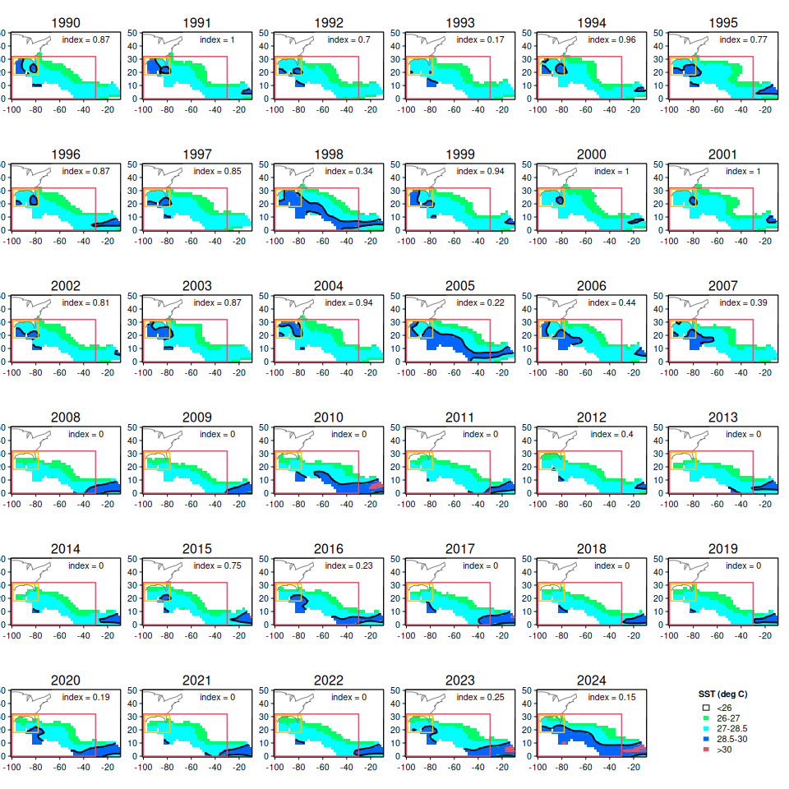
To ensure correct calculation of the index we re-display the May temperature patterns in chronological order and note the index value on each plot.

17.5 Comparison of “blue blob” index with landings
Now we plot the “blue blob” index against the recreational landings.
# merge new index with landings data
d <- merge(rec, ind, by = "Year")
#head(d)
# plot the "blue blob" index against recreational landings
par(mar = c(5, 5, 1, 1))
plot(d$perar, d$ATL/10^6, col = 0,
xlab = "proportion of preferred dolphin temperatures near\nU.S. jurisdictions (out of entire Caribbean basin) in May",
ylab = "total U.S. Atlantic coast recreational landings\n(millions of pounds)")
text(d$perar, d$ATL/10^6, d$Year)
out <- lm(d$ATL/10^6 ~ d$perar)
abline(out, lty = 2, col = 2)
abline(v = mean(d$perar), col = 8)
abline(h = mean(d$ATL)/10^6, col = 8)
text(0.7, 28, "preferred temperatures clustered\nnear U.S. waters == higher landings", col = "darkgreen", font = 3)
text(0.25, 10.5, "preferred temperatures extend across\nCaribbean and/or absent from\nU.S waters == lower landings", col = "darkred", font = 3)
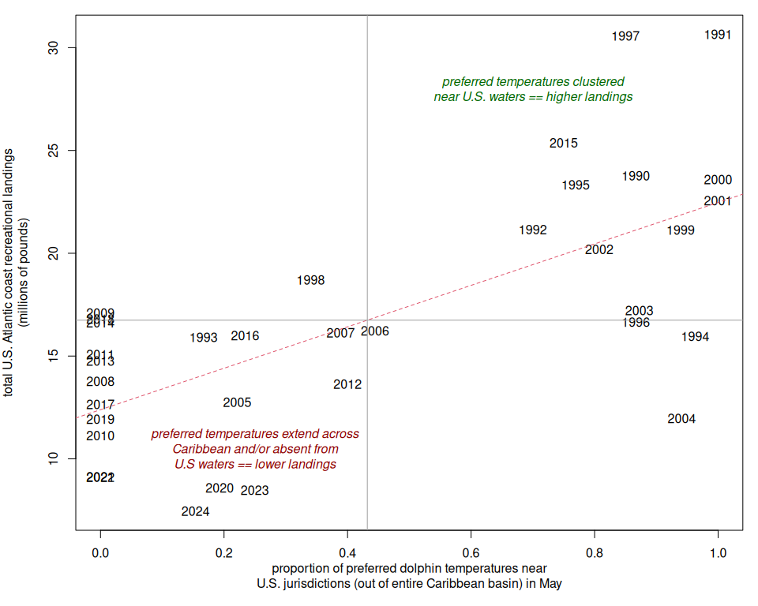
We can see that a statistical relationship does exist, whereby above average “blue blob” index values are associated with above average recreational landings in U.S. South Atlantic waters, and below average index values are associated with below average landings. Gray lines denote the mean values for the index and the landings; we see that this relationship holds true for almost all years in the time series.
The “blue blob” index explains about 45% of the variation in the landings in the U.S. South Atlantic.
summary(out)
Call:
lm(formula = d$ATL/10^6 ~ d$perar)
Residuals:
Min 1Q Median 3Q Max
-9.9082 -3.0254 0.0927 2.6638 9.6171
Coefficients:
Estimate Std. Error t value Pr(>|t|)
(Intercept) 12.391 1.094 11.324 6.58e-13 ***
d$perar 10.079 1.880 5.361 6.35e-06 ***
---
Signif. codes: 0 '***' 0.001 '**' 0.01 '*' 0.05 '.' 0.1 ' ' 1
Residual standard error: 4.339 on 33 degrees of freedom
Multiple R-squared: 0.4655, Adjusted R-squared: 0.4493
F-statistic: 28.74 on 1 and 33 DF, p-value: 6.352e-06
# output the index
write.csv(ind, file = "indices/blue_blob_index.csv", row.names = F)

18. Puerto Rico tournament index
In this section we consider tournament data from the U.S. Caribbean as a potential predictive index for dolphin abundance in the South Atlantic. Because dolphin migrate through the Caribbean region in the months before arriving in South Atlantic waters, peaks in catch-per-unit effort for fisheries operating in the Caribbean could potentially be indicative of high abundances later in the year in waters downstream of their migration patterns. Tournament data are available from Puerto Rico’s Departamento de Recursos Naturales y Ambientales, División de Pesquería Recreativa y Deportiva, going back to the year 2000. Tournament data were requested and received from the institution in June 2022.

18.1 Upload and clean data set
We first input the data set, parse out the dates to extract month and year, and standardize labeling of months.
# clear workspace
rm(list = ls())
if(!require("dplyr")) install.packages("dplyr")
if(!require("emmeans")) install.packages("emmeans")
library(dplyr)
library(emmeans) # Best for extracting standardized indices
# import data -------------------------------------
d <- read.csv("data/PRDNER-DolTournamentData.csv")
#apply(d, 2, table)
head(d)
Date Location Total.Number.Particpants
1 May-6-00 Club N\xe1utico de La Parguera 124
2 May-6-00 Club N\xe1utico de La Parguera 124
3 May-6-00 Club N\xe1utico de La Parguera 124
4 May-6-00 Club N\xe1utico de La Parguera 124
5 May-6-00 Club N\xe1utico de La Parguera 124
6 May-6-00 Club N\xe1utico de La Parguera 124
Total.Number.of.Boats Average.Time.Spent.Fishing Tournament.Duration
1 31 10.5 2
2 31 10.5 2
3 31 10.5 2
4 31 10.5 2
5 31 10.5 2
6 31 10.5 2
Fish.Type Fish.name Sex Boarded Bycatch Lenght..mm. Weight..Kg.
1 8835290101 Dolphinfish F TRUE FALSE 1675 9.09
2 8835290101 Dolphinfish F TRUE FALSE 1675 6.81
3 8835290101 Dolphinfish M TRUE FALSE 1675 10.45
4 8835290101 Dolphinfish F TRUE FALSE 1625 10.00
5 8835290101 Dolphinfish F TRUE FALSE 1625 12.27
6 8835290101 Dolphinfish F TRUE FALSE 1625 10.00
Distance.to.coast Zone
1 2
2 2
3 2
4 2
5 2
6 2
# clean dates and extract month day year ---------
d$Date <- as.character(d$Date)
d$month <- NA
d$day <- NA
d$year <- NA
for (i in 1:nrow(d)) {# M
d[i, 16:18] <- unlist(strsplit(d$Date[i], "-")) }
#head(d)
# clean up errors and check outputs ---------------------
d$month <- substr(d$month, 1, 3)
d$month[which(d$month == "Abr")] <- "Apr"
d$month[which(d$month == "Arp")] <- "Apr"
d$day[which(d$day == "November" | d$day == "December")] <- NA
d$year[which(d$year == "November" | d$year == "December")] <- NA
d$day <- as.numeric(d$day)
d$year <- as.numeric(d$year)
# standardize year format
d$year[which(d$year < 83)] <- d$year[which(d$year < 83)] + 2000
d$year[which(d$year < 2000)] <- d$year[which(d$year < 2000)] + 1900
d$mon <- match(d$month, month.abb)
table(d$month)
Apr Aug Dec Feb Jan Jul Jun Mar May Nov Oct Sep
7723 57 614 2360 2160 35 23 7995 1496 1036 1344 273
table(d$day)
1 2 3 4 5 6 7 8 9 10 11 12 13 14 15 16
694 829 792 689 718 1123 618 753 733 1417 493 775 1061 936 278 517
17 18 19 20 21 22 23 24 25 26 27 28 29 30 31
894 859 524 1213 726 875 880 655 661 808 854 1192 850 563 1050
table(d$year)
1983 1984 1985 1986 1987 2000 2001 2002 2003 2004 2005 2006 2007 2008 2009 2010
80 153 5 53 19 843 1254 1413 1040 1303 944 1411 1418 1209 1190 538
2011 2012 2013 2014 2015 2016 2017 2018 2019 2020 2021 2022
1263 1815 1321 1153 1512 916 944 808 1213 51 91 1070
In keeping with the definition of seasons in other parts of the MSE, we group December with the following January and February in a winter season.
# fix so Dec is grouped with following year -----------------
d$mon[which(d$mon == 12)] <- 0.5
d$year2 <- d$year
d$year2[which(d$mon == 0.5)] <- d$year[which(d$mon == 0.5)]+1
rbind(table(d$year), table(d$year2))
1983 1984 1985 1986 1987 2000 2001 2002 2003 2004 2005 2006 2007 2008 2009
[1,] 80 153 5 53 19 843 1254 1413 1040 1303 944 1411 1418 1209 1190
[2,] 80 153 5 53 19 789 1220 1501 1030 1313 944 1411 1418 863 1536
2010 2011 2012 2013 2014 2015 2016 2017 2018 2019 2020 2021 2022
[1,] 538 1263 1815 1321 1153 1512 916 944 808 1213 51 91 1070
[2,] 538 1263 1815 1321 1153 1512 915 945 801 1190 81 85 1076
#head(d)
#tail(d)

18.2 Viewing the raw data
Let’s take a look at some of the data columns using barplots and histograms.
# look at data columns ----------------------------------
par(mfrow = c(3, 2))
barplot(table(d$mon), main = "Number of observations - Month")
barplot(table(d$year), main = "Number of observations - Year")
barplot(table(d$day), main = "Number of observations - Day")
barplot(table(d$Sex), main = "Number of observations - Sex")
barplot(table(d$Zone), main = "Number of observations - Zone")
barplot(table(d$Bycatch), main = "Number of observations - Bycatch")
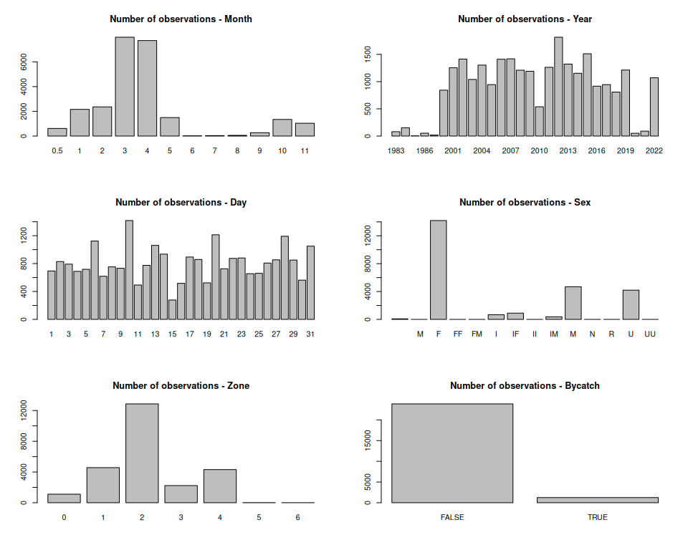
par(mfrow = c(2, 2))
hist(d$Total.Number.Particpants, main = "Total number of participants")
hist(d$Total.Number.of.Boats, main = "Total number of boats")
hist(d$Average.Time.Spent.Fishing, main = "Average time spent fishing")
hist(d$Tournament.Duration, main = "Tournament duration")
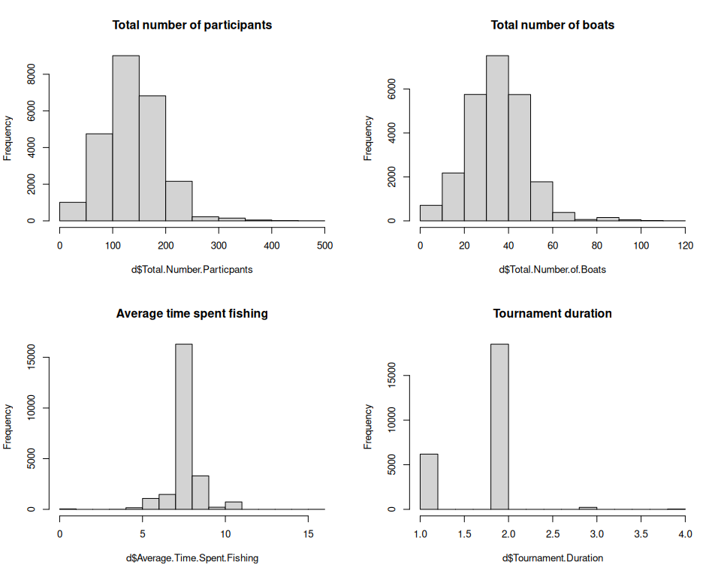
There are a few NAs in the tournament data columns. We need to consider what details are available and what factors we can feasibly use in the standardization process.
# find NAs in tournament details -------------------
table(is.na(d$Total.Number.of.Boats))
FALSE TRUE
24331 785
table(is.na(d$Total.Number.Particpants))
FALSE TRUE
24189 927
table(is.na(d$Total.Number.Particpants) & is.na(d$Total.Number.of.Boats))
FALSE TRUE
24332 784
table(is.na(d$Average.Time.Spent.Fishing))
FALSE TRUE
23290 1826
plot(d$Total.Number.of.Boats, d$Total.Number.Particpants, xlab = "total number of boats", ylab = "total number of participants")
out <- lm(d$Total.Number.Particpants ~ d$Total.Number.of.Boats)
abline(out, col = 8)
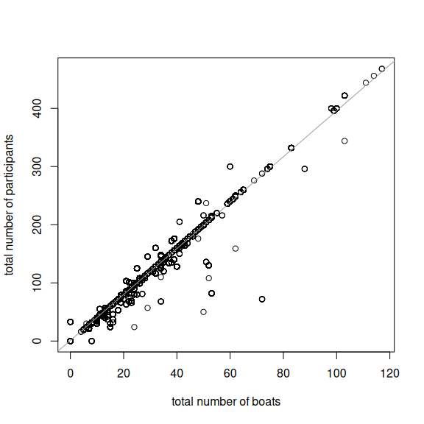
The total number of boats is highly correlated with the total number of participant and the linear regression indicates that most boats have 4 participants.

18.3 Data preparation for standardization
In preparation for creating a standardized catch-per-unit-effort (CPUE) index that can serve as a proxy for abundance, we have to specify nuisance factors in the data set that have to be accounted for. We create a unique tournament ID number with a combination of the day and number of participants.
# create unique tournament ID number -------------------------
d$dat <- paste0(d$day, d$month, d$year)
length(unique(paste0(d$day, d$month, d$year, d$Total.Number.Particpants)))
[1] 386
length(unique(paste0(d$day, d$month, d$year, d$Location)))
[1] 387
length(unique(paste0(d$day, d$month, d$year, d$Total.Number.of.Boats)))
[1] 386
length(unique(paste0(d$day, d$month, d$year, d$Tournament.Duration)))
[1] 366
d$datID <- paste0(d$day, d$month, d$year, d$Total.Number.Particpants)
#barplot(table(d$mon))
We remove all cases where dolphin is not listed as the target species; we will use only directed dolphin trips in the standardization. We also specify the months that we want to include in the index of abundance. Here we specify December to MArch With this subset of months, we have 128 unique tournaments in the data base across 121 different dates.
# remove non-target cases; use only directed trips -------------------
dfull <- d
d <- d[which(d$Bycatch == FALSE), ]
# subset by season, e.g. 0 - 4 is December to April -------------------
d <- d[which(d$mon >= 0 & d$mon <= 3), ]
#length(unique(d$Date))
length(unique(d$dat))
[1] 121
length(unique(d$datID))
[1] 128
Next we calculate the total weight by tournament, by summing the reported weights across each tournament ID. We then set up a new data frame where each tournament is a row, and columns represent the attributes of each tournament (year, month, zone, participants, number of boats, fishing time, duration, total weight and total abundance). We also calculate the average weight by dividing total weight by total abundance.
# calculate total by tournament ----------------------------
totWT <- tapply(d$Weight..Kg., d$datID, sum, na.rm = T)
totN <- table(d$datID)
mon <- tapply(d$mon, d$datID, mean, na.rm = T)
year <- tapply(d$year2, d$datID, mean, na.rm = T)
# checks on month and tournament assignments ----------------------
#table(d$year[d$mon == 0.5], d$year2[d$mon == 0.5])
#table(d$year[d$mon != 0.5], d$year2[d$mon != 0.5])
max(tapply(d$Total.Number.Particpants, d$datID, sd), na.rm = T) # should all be zeros
[1] 0
max(tapply(d$Total.Number.of.Boats, d$datID, sd), na.rm = T)
[1] 0
max(tapply(d$Average.Time.Spent.Fishing, d$datID, sd), na.rm = T)
[1] 0
# assign attributes of tournaments -------------------------------
Npart <- tapply(d$Total.Number.Particpants, d$datID, mean, na.rm = T)
Nboat <- tapply(d$Total.Number.of.Boats, d$datID, mean, na.rm = T)
Ftime <- tapply(d$Average.Time.Spent.Fishing, d$datID, mean, na.rm = T)
dura <- tapply(d$Tournament.Duration, d$datID, mean, na.rm = T)
zone <- tapply(d$Zone, d$datID, mean, na.rm = T)
# new data frame for standardization ----------------------------------
dat <- data.frame(cbind(year, mon, zone, Npart, Nboat, Ftime, dura, totWT, totN))
dat$avwt <- dat$totWT / dat$totN
head(dat)
year mon zone Npart Nboat Ftime dura totWT totN avwt
10Feb2007140 2007 2 1 140 35 8.0 1 347.64 49 7.094694
10Feb200824 2008 2 1 24 15 7.0 1 264.71 33 8.021515
10Jan2009332 2009 1 1 332 83 8.0 2 770.44 147 5.241088
10Jan2014188 2014 1 1 188 47 7.5 2 1479.82 249 5.943052
10Jan2015136 2015 1 1 136 34 7.5 2 794.72 264 3.010303
10Mar2001192 2001 3 2 192 48 8.0 2 2499.33 272 9.188713
There are a number of missing values in this data frame. For fishing time and number of boats, we impute the median of the known values into the missing values. For missing values for the number of boats, we take the number of participants and divide by 4 (given the relationship established above). If both values are missing, we impute the median into the unknown values.
# fill in NAs ---------------------------------------------------
dat$Nboat[which(dat$Nboat == 0)] <- NA
dat$Npart[which(dat$Npart == 0)] <- NA
dat$Ftime[which(dat$Ftime == 0)] <- NA
#hist(dat$Ftime)
which(is.na(dat$Ftime))
[1] 15 18 68 72 86 94 101 127 128
dat$Ftime[is.na(dat$Ftime)] <- median(dat$Ftime, na.rm = T)
#hist(dat$Nboat)
which(is.na(dat$Nboat))
[1] 15 83 94 122 128
which(is.na(dat$Npart))
[1] 11 12 15 94 101 110 122 128
dat$Npart[is.na(dat$Nboat)]
[1] NaN 33 NaN NA NaN
#plot(dat$Nboat, dat$Npart)
#dat$Npart / dat$Nboat
dat$Nboat[is.na(dat$Nboat)] <- dat$Npart[is.na(dat$Nboat)] / 4
#dat$Npart[is.na(dat$Nboat)]
dat$Nboat[is.na(dat$Nboat)] <- median(dat$Nboat, na.rm = T)
which(is.na(dat$Nboat))
integer(0)
which(is.na(dat$Ftime))
integer(0)
which(is.na(dat$totN))
integer(0)
Finally, we subset the years. Data are very sparse prior to 2000 so we only include the data for 2000 and forward. We calculate the catch-per-unit-effort, defining catch as the total abundance, and effort as the number of boats multiplied by the average time spent fishing.
# subset years -----------------------------------
yrs <- c(2000:2020, 2022)
dat[is.na(dat)] <- NA
dat <- dat[which(dat$year >= min(yrs)), ]
dat <- dat[which(dat$year <= max(yrs)), ]
# calculate CPUE -----------------------------------
dat$eff <- dat$Nboat * dat$Ftime # dat$dura
dat$cpue <- dat$totN / dat$eff
dat$cpueW <- dat$totWT / dat$eff
which(dat$cpue == "Inf")
integer(0)
which(dat$cpueW == "Inf")
integer(0)
#dat$cpue[which(dat$cpue == "Inf")] <- NA
barplot(table(dat$year), las = 2, main = "Number of tournaments per year")
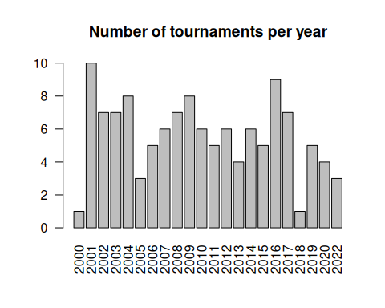
The plot shows the number of tournaments per year. We can see that there are relatively few events for each year.

18.4 Analyze the nominal CPUE trends
Now using this clean data set we can look at the nominal (average) CPUE by year. We first look at the average weight across all tournaments, and weight by the northern and southern coasts. The weights appear to be highly variable across year and coasts.
# look at nominal trends ----------------------------
par(mfrow = c(3, 1), mar = c(3, 5, 3, 1))
barplot(tapply(dat$avwt, dat$year, mean, na.rm = T), las = 2,
main = "Average weight of tournament-caught dolphinfish by year",
ylab = "average weight (kg)")
d2 <- dat[which(dat$zone == 2), ]
barplot(tapply(d2$avwt, d2$year, mean, na.rm = T), las = 2,
main = "Average weight of tournament-caught dolphinfish by year\n(Southern coast)",
ylab = "average weight (kg)")
d2 <- dat[which(dat$zone != 2), ]
barplot(tapply(d2$avwt, d2$year, mean, na.rm = T), las = 2,
main = "Average weight of tournament-caught dolphinfish by year\n(other coasts)",
ylab = "average weight (kg)")
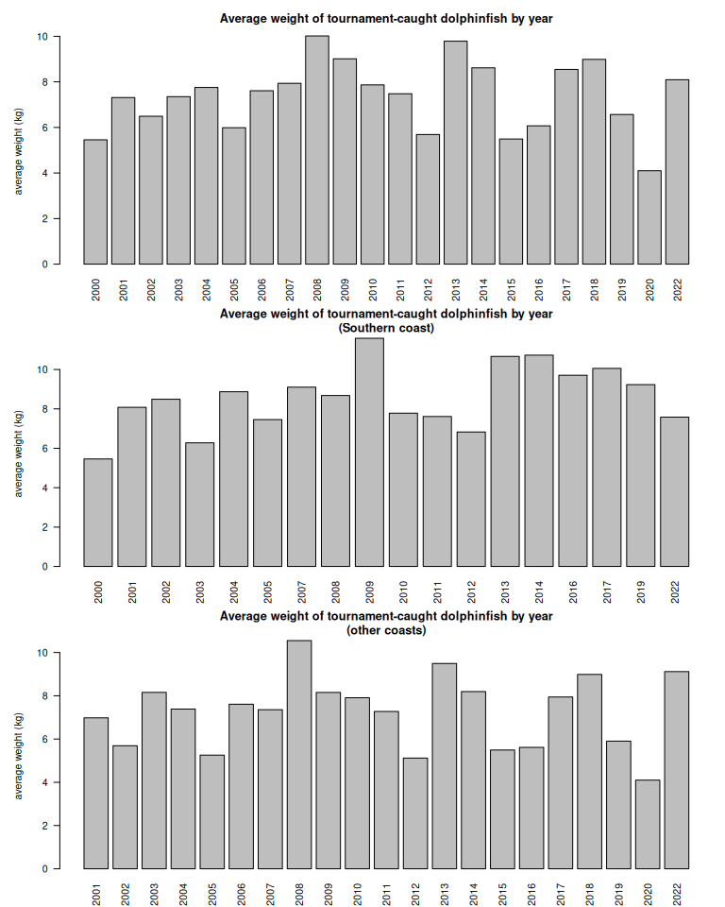
# look at nominal trends by year, month and zone
barplot(tapply(dat$cpue, dat$year, mean, na.rm = T), las = 1,
main = "Average CPUE of tournament-caught dolphinfish by year",
xlab = "year", ylab = "CPUE")
barplot(tapply(dat$cpue, dat$mon, mean, na.rm = T), las = 1,
main = "Average CPUE of tournament-caught dolphinfish by month",
xlab = "month", ylab = "CPUE")
barplot(tapply(dat$cpue, dat$zone, mean, na.rm = T), las = 1,
main = "Average CPUE of tournament-caught dolphinfish by zone",
xlab = "zone", ylab = "CPUE")
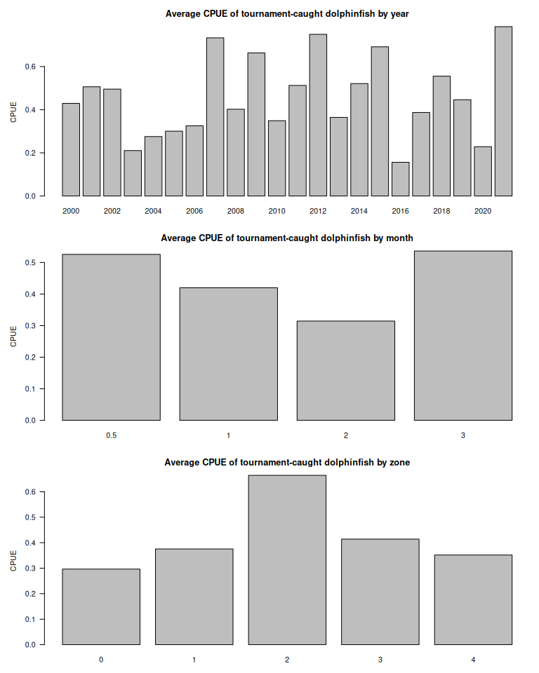
par(mfrow = c(1, 1), mar = c(5, 5, 1, 1))
plot(tapply(dat$cpue, dat$year, mean, na.rm = T), tapply(dat$cpueW, dat$year, mean, na.rm = T),
xlab = "nominal CPUE by number", ylab = "nominal CPUE by weight")
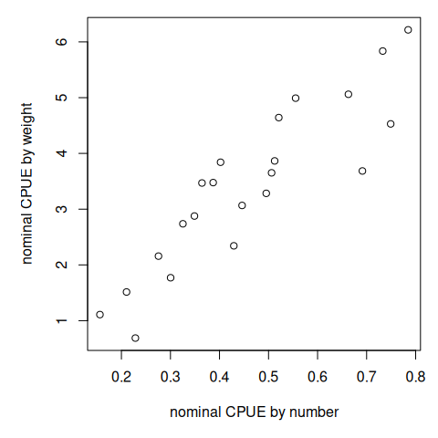
cor(tapply(dat$cpue, dat$year, mean, na.rm = T), tapply(dat$cpueW, dat$year, mean, na.rm = T))
[1] 0.8957364
There appears to be high variability in the CPUE by year. The highest CPUE appears to occur in December and March. CPUE also varies by zone, the Southern coast having the highest catch rates. CPUE based on number and weight are highly correlated.

18.5 Calculate standardized CPUE trends
Now we will carry out the standardization, using day, month and zone as standardization factors. Since the catch rates are highly skewed, we carry out the standardization based on the log CPUE.
# convert variables to factors ----------------------
dat$year <- as.factor(dat$year)
dat$mon <- as.factor(dat$mon)
dat$zone <- as.factor(dat$zone)
# standardization -----------------------------------
out <- glm(log(dat$cpue) ~ dat$year + dat$mon + dat$zone,
family = gaussian)
summary(out)
Call:
glm(formula = log(dat$cpue) ~ dat$year + dat$mon + dat$zone,
family = gaussian)
Coefficients:
Estimate Std. Error t value Pr(>|t|)
(Intercept) -1.40759 0.99693 -1.412 0.161
dat$year2001 0.28181 0.83836 0.336 0.738
dat$year2002 0.48350 0.85421 0.566 0.573
dat$year2003 -0.52084 0.85383 -0.610 0.543
dat$year2004 -0.14562 0.85154 -0.171 0.865
dat$year2005 -0.18291 0.92692 -0.197 0.844
dat$year2006 0.02815 0.88439 0.032 0.975
dat$year2007 0.83641 0.86104 0.971 0.334
dat$year2008 0.13978 0.85457 0.164 0.870
dat$year2009 0.55629 0.84928 0.655 0.514
dat$year2010 -0.10216 0.86124 -0.119 0.906
dat$year2011 0.45982 0.86863 0.529 0.598
dat$year2012 0.83088 0.86131 0.965 0.337
dat$year2013 0.32462 0.89425 0.363 0.717
dat$year2014 0.74916 0.87838 0.853 0.396
dat$year2015 1.15411 0.88386 1.306 0.195
dat$year2016 -0.87199 0.84836 -1.028 0.307
dat$year2017 -0.09821 0.85408 -0.115 0.909
dat$year2018 0.56177 1.16405 0.483 0.630
dat$year2019 0.29081 0.87708 0.332 0.741
dat$year2020 -0.66680 0.91493 -0.729 0.468
dat$year2022 0.78828 0.91415 0.862 0.391
dat$mon1 -0.31971 0.39283 -0.814 0.418
dat$mon2 -0.06351 0.38114 -0.167 0.868
dat$mon3 -0.12341 0.40595 -0.304 0.762
dat$zone1 0.12877 0.47137 0.273 0.785
dat$zone2 0.68527 0.49968 1.371 0.174
dat$zone3 0.38090 0.55850 0.682 0.497
dat$zone4 -0.12452 0.47920 -0.260 0.796
(Dispersion parameter for gaussian family taken to be 0.6226789)
Null deviance: 103.767 on 122 degrees of freedom
Residual deviance: 58.532 on 94 degrees of freedom
AIC: 317.72
Number of Fisher Scoring iterations: 2
anova(out)
Analysis of Deviance Table
Model: gaussian, link: identity
Response: log(dat$cpue)
Terms added sequentially (first to last)
Df Deviance Resid. Df Resid. Dev F Pr(>F)
NULL 122 103.767
dat$year 21 34.426 101 69.341 2.6327 0.0007729 ***
dat$mon 3 2.382 98 66.959 1.2752 0.2874289
dat$zone 4 8.427 94 58.532 3.3835 0.0124215 *
---
Signif. codes: 0 '***' 0.001 '**' 0.01 '*' 0.05 '.' 0.1 ' ' 1
# estimated coefficients from standardization
ind <- emmeans(out, "year", type = "response") %>% as.data.frame()
names(ind)[1] <- "Year"
Finally, we compare the standardized CPUE with the nominal CPUE. The two time series are somewhat closely related, indicating similar years of low and high relative abundance.
# look at nominal vs standardized index ------------------------
plot(yrs, ind$response, type = "l", lwd = 2, col = 4, main = "Nominal versus standardized CPUE from dolphin tournament data",
xlab = "year", ylab = "CPUE (fish / (boats x time))", ylim = c(0, 1.8))
points(yrs, ind$response, pch = 1, lwd = 2, col = 4)
lines(yrs, ind$lower.CL, col = 4, lty = 2)
lines(yrs, ind$upper.CL, col = 4, lty = 2)
lines(yrs, tapply(dat$cpue, dat$year, mean, na.rm = T) *1.0, col = 2, lwd = 2)
points(yrs, tapply(dat$cpue, dat$year, mean, na.rm = T) *1.0, col = 2, lwd = 2, pch = 1)
legend("topleft", c("nominal", "standardized"), lwd = 2, pch = 19, col = c(2, 4), bty = "n")
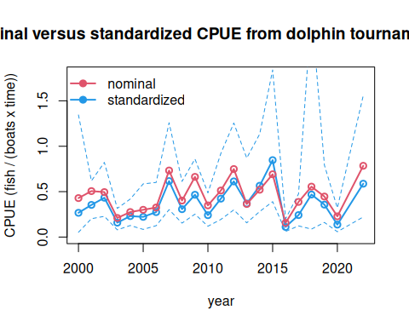
cor(ind$response, tapply(dat$cpue, dat$year, mean, na.rm = T))
[1] 0.9068784
Finally, let’s look at how our standardized index compares to the South Atlantic landings. We experimented with CPUE in both units of abundance and weight, and for different combinations of winter months (e.g., Dec - Feb, Jan - Apr). The highest correlation with South Atlantic landings occurs with tournament data from December to March with CPUE based on abundance. In this case the tournament data describes 18% of the variation in South Atlantic landings, with 2015 as a well above-average outlier in both the tournament CPUE and the landings.
rec <- read.csv("data/recLandings.csv")
names(rec)[1] <- "Year"
rec$ATL <- rowSums(rec[3:6], na.rm = T)
d <- merge(rec, ind, by = "Year")
par(mar = c(4, 6, 2, 1))
plot(d$response, d$ATL/10^6, col = 0, xlab = "standardized tournament CPUE",
ylab = "total U.S. Atlantic coast recreational landings\n(millions of pounds)")
text(d$response, d$ATL/10^6, d$Year, col = 1)
out <- lm(d$ATL/10^6 ~ d$response)
abline(out, col = 8)
summary(out)
Call:
lm(formula = d$ATL/10^6 ~ d$response)
Residuals:
Min 1Q Median 3Q Max
-8.2004 -2.2964 -0.8387 2.2794 8.8767
Coefficients:
Estimate Std. Error t value Pr(>|t|)
(Intercept) 12.535 2.066 6.067 6.26e-06 ***
d$response 8.131 4.941 1.646 0.115
---
Signif. codes: 0 '***' 0.001 '**' 0.01 '*' 0.05 '.' 0.1 ' ' 1
Residual standard error: 4.195 on 20 degrees of freedom
Multiple R-squared: 0.1193, Adjusted R-squared: 0.07524
F-statistic: 2.709 on 1 and 20 DF, p-value: 0.1154
r2 <- summary(out)$adj.r.squared
p_val <- summary(out)$coefficients[2, 4]
p_display <- ifelse(p_val < 0.001, "p < 0.001", paste("p =", round(p_val, 3)))
legend("topleft",
legend = bquote(R^2 == .(round(r2, 2)) ~ "; " ~ p == .(round(p_val, 3))),
bty = "n", cex = 1.2, text.col = 4)
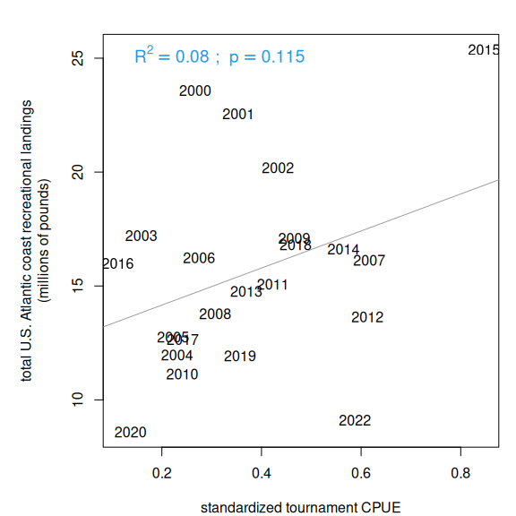
# output the index
write.csv(ind, file = "indices/PRtournament_index.csv", row.names = F)

19. Wintertime pelagic longline index
A substantial portion of the U.S. pelagic longline fishery operates in the Caribbean region, and we can analyze the catch rates in this region as a potential predictive index of dolphin abundance in the South Atlantic later in the year. The logbook data are confidential and cannot be shown here, but we show the results of the standardization process. The code for processing the pelagic longline logbook data can be seen in the file “PLL_index.R” and the steps are outlined below.

19.1 Analysis of logbook data
The goal of the analysis is to create a standardized index of relative abundance for dolphin, using wintertime catch rates from the pelagic longline (PLL) fleet. The standardization process removes the potential influence of nuisance factors from the catch data, such as species targeting or differences in gear deployment, so that the index represents the underlying abundance of the fish.
The steps are as follows:
- Read in the pelagic longline data which contains set level entries including location of fishing, target species, gear used, other details of the fishing trip and number of dolphin caught, discarded alive, discarded dead, and the total pounds of dolphin kept.
- Format the longitude and latitude of the sets into decimal degrees, and find the points that fall in the Caribbean region (we use 76°W - 60°W and 12°N - 23°N as boundaries). Check that subsetting was done correctly, and extract the Caribbean data from the data set.
- Inspect the dolphin catch columns (number of dolphin kept, discarded alive and dead). Replace NA values with zeros. Calculate the total dolphin catch as the total kept and discarded. Remove data for which the number of hooks is not reported. Calculate the catch rate as total dolphin caught divided by 1,000 hooks.
- Standardize date formatting and add identifiers for month. Index December so that it is included with the winter months of the following year. Subset the data set so that it includes only the winter months (December - February).
- Explore the different factors to include in the standardization model, relying on previous literature and best practices for standardizing PLL logbook data. Analyze the number of observations for different gear configurations and target species. Factors considered were: temperature, month, number of hooks between floats, bait type, number of lights between hooks, and species targeted. Temperature was binned in 5-degree increments. Month and hooks between floats were converted to factors. There was little resolution in the data for bait type and number of lights per hook, with similar values across all observations. The only major reported species targeted were dolphin, swordfish and mixed; targeting for other species were only listed in a small number of sets.
- Use the delta-lognormal method to create an index of abundance for dolphin, estimated using a generalized linear model approach. The delta model fits separately the: 1) proportion of positive sets, assuming a binomial error distribution, and 2) the mean catch rate of sets where at least one dolphin was caught, assuming a lognormal error distribution. Use a step-wise regression process was used to determine the set of factors that significantly explain the observed variability. Model selection of fixed factors was based on significance with alpha=0.05. Once the final model is determined, calculate the least-squares means from the linear models for the year predictor estimates. The index of abundance is the standardized proportion positive by year multiplied by the standardized abundance when present.
- Calculate the deviance explained by each model, the standard errors, and the combined variance for the standardized index.

19.2 Model results
Here we upload the model results and show the standardized index.
load("data/linear_model_outputs.RData")
# Print results
cat("Deviance Explained (Binomial): ", round(d2_bin * 100, 2), "%\n")
Deviance Explained (Binomial): 7.75 %
cat("Deviance Explained (Lognormal):", round(d2_log * 100, 2), "%\n")
Deviance Explained (Lognormal): 17.28 %
cat("Total Delta-Lognormal D^2: ", round(total_d2 * 100, 2), "%\n")
Total Delta-Lognormal D^2: 9.63 %
The deviance explained by the model is relatively low, and thus the standardized index is similar to the nominal CPUE index. The primary impact of standardization is to lower slightly the index of relative abundance in the earlier years of the time series.
ind <- read.csv("indices/PLL_index.csv")
plot(ind$Year, ind$index, type = "l", lwd = 2, col = 4, main = "Nominal versus standardized CPUE from PLL data",
xlab = "year", ylab = "CPUE (dolphin / 1000 hooks)", ylim = c(0, 14))
points(ind$Year, ind$index, pch = 1, lwd = 2, col = 4)
lines(ind$Year, ind$index - 1.96*ind$SE, col = 4, lty = 2)
lines(ind$Year, ind$index + 1.96*ind$SE, col = 4, lty = 2)
lines(ind$Year, ind$nominal, col = 2, lwd = 2)
points(ind$Year, ind$nominal, col = 2, lwd = 2, pch = 1)
legend("topleft", c("nominal CPUE", "standardized CPUE"), lwd = 2, pch = 19, col = c(2, 4), bty = "n")
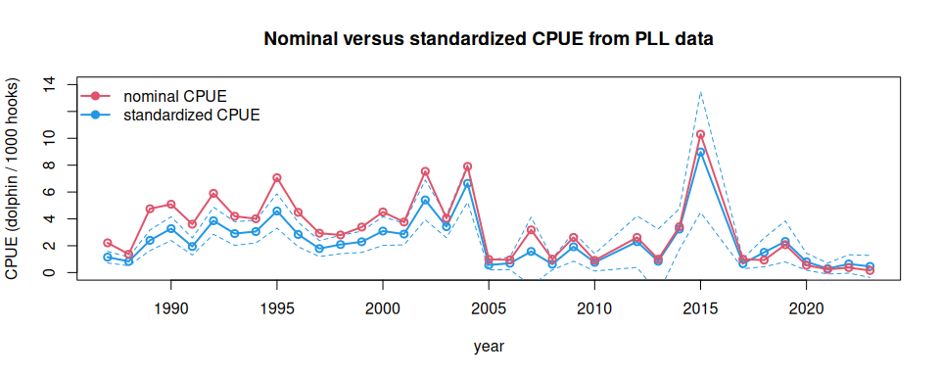
Now we compare the nominal and the standardized index with the Atlantic recreational landings. We experimented with altering the forecasting time period (e.g., Dec - Feb versus Jan - Mar) and also with the latitudinal boundaries (e.g., 70°W versus 76°W ). A smaller bounding box of 70°W resulted in very small sample sizes (<10) for some individual years; extending the bounding box to 76°W to cover fishing activity between Cuba and Hispanola resulted in much higher sample sizes and improved correlations. Including only the winter months (Dec - Feb) also resulted in higher correlations than when spring months were included.
rec <- read.csv("data/recLandings.csv")
names(rec)[1] <- "Year"
rec$ATL <- rowSums(rec[3:6], na.rm = T)
rec <- rec[which(rec$Year >= 1990), ]
d1 <- merge(rec, ind, by = "Year")
lis <- c("index", "nominal", "predpos", "Npres")
labs <- c("standardized CPUE index", "nominal CPUE",
"standardized probability of occurrence",
"standardized abundance when present")
par(mfrow = c(2, 2), mar = c(4, 5, 2, 1), mgp = c(2.5, 1, 0))
for (i in 1:4) {
j <- which(names(d1) == lis[i])
plot(d1[, j], d1$ATL/10^6, col = 0, xlab = labs[i], ylim = c(5, 32), las = 1,
ylab = "total U.S. Atlantic coast recreational landings\n(millions of pounds)")
text(d1[, j], d1$ATL/10^6, substr(d1$Year, 1, 4), col = 1)
out <- lm(d1$ATL/10^6 ~ d1[, j ])
abline(out, col = 8)
summary(out)
r2 <- summary(out)$adj.r.squared
p_val <- summary(out)$coefficients[2, 4]
p_display <- ifelse(p_val < 0.001, "p < 0.001", paste("p =", round(p_val, 3)))
legend("bottomright",
legend = bquote(R^2 == .(round(r2, 2)) ~ "; " ~ p == .(round(p_val, 3))),
bty = "n", cex = 1.2, text.col = 4)
}
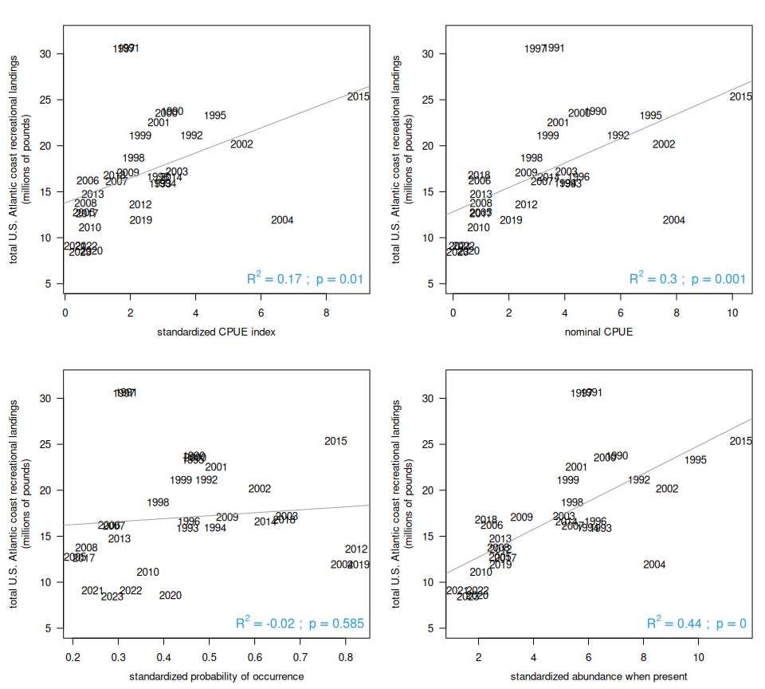
Interestingly, the nominal CPUE is more highly correlated with Atlantic recreational landings than the standardized index. However when the standardized index is broken into its two components, we can see that the probability of occurrence is not significantly correlated with the Atlantic landings, while the abundance when present has a highly significant correlation and explains 44% of the variation in the Atlantic landings.

