Albert Quon, Daniel Holmes, Garvin Hui

SEG Project Report

SEG2105 Group 69

# Table of Contents

Contents

Table of Contents 1

Introduction 4

Lessons Learned 4

Roles 4

Screenshots of App 5

Customer 5

Admin 6

Employee/branch 8

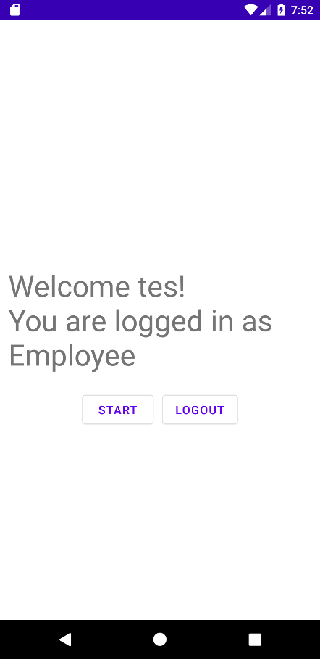 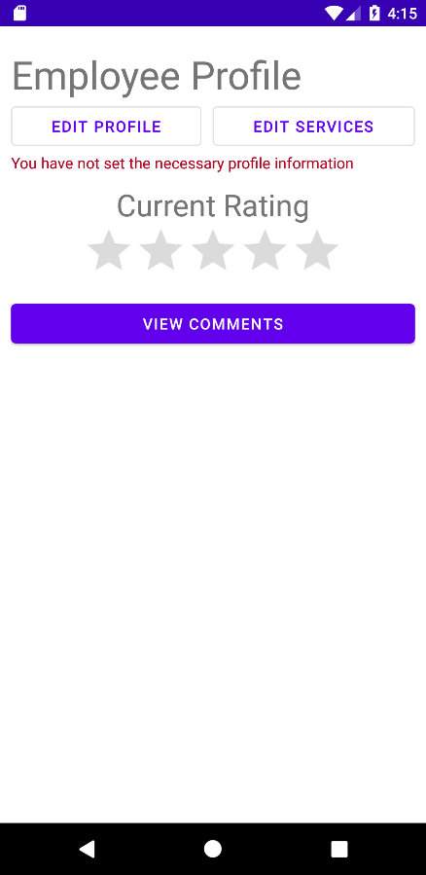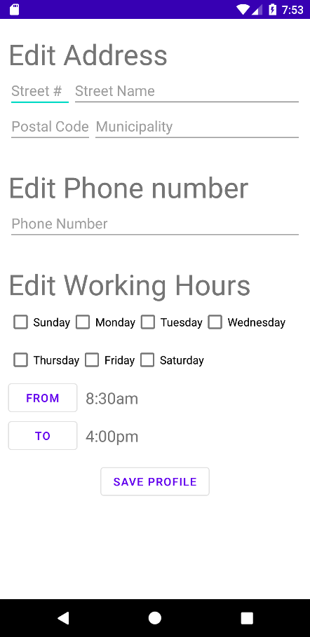 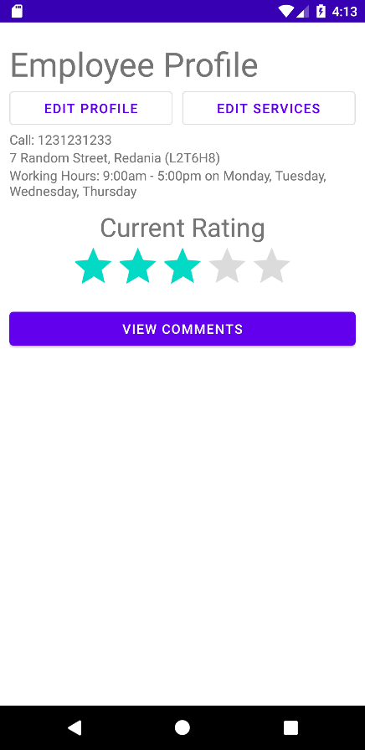 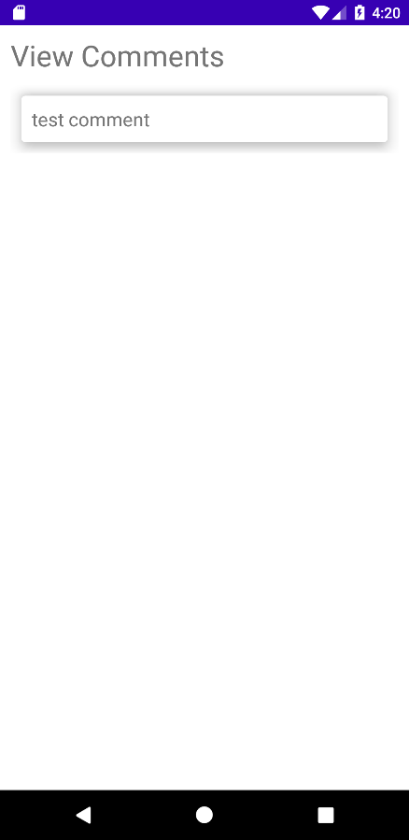 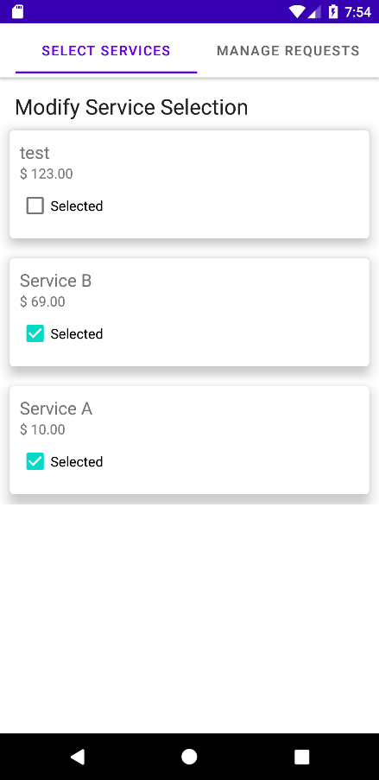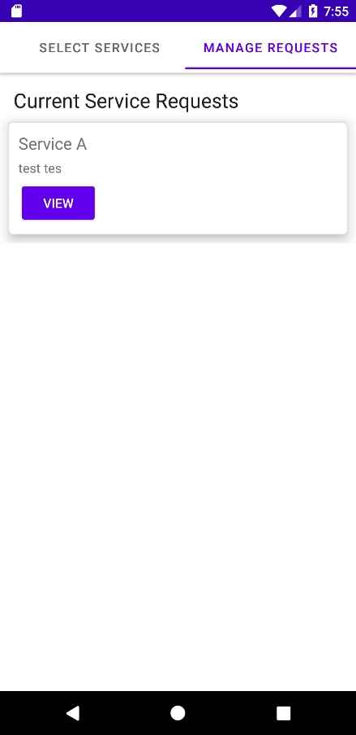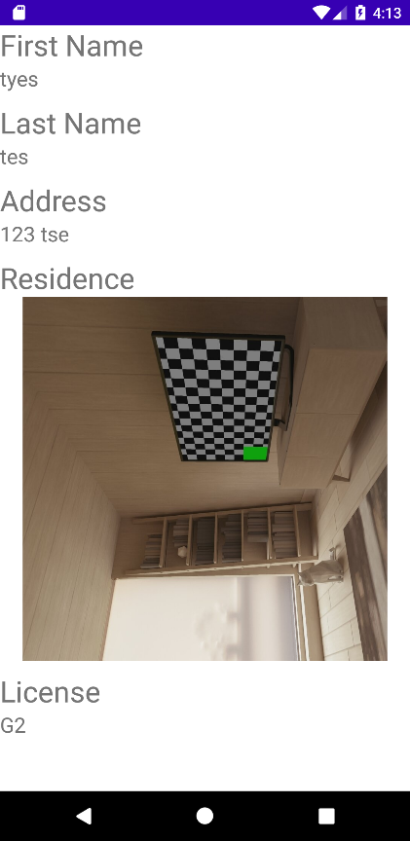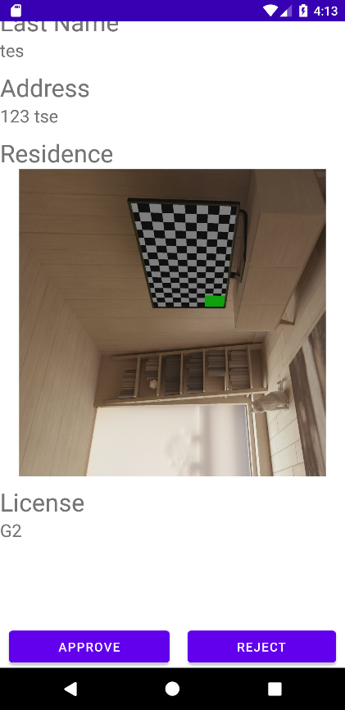 9

UML Diagram 10

# Introduction

This report discusses what we have learned and the roles each member has played throughout the development of the Novigrad Android application. Furthermore, we divided our roles based on our previous work on previous deliverables (i.e., one member that did a lot of work in one deliverable would be given less in the next one). As for the application, we used Firebase as our database to store the data of our users and services and a variety of libraries for our UI (e.g., Recycler View, Volley, Material Design). Furthermore, we used Visual Paradigm to help plan out our domain model with a UML class diagram, which is provided separately from this report in a UML diagram.

# Lessons Learned

* Communicate about our tasks to avoid missing deadlines
* Organize related classes into packages to manage the large amount of classes
* Consistency in functions and naming conventions is important to establish between all group members to prevent confusion
* Asynchronous methods with Firebase do not act in the same way as conventional code
* Plan and communicate early to give members time for learning about the new technologies and new changes in the application

# Roles

|  |  |  |  |
| --- | --- | --- | --- |
| **Deliverable** | **Albert** | **Daniel** | **Garvin** |
| 1 | Welcome Activity  UML Diagram | Initial UI  Firebase integration  Unit Tests | Register Activity  Register Validation + Submission |
| 2 | Service Editor  UML Diagram | Integrated Admin Login  Service/User Deletion | Field validation (service)  Service Creation  CircleCI |
| 3 | Service Selection  Service Request Manager  UML Diagram | Working Hours creation + editor  UI refinement | Unit Tests  Profile creator  Field validation (Profile) |
| 4 | Service Request Form  Field validation (Service Request)  Unit Tests  UML Diagram | Service Request List  Search  UI refinement | Branch rating  Unit tests  Service Request View  Image upload/download |

# Screenshots of App

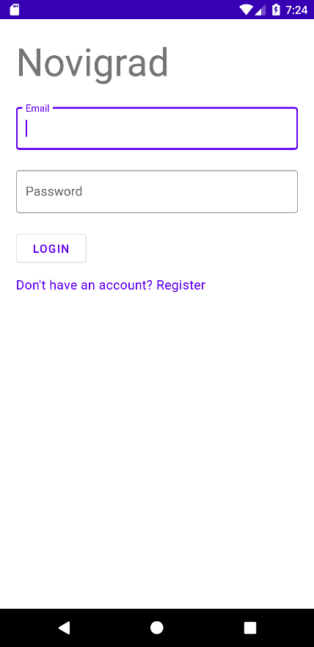 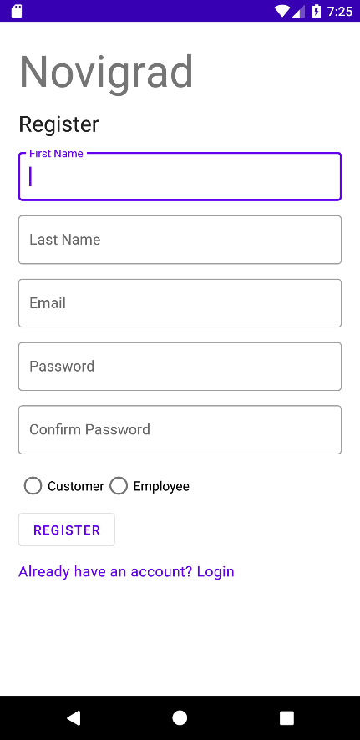

## Customer

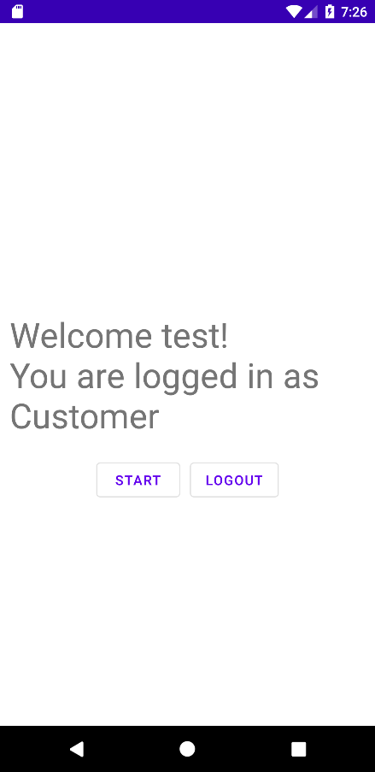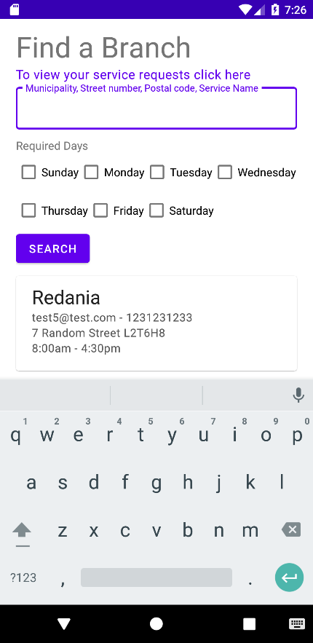 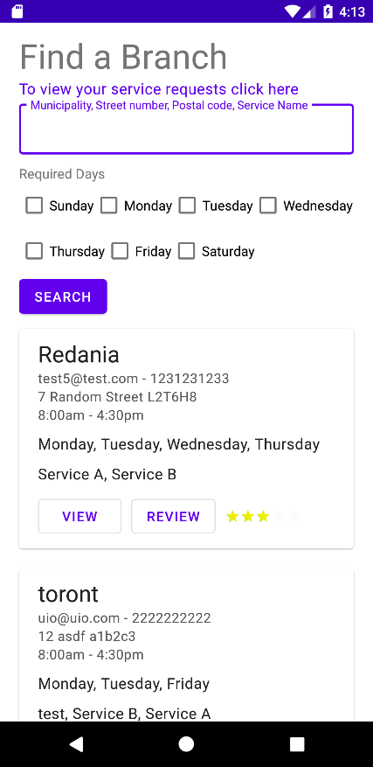 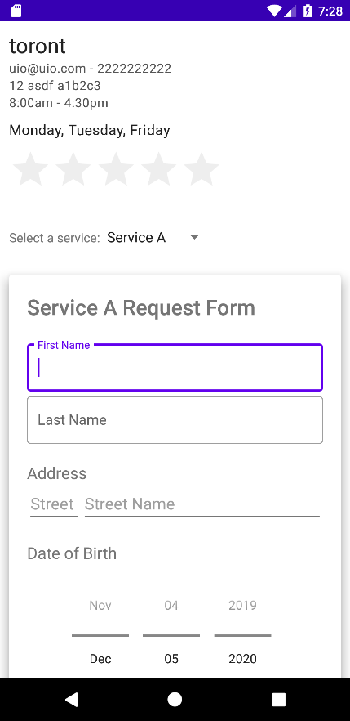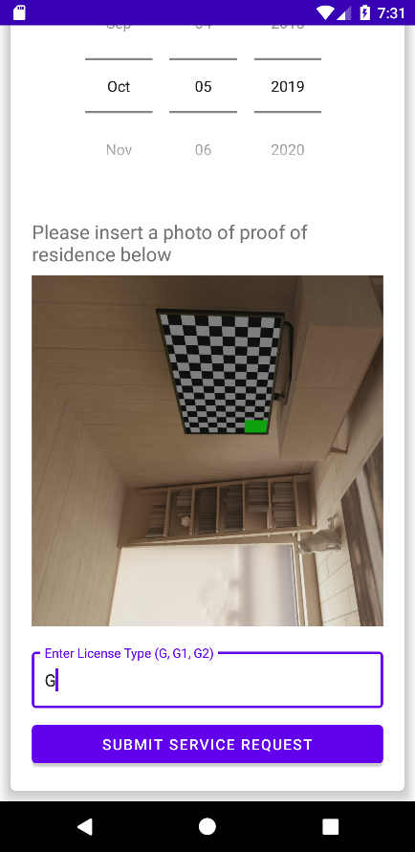 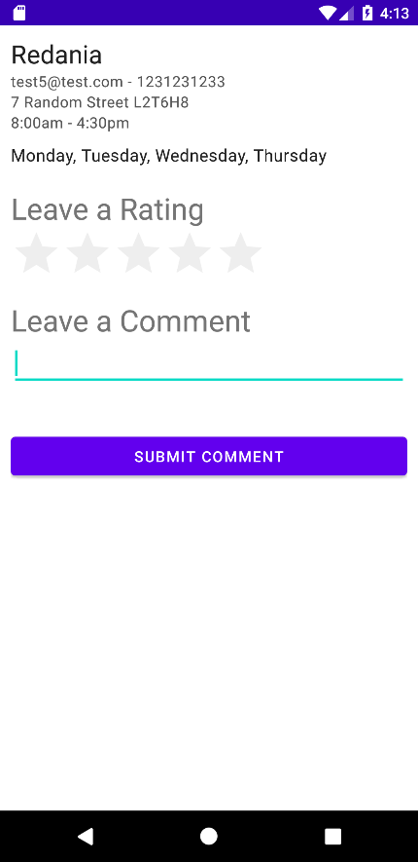

## Admin

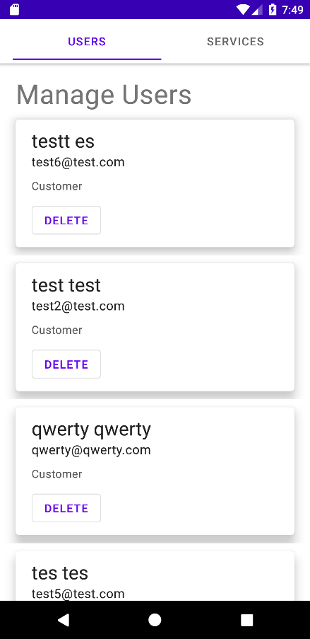 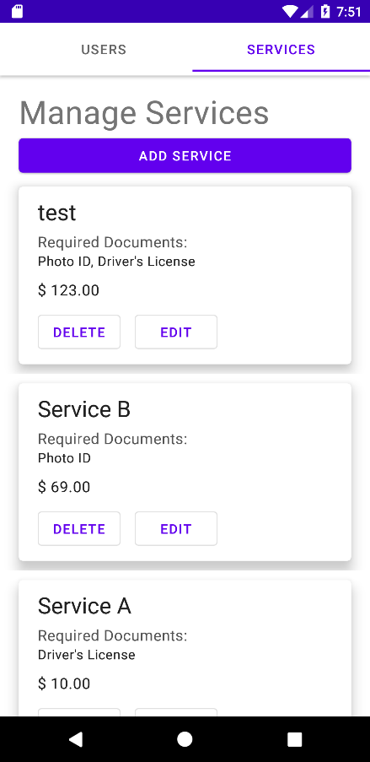 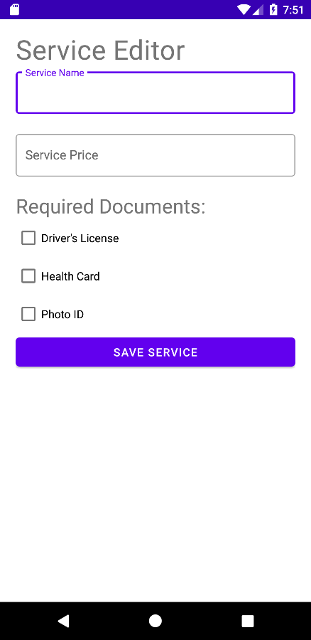

## Employee/branch

## 

# UML Diagram

*attached in pdf