**Server-Database Design**

**1. Abstract: This report is about design of server-side database.it will cover all aspect including all requirement, justification and visual representation of database design.**

**2. Introduction: This report describes all aspect for database design. I have discussed creating and uploading database. In the design different entities and their attributes including their relation to solve the problem. I have further present justification and visual presentation.**

**3. Problem Statement: We six members of group are going to made LAN based communication App.In which there will be a server (Desktop Based) and many Clients (Android App Base) which will communicate with each other our server will control all communication and will keep all record of communication.**

**4. Data Analysis: According to problem statement there will be a server to keep the data and will be many clients so clients will send data to server and server will kept signup recording. For this purpose there will be two tables in server side, First table will contain complete information of the clients, Second will contain communication record of the clients .At the communication time first request goes to server to fetch all previous record of dialed client. Whenever communication starts server database and client local database both will keep the record.**

**5. Design Normalization: in the above database design no table have multivalued attributes. Each table has its unique value so tables have first normal form. In the both tables there will be primary key to identify each row specify so they also fulfill 2nd normal form.**

**6. ER Diagram:**

**Table and their entities represented through ER diagram.**

**6.1 Users:**

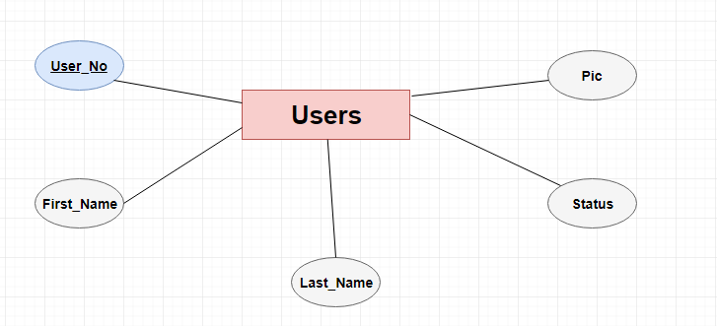

**6.2 Messages:**

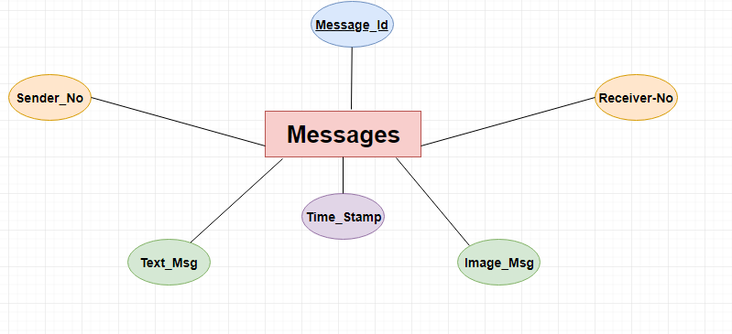

**7. Data Design:**

**In Order to explain above mentioned problem the database with the following tables will explain in detail.**

**Users:**

**Attributes: User-No, First Name, Last Name, Pic, Status**

**Primary Key: User-No**

**Value Set:**

**User-No: {Numeric Value}**

**First Name: {Alpha Character Value}**

**Last Name: {Alpha Character Value}**

**Pic: {Long Blob}**

**Status: {Boolean}**

**7.1.1 Description: In our database each client has its unique identification. It have its Cell no, First Name, Last Name, Pic and Status. Client Cell no will act as a primary key which will differentiate it with other clients. There will be no clients with same cell no.**

**Messages:**

**Attributes: Message-Id, Sender No, Receiver No, Time Stamp, Text msg, Img Msg**

**Primary Key: Message Id**

**Value Set:**

**Message-id: {Numeric Value}**

**Sender No: {Specific Numeric Value}**

**Receiver No: {Specific Numeric Value}**

**Time Stamp: {timestamp}**

**Text Msg: {Alpha Character Value}**

**Img Msg: {Long Blob}**

**7.1.2 Description: In our database to kept communication record there are the following attributes Message-id, Sender No, Receiver No, Time Stamp, Text Msg, Img Msg. All the communication between clients store in the database according to their cell no. When the clients have to fetch data the data comes client database according to the same sequence.**

**8. Final Database Design:**

**8.1: Users:**

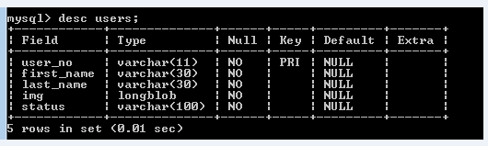

**8.2: Messages:**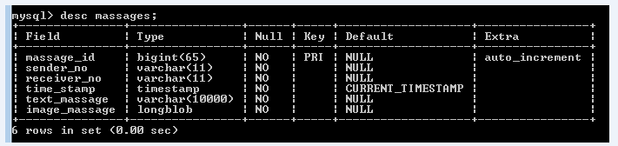

**Conclusion: Database is something which is well organized way to store data. It is made in such a way multiple users can share this resource.**

**Bibliography** *Elmasri, R., Navathe, S.B. (2010) Fundamentals of database systems, 6th edn., : Addison-Wesley.*