3.4
蚂蚁花呗是怎样分期付款？
电脑3000元，分12个月还款。讲一个例子。

Ant credit pay submit a interset-free installment payment strategy for retailers under Third Party payment paltform.
The results show that when consumers choose to use interest-free installment payments within a certain range, providing interest-free installment payment services can bring greater profits to retailers.

discription

Ant Credit Pay charges a fee for each installment. Currently all the fees are paid by the customer.
In other country, All numbers involved in the calculation of installment is accurate to the cent.
The amount of principal of each installment is payment amount divided by number of installments and then rounded down. The amount of service fee of each installment is the product of payment amount multiplying fee rate divided by number of installments.

Java code

//计算每期本金
BigDecimal eachPrin = BigDecimal.valueOf(payAmount).divide(new BigDecimal(“value of hb_fq_num”), BigDecimal.ROUND_DOWN);
//计算总利息并取整
BigDecimal totalFeeInDecimal = BigDecimal.valueOf(cent).multiply(feeRate);
long totalFeeInLong = totalFeeInDecimal.setScale(0, BigDecimal.ROUND_HALF_EVEN).longValue();
//计算每期利息并取整
BigDecimal eachFee = BigDecimal.valueOf(totalFeeInLong).divide(new BigDecimal(“value of hb_fq_num”), BigDecimal.ROUND_DOWN);
//计算每期还款总金额
BigDecimal prinAndFee = eachFee.add(eachPrin);

example

The following table contains the fee rate for different installment plans.
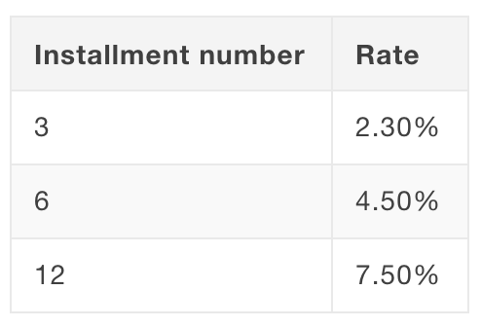
The payment amount is 1111.11 CNY, where the customer pays in 3 installments, with a fee rate of 2.3%. The amounts are calculated in cents:
- Principal of each installment:
111111/3 = 37037 (370.37 CNY)
- Service fee of each installment:
111111 * 2.3%/3 = 852 (8.52 CNY)
- Total amount of each installment:
37037 + 852 = 37889 (378.89 CNY)

