**1.** Consider a paging system with the page table stored in memory.

a. If a memory reference takes 200 nanoseconds, how long does a paged memory reference take?

b. If we add associative registers, and 75 percent of all page-table references are found in the associative registers, what is the effective memory reference time? (Assume that finding a page-table entry in the associative registers takes zero time, if the entry is there.)

**ANS:**

1) 400 纳秒﻿： 200纳秒﻿﻿的页表访问和200纳秒的﻿﻿﻿﻿﻿内存访问

2) ﻿﻿﻿Eat = 0.75*200ns + 0.25*400ns = 250ns﻿﻿﻿﻿﻿﻿

**2.**

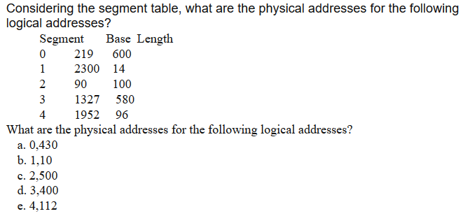

**ANS：**

a. 649

b. 2310

c. 非法访问

d. 1727

e. 非法访问

**3.**

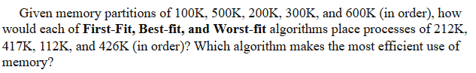

**ANS：**

1) First-fit

212K → 500K

417K → 600K

112K → 288K ( 500K – 212K )

426K → 等待

2) Best-fit

212K → 300K

417K → 500K

112K → 200K

426K → 600K

3) Worst-fit

212K → 600K

417K → 500K

112K → 388K ( 600K – 212K )

426K → 等待

由以上例子可得，Best-fit对内存的使用最有效

[CH8习题答案](https://wenku.baidu.com/view/347654de6137ee06eff91894.html)