6.7

|  |  |
| --- | --- |
| grammar Rule | semantic Rules |
| decl → var-list : type | var-list.dtype = type.dtype |
| var-list1 → var-list2 , id | var-list2.dtype = var-list1.dtype  id.dtype = var-list1.dtype |
| var-list →id | id.dtype = var-list.dtype |
| type → integer | type.dtype = int |
| type → real | type.dtype = float |

6.8

decl → id var-list

var-list → , id var-list | : type

type → integer | real

|  |  |
| --- | --- |
| grammar Rule | semantic Rules |
| decl → id var-list | id.dtype = var-list.dtype |
| var-list1 → , id var-list2 | var-list1.dtype = var-list2.dtype  id.dtype = var-list2.dtype |
| var-list →: type | var-list.dtype = type.dtype |
| type → integer | type.dtype = int |
| type → real | type.dtype = float |

6.13

a.

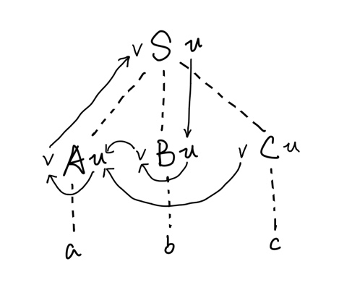

按照

B.u = S.u

B.v = B.u

C.v = 1

A.u = B.v + C.v

A.v = 2 * A.u

S.v = A.v

顺序计算，即S.u B.u B.v C.v A.u A.v S.v。

b.

S.u = 3

B.u = S.u = 3

B.v = B.u = 3

C.v = 1

A.u = B.v + C.v = 4

A.v = 2 * A.u = 8

S.v = A.v = 8

The value of S.v is 8.

c.

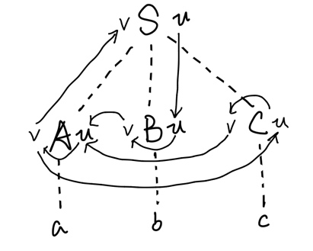

S.u = 3

B.u = S.u = 3

B.v = B.u = 3

C.u = A.v = 2 * A.u = 2 * (B.v + C.v) = 2 * (3 + C.v) = 2 * (3 + C.u - 2)

C.u = -2

A.v = C.u = -2

S.v = A.v = -2

The value of S.v is 2.