7.4

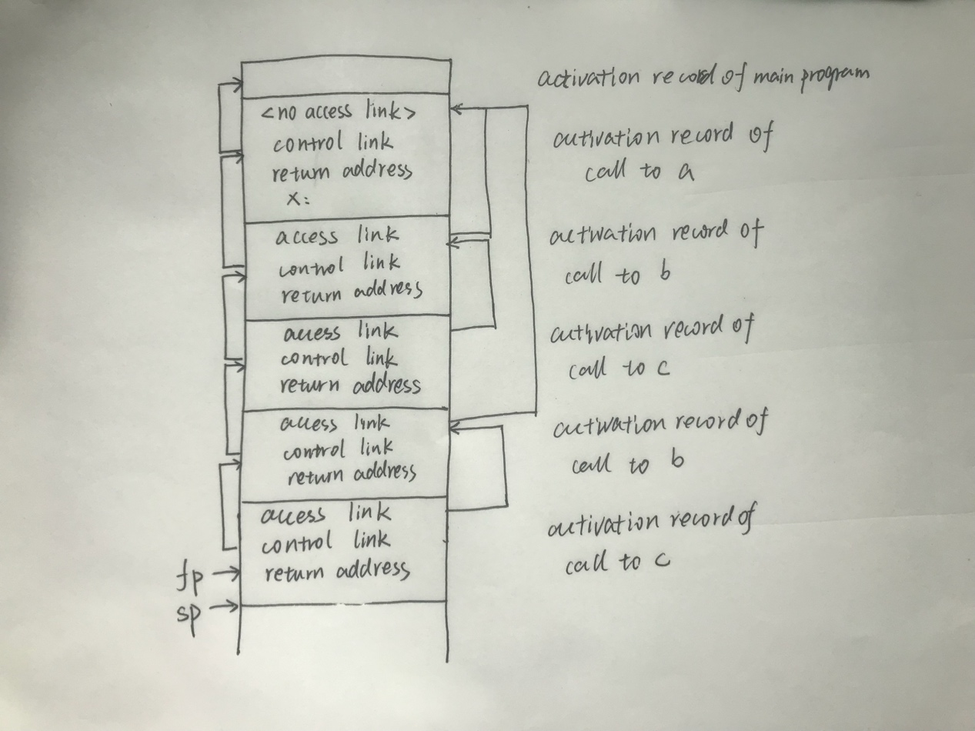

7.15

By value: 1 1

By reference: 3 1

By value-result : 2 1

By name: 2 2