A 100-km-long cable runs at the T1 data rate. The propagation speed in the cable is 2/3 the speed of light in vacuum. How many bits fit in the cable?

772bits

What is the minimum overhead to send an IP packet using PPP? Count only the overhead introduced by PPP itself, not the IP header overhead.

At its smallest, each frame has two flag bytes, one protocol byte, and two checksum bytes, for a total of five overhead bytes per frame.

What is the remainder obtained by dividing x7 + x5 + 1 by the generator polynomial x3 + 1?

x2+x+1

A channel has a bit rate of 4 kbps and a propagation delay of 20 msec. For what range of frame sizes does stop-and-wait give an efficiency of at least 50 percent?

160bits

A bit string, 0111101111101111110, needs to be transmitted at the data link layer. What is the string actually transmitted after bit stuffing?

011110111110011111010

What is the baud rate of the standard 10-Mbps Ethernet?

20Mbaud

Sketch the Manchester encoding for the bit stream: 0001110101.

LHLHLHHLHLHLLHHLLHHL.

Consider building a CSMA/CD network running at 1 Gbps over a 1-km cable with no repeaters. The signal speed in the cable is 200,000 km/sec. What is the minimum frame size in bytes?

1250

A group of N stations share a 56-kbps pure ALOHA channel. Each station outputs a 1000-bit frame on an average of once every 100 sec, even if the previous one has not yet been sent (e.g., the stations can buffer outgoing frames). What is the maximum value of N?

1030

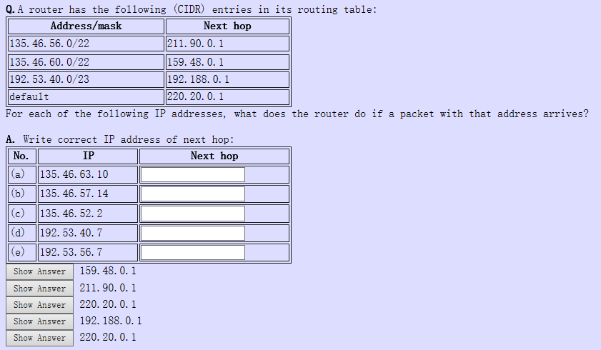

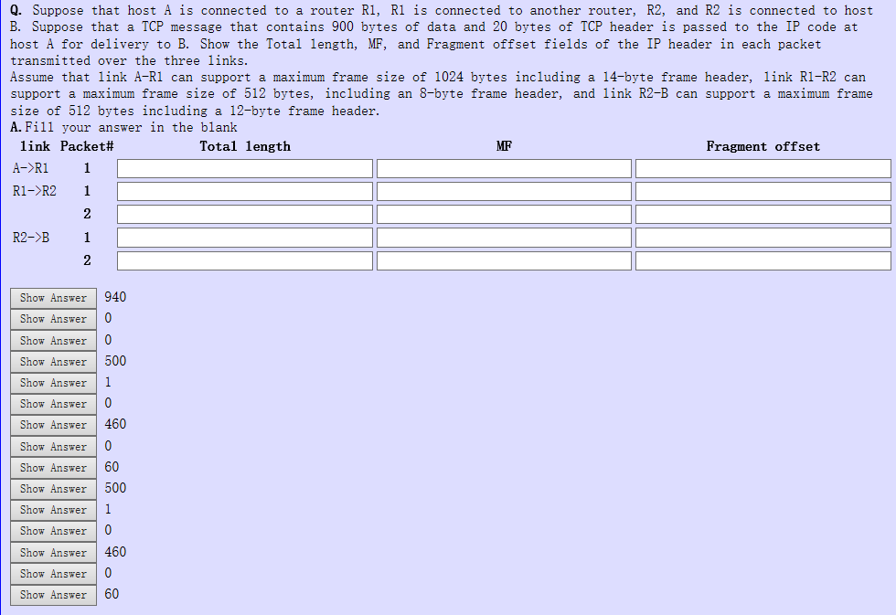

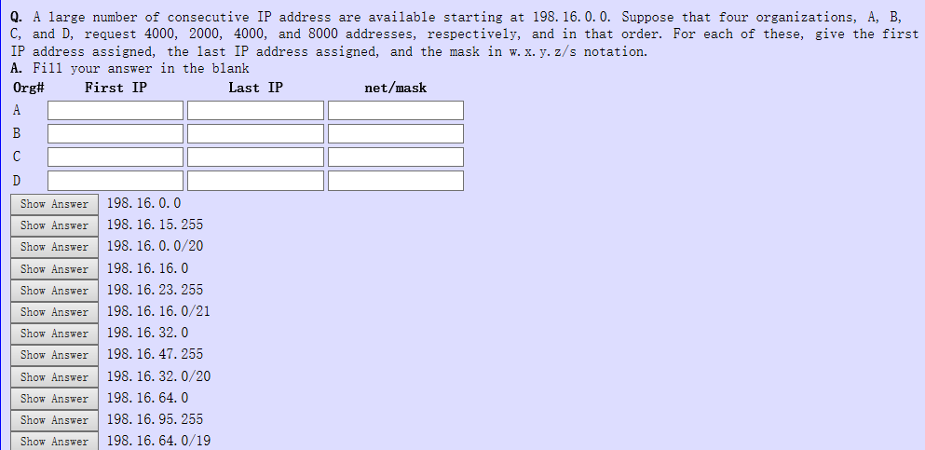

A network on the Internet has a subnet mask of 255.255.240.0. What is the maximum number of address can be used for a single host?

4094

Assumeing that all routers and hosts are working properly and that all software in both is free of all errors, is there any chance, however small, that a packet will be delivered to the wrong destination?

Yes. A large noise burst could garble a packet badly. With a k-bit checksum, there is a probability of 2^-k that the error is undetected. If the destination field or, equivalently, virtual-circuit number, is changed, the packet will be delivered to the wrong destination and accepted as genuine. Put in other words, an occasional noise burst could change a perfectly legal packet for one destination into a perfectly legal packet for another destination.

In a network that has a maximum TPDU size of 128 bytes, a maximum TPDU lifetime of 30 sec, and an 8-bit sequence number, what is the maximum data rate per connection?

8.704kbps

Suppose that the TCP congestion window is set to 18 KB and a timeout occurs. How big will the window be if the next four transmission bursts are all successful? Assume that the maximum segment size is 1 KB.

9KB

What is the total size of the minimum TCP MTU, including TCP and IP overhead but not including data link layer overhead?

576 bytes

A TCP machine is sending full windows of 65,535 bytes over a 1-Gbps channel that has a 10-msec one-way delay. What is the maximum throughput achievable? What is the line efficiency? (give your answer as xx.x)

maximum througput: 3.3 MB/s

line efficiency: 2.6%

Consider the effect of using slow start on a line with a 10-msec round-trip time and no congestion. The receive window is 24 KB and the maximum segment size is 2 KB. How long does it take before the first full window can be sent?

40 msec

Can a machine with a single DNS name have multiple IP addresses? How could this occur?

Yes. In fact, in Fig. 7-3 we see an example of a duplicate IP address.Remember that an IP address consists of a network number and a host number. If a machine has two Ethernet cards, it can be on two separate networks, and if so, it needs two IP addresses.

A binary file is 3072 bytes long. How long will it be if encoded using base64 encoding, with a CR+LF pair inserted after every 80 bytes sent and at the end?

4200