REQUIREMENT1: Project Organization

1(a) develop an initial project charter

**Project Name**

The GPS Auto-navigation System Verification Project

**Background**

Hangzhou AUTONAV, Inc. launched IRIS project for development of a new project. The IRIS proposes a new strategy which is “first to market with technological superior and high reliability at a reasonable cost” and can exceed all field expectations for reliability. IRIS promotes the transition of the company into a new market and the transformation of the company into a new line of products. And the IRIS represents the movement by the company into very profitable and high growth areas of commercial navigation equipment.

Opportunity:

Hangzhou AUTONAV, Inc. is an is an organization whose main business is the production of high reliability auto guidance and navigation systems for various customers. It has made a profit by following a philosophy of careful development and maintenance of a competitive strategy. The strategy has been to “produce the most technologically superior and most reliable electronics equipment in the world”.  They are known in the industry as excelling in technological sophistication and high reliability products. The company also had a reputation of producing high technology products that were developed on time, within budget, and to all performance requirements --- they operated on a project mentality and had been quite successful.

The project is receiving a lot of attention from senior management.

Problem:

The IRIS need to receive some tests.  
 **Goals**

* Test 5 systems under operational conditions to support claims of reliability to convince the customer that product design performance was stable and reliable
* Receive a “tear down” workmanship assessment
* Receive engineer design review

**Scope**

* Design test plan and time arrangement
* Guidance system reliability testing
* Module decomposition audit and result of audit
* Analysis test and result of audit

**Key Stakeholders**

|  |  |
| --- | --- |
| Client Represent | Robert HOU |
| IRIS Project Manager | George WU |
| Senior vice-president and Director of Product Manufacturing | Peter WANG |
| Director of Marketing and Sales | Thomas GU |
| Director of Inspection & Test | Jane YANG |
| Director of Engineer | James TAN |
| Quality Engineering | Gail YU |
| Design & Product | Tom HUANG |
| The Manager of Reliability Engineering | ZJY |
| Executive assistant | Adam OUYANG |

**Project Milestones**

|  |  |
| --- | --- |
| Pre-briefing of the results and recommended actions prior | At least 1 week at advance |
| A full customer briefing | In 3 weeks |

**Constraints, Assumptions, Risks and Dependencies**

|  |  |
| --- | --- |
| Constraints | Loss test data |
| Assumptions | 5 systems |
| Risks and Dependencies | Irreconcilable conflicts with customers |

**Approval Signatures**

|  |  |
| --- | --- |
| zjy |  |
| [Name], Project Client, Project Manger… |  |

1(b) develop a complete Linear Responsibility Chart

✅ means the primary responsibility.

⭕️ means consulting responsibility.

❌ means reviewing responsibility.

|  |  |  |  |  |  |  |  |  |  |
| --- | --- | --- | --- | --- | --- | --- | --- | --- | --- |
|  | George WU | Peter WANG | Thomas GU | Jane YANG | James TAN | Adam OUYANG | Gail YU | Tom HUANG | ZJY |
| Lead and manager the project | ✅ |  |  |  |  | ⭕️ |  |  |  |
| design the system | ❌ | ✅ |  |  |  | ⭕️ |  | ✅ |  |
| Test the system | ❌ |  |  | ✅ |  | ⭕️ | ✅ | ⭕️ |  |
| Pre-briefing of the results and recommended actions prior | ❌ |  |  | ✅ | ⭕️ | ⭕️ | ✅ | ✅ |  |
| Negotiate with customers | ❌ |  | ✅ | ✅ |  | ⭕️ |  |  |  |
| Make plan | ❌ | ⭕️ | ⭕️ | ⭕️ | ⭕️ | ⭕️ | ⭕️ | ⭕️ | ✅ |

1(c) complete a stakeholder analysis

**1. stakeholders in project team**

|  |  |  |  |  |
| --- | --- | --- | --- | --- |
| Name | Organization | Role | Profit | Impact |
| George WU | Senior manager | IRIS Project Manager | High | High |
| Peter WANG | Senior manager | Senior vice-president, director of product manufacturing | High | High |
| Thomas GU | Senior manager | Director of marketing and sales | High | Medium |
| Jane YANG | Senior manager | Director inspection & test | Pretty high | High |
| ZJY | Project team | The Manager of Reliability Engineering | Pretty high | Pretty high |
| Gall YU | Project team | Manager of Quality Engineering | Pretty high | High |
| Tom HUANG | Project team | Manager of Design and Product Engineering | Pretty high | High |

**2. stakeholders from other apartments in company**

|  |  |  |  |  |
| --- | --- | --- | --- | --- |
| Name | Organization | Role | Profit | Impact |
| James TAN | Senior manager | Director of engineering | Pretty high | Pretty high |
| George WU | Senior manager | IRIS Project manager | Pretty high | Pretty high |

**3. stakeholders from customers**

|  |  |  |  |  |
| --- | --- | --- | --- | --- |
| Name | Organization | Role | Profit | Impact |
| Robert HOU | Customer representative | Internal customer representative | High | Medium |

REQUIREMENT2: Network Planning for the Reliability Testing and Workmanship Auditing

2(a) Develop a CPM Activity on Node diagram for the project,

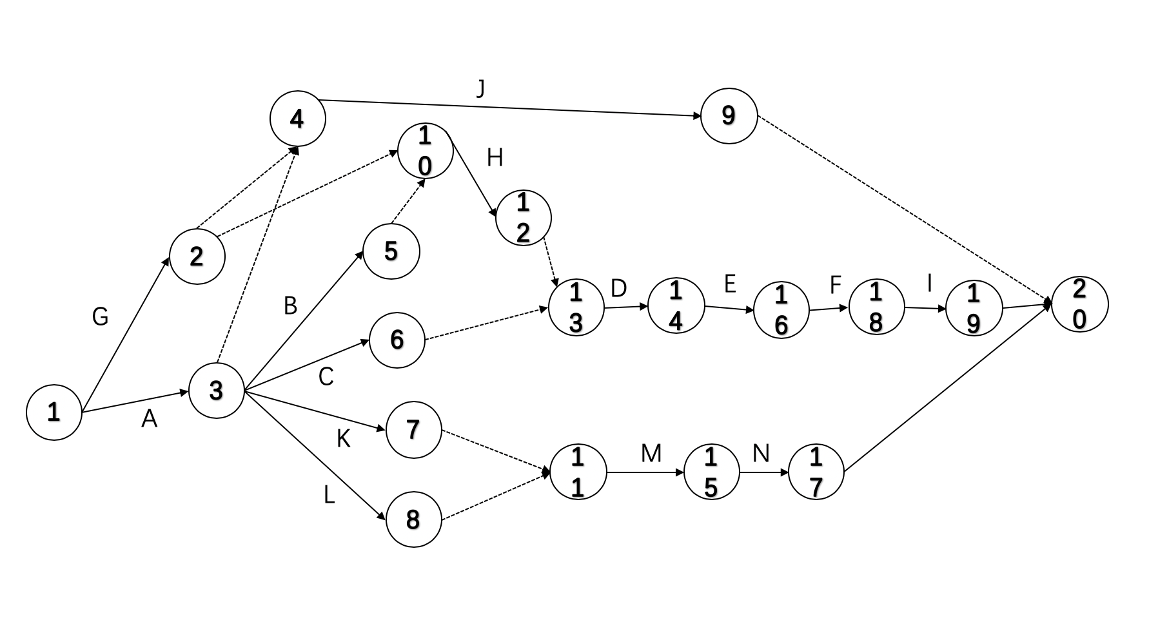

2(b) Determine the critical path and the duration of the critical path for the project,

As we know, the critical path has the longest duration and its duration is known as the duration of the project.

Therefore, the critical path of this project is A->K->M->N. So, the total day would be cost is 5 + 2 + 11 + 3 = 21days.

2(c), What conclusions can you draw from the CPM diagram?,

The duration of the project is 21 days. In this project, we should finish task A and task G at first and finish task I and task N in last. Task B, C, J, K, L need to run concurrently with executing.

Reliability testing costs the most time and workload in the processing of project.

Tasks are all related, one after another. Each task needs to be completed on time to ensure the smooth progress of the whole project. Balance the progress of the project by tracking critical paths.

2(d) Discuss the assumptions, limitations, and implications for using the CPM as an approach for scheduling this project?

Assumptions:

* CPM operates on the assumption that there is a precise known time that each activity in the project will take. But in real, it’s not true.
* It identifies the most critical elements in the project.

Limitations:

* The functions of CPM mainly to describe the historical developments and the current status. Even in the cases where CPM is claimed to be successfully used, updating the plan has been reported as a considerably difficulty. CPM is that performing an action should be always the result of a preceding plan, so large amount of efforts are required to re-plan and redraw the network each time it is updated.
* The time estimation of CPM is not based on statistical analysis.
* Any change introduced will change the entire structure of network. CPM cannot be used as a dynamic controlling device.

Implications:

CPM can tell which task should be done first, which task should be done after others is finished and which tasks can de done concurrently. Using CPM can increase the efficiency. And it provides a graphical display of the project and its main activities and provides quantitative information for identifying potential risk of project delays.

REQUIREMENT3: PERT as a method to schedule the Project

3(a) Develop a PERT Activity on Node diagram for the project (This diagram must specify the critical path and duration of the CP,

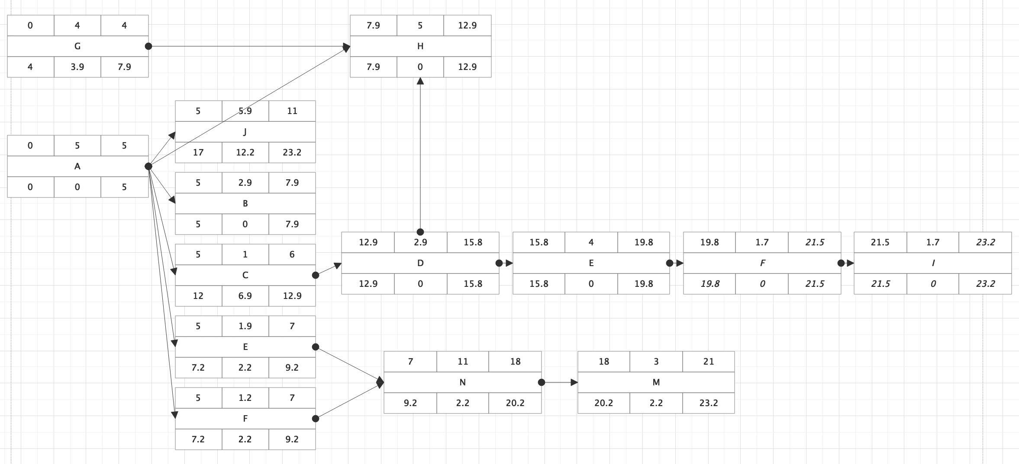

3(b) Construct a table which identifies: Activity, duration, Early Start, Early Finish, Late Start, Late Finish, and Slack (Float), and Activity Standard Deviation (round to 1 decimal place),

|  |  |  |  |  |  |  |  |
| --- | --- | --- | --- | --- | --- | --- | --- |
| **Activity** | **A** | **B** | **C** | **D** | **E** | **F** | **G** |
| Duration | 5 | 2.8 | 1 | 2.8 | 4 | 1.7 | 4 |
| Early start | 1 | 5 | 5 | 12.9 | 15.8 | 19.8 | 1 |
| Early finish | 5 | 7.9 | 6 | 15.8 | 19.8 | 21.5 | 4 |
| Late start | 0 | 5 | 11.9 | 12.9 | 15.8 | 19.8 | 4 |
| Late finish | 5 | 7.9 | 12.9 | 15.8 | 19.8 | 21.5 | 7.9 |
| slack | 0 | 0 | 6.9 | 0 | 0 | 0 | 3.9 |
| Activity Standard deviation | 0.3 | 1.2 | 0 | 1.2 | 1 | 0.7 | 0.3 |

|  |  |  |  |  |  |  |  |
| --- | --- | --- | --- | --- | --- | --- | --- |
| **Activity** | **H** | **I** | **J** | **K** | **L** | **M** | **N** |
| Duration | 5 | 1.7 | 5.8 | 1.8 | 1.2 | 11 | 3 |
| Early start | 7.9 | 21.5 | 5 | 5 | 5 | 7 | 18 |
| Early finish | 12.9 | 23.2 | 11 | 7 | 7 | 18 | 21 |
| Late start | 7.9 | 21.5 | 17.2 | 7.2 | 7.2 | 9.2 | 20.2 |
| Late finish | 12.9 | 23.2 | 23.2 | 9.2 | 9.2 | 20.2 | 23.2 |
| Slack | 0 | 0 | 12 | 2.2 | 2.2 | 2.2 | 2.2 |
| Activity Standard deviati | 1.3 | 0.7 | 0.5 | 0.2 | 0.2 | 0.3 | 0.3 |

3(c) What can you conclude about the project duration from analysis of the PERT network diagram?,

From the PERT network diagram, the minimum amount of time needed to complete the project is 21.5 and the maximum amount of time needed to complete the project is 23.2. It makes me more easily to organize a complex project with a variety of moving parts by visualizing the dependencies between each step of the process. For example, A 🡪 B 🡪 H 🡪 D 🡪 E 🡪 F 🡪 I is the critical path and should be put at the highest priority. I can measure the process of this task.

3(d) What are the primary concerns that a PM must consider in using PERT for project scheduling?

The PM wants to shorten the cost and focus on the critical path of the project. The PM concerns the sequence and timing of each step in the project, especially start time, end time and the time required to complete each task. The PM also concerns the dependencies between each tasks.

The PM need to know the usage and disadvantage of the PERT:

* PERT fits for project with a variety of small tasks and is not easily scalable.
* PERT is less useful for measuring progress than a GANTT chart.
* PERT may become inaccurate in complex project.

REQUIREMENT4: Risk Management

4(a) discuss the statement made by James TAN,

Risk management in projects involves identifying, quantifying, and managing risks. It is impossible to remove all risks. Even the smallest and simplest project has some element of risk. But risk management is considered a major part of project management to reduce or avoid risks. All projects should do risk management.

4(b) identify primary sources of risk inherent in this project,

1) Technical risks: we may encounter problems when using this technology.

2) Property risk, including the loss and damage to property caused by fire or theft.

3) Cost risk: the company promised to provide team support, but did not clearly define the specific cost.

4) Human resource risk: the skills of team members are not enough to complete the project.

5) Communication risks: we may not be able to communicate with customers and company leaders.

6) Personal risk refers to the loss of life or income caused by illness, disability or unemployment.

7) Time risk: we may have error in estimating time cost.

4(c) develop and discuss the role that risk management can play in successful accomplishment of THIS project.

1. Time: The project was completed on time. The project leader shall timely adjust the task schedule to cope with the advance or delay of the end of the previous task.
2. Technology: Solve technical problems in time. The test results of the system meet the reliability requirements.
3. User requirements are clear, differences between requirements and system are found in advance, and changes and repairs are made in time. Communication efficiency among senior managers, project teams and customers is improved. In addition, periodic reports summarize periodic work to track projects and prevent the accumulation of errors.