1. Plan the operation framework and workflow of the user help center of "software engineering series course teaching auxiliary website".

**Operational Framework for**

**User Help Center**

**Part 1: Role of User Help Center**

Role of User help center of software engineering series course teaching auxiliary website is a critical entry point or gateway to using process support service system. The purpose is to actively solve the difficulties encountered by users in the process of using the teaching platform ,handle users' complaints and opinions on the system and get feedback for system.

**Part 2: Principles**

## *Involvement of All users*

User Help Center must focus on the needs of all users of the Internet. That is to say, possible users include not only teachers and students of software engineering courses, but also teachers and students of non software engineering courses; not only readers of school-based majors, but also readers of other schools or other majors; not only domestic users, but also foreign users.

## *Client Diversity*

User Help Center must ensure that users, regardless of a real or perceived barrier to receiving assistance, are able to access their services.

## *Services to Indigenous Clients*

User Help Center should provide flexible, culturally sensitive and accessible service delivery models and practices to Indigenous clients in their area.

## *Fees Policy*

All for free.

## *Refusal of Service*

User Help Center may refuse to provide services to a client who seeks help in violation of laws or platform regulations.

## *Privacy*

Protect the privacy of all customers.

**Part 3: Operation Process**

The basic description of the operation process of User Help Center is as follows:

Users can use the help center whenever they encounter problems.

First of all, it provides users with a basic guide to the use of teaching auxiliary website at the first time of users’ landing, and suggests users to read it completely. User can download the guide at any time.

Users can choose independent query and artificial consultation.

As for independent query, the user can browse our website and see the list of common problems and solutions on the page. Though search, the users may find the correct answer for its problem.

As for artificial consultation, users can users write the problems encountered and submit them to the backstage. There will be a special backstage customer service to reply. Users can communicate with the customer service constantly. The customer service should take responsibility for be patient and figure out the key problem confused the users. If the customer service can solve it by himself, he provides solutions to uses. Or the background staff will collect the problems submitted by users, classify them, and then feed them back to the technicians to solve the problems. Then the customer service transfer the solutions to users. If the problem is common and asked by many people, it will be added to the common FAQ layout.

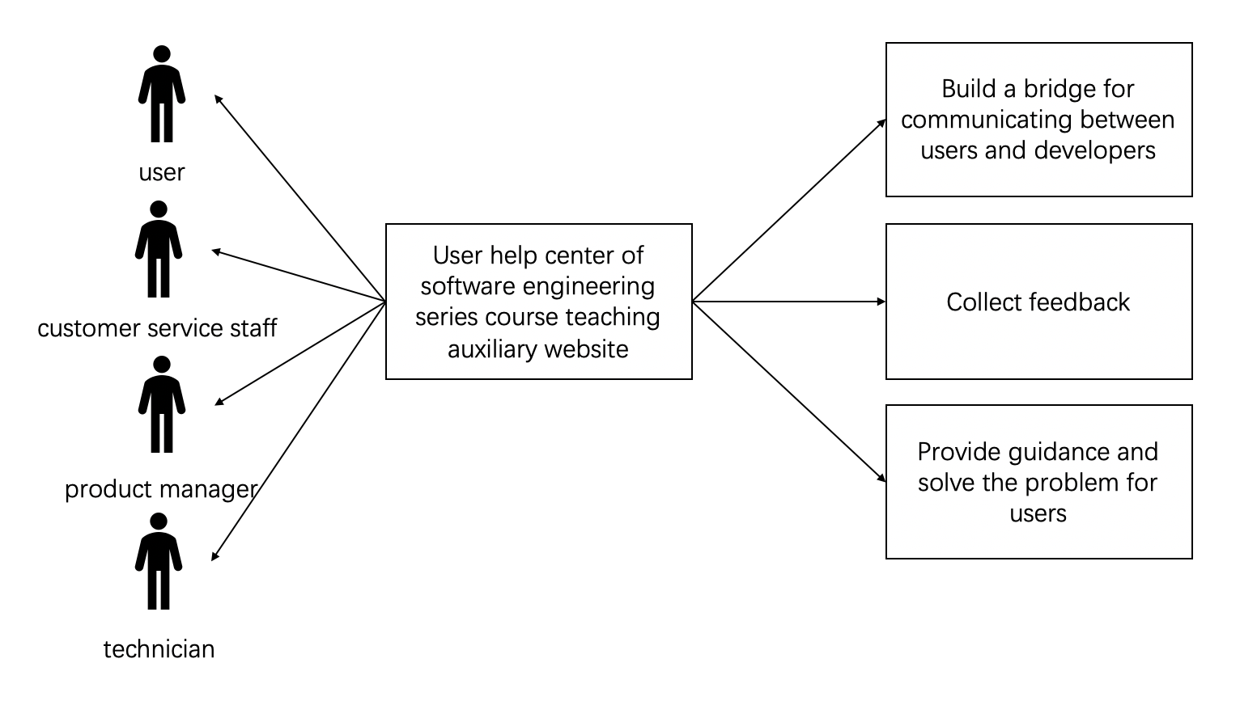

**Workflow**

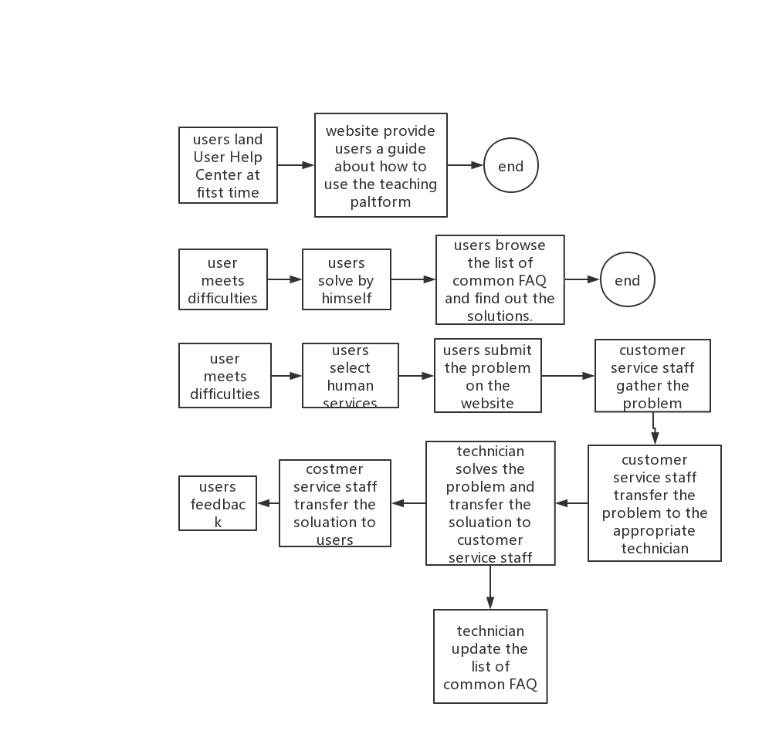

1. Design the roles and responsibilities or possible behavior patterns of the relevant stakeholders in the user help center.

|  |  |
| --- | --- |
| **stakeholders** | **responsibilities** |
| Ambassador User | Responsible for bringing knowledge of the user community into the project team and disseminating information from the team back to the rest of the users. |
| Advisor User | Part of a panel of staff that attends and channel their information and feedback through the Ambassador Users. |
| Visionary | Responsible for ensuring that the right decisions are made with respect to system scope and that the original business objectives of the project are met. |
| Executive Sponsor | Responsible for project funding and make ultimate decision. |
| End User | Browse the website, submit questions and give feedback |
| Product Manager | Manager the whole project. Oversee the day-to-day performance of employees. |
| Business Manager | Started the project and owned the results.  Was responsible for providing all needed facilities and resources for the project. |
| Customer Service Staff | Connect with users, find appropriate technicians for users' problems, and inform users of solutions obtained from technicians |
| Technician | A) designated by the customer service staff, provide one-to-one testing and troubleshooting services for customers according to their technical knowledge.  B) feedback the solution to the customer service staff.  C) update the common FAQ list. |
| Tester | Planned an executed system tests. |

1. If you are the head of the User Help Center, how would you manage your roles well?
2. Develop the staff plan and clarify roles and responsibilities of every members and check the work progress of members regularly. Now there are ambassador user, advisor user, visionary, product manager common user, customer service staff and technician.
3. Establish a reasonable, effective and justify reputation of rewards and punishments. Implement it resolutely.
4. While abiding by the rules, create a harmonious team atmosphere through relevant built-in activities, which helps to understand each employee's working conditions and psychological state.
5. Pay attention to psychological guidance. Provide free and professional psychological guidance for members.
6. Get feedback.
7. Create, execute and control the project plan.
8. If you are the person in charge of the User Help Center, how would you design a communication plan and conduct communication management?
9. Clear and user communication channels to ensure that users need to contact the help center when there is a smooth communication channels.
10. Each customer service should be trained to fully understand how to use the user help center.
11. When communicating with users, relax and pacify users at first and interact with users in time.
12. Keep a positive attitude.
13. Customer service needs to know the basic data of users, such as whether they are teachers and students of software engineering courses or non software engineering courses, whether they are not domestic users or foreign users, whether they are novices or veterans.
14. Customer service needs to patiently guide users to express their own questions clearly. They can obtain users' core questions by asking questions to users, answer questions for users as soon as possible. If they can't answer in time, they must consult technicians in time and look for technical personnel to obtain professional method guidance.
15. After solving the user's problems, collect the user's feedback information and summarize it.
16. Organize the questions that users respond to in phases and put them in the common FAQ page.
17. Pay attention to the customer's return visit.