The centralized old scheme was this:

The new multi-asset scheme is

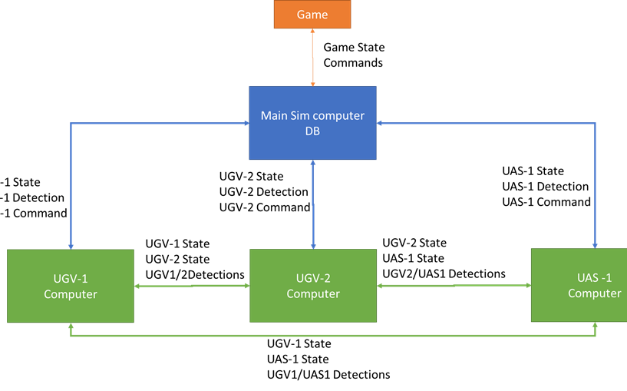

Trying to re-use existing code and libraries as much as possible, we are thinking in following the next steps:

1. Simplify the drawing of the centralized old scheme to

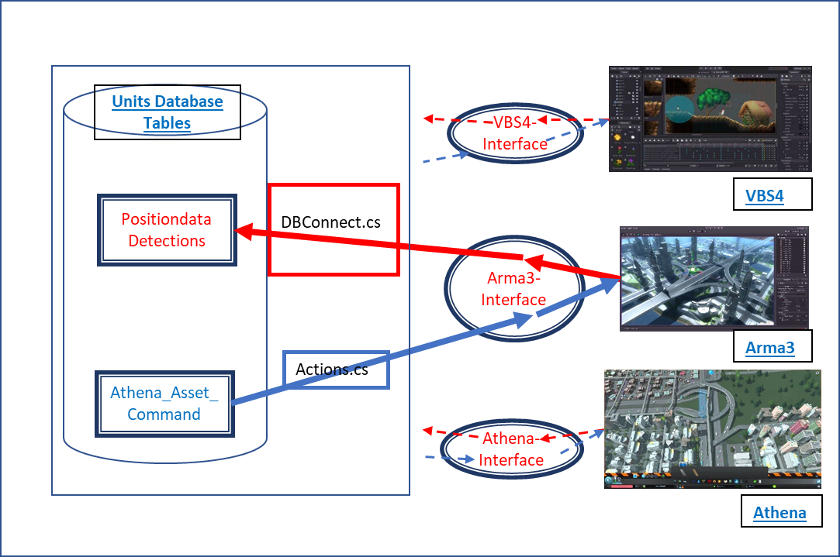

Where now, to spare space, we understand that Positiondata and Detections are really two tables, but we use a single box to represent them, and similarly with the red arrows. a difference with the original interface might be that we don’t delete each row of the tables after reading them, but we keep them for later use and reference. We can also add a first column to each table playing the role of index or key, to identify each row at a later stage.

1. We will keep that “Main scheme’, with the name ‘Main Sim Computer, DB’ (as Roy’s model) and we will replace the ‘Python Code’ symbol by a more complex structure representing the multiple assets:

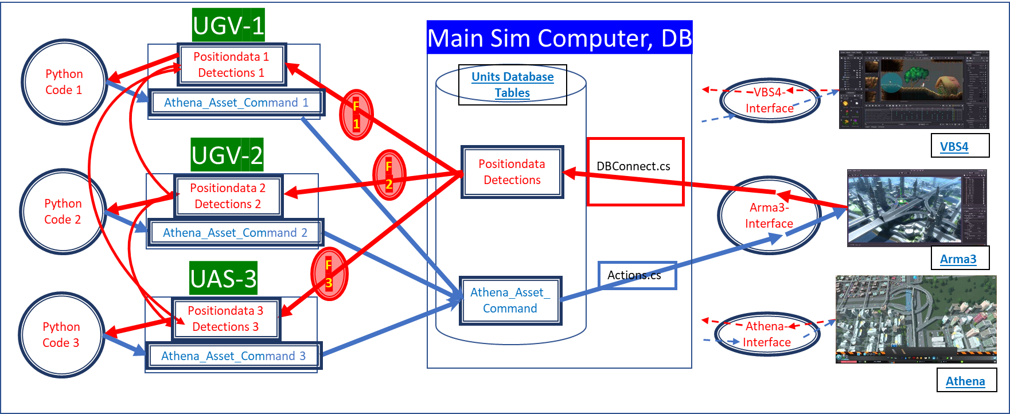

* 1. Where each one of the structures

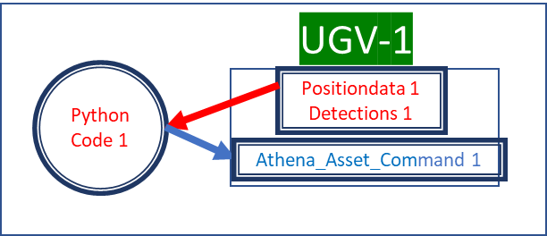

is formally equal to the original ‘Units Database’ and interfaces, where now each ‘Python Code’ is similar to the original one, but with small modifications depending on the particular asset where it is applied. The individual asset’s tables and database can keep the same structure as the centralized old one. They will be updated by querying the tables in the ‘Main Sim Computer, DB’ unit, but applying a filter specific to the particular asset, for example adding to the sql query something like “where unit = ugv_1 and where index > last_index” or equivalent, where last_index is the index of our last query. This filter is represented in the scheme by the



symbol.

* 1. The additional arrows like

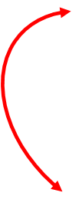

joining the tables of the different assets correspond to new queries to the tables of the other assets to obtain the new position and new detections performed by that asset. We need to decide if we keep all the information, or we remove repeated events.

1. It is important to notice that now the commands sent to the game are generated by each individual asset and should refer to actions of that particular asset only. All commands are collected by the Main SimComputer and sent to the game.