P1:
- Number of iterations until convergence for both algorithms
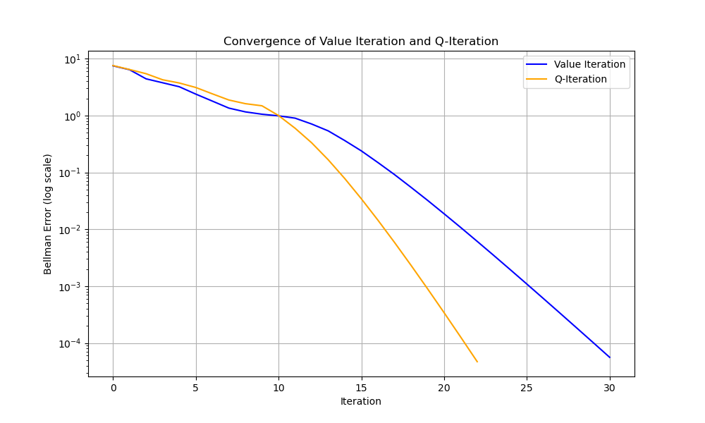
Q-it: 23
Value: 31
- Visualization of the final value function (heatmap)
QI Value Function
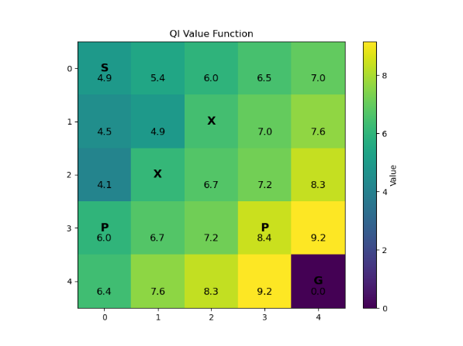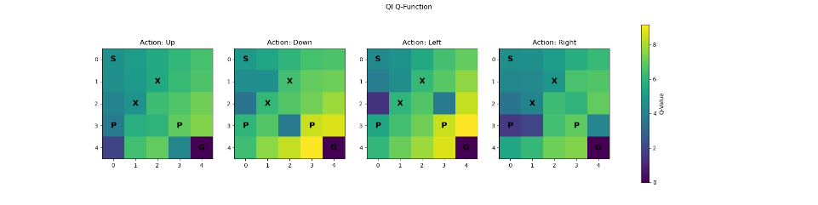
VI value function
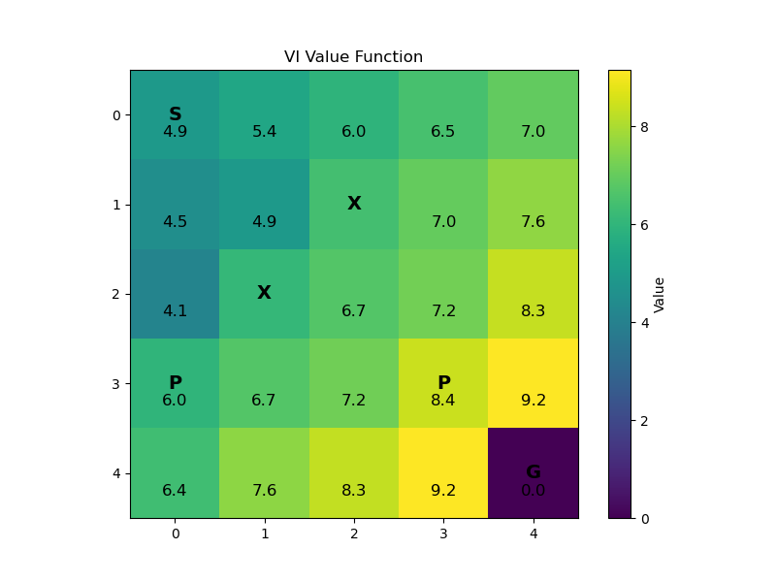
- Visualization of the optimal policy (arrows on grid)
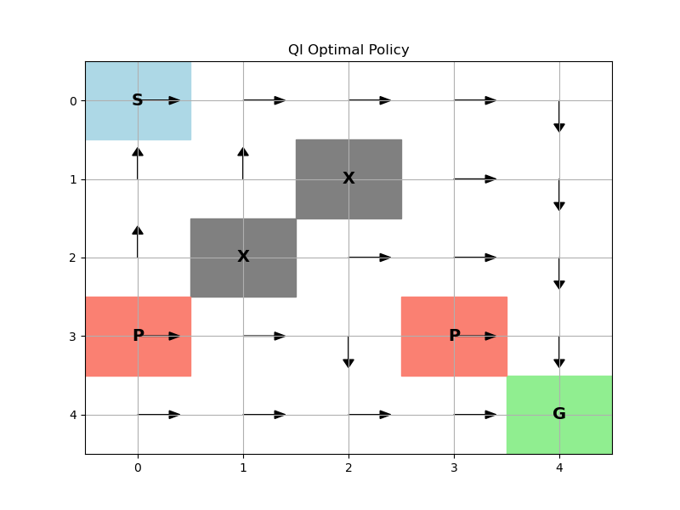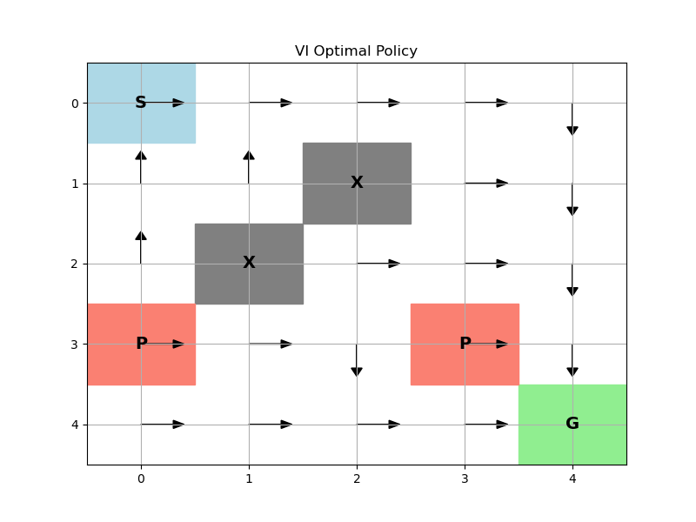
Same
- Brief comparison of Value Iteration vs Q-Iteration convergence rates
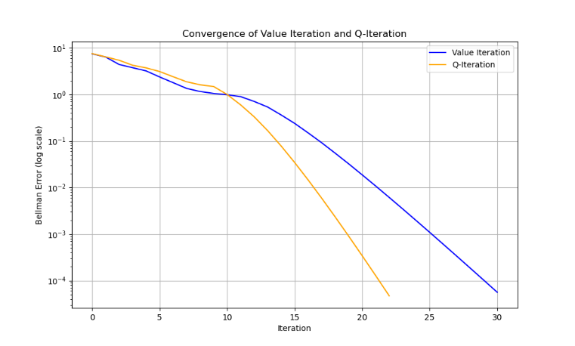
At first, they are about the same. After 10 iterations, Q-it converges faster.
- Discussion of how the stochastic transitions affect the optimal policy
In deterministic environments, agents seek only the shortest path. However, in stochastic environments, agents seek paths that maximize expected return. This means they sacrifice speed for safety. It prefers open spaces and keep away from the penalty areas.

