P1:
- Attention pattern visualizations from at least 4 different heads
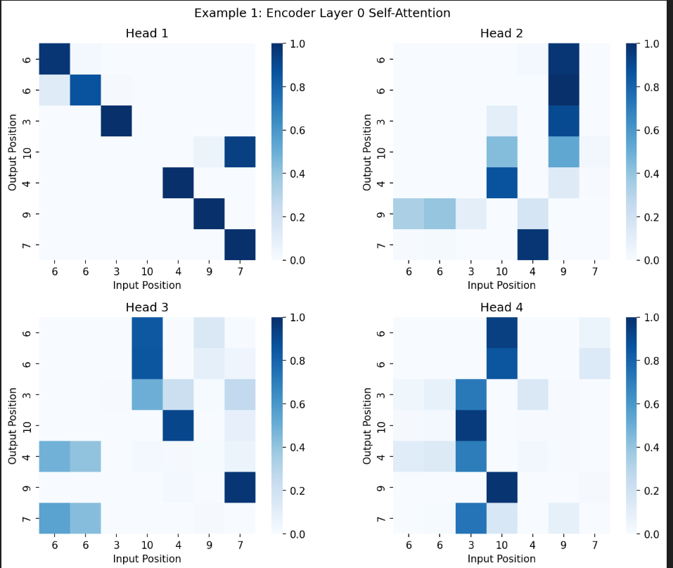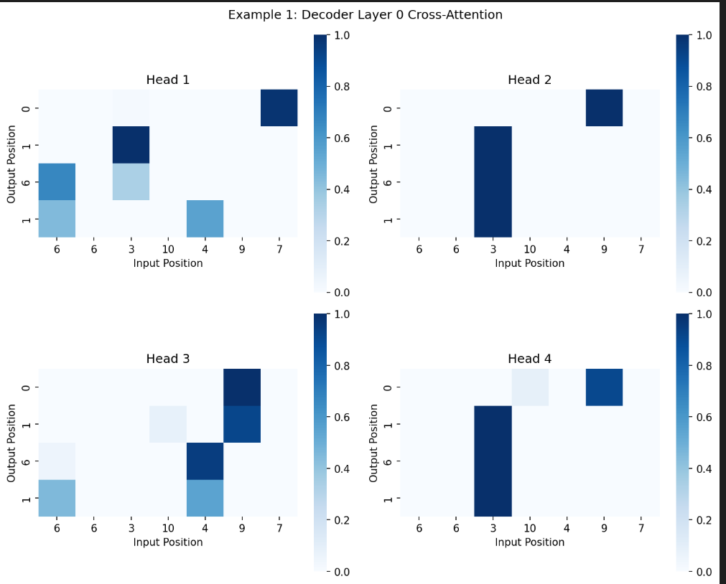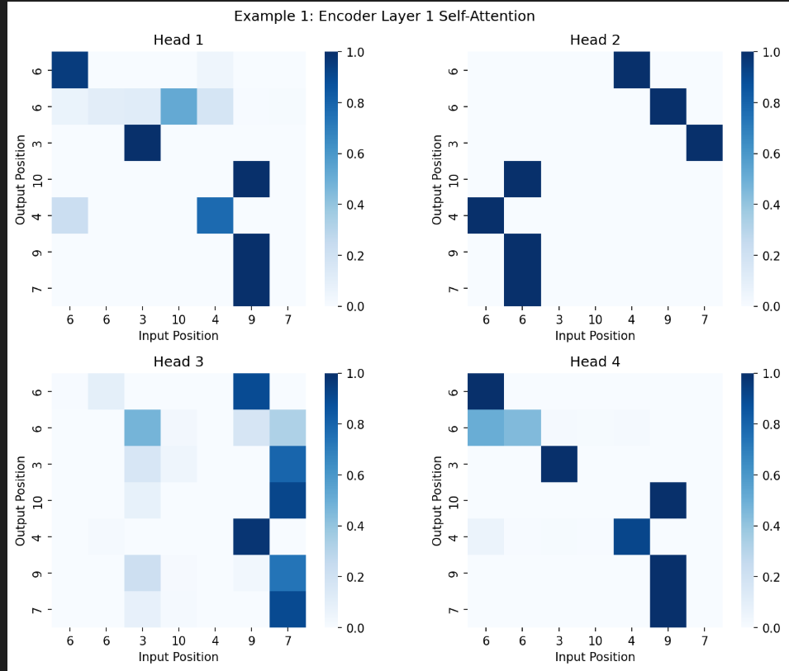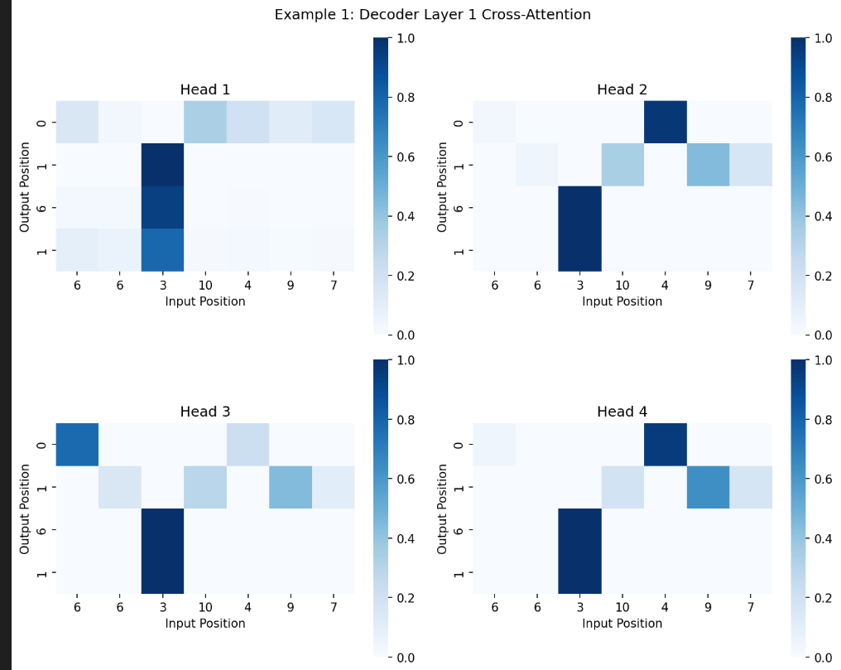
From this picture, we can know that
Head1: Position head
Head2: Study the last digits
Head3: Adjacent digits and carry
Head4: Token
- Head ablation study: which heads are critical vs redundant?
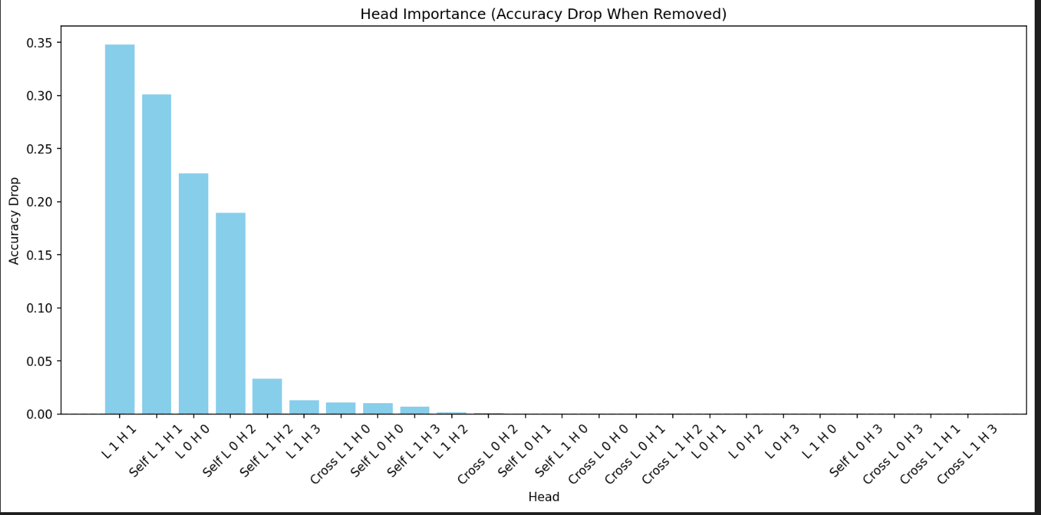
Layer_0_head_0, layer_1_head_1, Self L1H1, Self L0H2 is critical.
- Discussion: How do attention heads specialize for carry propagation?
For heads focused on the lower triangular region from t → t-1, this head is more likely to learn to pass carry information from lower-order additions to higher-order positions.
For heads paying greater attention to the position of the “+” sign in the input, they may learn to recognize the boundary between the two addends.
- Quantitative results: percentage of heads that can be pruned with minimal accuracy loss

15/24 = 62.5% heads can be pruned.

P2:
- Extrapolation curves showing accuracy vs. sequence length for all three methods
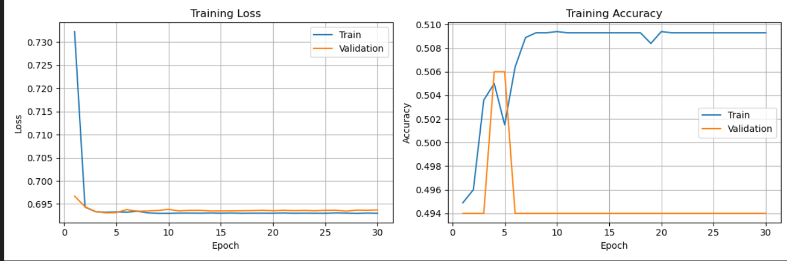
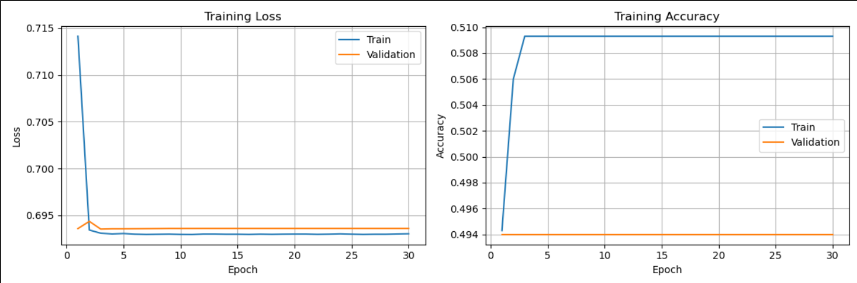
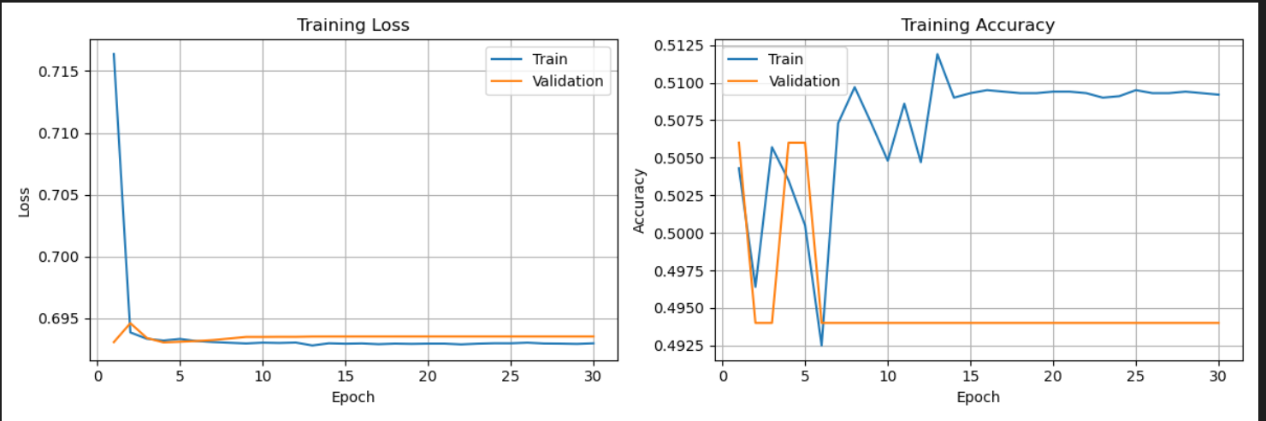
- Mathematical explanation: Why does sinusoidal encoding extrapolate while learned encoding fails?
In theory, Sinusoidal encoding uses a continuous function that is continuously computable at all positions pos. Whether pos is 10, 100, or 10,000, it is defined. Therefore, it can naturally generalize to longer sequences (extrapolation).
For learned encoding, only positions pos that appear during training acquire learned values. For new positions beyond the training length, the model has never seen them and can only randomly select or reuse the last row of embeddings. Therefore, it cannot extrapolate.
- Position embedding visualization for learned encoding
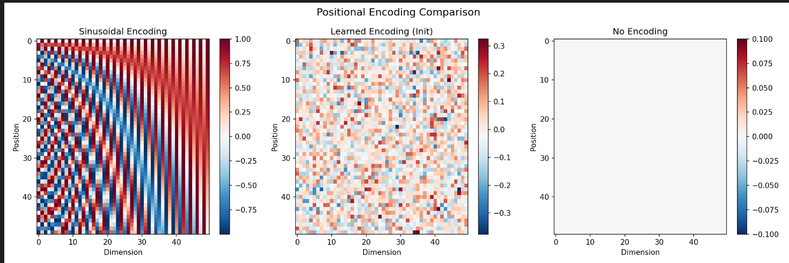
Sinusoidal: Periodic corrugated structures, corresponding to waves of different frequencies across different dimensions, show that this encoding is a regular and predictable continuous function.
Learned: Color distribution is random and lacks any discernible pattern.
None: All zero.
- Quantitative comparison: accuracy at lengths 32, 64, 128, 256
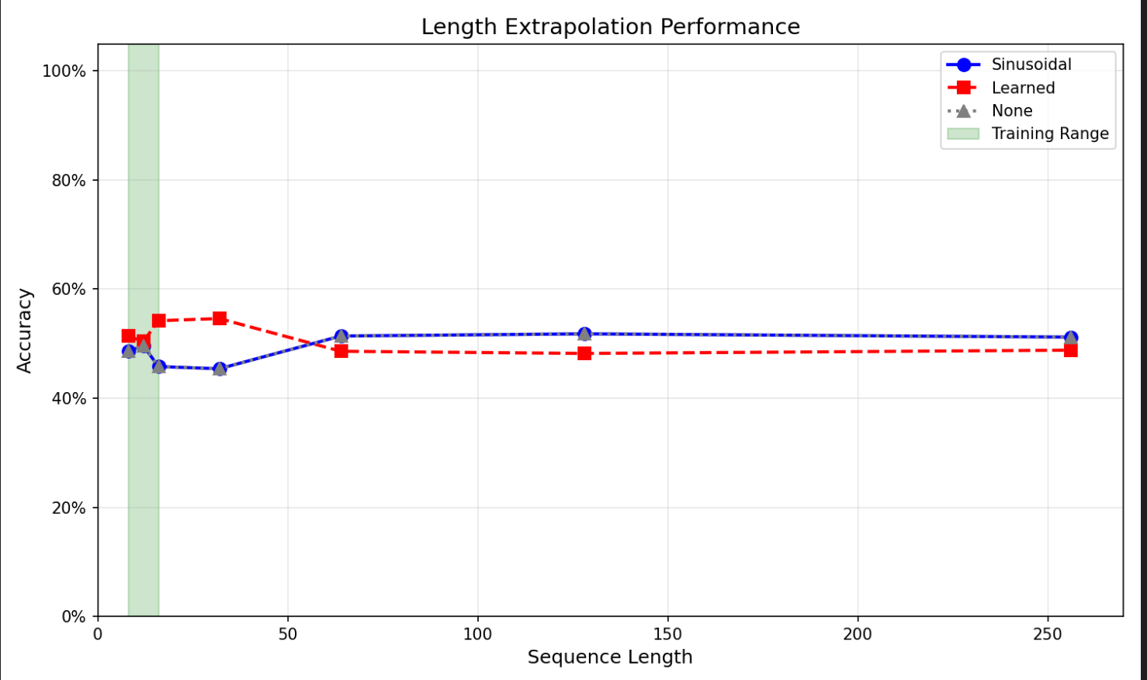
Due to some problem, all accuracy of three methods is about 50% and for different length, the accuracy is about the same.

