Initial Database Setup

CREATE DATABASE bankdb;
USE bankdb;

CREATE TABLE Customers (
CustomerID INT PRIMARY KEY,
Name VARCHAR(100),
DOB DATE,
Balance DECIMAL(10,2),
LastModified DATETIME
);

CREATE TABLE Accounts (
AccountID INT PRIMARY KEY,
CustomerID INT,
AccountType VARCHAR(20),
Balance DECIMAL(10,2),
LastModified DATETIME,
FOREIGN KEY (CustomerID) REFERENCES Customers(CustomerID)
);

CREATE TABLE Transactions (
TransactionID INT PRIMARY KEY,
AccountID INT,
TransactionDate DATETIME,
Amount DECIMAL(10,2),
TransactionType VARCHAR(10),
FOREIGN KEY (AccountID) REFERENCES Accounts(AccountID)
);

CREATE TABLE Loans (
LoanID INT PRIMARY KEY,
CustomerID INT,
LoanAmount DECIMAL(10,2),
InterestRate DECIMAL(5,2),
StartDate DATE,
EndDate DATE,
FOREIGN KEY (CustomerID) REFERENCES Customers(CustomerID)
);

CREATE TABLE Employees (
EmployeeID INT PRIMARY KEY,
Name VARCHAR(100),
Position VARCHAR(50),
Salary DECIMAL(10,2),
Department VARCHAR(50),
HireDate DATE
);

INSERT INTO Customers (CustomerID, Name, DOB, Balance, LastModified)
VALUES (1, 'Tarun Karrthick', '1985-05-15', 1000.00, NOW()),
(2, 'Tarun', '1990-07-20', 1500.00, NOW());

INSERT INTO Accounts (AccountID, CustomerID, AccountType, Balance, LastModified)
VALUES (1, 1, 'Savings', 1000.00, NOW()),
(2, 2, 'Checking', 1500.00, NOW());

INSERT INTO Transactions (TransactionID, AccountID, TransactionDate, Amount, TransactionType)
VALUES (1, 1, NOW(), 200.00, 'Deposit'),
(2, 2, NOW(), 300.00, 'Withdrawal');

INSERT INTO Employees (EmployeeID, Name, Position, Salary, Department, HireDate)
VALUES (1, 'Tarun Karrthick', 'AI Engineer', 98000.00, 'Customer Service', '2020-01-10'),
(2, 'Vignesh', 'Manager', 70000.00, 'HR', '2015-06-15'),
(3, 'Viswa', 'Developer', 60000.00, 'IT', '2017-03-20'),
(4, 'Sankar', 'Tester', 50000.00, 'QA', '2018-08-10'),
(5, 'Siva', 'Analyst', 55000.00, 'Finance', '2019-09-25');

Exercise 1: Control Structures

Scenario 1: The bank wants to apply a discount to loan interest rates for customers above 60 years old.
Question: Write a PL/SQL block that loops through all customers, checks their age, and if they are above 60, apply a 1% discount to their current loan interest rates

Solution:
DELIMITER //
CREATE PROCEDURE ApplySeniorDiscount()
BEGIN
DECLARE done INT DEFAULT FALSE;
DECLARE customerId INT;
DECLARE dob DATE;
DECLARE age INT;
DECLARE customerCursor CURSOR FOR
SELECT CustomerID, DOB FROM Customers;
DECLARE CONTINUE HANDLER FOR NOT FOUND SET done = TRUE;
OPEN customerCursor;
readLoop: LOOP
FETCH customerCursor INTO customerId, dob;
IF done THEN
LEAVE readLoop;
END IF;
SET age = FLOOR(TIMESTAMPDIFF(MONTH, dob, CURDATE()) / 12);
IF age > 60 THEN
UPDATE Loans
SET InterestRate = InterestRate - 1
WHERE CustomerID = customerId;
END IF;
END LOOP;
CLOSE customerCursor;
END;
//
DELIMITER ;
INSERT INTO Loans (LoanID, CustomerID, LoanAmount, InterestRate, StartDate, EndDate)
VALUES(1, 1, 5000.00, 5.00, CURDATE(), DATE_ADD(CURDATE(), INTERVAL 24 MONTH)),
(2, 2, 7000.00, 6.00, CURDATE(), DATE_ADD(CURDATE(), INTERVAL 36 MONTH));
CALL ApplySeniorDiscount();
SELECT LoanID, CustomerID, InterestRate FROM Loans;
Output:

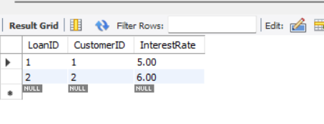
Scenario 2: A customer can be promoted to VIP status based on their balance.
Question: Write a PL/SQL block that iterates through all customers and sets a flag IsVIP to TRUE for those with a balance over $10,000.

Solution:
ALTER TABLE Customers ADD IsVIP BOOLEAN DEFAULT FALSE;
DELIMITER //
CREATE PROCEDURE PromoteVIPCustomers()
BEGIN
DECLARE done INT DEFAULT FALSE;
DECLARE custId INT;
DECLARE balance DECIMAL(10,2);
DECLARE custCursor CURSOR FOR
SELECT CustomerID, Balance FROM Customers;
DECLARE CONTINUE HANDLER FOR NOT FOUND SET done = TRUE;

OPEN custCursor;
promoteLoop: LOOP
FETCH custCursor INTO custId, balance;
IF done THEN
LEAVE promoteLoop;
END IF;

IF balance > 10000 THEN
UPDATE Customers
SET IsVIP = TRUE
WHERE CustomerID = custId;
END IF;
END LOOP;
CLOSE custCursor;
END;
//
DELIMITER ;

CALL PromoteVIPCustomers();
SELECT CustomerID, Name, Balance, IsVIP FROM Customers;

Output:

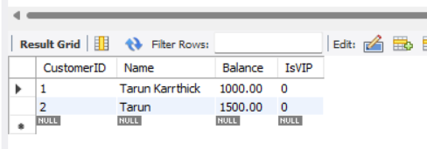

Scenario 3: The bank wants to send reminders to customers whose loans are due within the next 30 days.
Question: Write a PL/SQL block that fetches all loans due in the next 30 days and prints a reminder message for each customer.

Solution:

DROP PROCEDURE IF EXISTS SendLoanReminders;
DELIMITER //
CREATE PROCEDURE SendLoanReminders()
BEGIN
DELETE FROM LoanReminders;
INSERT INTO LoanReminders (Message)
SELECT
CONCAT('Reminder: Loan ID ', L.LoanID, ' for customer ', C.Name,
' (ID ', L.CustomerID, ') is due on ', L.EndDate)
FROM Loans L
JOIN Customers C ON L.CustomerID = C.CustomerID
WHERE L.EndDate BETWEEN CURDATE() AND DATE_ADD(CURDATE(), INTERVAL 30 DAY);
SELECT * FROM LoanReminders;
END;
//
DELIMITER ;
CALL SendLoanReminders();

Output:
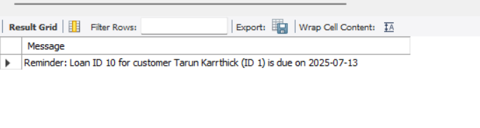

Exercise 3: Stored Procedures

Scenario 1: The bank needs to process monthly interest for all savings accounts.
Question: Write a stored procedure ProcessMonthlyInterest that calculates and updates the balance of all savings accounts by applying an interest rate of 1% to the current balance.

Solution:

SET SQL_SAFE_UPDATES = 0;
DELIMITER //
CREATE PROCEDURE ProcessMonthlyInterest()
BEGIN
UPDATE Accounts SET Balance = Balance * 1.01 WHERE AccountType = 'Savings';
END //

DELIMITER ;
CALL ProcessMonthlyInterest();

SELECT * FROM Accounts WHERE AccountType = 'Savings';
SET SQL_SAFE_UPDATES = 1;

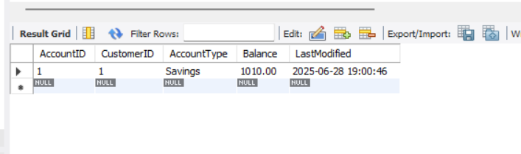
Output:

Scenario 2: The bank wants to implement a bonus scheme for employees based on their performance.
Question: Write a stored procedure UpdateEmployeeBonus that updates the salary of employees in a given department by adding a bonus percentage passed as a parameter.

Solution:

DELIMITER //
CREATE PROCEDURE UpdateEmployeeBonus (
IN dept_name VARCHAR(100),
IN bonus_percent DECIMAL(5,2)
)
BEGIN
UPDATE Employees SET Salary = Salary + (Salary * bonus_percent / 100)
WHERE Department = dept_name;
END //
DELIMITER ;

SET SQL_SAFE_UPDATES = 0;
CALL UpdateEmployeeBonus('HR', 10);
SELECT * FROM Employees WHERE Department = 'HR';
SET SQL_SAFE_UPDATES = 1;

Output:
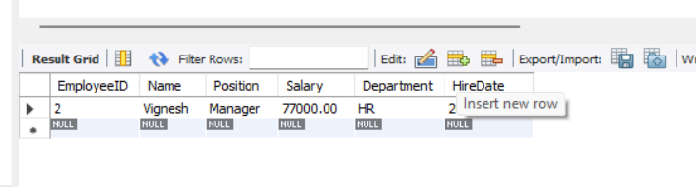
Scenario 3: Customers should be able to transfer funds between their accounts.
Question: Write a stored procedure TransferFunds that transfers a specified amount from one account to another, checking that the source account has sufficient balance before making the transfer.

Solution:

SET SQL_SAFE_UPDATES = 0;
DELIMITER //
CREATE PROCEDURE TransferFunds (
IN from_account INT,
IN to_account INT,
IN amount DECIMAL(10,2)
)
BEGIN
DECLARE from_balance DECIMAL(10,2);
START TRANSACTION;
SELECT Balance INTO from_balance FROM Accounts
WHERE AccountID = from_account FOR UPDATE;

IF from_balance >= amount THEN
UPDATE Accounts SET Balance = Balance - amount,
LastModified = NOW()
WHERE AccountID = from_account;
UPDATE Accounts SET Balance = Balance + amount,
LastModified = NOW()
WHERE AccountID = to_account;

COMMIT;
ELSE
ROLLBACK;
SIGNAL SQLSTATE '45000'
SET MESSAGE_TEXT = 'Insufficient balance in source account';
END IF;
END //
DELIMITER ;
CALL TransferFunds(1, 2, 500.00);
SELECT * FROM Accounts;

Output:
