Exercise 1: Setting Up JUnit
Scenario:
To begin writing unit tests, I needed to set up JUnit in my Java project using Maven in Eclipse.
Solution:
Tools Used:
- Eclipse IDE
- Apache Maven
- JUnit 5
Steps Performed:
- Created a Maven Project in Eclipse
- Added JUnit Dependency
<dependency>
<groupId>org.junit.jupiter</groupId>
<artifactId>junit-jupiter-api</artifactId>
<version>5.10.0</version>
<scope>test</scope>
</dependency>

3 .Created a Sample JUnit Test Case
package com.example;
public class Calculator {
public int add(int a, int b) {
return a + b;
}
}
package com.example;
import static org.junit.jupiter.api.Assertions.*;
import org.junit.jupiter.api.Test;
class CalculatorTest {
@Test
public void testAdd() {
Calculator calc = new Calculator();
assertEquals(5, calc.add(2, 3));
}

}

Output:

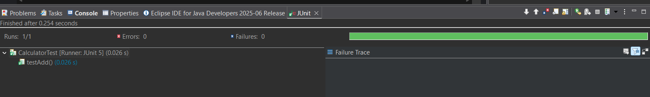

Exercise 3: Assertions in Junit
Scenario:
You need to use different assertions in JUnit to validate your test results.
Solution:
Tools Used: Eclipse IDE, JUnit 5, Java, Maven
Steps Performed:
- Created a new test class named AssertionsTest inside the src/test/java folder.
- Wrote unit tests using different assertion methods provided by JUnit.
- Used assertions
package com.test;
import static org.junit.jupiter.api.Assertions.*;
import org.junit.jupiter.api.Test;
public class AssertionsTest {
@Test
public void testAssertions() {
assertEquals(5, 2 + 3);
assertTrue(5 > 3);
assertFalse(5 < 3);
assertNull(null);
assertNotNull(new Object());
}
}
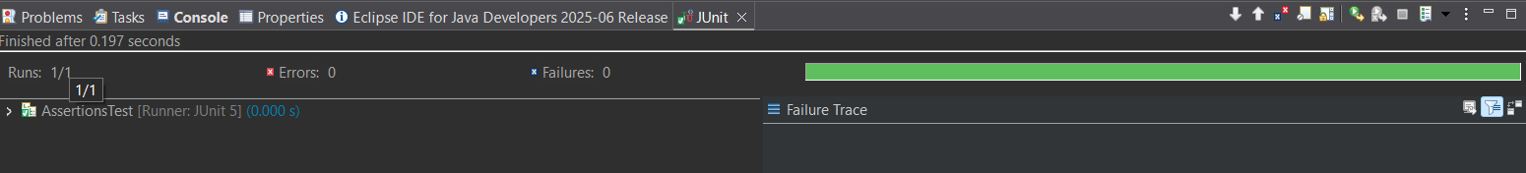
Output:
Exercise 4: Arrange-Act-Assert (AAA) Pattern, Test Fixtures, Setup and Teardown Methods in Junit
Scenario:
You need to organize your tests using the Arrange-Act-Assert (AAA) pattern and use setup and teardown methods.
Solution:
Tools Used: Eclipse IDE, JUnit 5, Java, Maven

Steps Performed:
- Created a sample class Calculator with an add() method (in src/main/java).
- Created a JUnit test class CalculatorTest (in src/test/java).
- Used the AAA pattern in each test method.
- Used @BeforeEach to initialize the Calculator object.
package com;
public class CalculatorTt {
public int add(int a, int b) {
return a + b;
}
public int subtract(int a, int b) {
return a - b;
}
public int multiply(int a, int b) {
return a * b;
}
public int divide(int a, int b) {
if (b == 0) {
throw new IllegalArgumentException("Division by zero");
}
return a / b;
}
}
package com;
import org.junit.jupiter.api.*;
import static org.junit.jupiter.api.Assertions.*;
public class CalculatorTtTest {
private CalculatorTt calculator;
@BeforeEach
void setUp() {
calculator = new CalculatorTt();
}
@AfterEach
void tearDown() {
calculator = null;
}
@Test
void testAddition() {
int result = calculator.add(2, 3);
assertEquals(5, result, "2 + 3 should equal 5");
}
@Test
void testSubtraction() {
int result = calculator.subtract(10, 4);
assertEquals(6, result, "10 - 4 should equal 6");
}
@Test
void testMultiplication() {
int result = calculator.multiply(3, 5);
assertEquals(15, result, "3 * 5 should equal 15");
}
@Test
void testDivision() {
int result = calculator.divide(10, 2);
assertEquals(5, result, "10 / 2 should equal 5");
}
@Test
void testDivisionByZero() {
Exception exception = assertThrows(IllegalArgumentException.class, () -> {
calculator.divide(10, 0);
});
assertEquals("Division by zero", exception.getMessage()); }
}
Output:
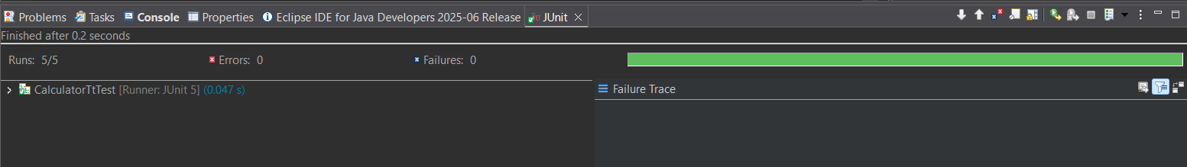
Exercise 1: Mocking and Stubbing
Scenario: You need to test a service that depends on an external API. Use Mockito to mock the external API and stub its methods.
Solution:
Tools Used: Java 8, JUnit 5, Mockito 3.12.4, Eclipse IDE, Maven for dependency management
Steps Performed:
- Create a Maven project in Eclipse named mockito-demo
- Add dependencies in pom.xml
- Create an external API interface

package com.example;
public interface WeatherApi {
String getWeather(String city);
}
package com.example;
public class WeatherService {
private WeatherApi weatherApi;
public WeatherService(WeatherApi weatherApi) {
this.weatherApi = weatherApi;
}
public String getWeatherMessage(String city) {
String weather = weatherApi.getWeather(city);
return "The weather in " + city + " is " + weather;
}
}
package com.example;
import static org.mockito.Mockito.*;
import org.junit.jupiter.api.Test;
import static org.junit.jupiter.api.Assertions.*;
public class WeatherServiceTest {
@Test
public void testGetWeatherMessage() {
WeatherApi mockApi = mock(WeatherApi.class);
when(mockApi.getWeather("Chennai")).thenReturn("Sunny");

WeatherService service = new WeatherService(mockApi);
String result = service.getWeatherMessage("Chennai");
assertEquals("The weather in Chennai is Sunny", result);
}
}

Output:

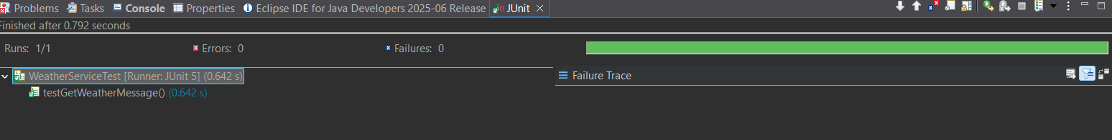

Exercise 2: Verifying Interactions
Scenario: You need to ensure that a method is called with specific arguments.

Solution:

Tools Used: Java 8, JUnit 5, Mockito 3.12.4, Eclipse IDE, Maven for dependency management
Steps Performed:
- Created a Maven project and added the required dependencies (junit-jupiter and mockito-core).
- Defined an external API interface named ExternalApi.
- Created a service class named MyService that depends on ExternalApi.
- Wrote a JUnit test to verify the interaction between the service and the API mock.

package New;
public interface ExternalApi {
void getData();
}

package New;
public class MyService {
private ExternalApi externalApi;
public MyService(ExternalApi externalApi) {
this.externalApi = externalApi;
}
public void fetchData() {
externalApi.getData();
}
}

package New;
import static org.mockito.Mockito.*;
import org.junit.jupiter.api.Test;
import org.mockito.Mockito;
public class MyServiceTest {
@Test
public void testVerifyInteraction() {
ExternalApi mockApi = Mockito.mock(ExternalApi.class);
MyService service = new MyService(mockApi);
service.fetchData();

verify(mockApi).getData();
}
}

Output:

