Setup for Octophonic Mixing

Routing to the Mastertrack should be according to the track number:
Track 1 to 1, Track 2 to 2, etc.
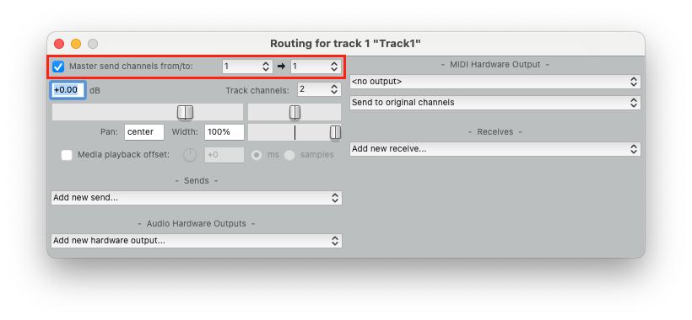
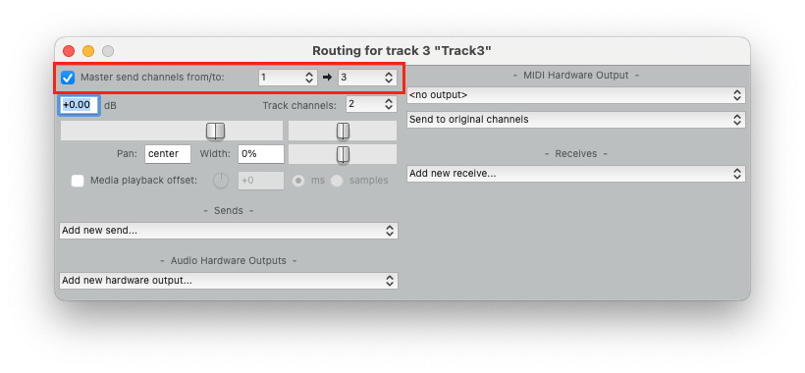

The Master track should be set to 8 Track channels.
The hardware output should be 8 as well according to you Soundcard.
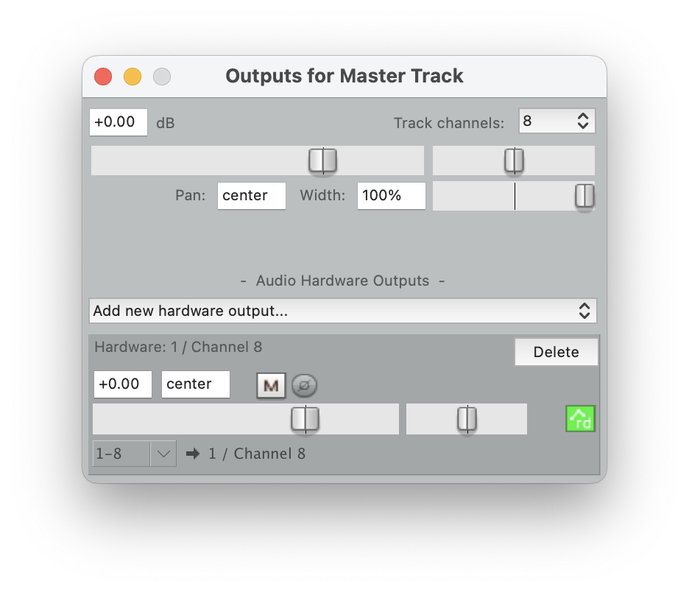
The Soundcard is selected in the Preferences under „Audio/Device“.
(In our Studio in 4010 it is “8M”)
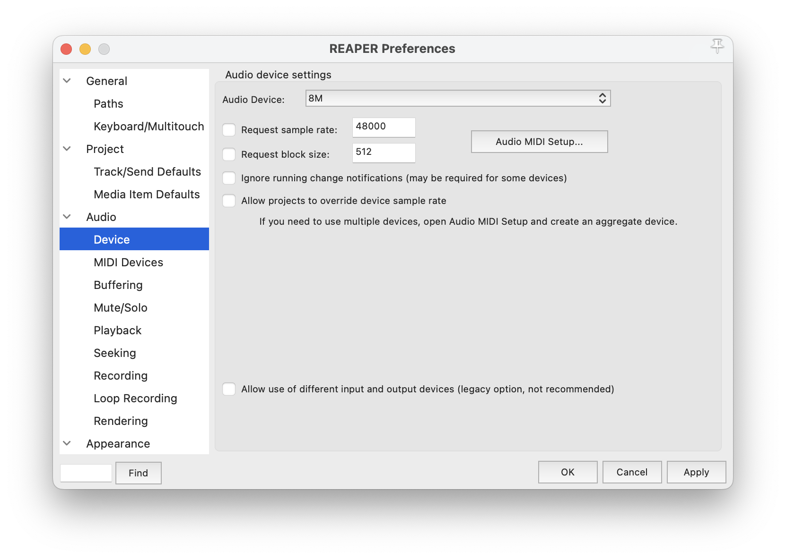
The reaSurround Plugin should have as many „Input channels“ as source tracks routed to it (in this case 8).
The output is set to 8 speakers (octophonic).
In the overview the position/movement of all source channels are displayed with a different number and colour.
The „Diffusion Level“ sets how much of the sound source's "environment" is integrated. Small circle = little environment, sound is only audible in the immediate vicinity of the loudspeaker; larger circle = more environment, position is reproduced by several loudspeakers. Set the „Speaker influence“ to „Relative“.
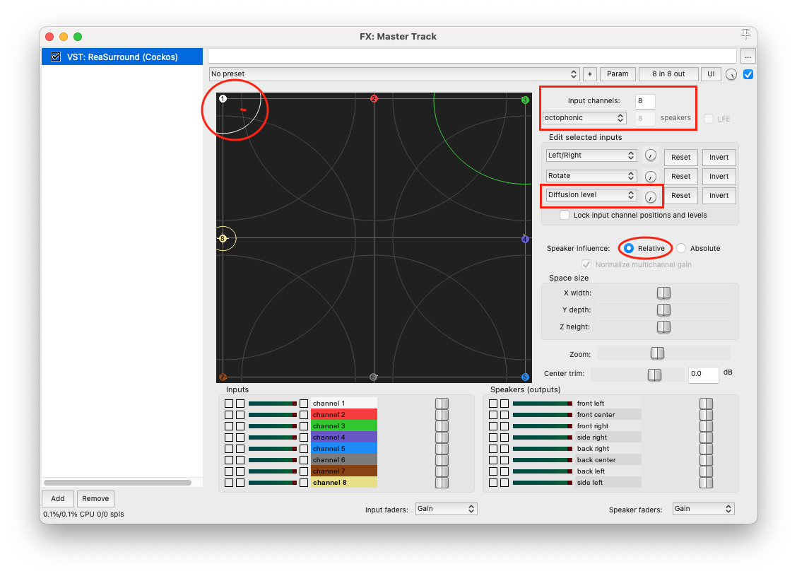

To set the automation click on the Automation of the Master track.
Search for the X and Y controller for each source and activate it.
To record a movement set the automation to „write“, to write a new one by not overwriting the existing one select „Latch“ or „Touch“.
For playback select „Read“.

