spatGRIS / spatCONTROL Template for Reaper

The SpatGRIS system is made of three elements:

- The ControlGRIS plugin where the trajectories are designed and recorded in a DAW (or any OSC device).

- The SpatGRIS itself that spatializes the sound, according to the setup of the speakers done in the Speaker Setup Edition window.

- The virtual audio device BlackHole which connects the DAW to SpatGRIS.

The whole architecture, including these elements, looks like this (audio and OSC are working in parallel):

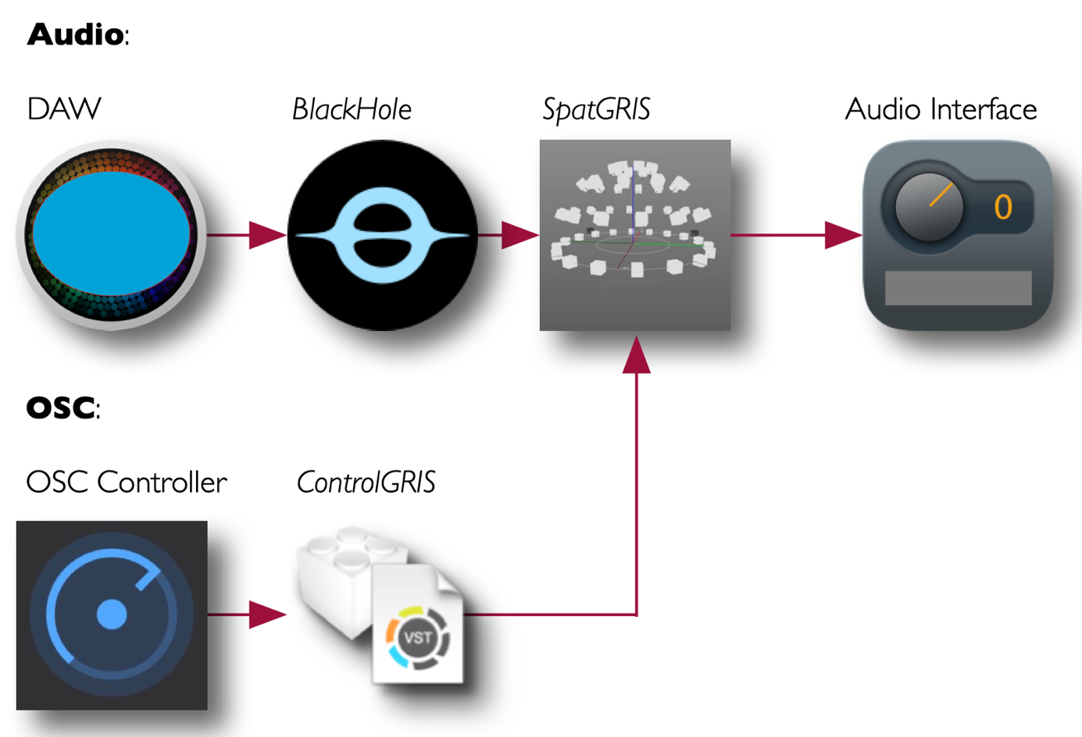

Download spatGRIS (including spatCONTROL and BlackHole 128 and BlackHole 256) from the official website:
https://gris.musique.umontreal.ca
or directly from Sourceforge: https://sourceforge.net/projects/spatgris3/files/
or Github: https://github.com/GRIS-UdeM/SpatGRIS

Setup

SpatGris

- In "Settings" set the Audio input device to BlackHole 128ch (or 256ch)
- Set the according Audio output device (e.g. in 4010 to 8M)
- Sampling Rate should be 48000
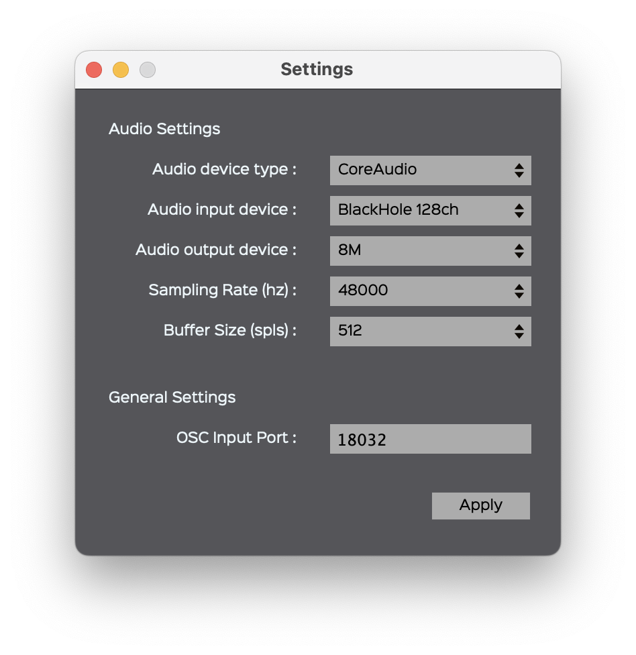
- Under "Open Project" Open the Project Template spatgris-project-template.xml
- Under "Open Speaker Setup" load appropriate setup:
  - 4010-8ch-SpeakerSetup.xml (for the Studio in Room 4010)
  - Budapest-36.4-SpeakerSetup.xml (for the Dome in Budapest)
- Note: You only need to make one Mixing session in Reaper and just change the Speaker Setup.

For multichannel output set the "Stereo reduction" to "None". To work with 2 channels set it to "Binaural" or "Stereo".
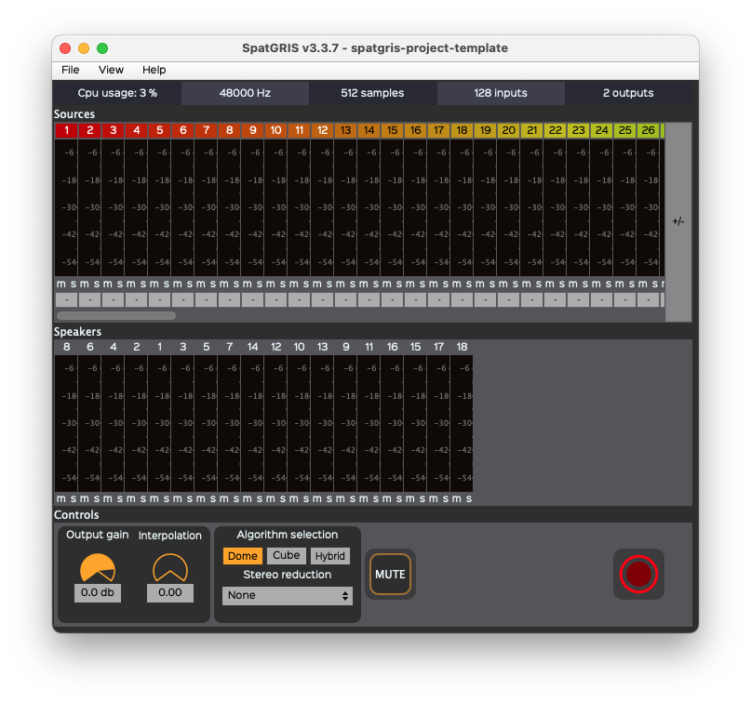
Under "View/Show Speaker View" load the SpeakerView App to see the speaker and the sources. In "View/Speaker Setup Edition" you can make your own speaker setup with azimuth, elevation, etc. information for all speakers.
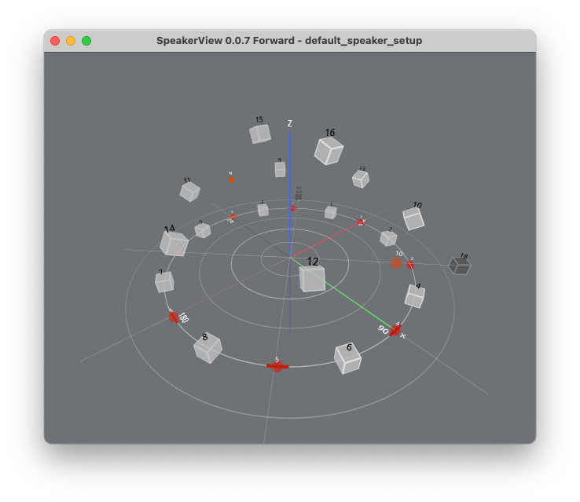

Reaper

- Open the Reaper session SpatGris-Template.RPP
- In "Preferences/Device" set the Audio Device to BlackHole 128ch (or 256ch)
- Set the sample rate to 48000

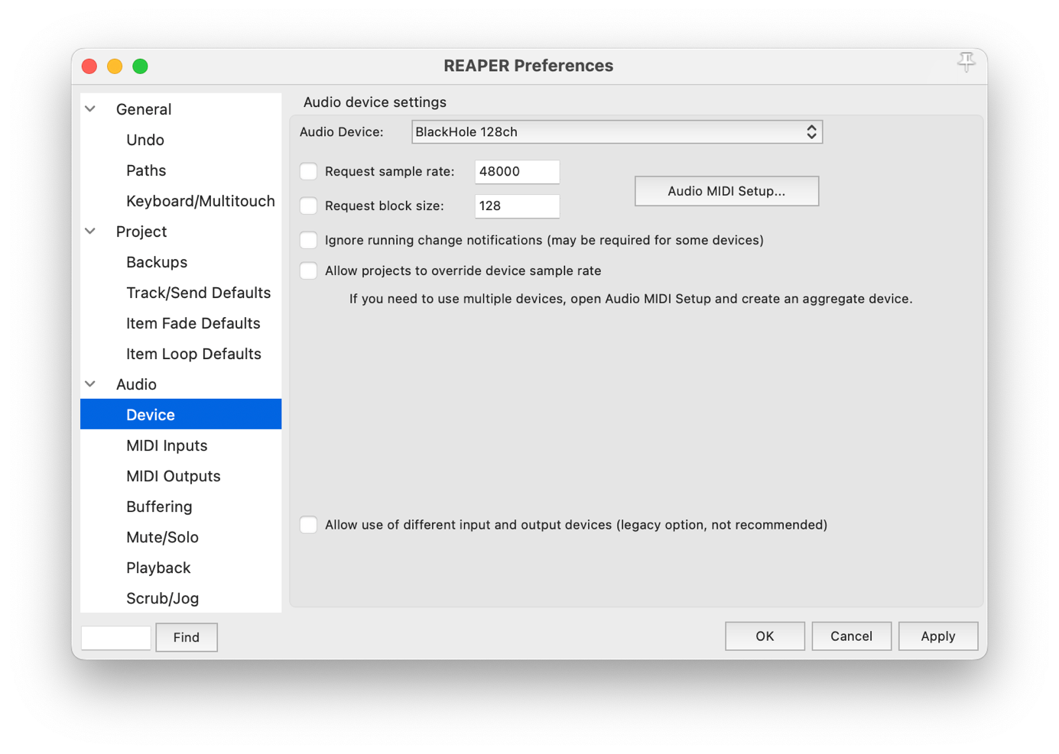

Master

- The Master track must have the same number of channels than the BlackHole connection to SpatGris
- Each output (!) must be set as individual hardware output according to the channel routed to SpatGris: 1 → Output 1, 2 → Output 2, etc., 128 → Output 128.

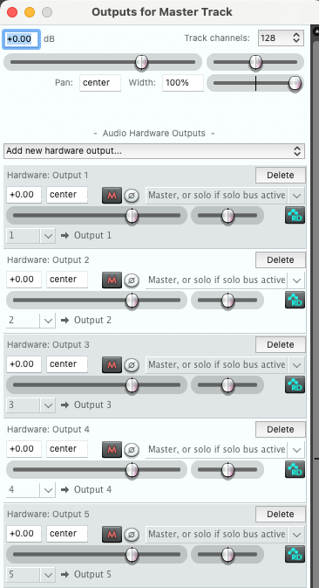

Tracks
- Each track must have the same number of channels as the master (BlackHole channels).
- The number of channels send to the master/or parent is depending on the number of track channels or number of child tracks.
- Each audio channel in Reaper must have an individual hardware output channel to SpatGris!

A bus channel (parent) sends all incoming channels to the master:
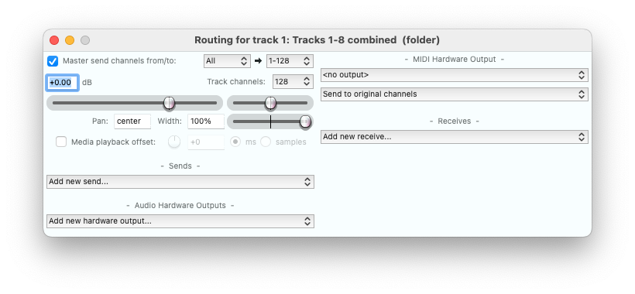
A stereo channel is sent directly to the master.
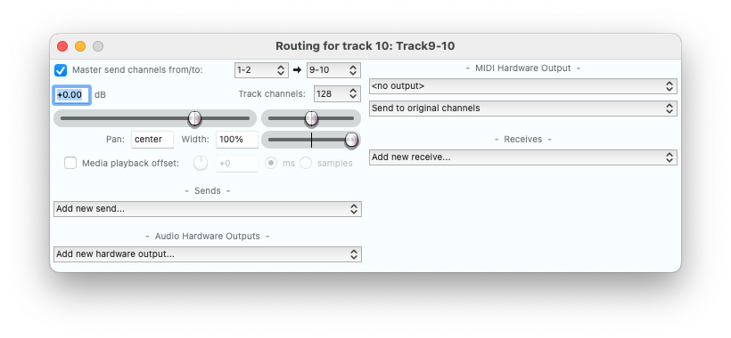
An individual mono channel is sent directly to the master.
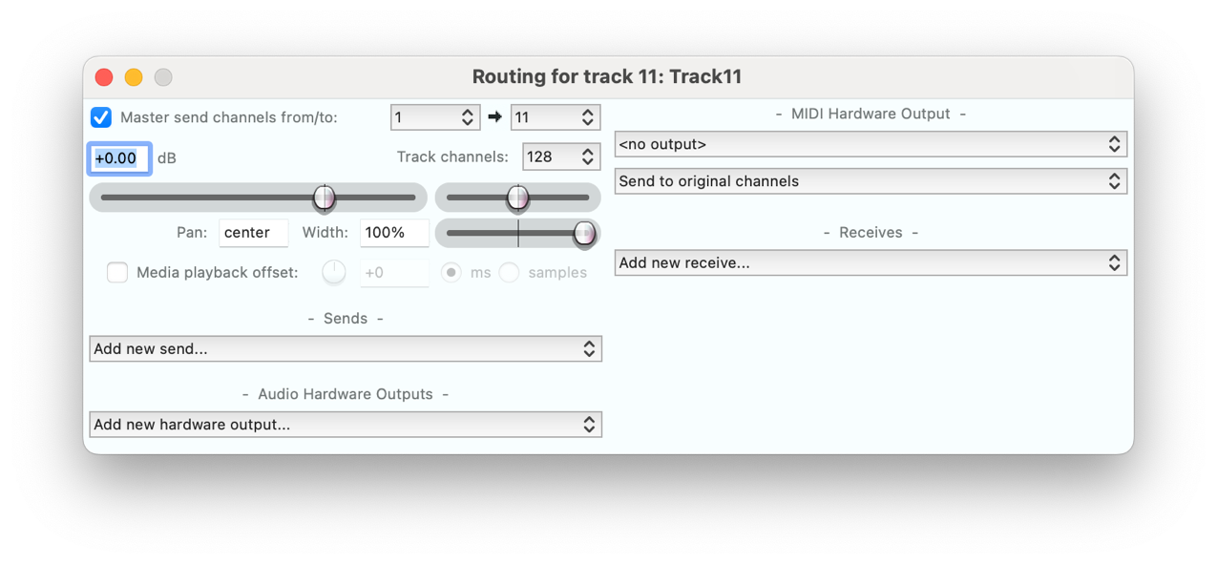

controlGris

- The ControlGris plugin sends the position and movement data to SpatGris
- Set the "Number of Sources" to the appropriate nummer of audio sources/tracks.
- Set the correct "First Source ID" (starting ID) of the audio channel sent to SpatGris.
- All channels of each ControlGris plugin must be sent to SpatGris on separate audio channels. Duplicate allocation of audio channels will result in errors in transmission.

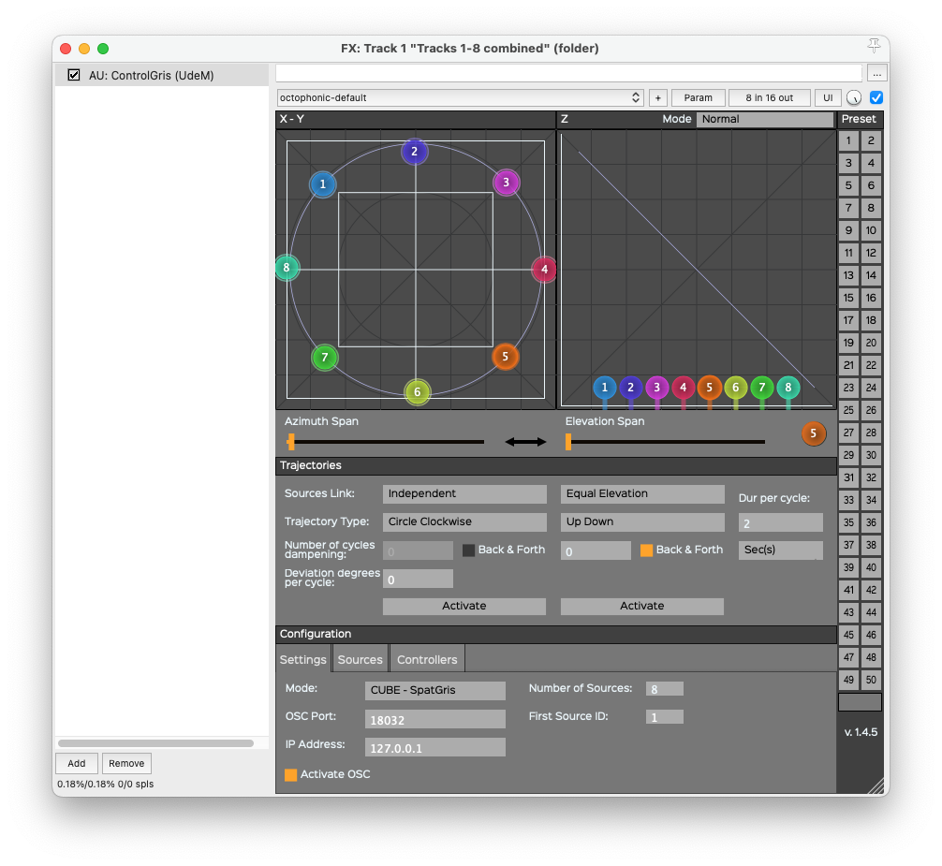

When the plugin has e.g. 8 sources than these sources are treated together. There are several modes of moving the azimuth ("Trajectory Type") and the elevation of these sources.

Here the ControlGris plugin hold only one individual channel ("Number of Sources" 1). It sends on audio hardware output (BlackHole) number 11 ("First Source ID").

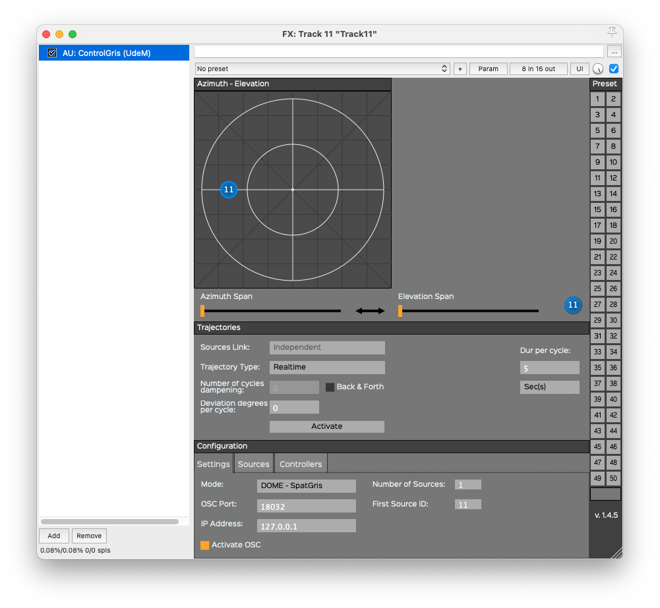
See quick setup tutorial on YouTube:
https://youtu.be/25-C2QXbCeM?si=yH_nNX3iiGXIayEu

Thanks to Matthias Brandt for converting the speaker setup (decode_dome_layout.json) for the Dome in Budapest to xml.

