Reaper -> Virtual Audio -> Pure Data

You need to install the virtual audio driver on your system first.
For Mac:
BlackHole: https://github.com/ExistentialAudio/BlackHole

For Windows:
Voicemeeter Potato: https://voicemeeter.com
LoopBeAudio: https://www.nerds.de/en/loopbeaudio.html

After Installing the virtual audio driver on your system choose it in Reaper under as "Audio Device".
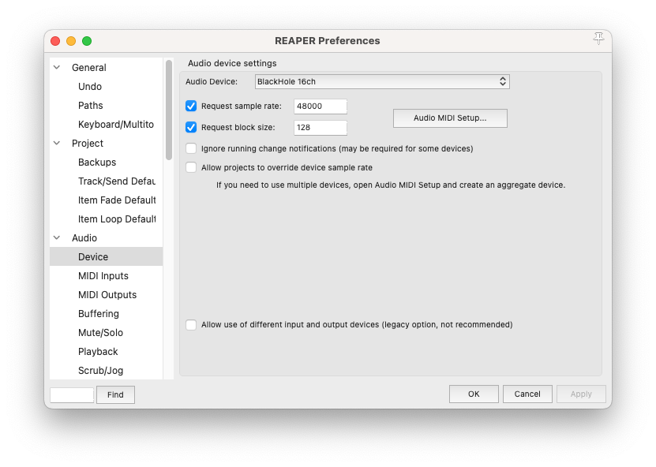

Make a Master Track with as many channels as you need (here 4):

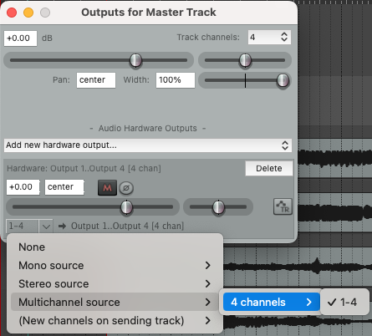

Route the individual tracks to the Master Track.

For stereo like this:

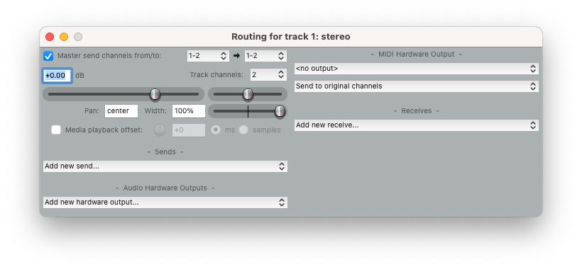

For multichannel mono like this:
1 to 1 means this mono track to the first track of the Master Track.

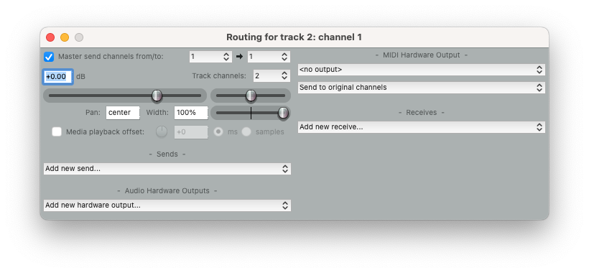

1 to 4 means this mono track to the fourth track of the Master Track.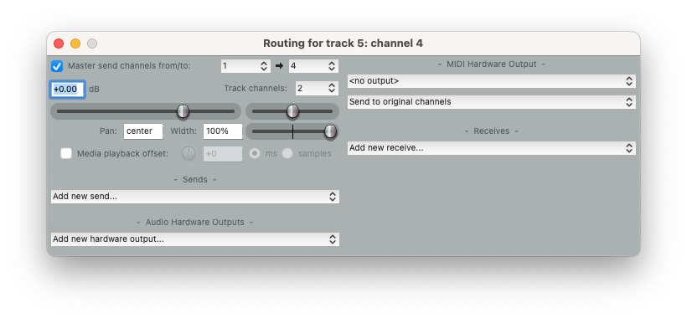

In Pure Data set "Input Devices" in "Audio Settings" to "Blackhole 16ch" and Channels to 4 (or more) In "Output Devices" to the same according to your physical output channels.
