Terminal Questions

Q1.

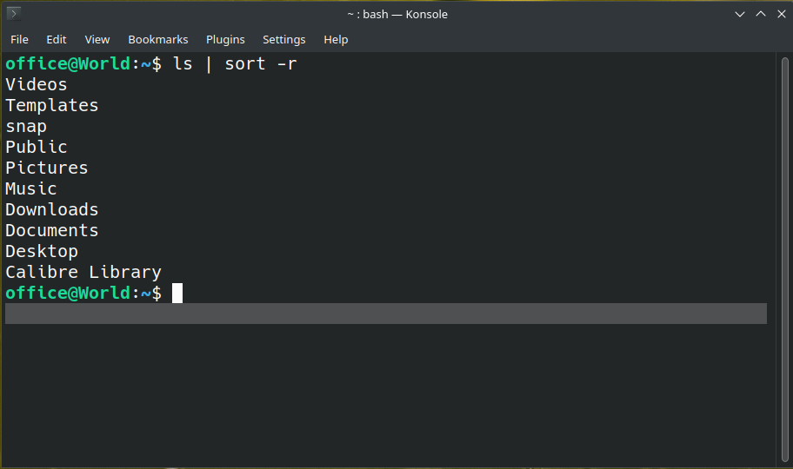

Q2.
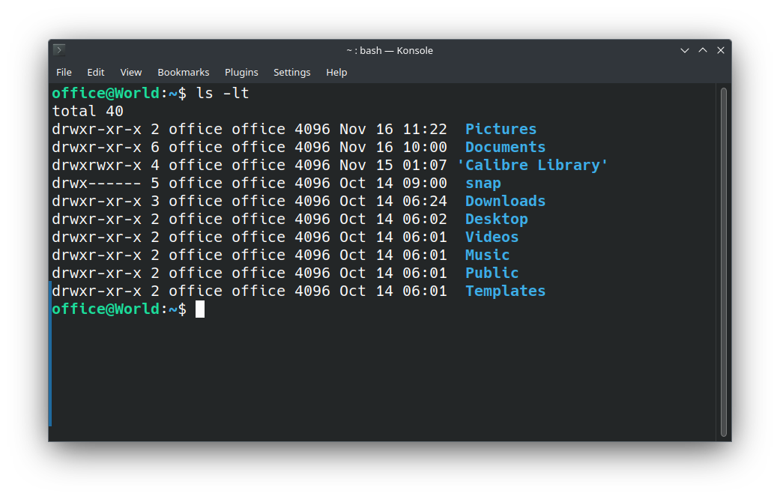

Q3.
For Hide a file/Folder, must use mv command for renaming and place a (.) before file/folder name.

Q4.
