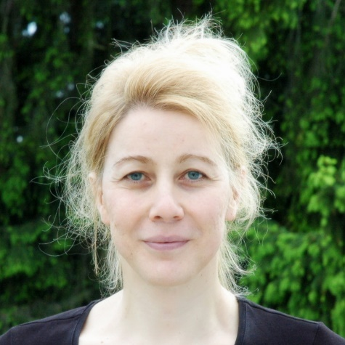  Hannah Bast  University of Freiburg  (DBpedia Keynote Speaker) | Prof. Dr Hannah Bast  is a full professor at the Department of Computer Science at the University of Freiburg and head of the Chair of Algorithms and Data Structures. Her general research interest is aptly described by the term “applied algorithmics,” as explained on the chair’s main page. Specific topics she is currently interested in and actively researching include route planning algorithms, all aspects of information retrieval (index building, query processing, user interfaces, complete information systems), and natural language processing, with and without deep learning.a W3 Full Professor at the AI Center ScaDS.AI, TU Dresden, Germany, where he leads the "Scalable Software Architectures for Data Analytics" group. Formerly Deputy Full Professor at KIT, he has been a driving force in semantic AI research, specializing in large language models (LLMs), knowledge graphs, and graph neural networks for scientific knowledge management.  With over 100 peer-reviewed publications at premier venues (ACL, EMNLP, ISWC, KDD) and by leading various national and international research projects, his work advances transparent, explainable AI solutions and powers semantic technologies that accelerate discovery, enhance comprehension, and broaden access to scientific insights.  - google scholar

