Membership Session

Session 2 (DBpedia)

Time: September 3, 2025 - 10:30 to 12:00

Chair: Milan Dojchinovski, InfAI/DBpedia Association, CTU Prague

Talks

Welcome & Introduction by chair
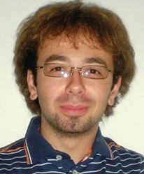  Milan Dojchinovski  InfAI/DBpedia Association, CTU Prague | Milan Dojchinovski is a research associate at the Knowledge Integration and Linked Data Technologies KILT at the AKSW. He joined the AKSW group in March 2015 and is a project manager of the H2020 FREME project. His research interests are in Semantic Web, Web services, NLP and Data Integration technologies. Milan has 10+ years experience in the computer industry in Germany, Czech Republic and Slovenia. He has previously been involved in the LOD2 and LinkedTV FP7 European projects. Milan is the author of 20+ peer-reviewed scientific publications. Milan is member of the W3C LD4LT and Open Annotation groups. He holds a MSc. degree in Computer Science from the University of Maribor in Slovenia. Milan is also affiliated with the Czech Technical University in Prague where he holds position of an Assistant Professor and he works on his PhD thesis with focus on Linked Data Access and Knowledge Extraction mechanisms.

TBA

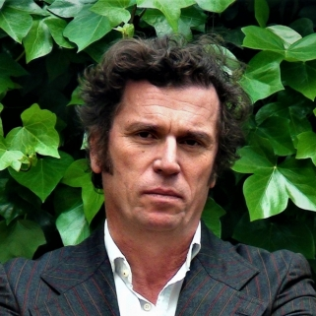  Ricardo Alonso Maturana  GNOSS | Dr. Ricardo Alonso Maturana (PhD in Sociology, B.S. in Philosophy) is the founder, promoter and CEO of RIAM I+L Lab, the enterprise that is owner of GNOSS and Didactalia. GNOSS is a technology company dedicated to the construction and exploitation of Knowledge Graphs in an Artificial Intelligence environment. Ricardo Alonso Maturana has been responsible for the direction, design and conceptualization of the GNOSS platform project, and the main use cases/projects developed by the company RIAM in the field of culture, tourism, education or banking to name a few. He has conceptualized, imagined and directed the most important projects of digital transformation of the organizations carried out by GNOSS in the last 10 years for clients such as Museo del Prado, Patrimonio Nacional de España, Instituto de Salud Carlos III, Museo Lázaro Galdiano, Mis Museos (My Museums), BBVA, Triodos Bank, Grupo Santillana, University of Deusto, University of Comillas, La Rioja Turismo, Previsión Sanitaria Nacional, Instituto Geográfico Nacional, Fundación COTEC, ADVEO Group, National Library of Spain, Air Liquide-Athelia, among others, as well as the direction in projects for AAPP as Ministry of Education, Culture and Sport, Ministry of Finance, Regional AAPP as La Rioja, Aragón, Vasque Country, Madrid or Castilla la Mancha, and Hércules project by University of Murcia (semantic architecture and ontological infrastructure of the research management system of Spanish universities);. He was Co-director of the European Project AFEL "Analytics for Everyday Learning" (financed by the H2020 program). AFEL main goal for RIAM is the development of tools to improve the teaching/ learning processes on the basis of the massive semantic data analysis that users deposit in the semantic platform, in order to personalize and recommend learning paths.  - LinkedIn

