LLM + DBpedia Session

Session 3 (DBpedia)

Time: September 3, 2025 - 13 to 14:30

Chair: Milan Dojchinovski, InfAI/DBpedia Association, CTU Prague

Talks

Welcome & Introduction by chair
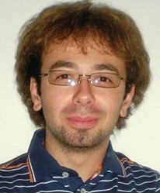  Milan Dojchinovski  InfAI/DBpedia Association, CTU Prague | Milan Dojchinovski is a research associate at the Knowledge Integration and Linked Data Technologies KILT at the AKSW. He joined the AKSW group in March 2015 and is a project manager of the H2020 FREME project. His research interests are in Semantic Web, Web services, NLP and Data Integration technologies. Milan has 10+ years experience in the computer industry in Germany, Czech Republic and Slovenia. He has previously been involved in the LOD2 and LinkedTV FP7 European projects. Milan is the author of 20+ peer-reviewed scientific publications. Milan is member of the W3C LD4LT and Open Annotation groups. He holds a MSc. degree in Computer Science from the University of Maribor in Slovenia. Milan is also affiliated with the Czech Technical University in Prague where he holds position of an Assistant Professor and he works on his PhD thesis with focus on Linked Data Access and Knowledge Extraction mechanisms.

