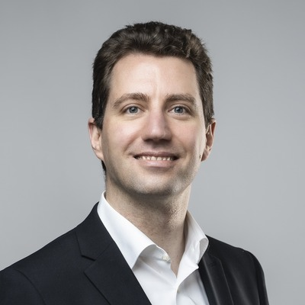  Michael Färber  Technical University of Dresden, ScaDS.AI Center  (Invited Speaker) | Prof. Dr.-Ing. Michael Färber  is a W3 Full Professor at the AI Center ScaDS.AI, TU Dresden, Germany, where he leads the "Scalable Software Architectures for Data Analytics" group. Formerly Deputy Full Professor at KIT, he has been a driving force in semantic AI research, specializing in large language models (LLMs), knowledge graphs, and graph neural networks for scientific knowledge management.  With over 100 peer-reviewed publications at premier venues (ACL, EMNLP, ISWC, KDD) and by leading various national and international research projects, his work advances transparent, explainable AI solutions and powers semantic technologies that accelerate discovery, enhance comprehension, and broaden access to scientific insights.  - website  - google scholar

Title: LLMs and Knowledge Graphs for Science: From Papers to Insights

Invited Speech

Time: TBA

Abstract: TBA

