Title: TBA

Keynote Speech

Time: September 3, 2025 - 09:15 to 10:00

Speaker
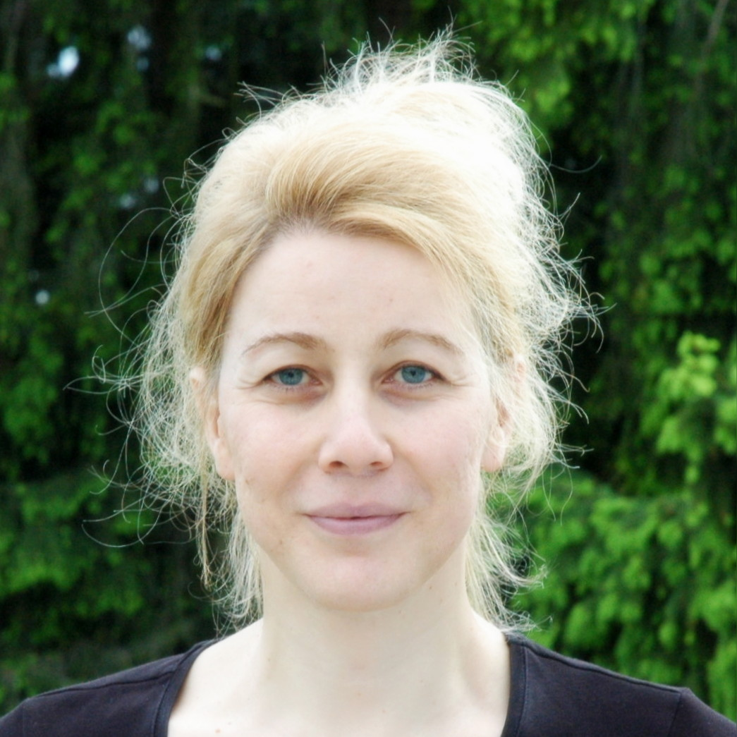  Hannah Bast  Full professor at the department of computer science of the University of Freiburg  (DBpedia Keynote Speaker) | Hannah Bast is a full professor at the Department of Computer Science at the University of Freiburg and head of the Chair of Algorithms and Data Structures. Her general research interest is aptly described by the term “applied algorithmics,” as explained on the chair’s main page. Specific topics she is currently interested in and actively researching include route planning algorithms, all aspects of information retrieval (index building, query processing, user interfaces, complete information systems), and natural language processing, with and without deep learning.

