

Practices for Secure Software Report

Table of Contents
Document Revision History 3
Client 3
Instructions 3
Developer 3
1. Algorithm Cipher 3
2. Certificate Generation 4
3. Deploy Cipher 4
4. Secure Communications 4
5. Secondary Testing 5,6
6. Functional Testing 6
7. Summary 7
8. Industry Standard Best Practices 7

Document Revision History

Version | Date | Author | Comments
1.0 | 02/16/2026 | Steven Halliwell | Certificate generation, HTTPS configuration, and testing

Client



Instructions

Developer
Steven Halliwell

Algorithm Cipher

For this project, I used SHA-256 to hash my test data and RSA for the SSL certificate. SHA-256 is a solid choice as it is very secure as it produces a 256-bit output, which makes it very hard to reverse and excellent for making sure data is secure. RSA is an asymmetric system with a public and private key, so the server can prove who it is and exchange data securely. After the secure connection is set up, one could use something faster like AES for sending data, but RSA does the key exchange and authentication part. I ran into a few hiccups getting the certificate to work at first but sticking to standard practices like keeping passwords in the keystore and using proper key sizes and eventually this made it all come together. Getting hands-on with things like generating keys, running the server, and seeing the hash show up made everything from class feel real instead of just theory. Overall, using SHA-256 and RSA is standard, and it gets the job done without being unnecessarily complicated.

Certificate Generation
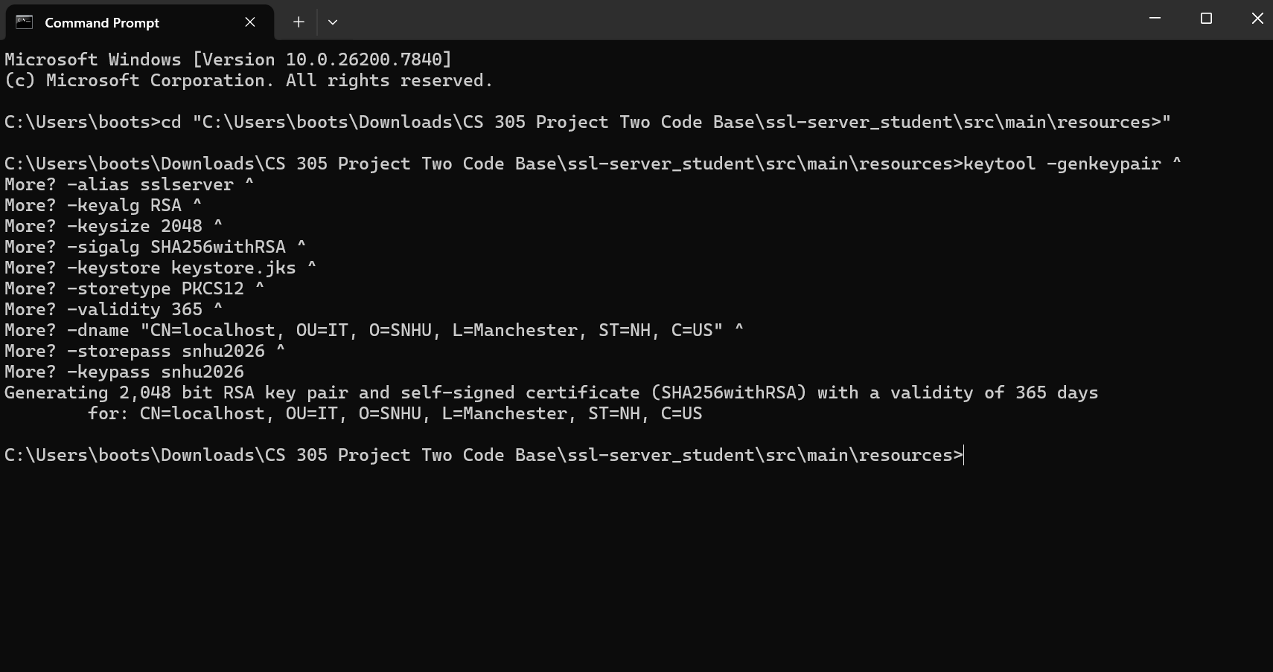

Deploy Cipher
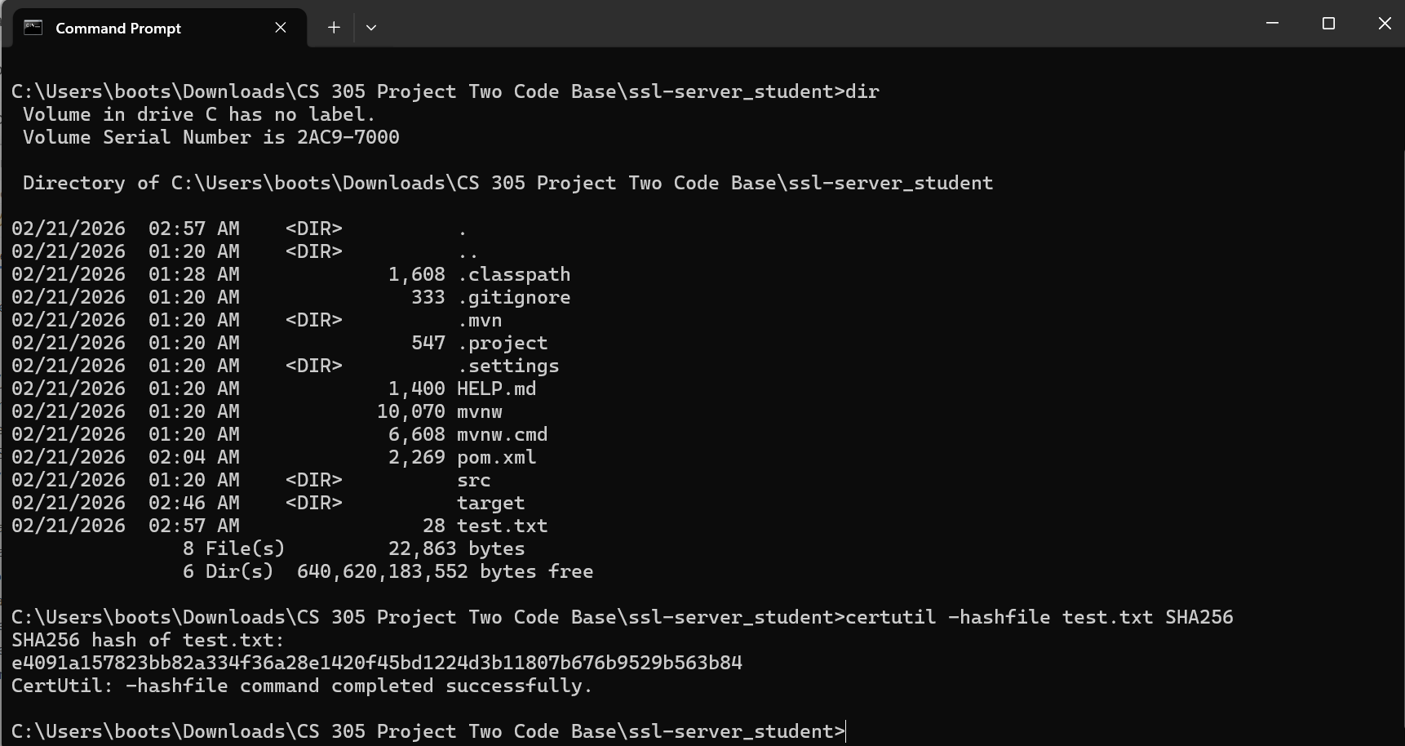

Secure Communications
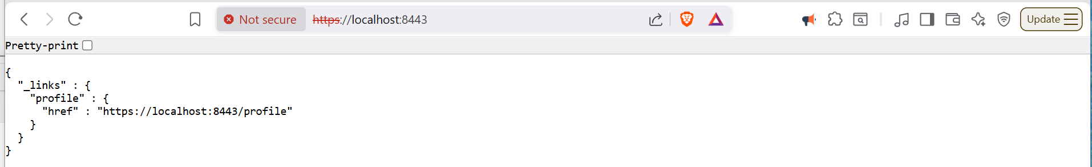

Secondary Testing

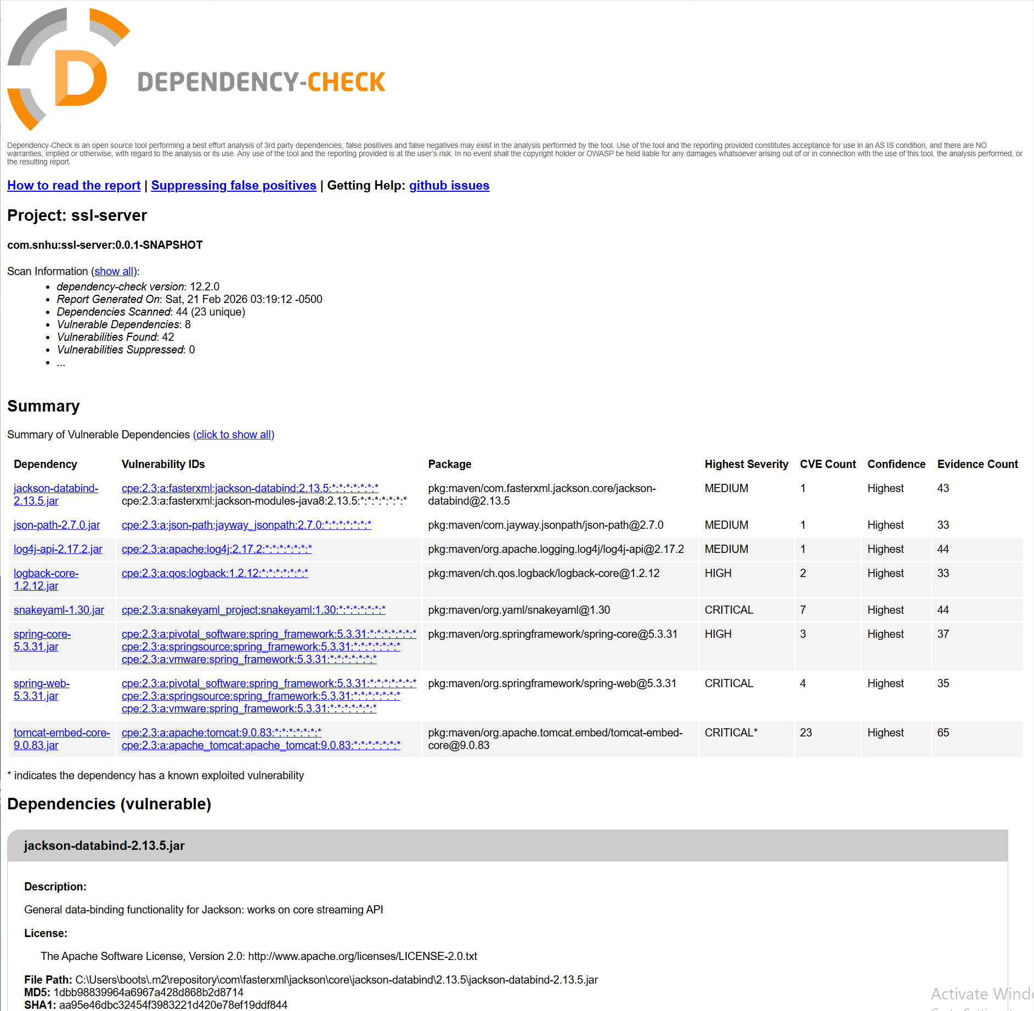
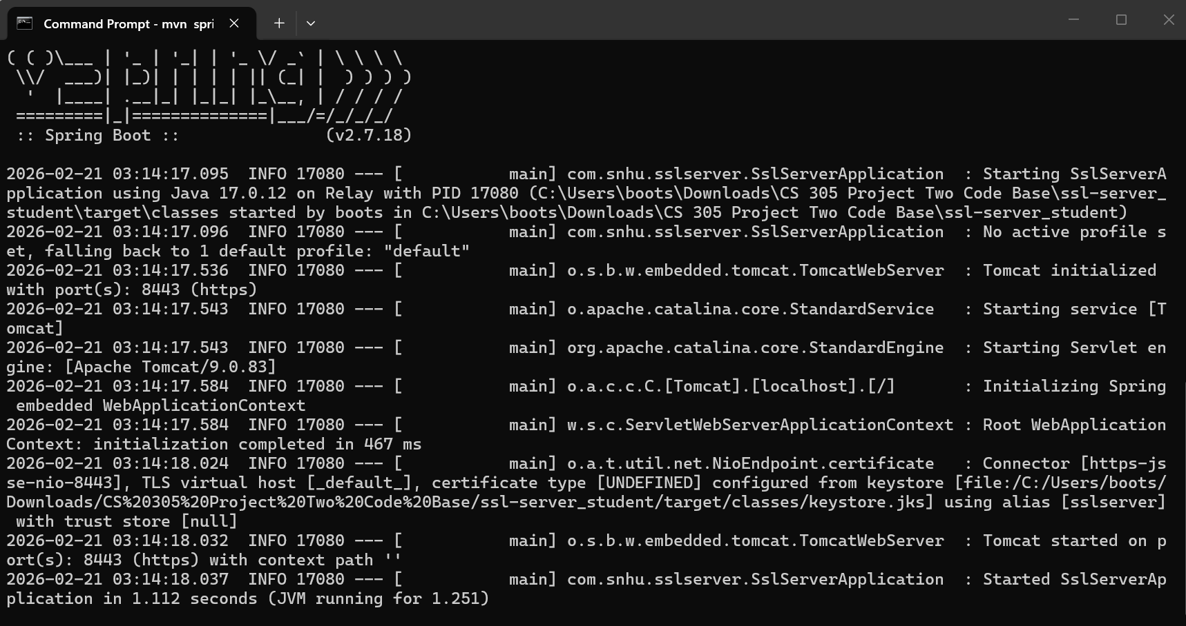

Functional Testing
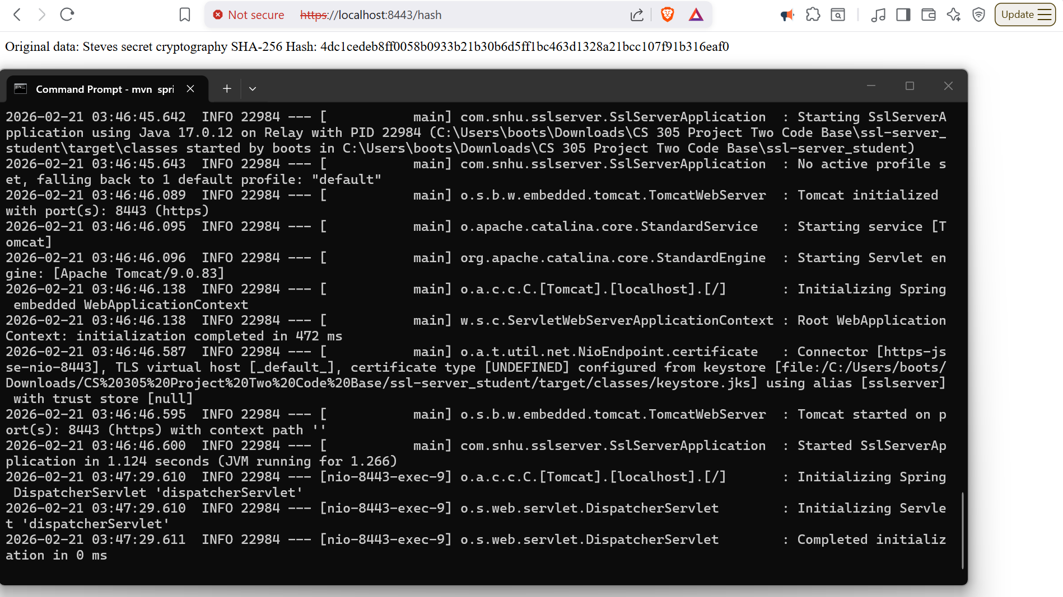

Summary

In this project, the code was carefully refactored and included layers of security while maintaining functional integrity. Initially, the SSL server application ran without HTTPS and did not demonstrate cryptographic verification. By generating a self-signed certificate and configuring Spring Boot to use HTTPS, it ensured that all communication between the client and server was encrypted, protecting sensitive data from interception.

Next, a SHA-256 checksum endpoint was added to the application. This allows us to verify the integrity of data and detect any tampering or corruption. By using a cryptographic hash function, I addressed vulnerabilities and strengthened the application’s security. The checksum endpoint also demonstrates proper usage of a cryptographic algorithm, showing that the system now enforces secure data handling and verification protocols.

I completed a secondary static analysis using the dependency-check tool to identify any vulnerabilities introduced during refactoring. By reviewing the report and confirming that no new issues were present, this validated that the code adheres to industry standards and does not expose the application to any security risks.

The combination of HTTPS, cryptographic verification, and careful dependency management adds value to the company by protecting both the organization and its clients from any attacks. These measures ensure that client data is confidential, that transmitted data cannot be altered, and that the application remains safe against any threats. Best practices, such as keeping dependencies updated and using cryptography are essential for maintaining this level of security over time. By following these procedures, the organization demonstrates a commitment to secure software practices.

Industry Standard Best Practices

Following industry standard practices is extremely important for secure coding to protect the application and any data coming in or out. For example, using SHA-256 for hashing and generating a strong RSA key pair ensures that data integrity and encryption is reliable, which is exactly what professional guidelines recommend. Initially, I ran into a few issues, like making sure the keystore path was correct and confirming that the checksum outputs matched the data. Using these standards as a reference helped me quickly spot and fix those mistakes.

Another key practice was running a dependency-check to make sure no outdated libraries or vulnerabilities were introduced. At first, some warnings appeared in the report, which could have become serious problems if left unchecked. By paying attention to these alerts and understanding the tutorials and learning material, I could confirm that all added code and libraries were safe, which made the application work correctly.

Finally, I focused on clean, organized code with comments explaining each step, especially around the checksum controller and HTTPS setup. This approach aligns with best practices because it makes the software easier to maintain and reduces the chance of accidental errors in the future.
Following these industry standards not only strengthened the security of the project but also gave me confidence that I was building software in a way that a professional company would trust. It showed me that even small steps, like proper encryption, clear code structure, and checking dependencies, can prevent bigger security problems down the line.

