模型 | Precision | Recall | F1-Score | mAP50
SSD | 0.5040 | 0.3670 | 0.4251 | 0.4420
RetinaNet | 0.6460 | 0.4860 | 0.5547 | 0.5310
Faster R-CNN | 0.7570 | 0.6470 | 0.6982 | 0.5890
DETR | 0.6340 | 0.7180 | 0.6739 | 0.5930
YOLOv9 | 0.7680 | 0.6520 | 0.7059 | 0.7740
YOLOv10 | 0.7890 | 0.5730 | 0.6625 | 0.6190
YOLO11n | 0.8401 | 0.7790 | 0.8083 | 0.8315
ECB-YOLO | 0.8971 | 0.7859 | 0.8376 | 0.8663

模型 | 参数量 / M | 计算量 / GFLOPs | 推理速度 / FPS | 推理时间 /ms
SSD | 25.1 | 241.6 | 56.8 | 17.6
RetinaNet | 37.2 | 147.3 | 44.2 | 22.6
Faster R-CNN | 141.8 | 375.2 | 30.5 | 32.8
DETR | 42.7 | 88.4 | 34.3 | 29.2
YOLOv9 | 25.3 | 102.1 | 68.4 | 14.6
YOLOv10 | 15.4 | 59.1 | 87.3 | 11.5
YOLO11n | 13.2 | 49.5 | 95.6 | 10.5
ECB-YOLO | 12.5 | 47.8 | 97.2 | 10.3

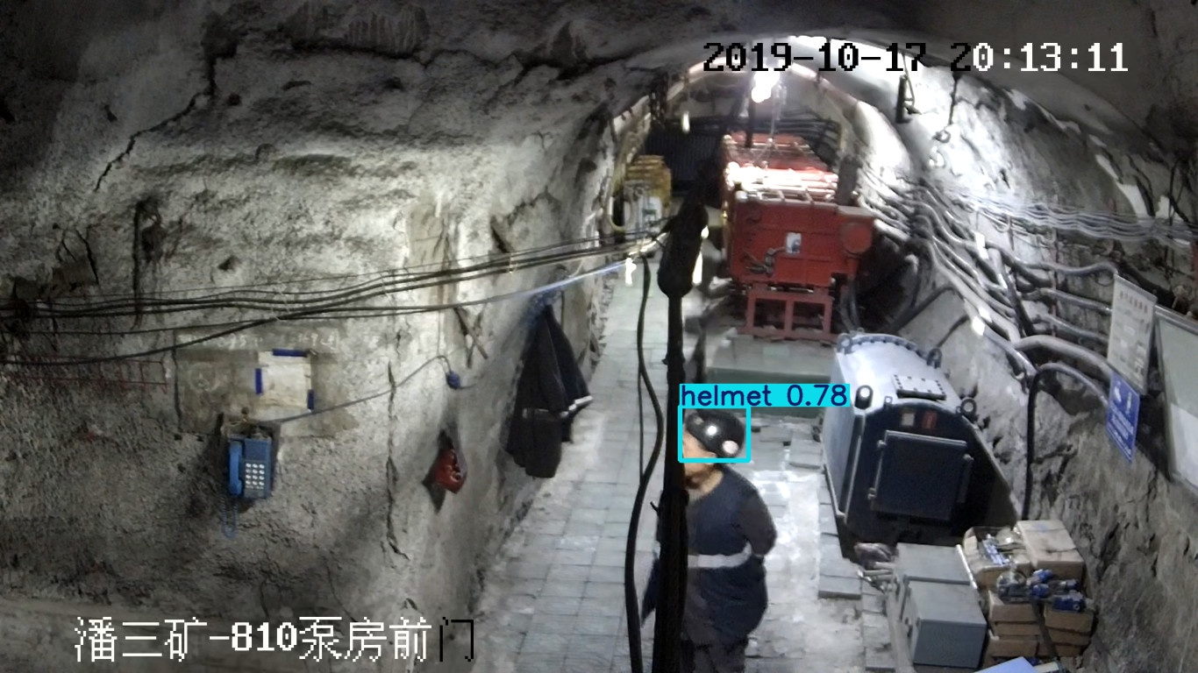 | 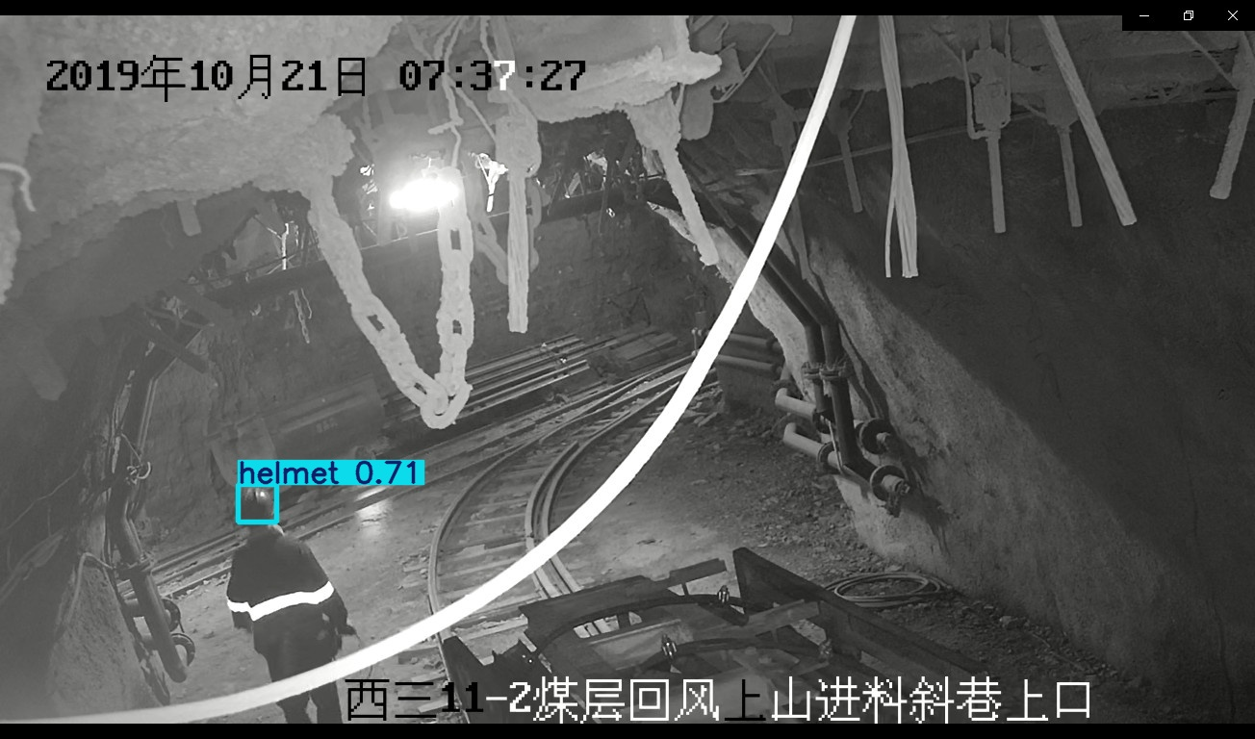 | 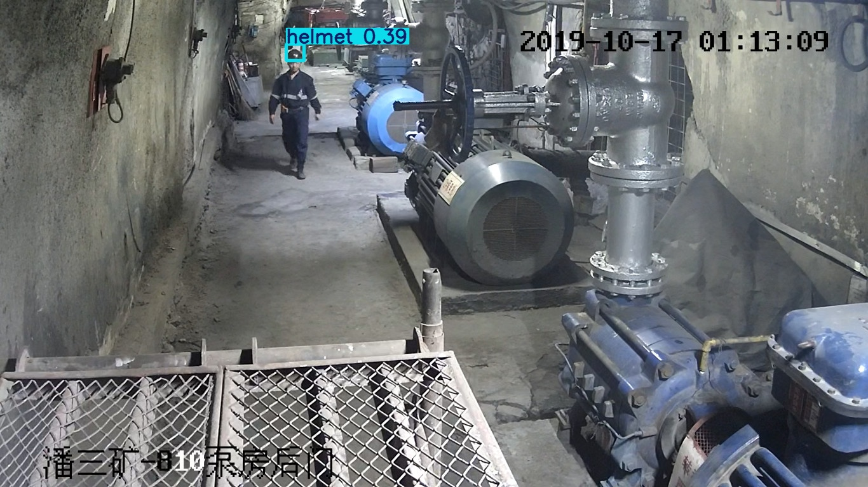 | 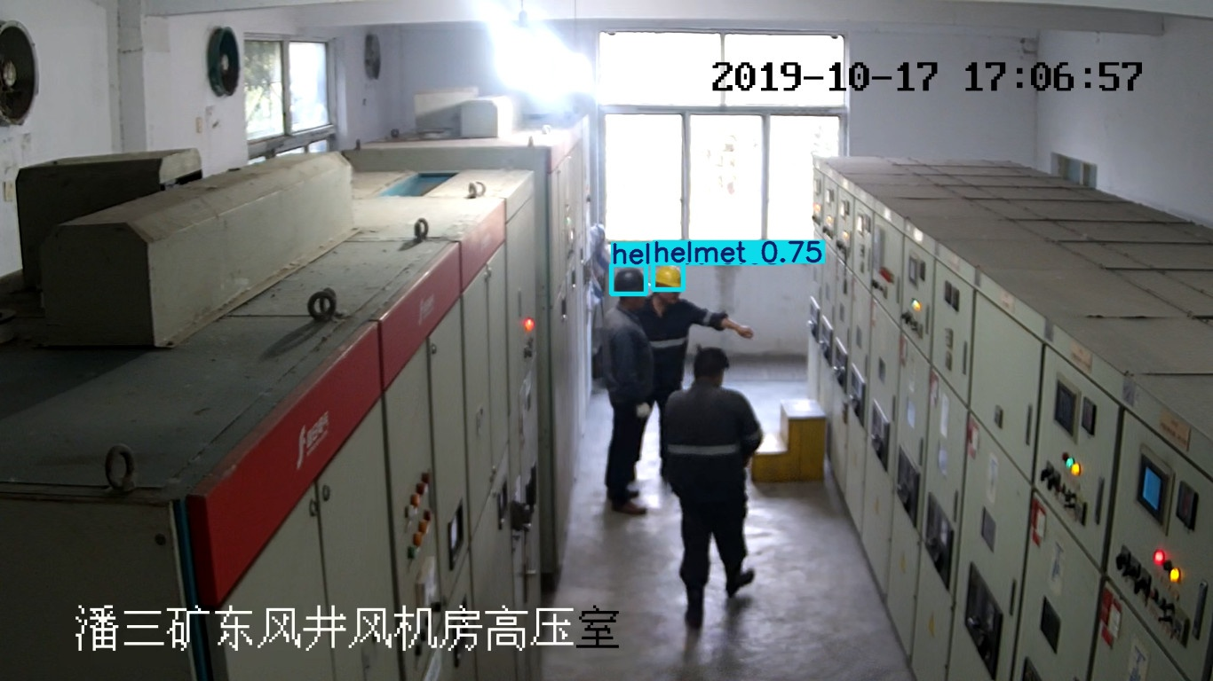
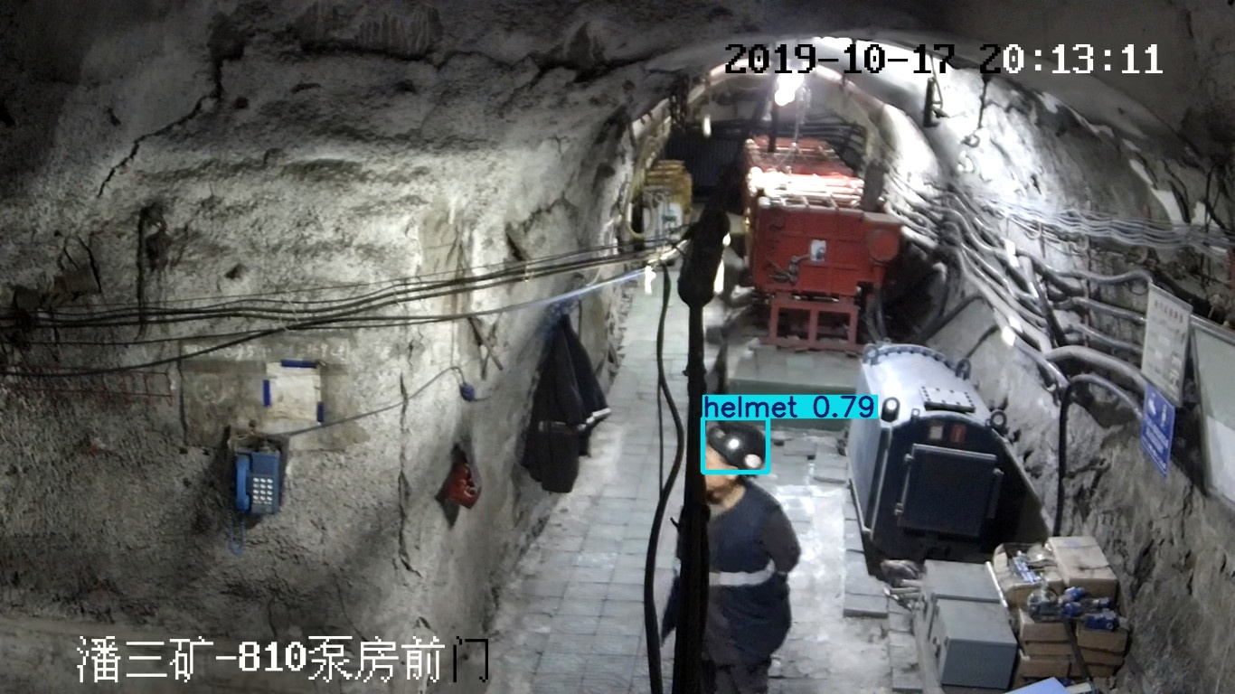 | 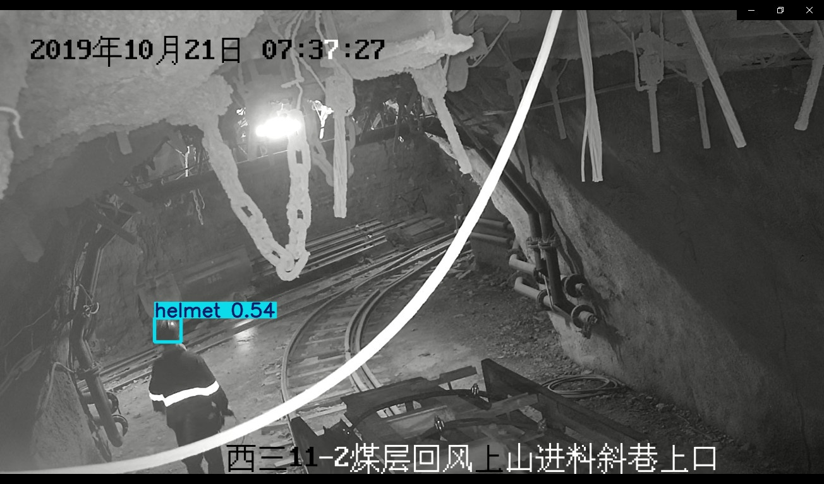 | 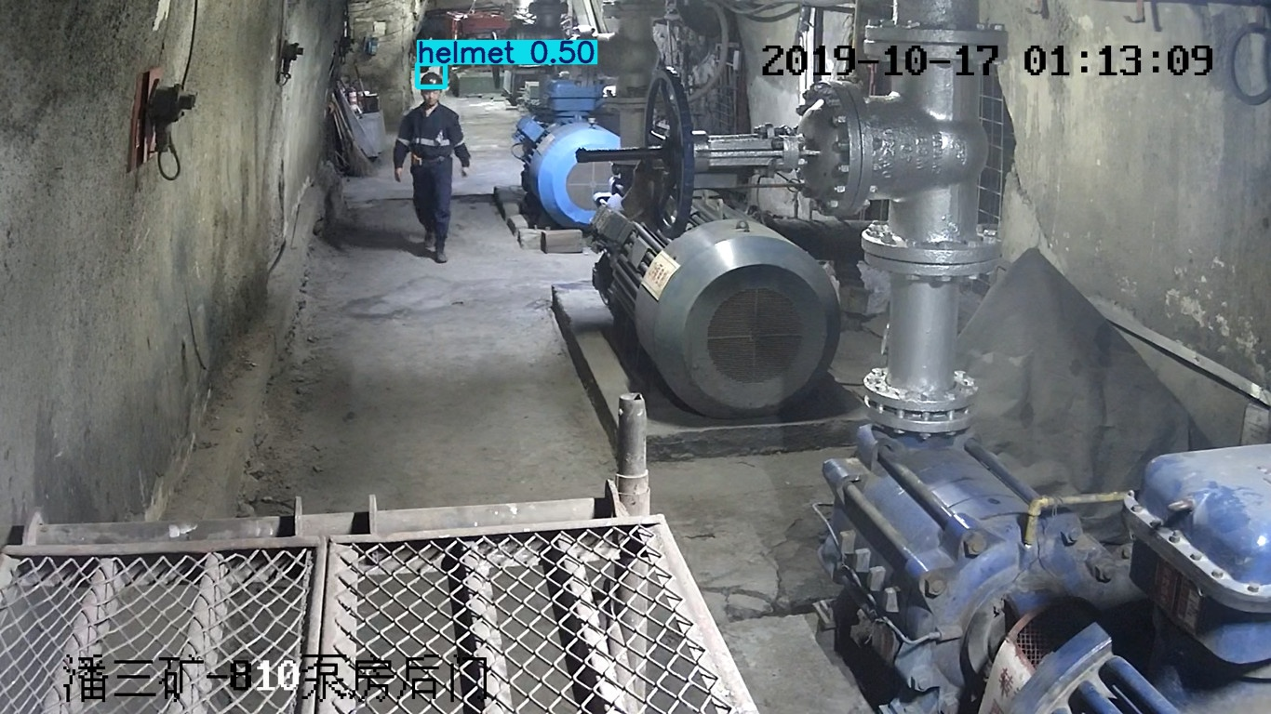 | 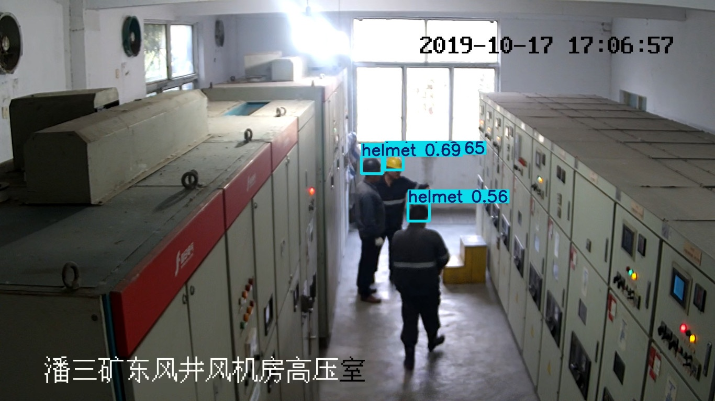
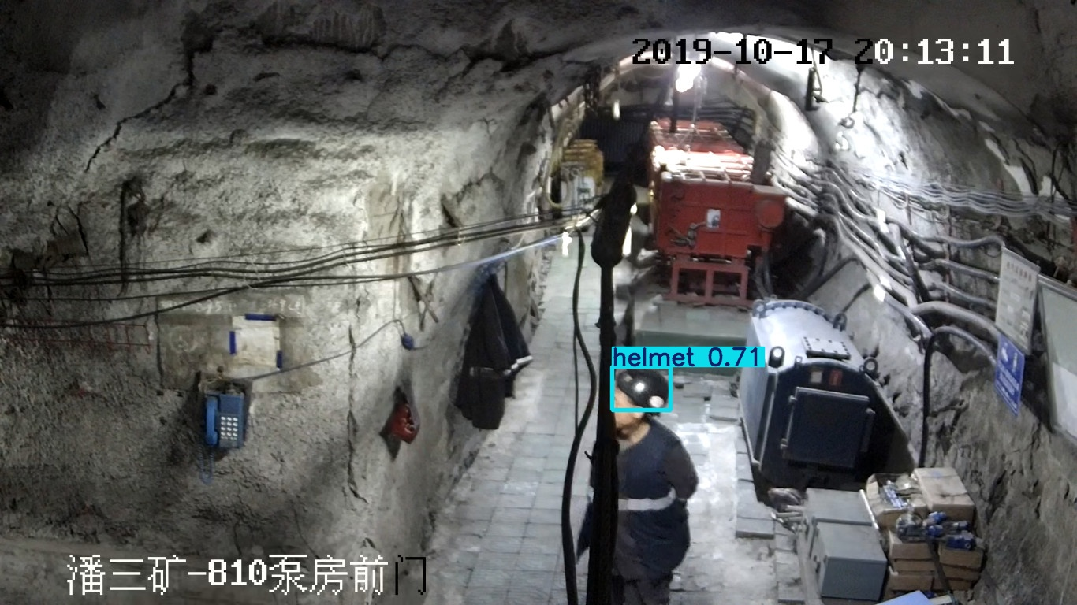 | 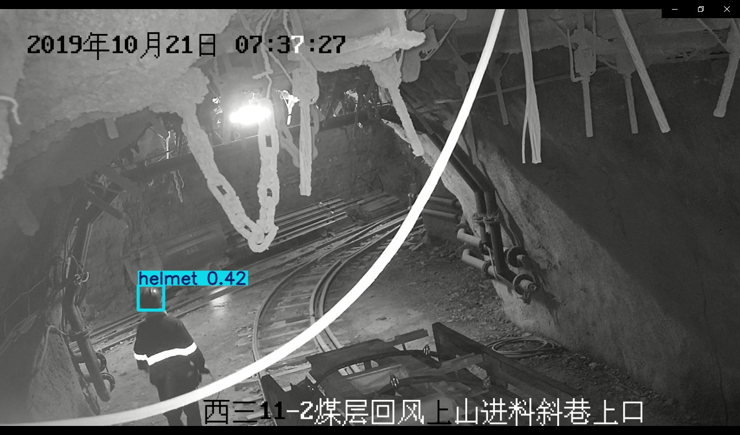 | 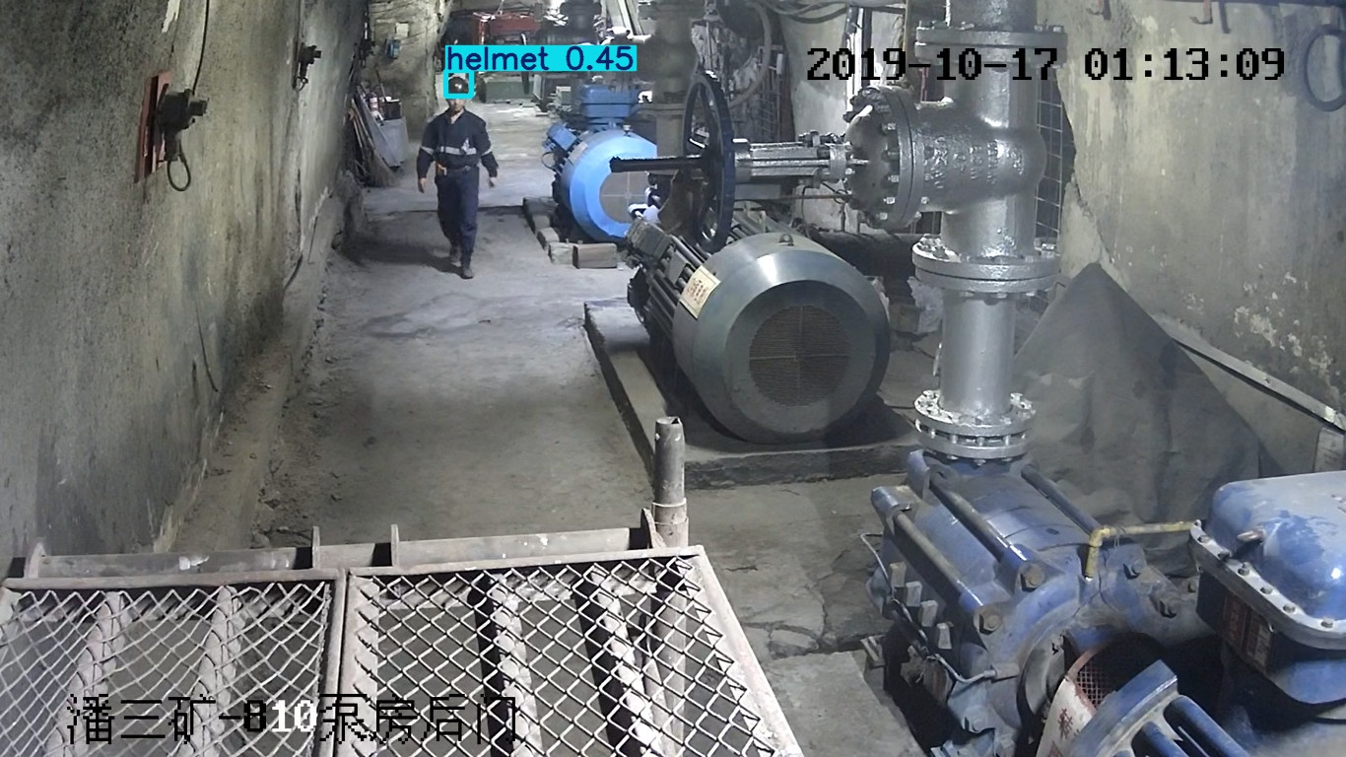 | 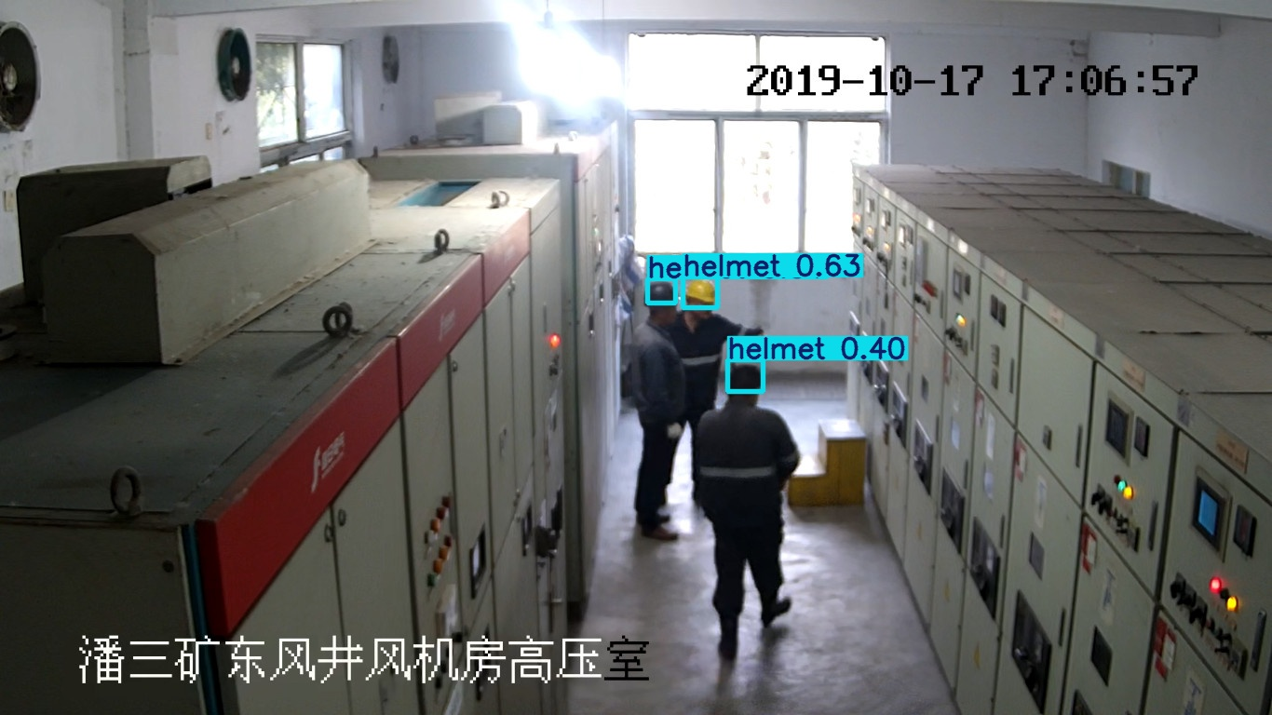
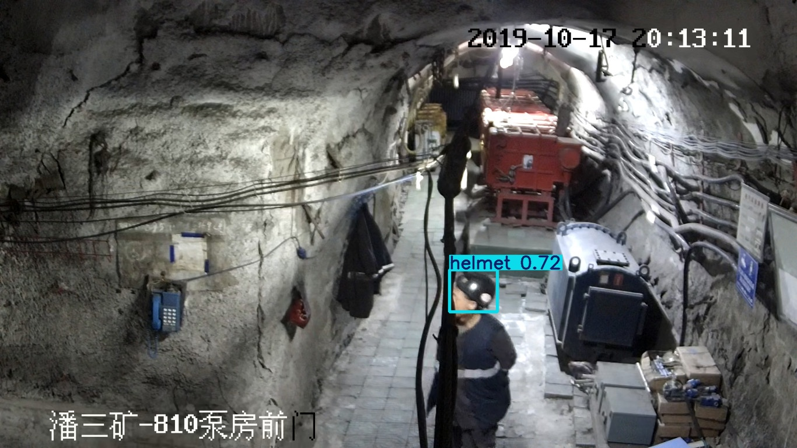 | 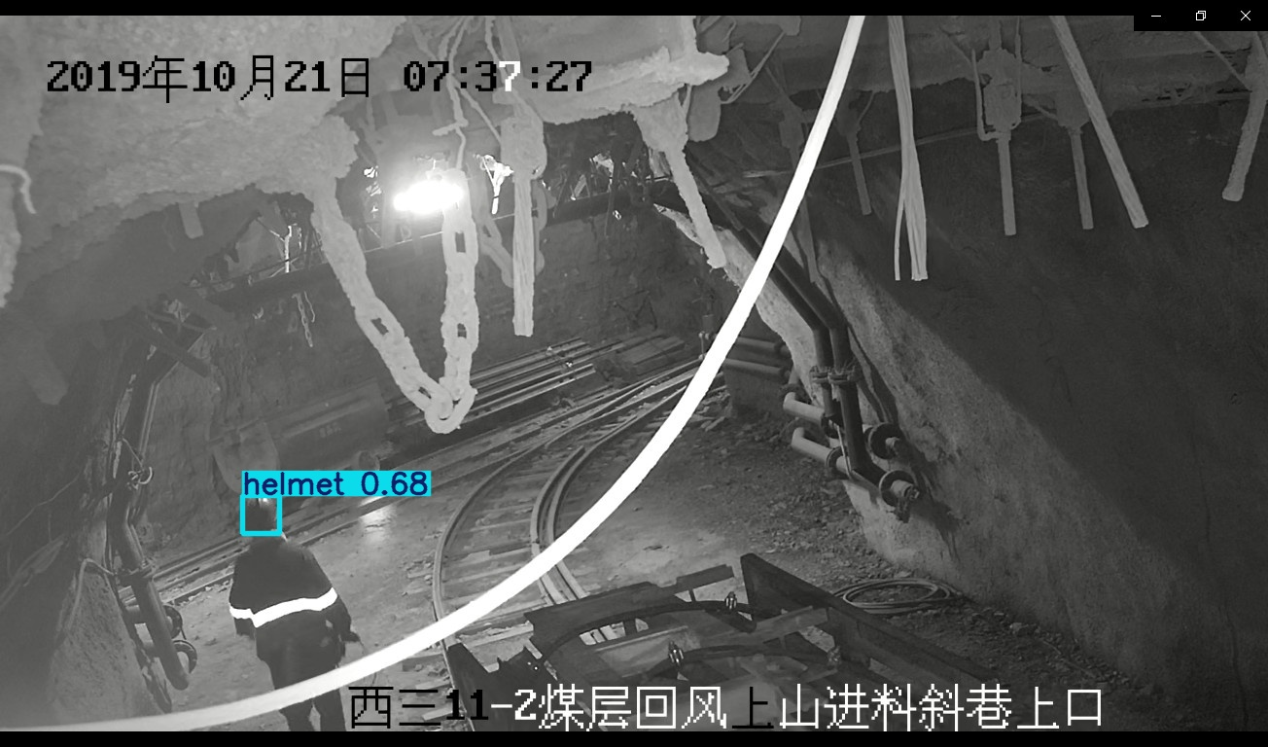 | 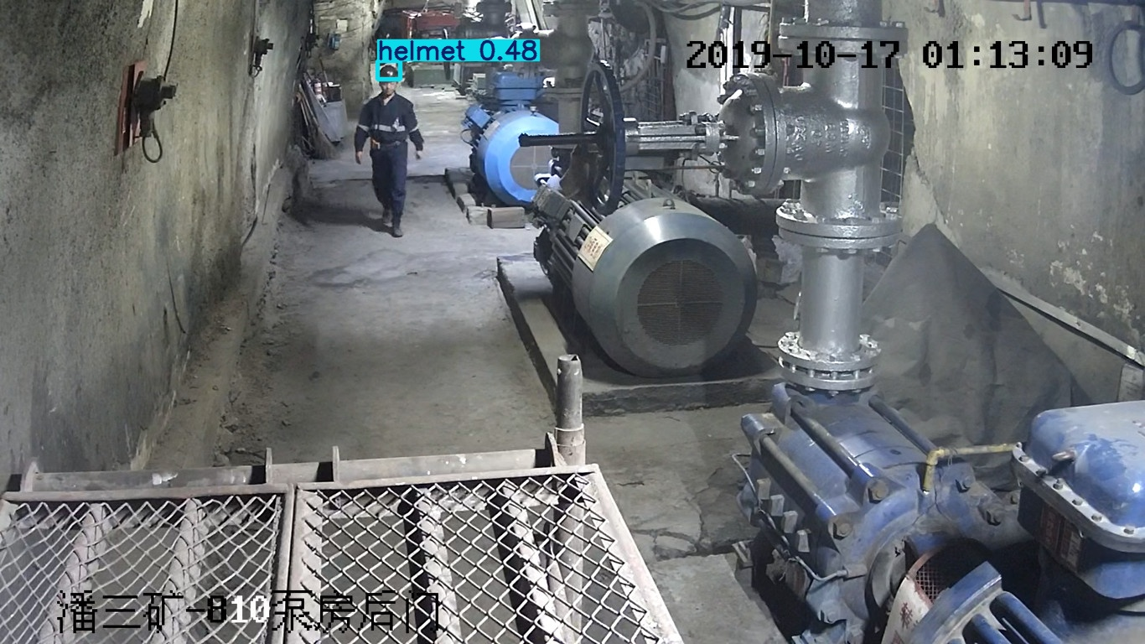 | 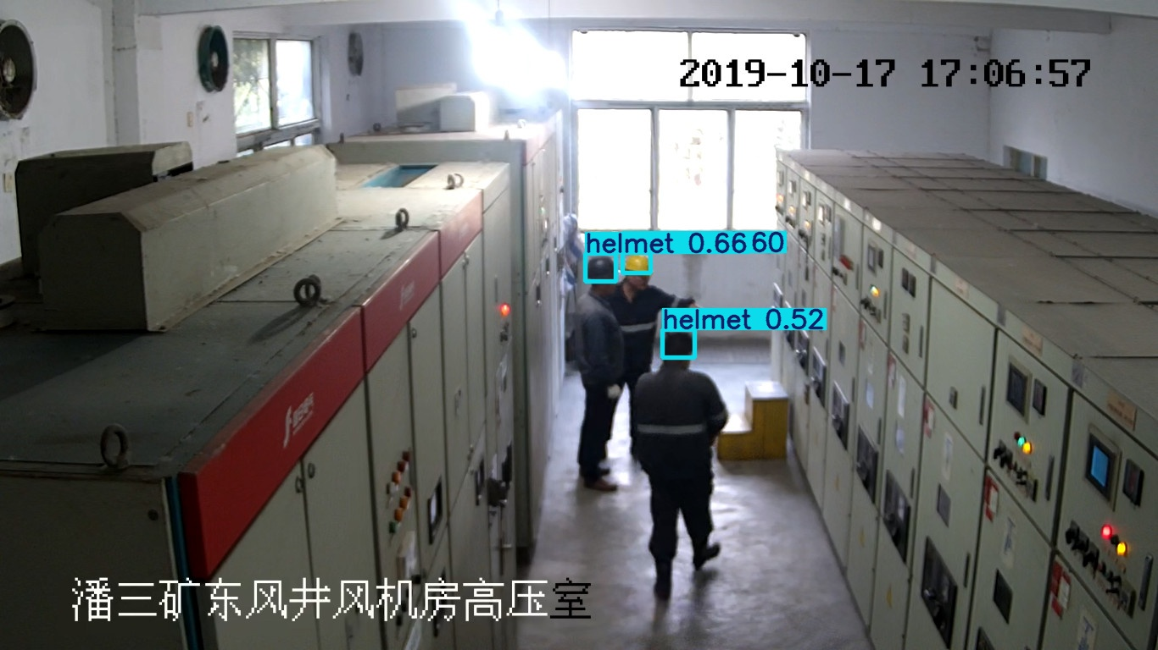
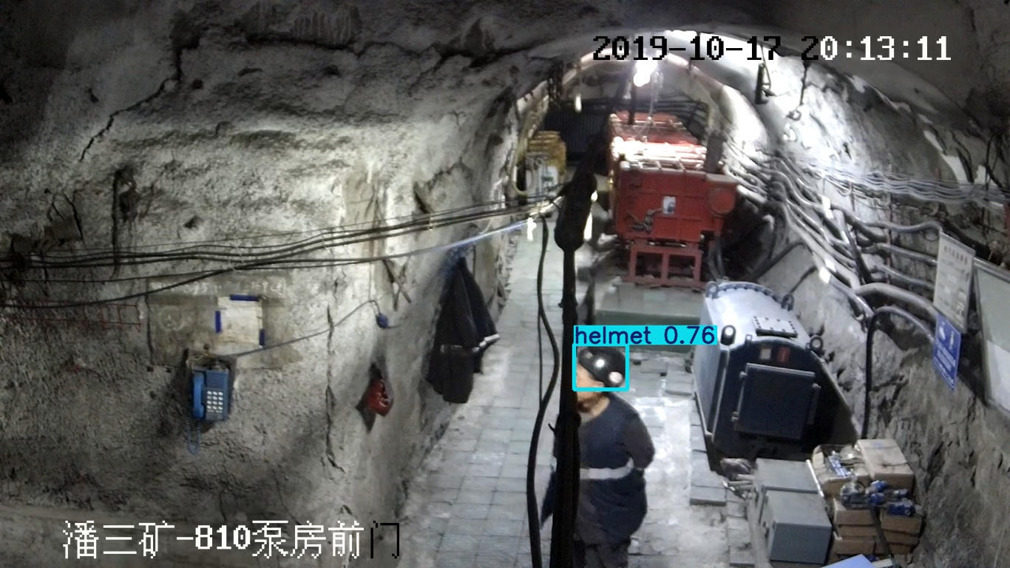 | 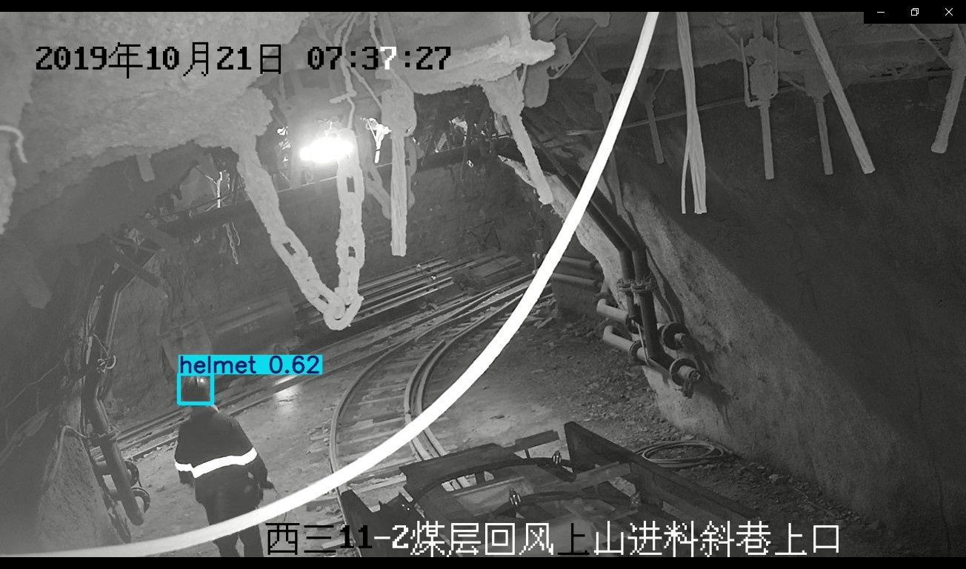 | 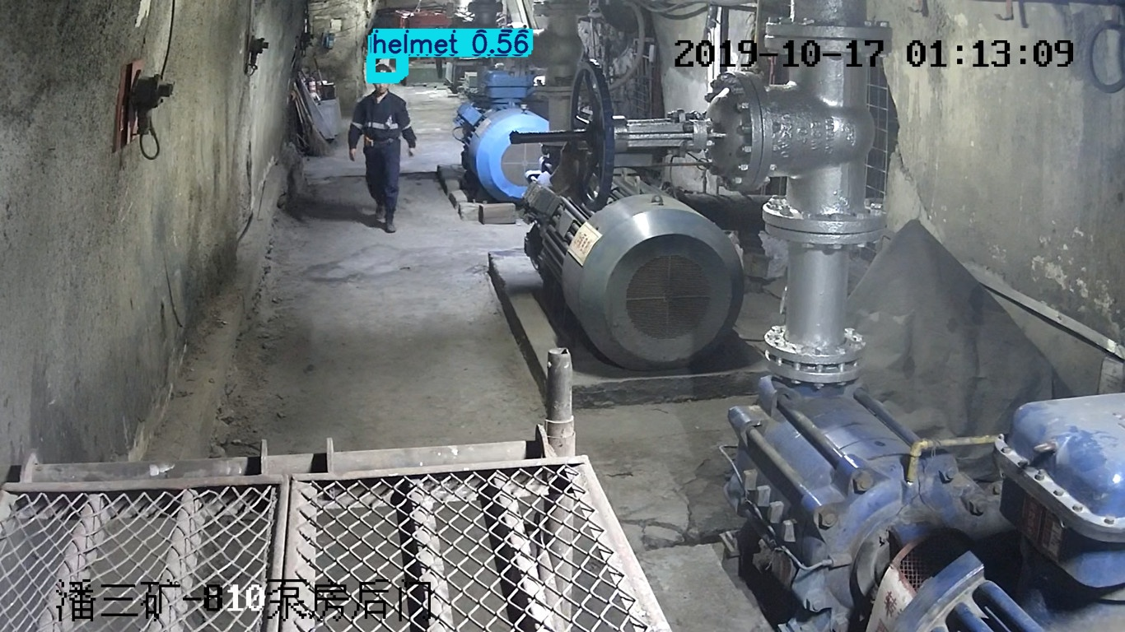 | 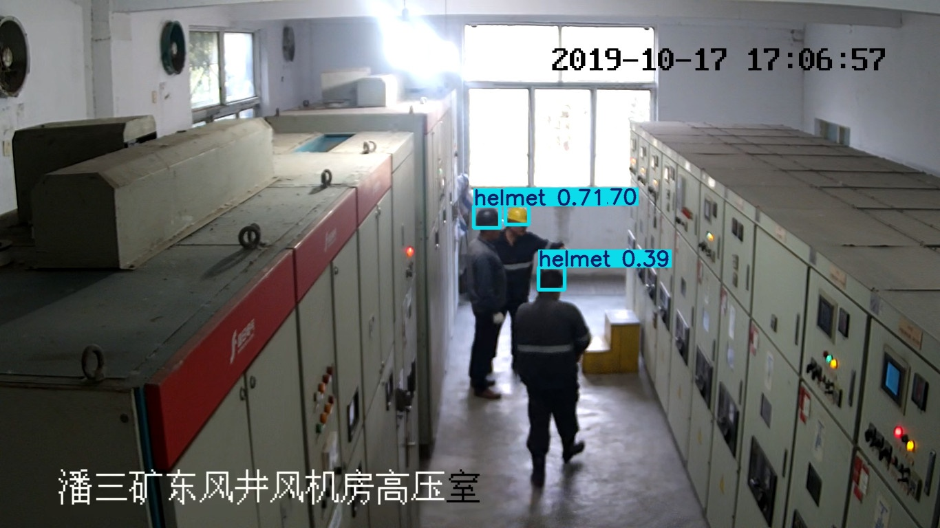
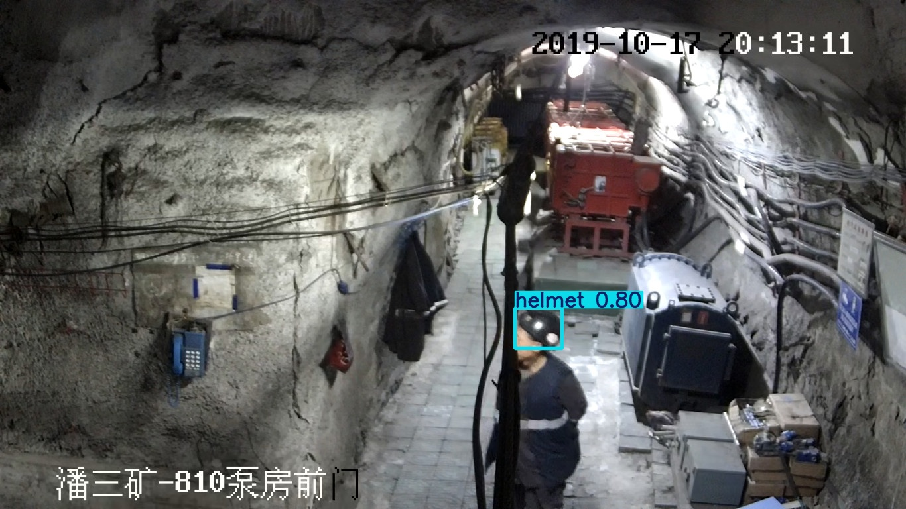 | 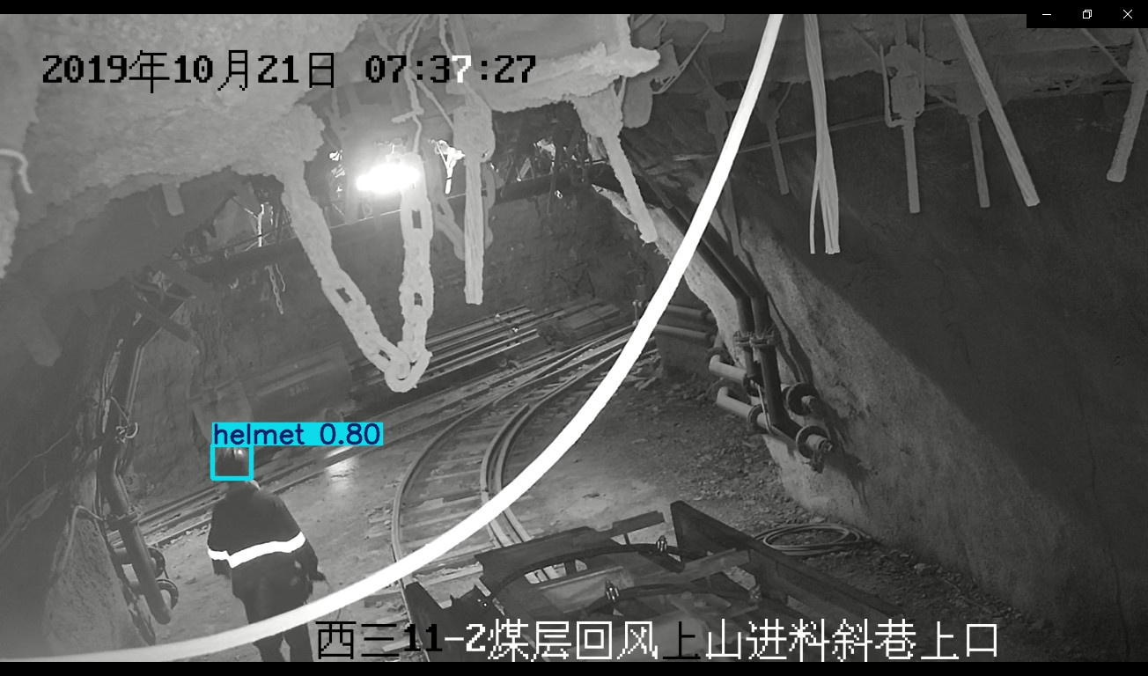 | 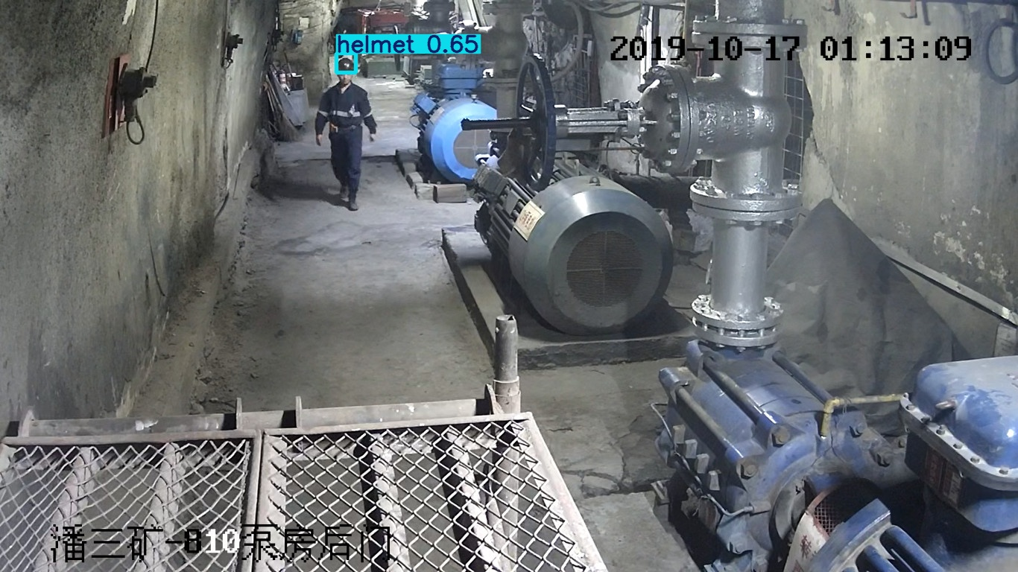 | 