CPSV-AP
Diagram
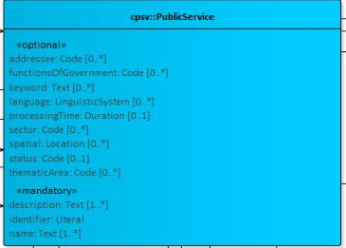

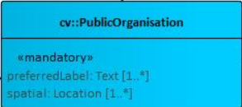

Classes Re-Used from Existing Ones

AddressType from Aggregat

addressee | Code | 0..* | The target recipient of the Public Service.
contact point | Contact Point | 0..* | The main contact information of the resource.
description | Text | 1..* | A free text Description of the Public Service.
follows | Rule | 0..* | It links a Public Service to the Rule(s) under which it operates.
functions of government | Code | 0..* | The purpose of a government activity, which the public service is intended for.
has channel | Channel | 0..* | It links the Public Service to any Channel through which an Agent provides, uses or otherwise interacts with the Public Service, such as an online service, phone number or office.
has competent authority | Public Organization | 1..* | It links a Public Service to a Public Organization, which is the responsible Agent for the delivery of the Public Service.
has cost | Cost | 0..* | It indicates the costs related to the execution of a Public Service for the citizen or business related to the execution of the particular Public Service.
has input | Evidence | 0..* | It links a Public Service to one or more instances of the Evidence class.
has input type | Evidence Type | 0..* | It links a Public Service to one or more instances of the EvidenceType class.
has legal resource | Legal Resource | 0..* | It indicates the Legal Resource (e.g. legislation) to which the Public Service relates, operates or has its legal basis.
has participation | Participation | 0..* | The way how a resource is organized.
holds requirement | Requirement | 0..* | It links a Public Service to a class that describes the Requirement.
identifier | Literal | 1 | A formally-issued Identifier for the Public Service.
is classified by | Concept | 0..* | It allows to classify the Public Service with any Concept other than those already foreseen and defined explicitly in the CPSV-AP (Thematic Area, Sector, etc.).
is grouped by | Event | 0..* | It links the Public Service to the Event class.
is part of | Dataset | 0..* | A related resource in which the described resource is physically or logically included.
keyword | Text | 0..* | A keyword, term or phrase to describe the Public Service.
language | Linguistic System | 0..* | The language(s) in which the Public Service is available.
name | Text | 1..* | The official Name of the Public Service.
processing time | Duration | 0..1 | The (estimated) time needed for executing a Public Service. The actual information is provided using the ISO8601 syntax for durations.
produces | Output | 0..* | It links a Public Service to one or more instances of the Output class, describing the actual result of executing a given Public Service.
related service | Public Service | 0..* | A Public Service related to the particular instance of the Public Service class.
requires | Public Service | 0..* | The way a Public Service makes use of other Public Services.
sector | Code | 0..* | The industry or sector a Public Service relates to, or is intended for.
spatial | Location | 0..* | A Public Service is likely to be available only within a given area, typically the area covered by a particular public authority.
status | Code | 0..1 | It indicates whether a Public Service is active, inactive, under development etc. according to a controlled vocabulary.
thematic area | Code | 0..* | The Thematic Area of a Public Service.

