
Deloitte



Adding A New Data Quality Rule in SEMOSS

Revision History
Version | Comments | Editor
0.1 | Created Document. | Max Gerlach
0.2 | Format Changes and some minor edits | Randall Brown

Table of Contents
Adding New R File 1
Adding the New Rule to Mission Control 1
Formatting the R script to work within Data Quality Framework 2

Adding New R File
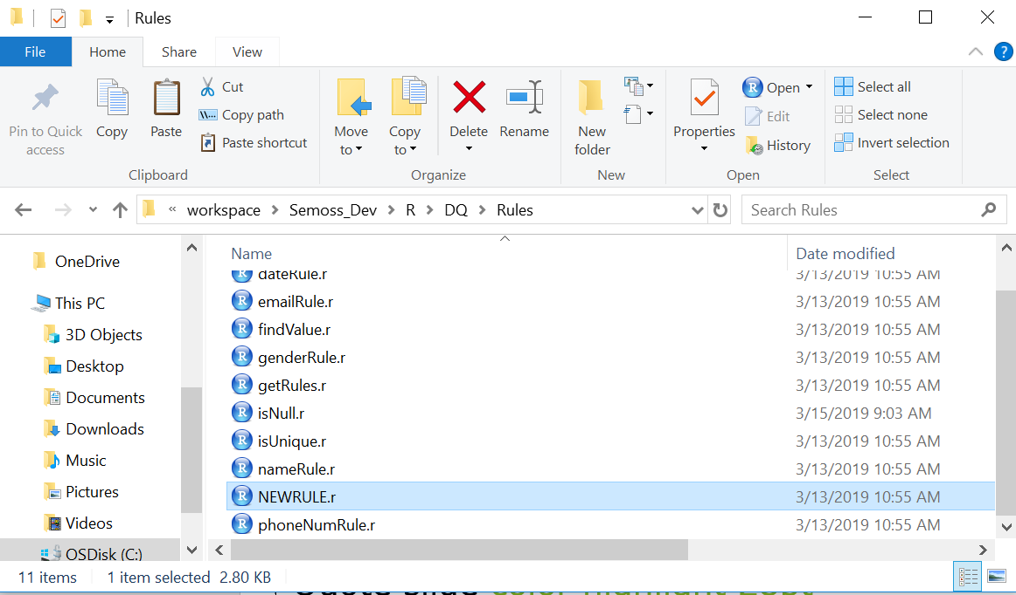
- Start by moving the newly created R file into C:\workspace\Semoss_Dev\R\DQ\Rules directory with a name that matches the functionality of your rule. (e.g. isNull.r, isUnique.r)

- Open sourceFile.R with RStudio (C:/workspace/Semoss_Dev/R/DQ/sourceFile.R)
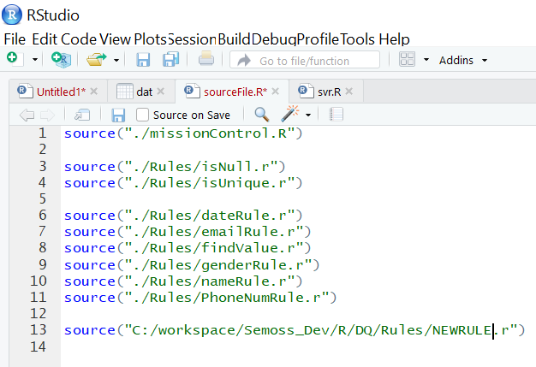
- Below all the other lines of code add:
“ source(“C:/workspace/Semoss_Dev/R/DQ/Rules/NEWRULE.r”) ”

- Save sourceFile.R and close the file.

Adding the New Rule to Mission Control
- Open missionControl.R with RStudio (C:/workspace/Semoss_Dev/R/DQ/missionControl.R)
- After the last ‘else if’ statement in the rulesList statements, add the following lines of code:

else if(rulesList[[i]]$rule == " YOUR_RULE_IDENTIFIER"){
tempResultsTable <- YOUR_RULE_FUNCTION_NAME(dt, rulesList[[i]])
resultsTable <- rbind(resultsTable, tempResultsTable)
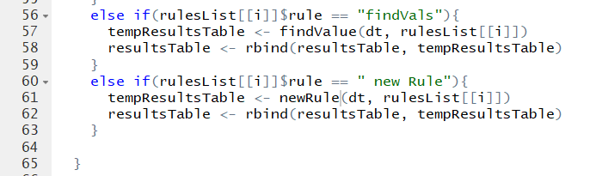
}
Note: This statement calls your new function when a ‘rule identifier’ like ‘findVals’ gets passed from SEMOSS via Pixel to R.

Formatting the R script to work within Data Quality Framework
- If the new rule makes use of regex to compare values to a desired input format, note the dateRule.r, nameRule.r, and emailRule.r files.
  - they are all almost identical besides the:
    - ruleName variable, which should be set to a string of what you would like your outputted rule name to be
    - xxxxxErrorArray variable name, which is a mirror of the column being checked filled with Booleans depending on whether the corresponding element are valid or invalid depending on the rule
    - name of the function that returns the desired regex and the regexes therein
  - Follow this format, updating it as needed for your rule.
- Otherwise, note the parameters passed into missionControl.R for you to work with
  - rulesList is the list of rules, which are to be executed and contain all the data for the rule
    - a rule includes:
      - the rule indicator, which missionControl uses to call the different functions
      - the column on which to operate the rule
      - an options variable, which can be anything else your rule needs to execute
  - dt is the data table passed from SEMOSS, with the data to be analyzed
  - resultsTable is the table populated with the results of the data quality rule(s)
    - this can be passed in if you’ve already run previous rules and would like to append rule outputs or will be freshly created if nothing is passed in
- Your R script needs to return a table with the results and proper headers so it can be bound to the main table which can be set up as such:
  - tempTable <- data.table(rule$col, numInvalid, numValid, totLength, ruleName, description)
  - names(tempTable) <- c('Columns', 'Errors', 'Valid', 'Total', 'Rules', 'Description')
  - this assumes you’re storing the number of invalid elements in a variable called ‘numInvalid,’ the valid elements in a variable called ‘numValid,’ the total length of the column in a variable called ‘totLength,’ the name of the rule you’d like to be put in the data table in a variable called ‘ruleName,’ and the description in a variable called ‘description.’
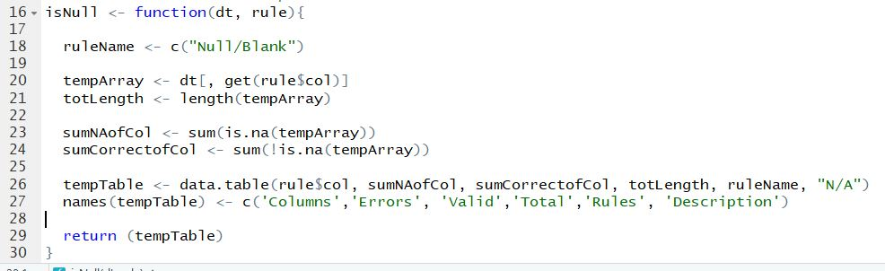
- Finally, return your table and debug if needed.

