Where do you fit in?

Our solutions provide a range of capabilities, made to meet your analytics needs. Whether you’re a prominent government official, or a leading scientist, SEMOSS has an already tested selection of resources at your disposal. Find out where **you** fit in.

Government

Understanding data is crucial for the Government’s ability to make decisions. Need to find redundant systems? Need to visualize projected cost savings? SEMOSS can help.

Learn More

Healthcare

SEMOSS can ensure your understanding of how your healthcare systems are talking to each other. Find relationships previously unseen, to find gaps in your healthcare business. SEMOSS can even help develop a data driven solution.

Learn More

Science

Learn More

Environment

Working with environmental data? Learn about how SEMOSS can create a panoramic view of a disaster, or how it helped NOAA evaluate their strategy to natural calamities.

Learn More

Portfolio Rationalization

Portfolio Rationalization can be a daunting task. It encompasses looking at your enterprise-wide portfolio, and understanding which systems can be decommissioned. SEMOSS visualizations can help make things easy.

Learn More

Legacy Modernization

Legacy Modernization is a key component to staying competitive. Yet, the process of implementing new systems can be challenging. SEMOSS can help you know which business functionalities will be covered, or missing, in the modernization.

Learn More

CIO Strategy

SEMOSS is the leading tool for CIO’s to develop their business strategy. It’s easy to use, free, and repeatedly proven to be successful. See how CIO’s have previously developed their successful business strategies.

Learn More

Custom

Don’t fit into any of our previous projects? SEMOSS can still be used in your own way. Build, visualize, and question nearly any type of data. Take on an independent project, or even just play around with available databases.

Learn More

Government

Data Driven Answers

There are a multitude of problems unique to the Government. SEMOSS can now effectively provide those unique solutions. How can our portfolio be optimized to cost effectively achieve our goals? What projects should we fund given budget and time constraints? Where are our project redundancies across sites? Tough questions, resolvable by data analytics.

SEMOSS has been previously used by various government branches, including the Department of Defense. All of the previous questions were real questions asked by the Ministry of Health Services. Click on each tab to find out more about each solution.

Tab 1 MHS Portfolio Rationalization

Businesses today are often plagued with unnecessary spending on historical legacy systems that are easier to ignore than to decommission.

* What is the health of my portfolio?
* Which applications can be decommissioned to save money?
* What are my long term opportunities for ROI?
* What is the impact of decommissioning?

Step 1: Understand the as-is state of the portfolio

Step 2: Analyze business value and technical maturity of the portfolio

Step 3: Understand cost models

Step 4: Identify portfolio rationalization opportunities

Client : Large healthcare organization with a 2.4B USD IT portfolio

* Saved $58M immediately by decommissioning systems
* Identified 30% duplication in systems from a long term perspective
* Visibility, impact analysis and true cost for decommissioning other systems

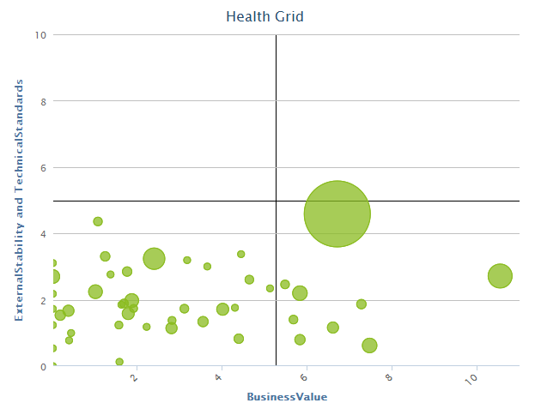

Tab 2 MHS Project Optimization

Enterprises today have a demand surplus and a budget deficit, making it difficult to decide which projects to fund

* Which projects should I fund given my budget and schedule constraints?
* What is the optimal sequence of execution based on risk and schedule constraints?

Step 1: Understand the as-is state of the portfolio

Step 2: Model optimization algorithm based on business needs and stakeholder heuristics

Step 3: Feed constraints based on fact of life challenges

Step 4: Provide dynamic roadmap for execution

Client : Large healthcare organization with a 2.4B USD IT portfolio

* 200M in projected ROI by fostering movement to Service Oriented Architecture
* Dynamic roadmap for legacy modernization and movement to modern Electronic Health Record
* 50% savings by balance risk in execution

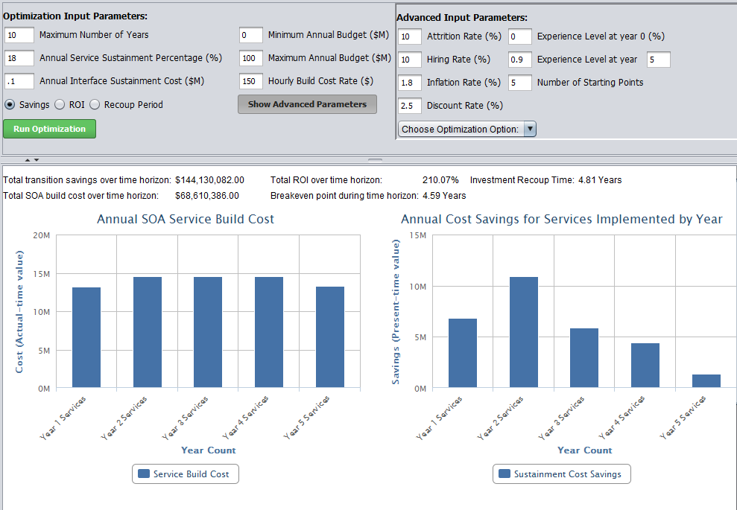

Tab 3 MHS Redundancy Analysis

Redundancies exists at various levels in an enterprise. They increase the budget and reduce the ability of an enterprise to focus efforts for the best ROI

* What are the application / system redundancies?
* What are the contract / vendor redundancies?

Step 1: Understand the as-is state of the portfolio

Step 2: Work with stakeholder to determine parameters & business rules for analysis

Step 3: Analyze portfolio for redundancy

Step 4: Visualize redundancy for actionable insights

Client : Large healthcare organization with a 2.4B USD IT portfolio

* Identified 30% redundancy across the business portfolio
* Ongoing work in terms of identifying contract and vendor redundancy

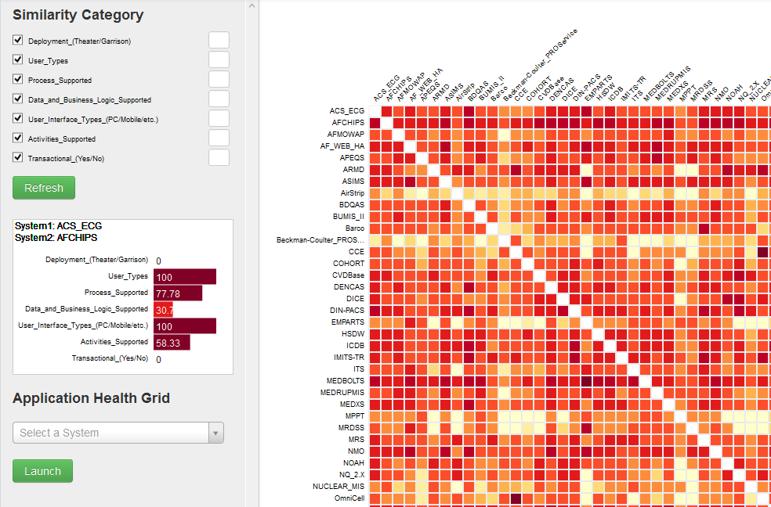

Healthcare

Analytics for a Better Health

As healthcare remains a growing industry, SEMOSS can help you gain the edge. Nobody understands the patient needs more than patients themselves. Exposing the public data effectively can not only help the patient determine their best options, but can also help avoid costly mistakes. SEMOSS lets you work easily with patient data, an important piece of securing better health.

More than just a tool for patient data, you can also explore your relationships across enterprise. Find the path your data travels, and easily determine any functional gaps in your business. Click on each tab to learn more about how SEMOSS can help you with your healthcare questions.

Tab 1 Public Data

Create public data to work with your patients to answer their health concerns.

Use visualization here.

Tab 2 Enterprise-wide Communications

Traverse freely between enterprise-wide data communications between your servers.

Use visualization here.

Tab 3 Understanding Costs

Explore costs associated with certain procedures and transactions.

Use visualization here.

Environment

Mapping Disasters

What happens when calamity strikes? At the National Oceanic and Atmospheric Agency, SEMOSS helped answer this question. The data analytics tool was used to analyze what happens to their organization and our society if observing systems such as satellites suddenly go dark. Click on each tab to see the steps taken to achieve a solution.

Tab 1 Collect Data

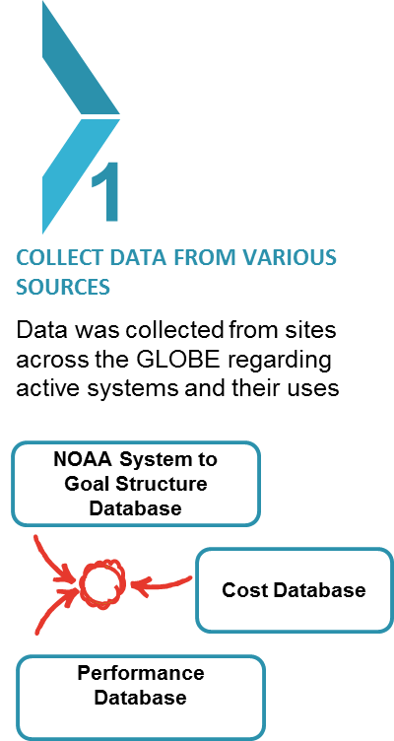

Tab 2 Asking Questions

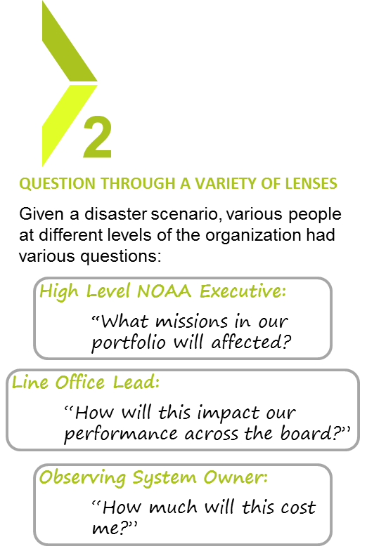

Tab 3 Visualize

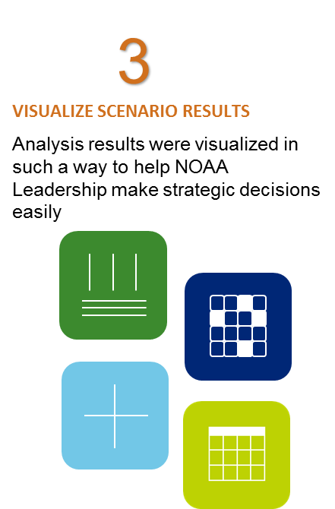

Portfolio Rationalization

***How do you identify savings in the enterprise without any business disruption?***

Portfolio Rationalization can be useful for any enterprise using numerous IT systems. Whether it’s 20, or 200 systems, it’s important to understand the health of your portfolio.

Graph theory based analysis can determine redundant systems in the enterprise to be decommissioned. This can lead to millions of dollars in savings, as it has with a previous healthcare client. Use understanding to balance foresight, new investments, with hindsight, portfolio rationalization. Also dive deeper with algorithm based analysis, performing mathematically based exploration.

**The best way to capture savings is through SEMOSS, the only tool that allows you to efficiently graph, traverse, or perform rationalization algorithms on your portfolio for free.**

Legacy Modernization

CIO Strategy

Custom