SMARTBUDGET
Software Requirements Specification
Prepared in accordance with the IEEE SRS structure (IEEE Std 830) and the Software Engineering Mini-Project Deliverables Part-1 specification
Version 1.1
Prepared by: Amrutha, Akanksha, Aniket
PES University — Department of Computer Science
Software Engineering Mini-Project
Date: 27 September 2026

Revision History
Date | Version | Description | Author
17 Sep 2026 | 1.0 | Initial formal document derived from implemented SmartBudget prototype and project source archive | Amrutha, Akanksha, Aniket
27 Sep 2026 | 1.1 | Corrected traceability gaps between requirements and test cases; aligned NFR/SR coverage with actual test case content; corrected test case wording | Amrutha, Akanksha, Aniket

Table of Contents
1. Introduction
1.1 Purpose
1.2 Document Conventions
1.3 Intended Audience and Reading Suggestions
1.4 Product Scope
1.5 References
2. Overall Description
2.1 Product Perspective
2.2 Product Functions
2.3 User Classes and Characteristics
2.4 Operating Environment
2.5 Design and Implementation Constraints
2.6 User Documentation
2.7 Assumptions and Dependencies
3. Specific Requirements
3.1 Functional Requirements
3.2 Non-Functional Requirements
3.3 External Interface Requirements
4. Security Requirements
4.1 Security Objectives
4.2 Security Requirements
5. UML Use Case Diagram
6. Data Model and Prototype Limitations

1. Introduction

1.1 Purpose
This document specifies the functional, non-functional and security requirements for SmartBudget, a personal finance and budgeting web application developed as a Software Engineering mini-project. It is intended for the course evaluator, the development team, and any reader who requires a precise, verifiable statement of what the implemented system does.

1.2 Document Conventions
Functional requirements are identified with the prefix FR-, non-functional requirements with the prefix NFR-, and security requirements with the prefix SR-. All requirement identifiers are unique and are referenced consistently in the Software Test Plan, the Software Architecture and Design Specification, and the Test Cases and Traceability document.

1.3 Intended Audience and Reading Suggestions
This SRS is intended for the course faculty evaluating the submission, for the student development team, and for testers preparing the associated Test Plan. Section 2 provides an overall description of the product. Section 3 lists functional and non-functional requirements. Section 4 states security objectives and requirements. Section 5 presents the UML use case model. Section 6 describes the underlying data model and known prototype limitations.

1.4 Product Scope
SmartBudget allows a single authenticated user to record income and expense transactions, define a monthly income and budget, import a bank statement in CSV format for automatic categorization, view category- and month-wise analytics, export reports, track savings goals, switch between light and dark themes, and observe a simulated auto-detection feed. The scope of this document is limited to the prototype as implemented; it does not extend to production banking integrations.

1.5 References
[1] IEEE Std 830-1998, IEEE Recommended Practice for Software Requirements Specifications.
[2] IEEE Std 829-2008, IEEE Standard for Software and System Test Documentation.
[3] IEEE Std 1016-2009, IEEE Standard for Information Technology — Systems Design — Software Design Descriptions.
[4] Software Engineering Mini-Project Deliverables Part-1 specification (faculty requirement sheet).
[5] SmartBudget project source archive (React/Vite client, Express API, Mongoose models).

2. Overall Description

2.1 Product Perspective
SmartBudget is a self-contained, three-tier web application: a React/Vite single-page client, an Express REST API, and a MongoDB database accessed through Mongoose models. CSV parsing and a portion of the analytics computation are performed client-side. The system does not depend on any external banking or payment gateway; the “auto-detection” feature described in Section 3 is a simulated client-side feed rather than a live integration.

2.2 Product Functions
The major functions provided to the user are: account creation and authentication; creation, listing and deletion of transactions; configuration of monthly income and budget; import and categorization of CSV bank statements; category- and month-wise analytics with CSV report export; creation, listing and deletion of savings goals; light/dark theme switching; and a simulated auto-detected transaction feed.

2.3 User Classes and Characteristics
The system defines a single user class: an authenticated SmartBudget user who manages their own personal financial data. No administrative, guest, or multi-tenant roles are implemented in the current prototype.

2.4 Operating Environment
Client: any modern desktop web browser. Server: Node.js running an Express application, listening on port 5001 in the current implementation. Database: MongoDB, addressed by default at mongodb://127.0.0.1:27017/smartbudget, configurable through the MONGODB_URI environment variable. Frontend build/development tooling is provided by Vite (development server on port 5173).

2.5 Design and Implementation Constraints
The auto-detection feature is a simulated, fixed client-side feed and is not connected to any real bank or UPI webhook. The implementation does not provide token-based session authentication, role-based authorization, or TLS/rate-limiting configuration; these are prototype-stage limitations rather than intended production features. Some project README material references an earlier SQLite-based design and port 5000; the current implementation uses MongoDB and port 5001, and this document reflects the current implementation.

2.6 User Documentation
No separate end-user manual is delivered with the prototype; the client interface is designed to be self-explanatory, and this SRS, together with the Software Architecture and Design Specification, constitutes the technical documentation delivered with the submission.

2.7 Assumptions and Dependencies
It is assumed that a MongoDB instance is reachable at application startup and that imported CSV files follow the Date/Narration/Debit/Credit column convention used by the supplied sample_bank_statement.csv. The system depends on the Node.js runtime, Express, Mongoose, React, Vite and Papa Parse packages declared in the project source archive.

3. Specific Requirements

3.1 Functional Requirements
Functional requirements are stated using the form “The system shall…” and are uniquely identified. Each requirement is verifiable against the implemented behaviour of the SmartBudget prototype.
ID | Requirement
FR-01 | The system shall allow account creation with name, email and password.
FR-02 | The system shall reject a signup request with missing fields or a password shorter than 6 characters.
FR-03 | The system shall reject registration with an email address that already exists, returning a conflict response.
FR-04 | The system shall authenticate a registered user by email and password.
FR-05 | The system shall allow creation of an income or expense transaction with name, category, amount and optional metadata.
FR-06 | The system shall list transactions for the requesting user_id.
FR-07 | The system shall allow deletion of a persisted transaction, and removal of a local-only transaction from the current list.
FR-08 | The system shall allow the user to save a non-negative monthly income and budget target.
FR-09 | The system shall parse an imported CSV statement whose rows contain Date, Narration, Debit and/or Credit fields.
FR-10 | The system shall categorize supported narrations as Food, Transport, Shopping, Entertainment, Income or Other.
FR-11 | The system shall display category-wise and month-by-month analytics derived from transaction data.
FR-12 | The system shall allow creation, listing and deletion of savings goals with a positive target amount.
FR-13 | The system shall display a report and allow the user to export transaction data as a CSV file.
FR-14 | The system shall allow the user to toggle between light and dark theme and persist the selection in browser localStorage.
FR-15 | The system shall insert a simulated detected transaction into the current client-side transaction list on user request.

3.2 Non-Functional Requirements
Non-functional requirements are stated as measurable constraints wherever the project evidence supports a specific, verifiable statement.
ID | Requirement
NFR-01 | All six primary navigation destinations of the application shall be separately reachable from the interface.
NFR-02 | Invalid numeric input values shall produce explicit, user-visible validation errors.
NFR-03 | User passwords shall be stored as bcrypt-derived hashes and never in plaintext.
NFR-04 | Serialized user objects returned by the API shall not expose the password_hash field.
NFR-05 | Expected API failures shall be reported using explicit HTTP status codes accompanied by a JSON error message.
NFR-06 | Frontend presentation logic, API routing logic, and persistence logic shall remain separated into distinct source modules.
NFR-07 | Backend request handling and database operations shall be implemented asynchronously.
NFR-08 | Transaction and goal read operations shall filter results by user_id so that one user cannot view another user’s records.
NFR-09 | The project shall build and run through the Node.js/Vite package scripts without additional manual configuration.
NFR-10 | Important state, error and category information shall be conveyed through text labels and not through colour or icon styling alone.

3.3 External Interface Requirements

3.3.1 User Interfaces
The client presents a dashboard, a transactions screen, a budget settings screen, an analytics/reports screen, a savings goals screen, and a settings/theme control, all reachable from primary navigation (NFR-01).

3.3.2 Software Interfaces
The client communicates with the Express REST API over HTTP using JSON request and response bodies, as detailed in Section 5.3 of the Software Architecture and Design Specification. The API communicates with MongoDB through the Mongoose object-data-modelling layer.

3.3.3 Communications Interfaces
All client-server communication uses HTTP request/response calls to endpoints under /api. No push, websocket or webhook interfaces are implemented in the current prototype.

4. Security Requirements

4.1 Security Objectives
ID | Objective
SEC-OBJ-01 | Protect user account credentials from plaintext storage and from disclosure in API responses.
SEC-OBJ-02 | Validate all user-controlled input at API boundaries to prevent malformed or unauthorized data from being persisted.

4.2 Security Requirements
ID | Requirement
SR-01 | The system shall hash signup passwords using bcrypt before persistence.
SR-02 | The system shall remove the password_hash field from User objects before serialization in API responses.
SR-03 | The system shall reject signup passwords shorter than 6 characters.
SR-04 | The system shall verify login credentials using bcrypt comparison rather than plaintext comparison.
SR-05 | The system shall reject transaction requests containing a non-numeric amount value.
SR-06 | The system shall require monthly income and budget values to be numeric and greater than or equal to zero.
SR-07 | The system shall require a savings-goal target to be numeric and greater than zero.
SR-08 | The system shall validate ObjectId syntax before executing a transaction or goal deletion.
Note: the current implementation does not include token-based session authentication, role-based access control, or transport-layer security configuration. These are prototype-stage limitations and are not represented as implemented security controls.

5. UML Use Case Diagram
The use case diagram below reflects the single implemented actor (User) and the eight functional use cases actually supported by the prototype. “Simulate Auto-Detection” is modelled explicitly as a prototype interaction rather than a real financial integration, consistent with Section 2.5.
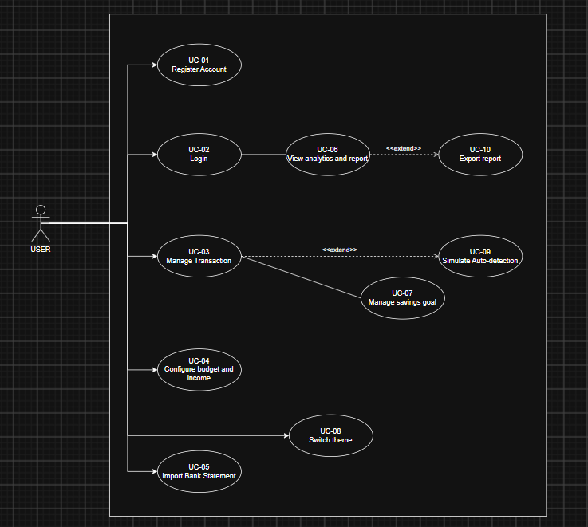
Figure 1. UML use case diagram for the SmartBudget system.

6. Data Model and Prototype Limitations
Entity | Fields / Role
User | id, name, email, password_hash, monthly_income, monthly_budget, created_at
Transaction | id, user_id, name, category, amount, txn_date, payment_method, notes, created_at
Goal | id, user_id, name, target, current, deadline, created_at
The current implementation does not provide token-based authentication, real bank/UPI webhook integration, or backend persistence for CSV-imported or simulated auto-detected transactions. These are documented as prototype limitations rather than as silently assumed requirements.

