SMARTBUDGET
Software Architecture and Design Specification
Prepared in accordance with the IEEE Std 1016 design description structure and the Software Engineering Mini-Project Deliverables Part-1 specification
Version 1.1
Prepared by: Amrutha, Akanksha, Aniket
PES University — Department of Computer Science
Software Engineering Mini-Project
Date: 27 September 2026

Revision History
Date | Version | Description | Author
17 Sep 2026 | 1.0 | Initial formal document derived from implemented SmartBudget prototype and project source archive | Amrutha, Akanksha, Aniket
27 Sep 2026 | 1.1 | Corrected traceability gaps between requirements and test cases; aligned NFR/SR coverage with actual test case content; corrected test case wording | Amrutha, Akanksha, Aniket

Table of Contents
1. Introduction
1.1 Purpose
1.2 Scope
1.3 References
2. Architecture
2.1 Architecture Pattern
2.2 Component Diagram
2.3 Component Descriptions
2.4 Requirement Traceability
2.5 Security Architecture
3. Detailed Design
3.1 Sequence Diagram — User Login
3.2 Sequence Diagram — Add Transaction
3.3 API Design
3.4 Error Handling
4. Configuration Notes

1. Introduction

1.1 Purpose
This Software Architecture and Design Specification (SADS) describes the architecture, component decomposition, architecture pattern, requirements traceability, security architecture, detailed design, API design and error handling of the SmartBudget system, as actually implemented.

1.2 Scope
This document covers the client, API, and persistence components of the SmartBudget prototype and their interactions. It does not describe infrastructure that is not present in the implementation, such as container orchestration or load balancing.

1.3 References
[1] IEEE Std 1016-2009, IEEE Standard for Information Technology — Systems Design — Software Design Descriptions.
[2] Software Requirements Specification, SmartBudget, Version 1.0.
[3] SmartBudget project source archive.

2. Architecture

2.1 Architecture Pattern
SmartBudget follows a layered client-server architecture: a React single-page application (presentation layer) communicates over HTTP with an Express REST API (application/business-logic layer), which in turn accesses MongoDB (data layer) through the Mongoose object-data-modelling layer. This pattern was selected because it reflects how the implementation is actually structured — the client contains no direct database access, and all persistence operations are mediated by the Express routes and Mongoose schemas. The system is not organized as microservices: there is a single backend process exposing all REST routes, which is consistent with a modular monolith rather than a distributed service architecture.

2.2 Component Diagram
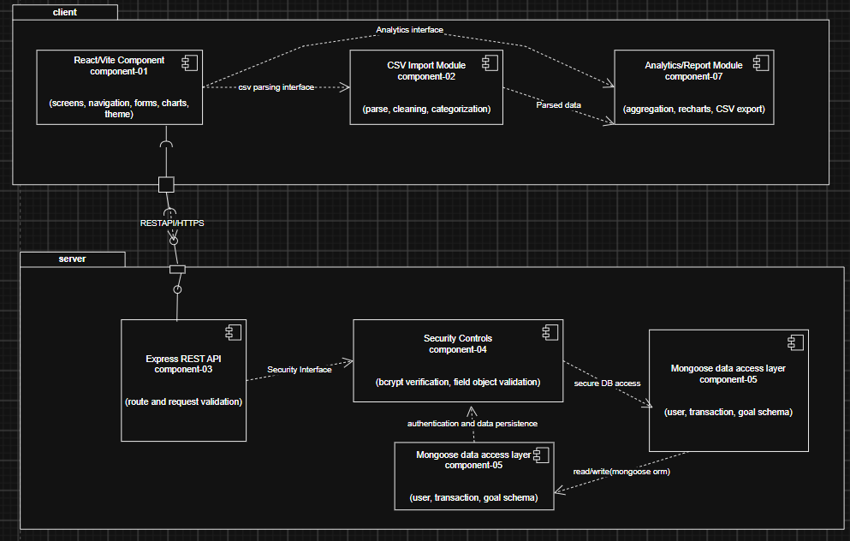
Figure 2. UML component diagram of the SmartBudget system.

2.3 Component Descriptions
Comp. ID | Name | Responsibility | Interfaces | Dependencies | Related Requirements
COMP-01 | React/Vite Client | Screens, navigation, forms, client state, charts and theme handling. | HTTP client to Express API (provided: user interaction; required: REST endpoints) | COMP-03, COMP-02 | FR-05–FR-15, NFR-01, NFR-10
COMP-02 | CSV Import Module | Parses uploaded CSV files (Papa Parse), cleans merchant text and applies rule-based categorization. | Invoked by COMP-01 (<<use>>) | COMP-01 | FR-09–FR-10
COMP-03 | Express REST API | Exposes authentication, settings, transaction and goal routes; performs request validation. | REST endpoints (provided); Mongoose models (required) | COMP-04, COMP-05 | FR-01–FR-15, SR-01–SR-08
COMP-04 | Security Controls | bcrypt password hashing/verification, field validation, ObjectId validation. | Invoked by COMP-03 (<<use>>) | COMP-03 | SR-01–SR-08
COMP-05 | Mongoose Data-Access Layer | Defines User, Transaction and Goal schemas; serializes responses. | Provided to COMP-03; required: MongoDB driver | COMP-06 | FR-01–FR-13, NFR-08
COMP-06 | MongoDB | Persists User, Transaction and Goal documents. | Database queries (provided to COMP-05) | — | FR-01–FR-13
COMP-07 | Analytics / Reports Module | Aggregates transaction data by category and month; renders charts (Recharts); generates CSV export. | Invoked by COMP-01/COMP-03 (data) | COMP-03, COMP-01 | FR-11, FR-13

2.4 Requirement Traceability
Architecture Element | Requirements
React screens / navigation (COMP-01) | FR-05–FR-15, NFR-01, NFR-10
Auth routes + User model (COMP-03, COMP-05) | FR-01–FR-04, SR-01–SR-04
Transaction routes / model (COMP-03, COMP-05) | FR-05–FR-07, NFR-08, SR-05
Settings route / model | FR-08, SR-06
CSV importer (COMP-02) | FR-09–FR-10
Analytics / report logic (COMP-07) | FR-11, FR-13
Goal routes / model | FR-12, SR-07–SR-08
Theme state (COMP-01) | FR-14
Auto-detection card (COMP-01) | FR-15

2.5 Security Architecture
Credential protection uses bcryptjs during signup and bcrypt comparison during login (COMP-04). User serialization removes the password_hash field before any API response is returned. API boundaries in COMP-03 validate required fields and numeric ranges for transactions, budgets and goals. Delete endpoints validate ObjectId syntax prior to executing a database operation. Express CORS middleware is enabled on the API. The source does not implement token-based authorization middleware; this prototype should therefore not be treated as a production-grade banking security architecture, consistent with the constraint stated in SRS Section 2.5.

3. Detailed Design

3.1 Sequence Diagram — User Login
This diagram traces the credential-verification workflow supporting FR-04, SR-01 and SR-04.
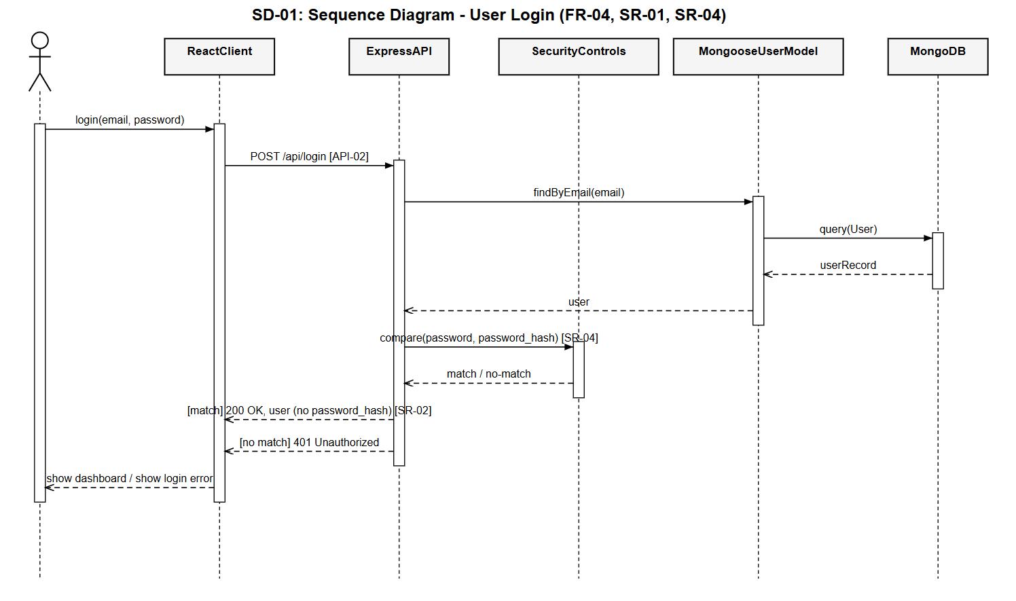

3.2 Sequence Diagram — Add Transaction
This diagram traces the transaction-creation workflow supporting FR-05, NFR-02 and SR-05.
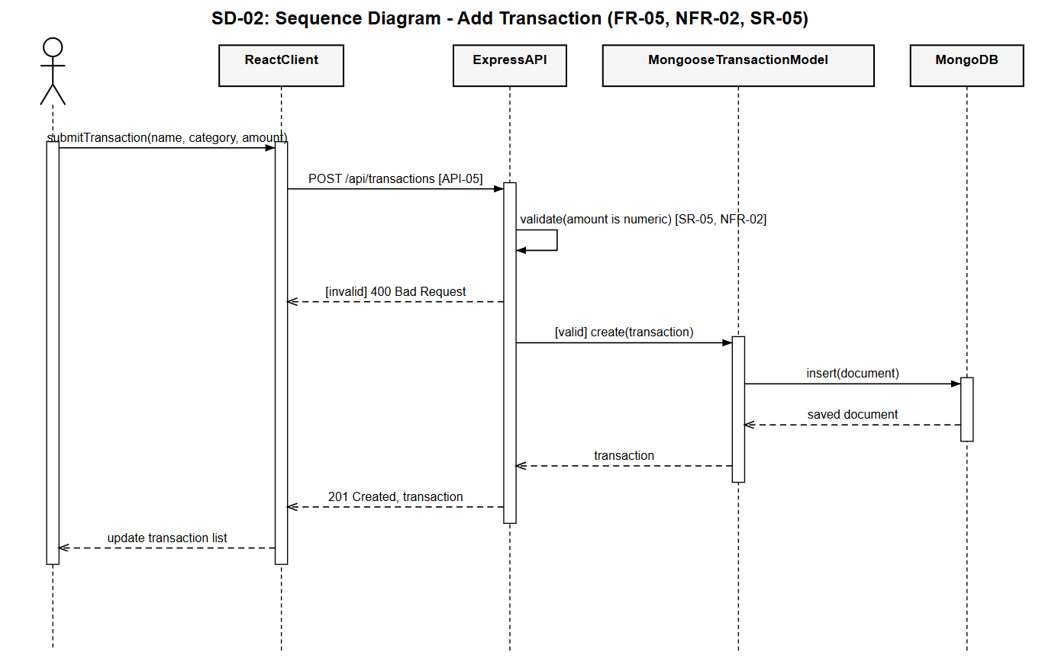

3.3 API Design
API ID | Method | Endpoint | Purpose / Validation | Related Req.
API-01 | POST | /api/signup | Create user account; required fields, password ≥ 6 characters; duplicate email returns 409. | FR-01–FR-03, SR-01, SR-03
API-02 | POST | /api/login | Authenticate user; missing fields return 400; invalid credentials return 401. | FR-04, SR-04
API-03 | PUT | /api/users/:id/settings | Update monthly income/budget; values must be numeric and ≥ 0; user id must be valid. | FR-08, SR-06
API-04 | GET | /api/users | List serialized users for demo/reporting purposes. | —
API-05 | POST | /api/transactions | Create a transaction; required fields and numeric amount enforced. | FR-05, SR-05
API-06 | GET | /api/transactions/:userId | List transactions filtered by user_id. | FR-06, NFR-08
API-07 | DELETE | /api/transactions/:id | Delete a transaction; validates ObjectId; returns 404 if not found. | FR-07, SR-08
API-08 | POST | /api/goals | Create a savings goal; target must be greater than 0. | FR-12, SR-07
API-09 | GET | /api/goals/:userId | List savings goals filtered by user_id. | FR-12, NFR-08
API-10 | DELETE | /api/goals/:id | Delete a savings goal; validates ObjectId; returns 404 if not found. | FR-12, SR-08

3.4 Error Handling
Layer | Behaviour
Frontend | Checks response.ok, parses the JSON body, and displays data.error or a fallback message to the user.
Validation | Returns HTTP 400 for malformed or missing input.
Authentication | Returns HTTP 401 for unknown users or incorrect credentials.
Duplicate resource | Returns HTTP 409 for duplicate email registration.
Not found | Returns HTTP 404 for an invalid or missing target resource, including malformed identifiers.
Server / database | Returns HTTP 500 with a generic error message on unexpected server or database failure.

4. Configuration Notes
db.js defaults to mongodb://127.0.0.1:27017/smartbudget and allows override via the MONGODB_URI environment variable. server.js listens on port 5001. The frontend API_BASE constant points to http://localhost:5001/api. Project README documentation referencing SQLite or port 5000 reflects an earlier design iteration and should be synchronized with these current implementation values.

