Laboratory Work 1

Course
Microcontroller Systems

Title
Buttons and LED Counter (8-bit Representation)

Objective
To implement a microcontroller-based 8-bit up/down counter controlled by two push-buttons and displayed on eight LEDs.

Task Requirements
- Build a circuit with a microcontroller, two buttons (UP, DOWN), and 8 LEDs.
- Implement firmware so that:
  - initial state is all LEDs OFF,
  - UP increases the 8-bit value,
  - DOWN decreases the 8-bit value,
  - LEDs represent the current value in binary form.

Circuit Diagram
The circuit was assembled according to the assignment structure (microcontroller + 2 buttons + 8 LEDs).
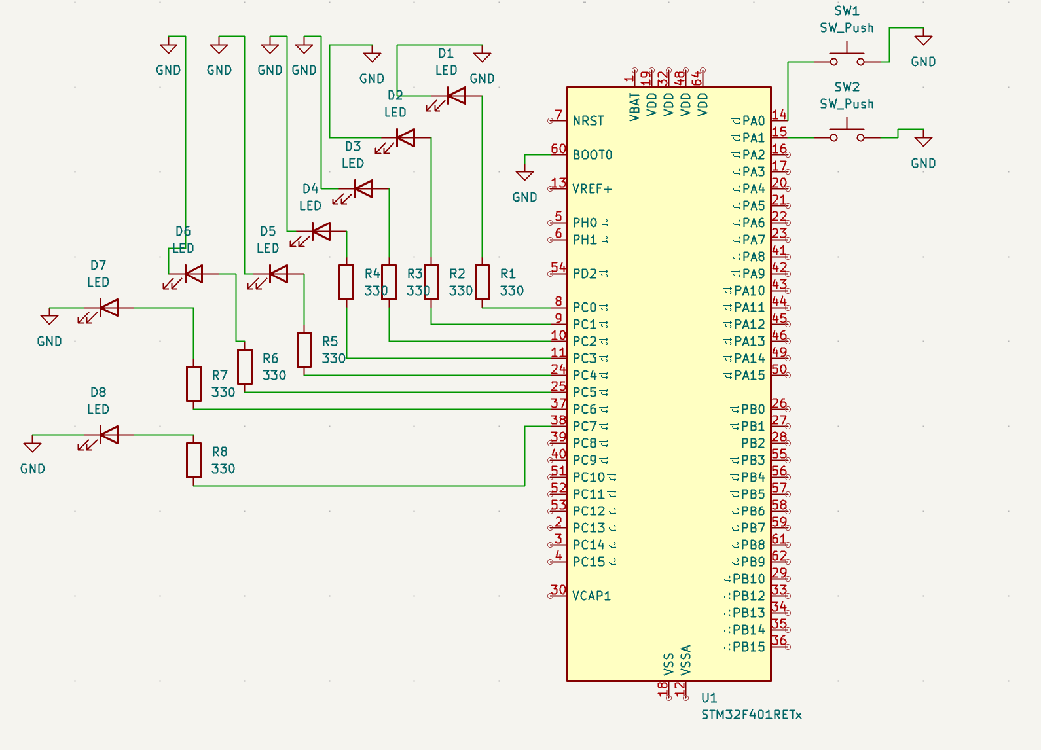
Lab 1 schematic

Software Implementation
Main source file: - Lab1_main.c
Firmware logic: 1. Configure two button inputs with pull-up behavior. 2. Configure eight LED outputs. 3. Store current 8-bit value in a counter variable. 4. Detect button press edges and increment/decrement the counter. 5. Output counter bits to 8 LED lines.

Runtime Verification
Initial state (counter = 0):
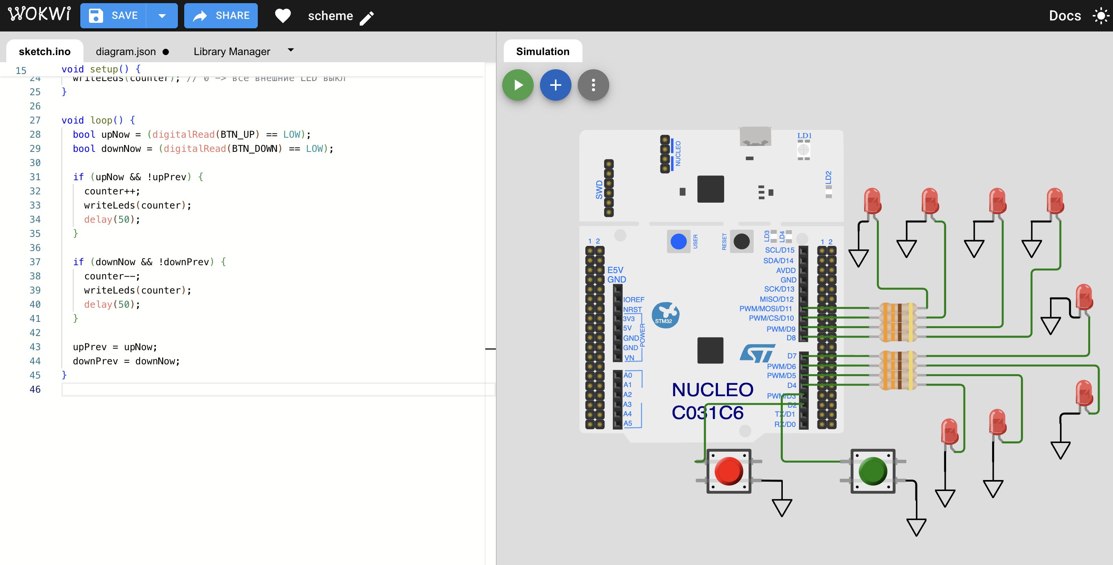
Lab 1 runtime zero state
Counter operation after button presses:
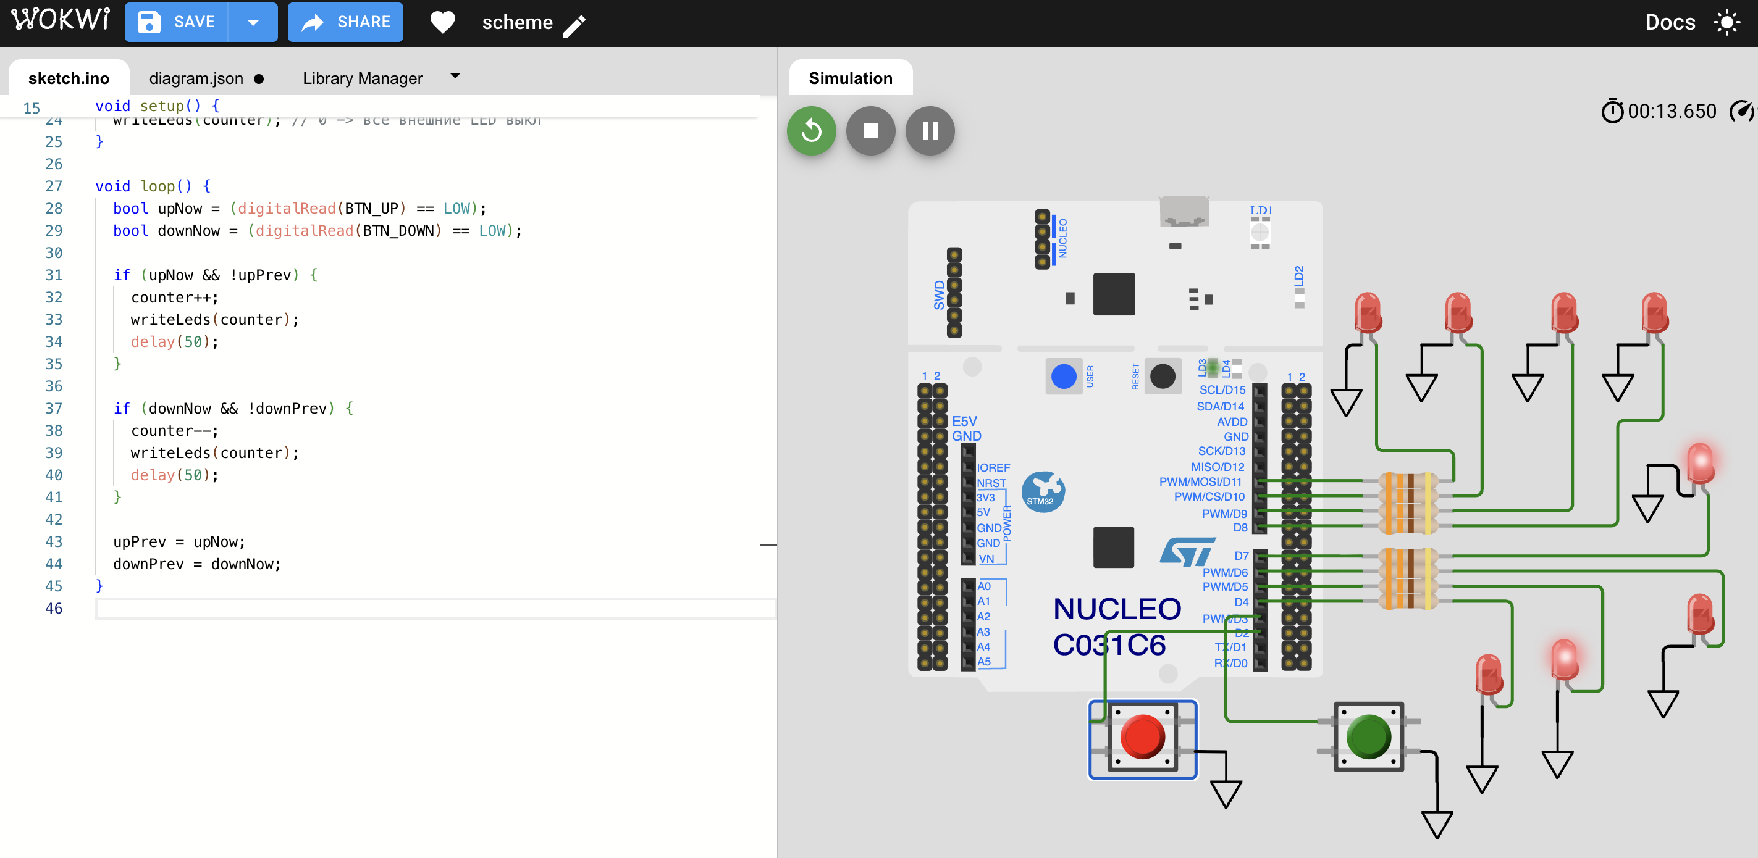
Lab 1 runtime active state
Observed behavior: 1. At startup all external LEDs are OFF. 2. Pressing UP increases the binary value shown on LEDs. 3. Pressing DOWN decreases the binary value shown on LEDs. 4. The counter operates as an 8-bit value (0..255 with wrap-around).

Code Listing (main.c)
#include "stm32f4xx.h"
#include <stdint.h>
#define LED_MASK_8BIT (0xFFu)
#define BTN_UP_PIN (0u) // PA0
#define BTN_DOWN_PIN (1u) // PA1
static void delay_cycles(volatile uint32_t n)
{
while (n--) {
__NOP();
}
}
static void gpio_init(void)
{
// Enable GPIOA and GPIOC clocks.
RCC->AHB1ENR |= RCC_AHB1ENR_GPIOAEN | RCC_AHB1ENR_GPIOCEN;
(void)RCC->AHB1ENR;
// PC0..PC7 as outputs (LEDs), push-pull, no pull.
GPIOC->MODER &= ~(0xFFFFu);
GPIOC->MODER |= (0x5555u);
GPIOC->OTYPER &= ~(LED_MASK_8BIT);
GPIOC->PUPDR &= ~(0xFFFFu);
// PA0 (UP) and PA1 (DOWN) as input with pull-up.
GPIOA->MODER &= ~((3u << (BTN_UP_PIN * 2u)) | (3u << (BTN_DOWN_PIN * 2u)));
GPIOA->PUPDR &= ~((3u << (BTN_UP_PIN * 2u)) | (3u << (BTN_DOWN_PIN * 2u)));
GPIOA->PUPDR |= ((1u << (BTN_UP_PIN * 2u)) | (1u << (BTN_DOWN_PIN * 2u)));
}
static void leds_write(uint8_t value)
{
uint32_t odr = GPIOC->ODR;
odr &= ~LED_MASK_8BIT;
odr |= value;
GPIOC->ODR = odr;
}
static uint8_t button_pressed(uint32_t pin)
{
// Active low because pull-up is enabled.
return ((GPIOA->IDR & (1u << pin)) == 0u) ? 1u : 0u;
}
int main(void)
{
uint8_t counter = 0u;
uint8_t up_prev = 0u;
uint8_t down_prev = 0u;
gpio_init();
leds_write(counter); // Initial state: all LEDs off.
for (;;) {
uint8_t up_now = button_pressed(BTN_UP_PIN);
uint8_t down_now = button_pressed(BTN_DOWN_PIN);
if ((up_now != 0u) && (up_prev == 0u)) {
counter++;
leds_write(counter);
delay_cycles(120000u); // Debounce delay.
}
if ((down_now != 0u) && (down_prev == 0u)) {
counter--;
leds_write(counter);
delay_cycles(120000u); // Debounce delay.
}
up_prev = up_now;
down_prev = down_now;
}
}

Conclusion
The laboratory task was completed successfully. The hardware structure and firmware behavior match the required functionality: 8-bit LED indication controlled by UP and DOWN buttons.

